Supplementary Information for:

Assessing the degradation of ancient milk proteins through site-specific deamidation patterns

Authors:
Abigail Ramsøe^{1,2*}*, Mia Crispin¹, Meaghan Mackie^{3,4}, Krista McGrath^{1,5}, Roman Fischer⁶, Beatrice Demarchi⁷, Matthew J. Collins^{3,8}, Jessica Hendy¹, Camilla Speller*^{1,9}

Affiliations:
1 BioArCh, Department of Archaeology, University of York, York, UK
2 Department of Earth Sciences, Natural History Museum, London, UK
3 The GLOBE Institute, University of Copenhagen, Copenhagen, Denmark
4 The Novo Nordisk Foundation Center for Protein Research, University of Copenhagen, Denmark
5 Department of Prehistory and Institute of Environmental Science and Technology (ICTA), Universitat Autònoma de Barcelona, Bellaterra, Spain
6 Target Discovery Institute, Nuffield Department of Medicine, University of Oxford, UK
7 Department of Life Sciences and Systems Biology, University of Turin, Italy
8 McDonald Institute for Archaeological Research, University of Cambridge, Cambridge, UK
9 Department of Anthropology, University of British Columbia, Vancouver, Canada

Supplementary Information

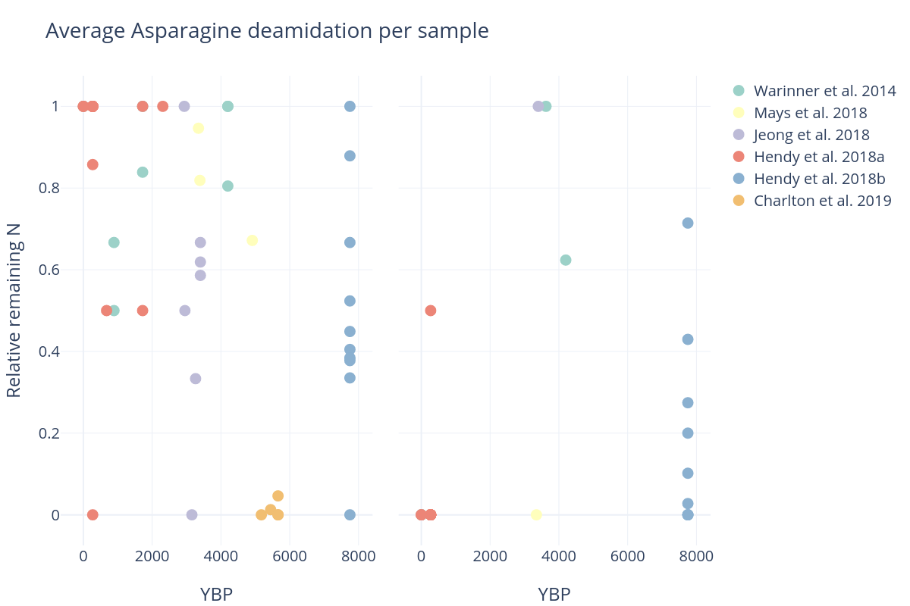

Figure S1: Average asparagine deamidation per sample within previously published archaeological datasets (left panel BLG; right panel caseins).
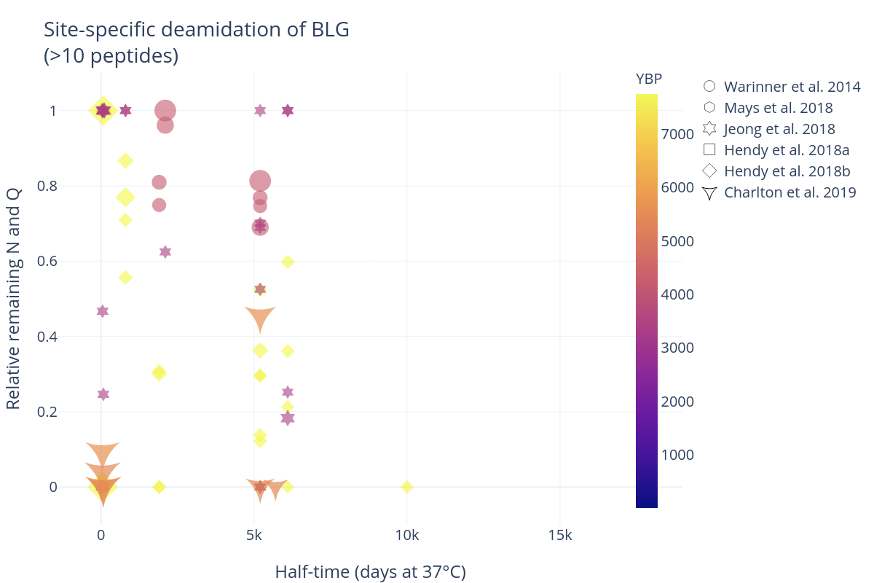
Figure S2: Site-specific deamidation in previously published archaeological samples containing more than ten unique BLG peptides.

