SUPPLEMENTARY INFORMATION

Zebrafish Automatic Monitoring System for Conditioning and Behavioral Analysis

¹Marta de Oliveira Barreiros, ¹Felipe Gomes Barbosa, ¹Diego de Oliveira Dantas, ¹Daniel Luna dos Santos, ²Sidarta Ribeiro, ³Giselle Cutrim Santos, ¹Allan Kardec Barros
marta-barreiros@hotmail.com; felipegomes.mj@gmail.com, diego_odantas@hotmail.com; dantmec@gmail.com; sidartaribeiro@neuro.ufrn.br; giselle.cutrim@gmail.com; akduailibe@gmail.com
¹Department of Electrical Engineering, Laboratory for Biological Information Processing (PIB), Federal University of Maranhão (UFMA), São Luís-MA, Brazil.
² Brain Institute, Federal University of Rio Grande do Norte, Natal-RN, Brazil
³ Department of Biology Sciences, State University of Maranhão, São Luís-MA, Brazil.
Corresponding author: M.B.
Department of Electrical Engineering, Federal University of Maranhão (UFMA)
Av. dos Portugueses, 1966, Vila Bacanga,
CEP 65080-805
São Luís - MA, Brazil
Phone/Fax: +55 98 3272 8220;
E-mail: marta-barreiros@hotmail.com

S1 - Stage of the zebrafish conditioning system. The zebrafish behavioral evaluation algorithm consists of the following stages: fish conditioning process, video processing, fish detection and behavioral tracking and modeling. From the tracking it is possible to measure the average polarization, speed, distance traveled, network of interaction between the fish and to create the fish route by heat map.
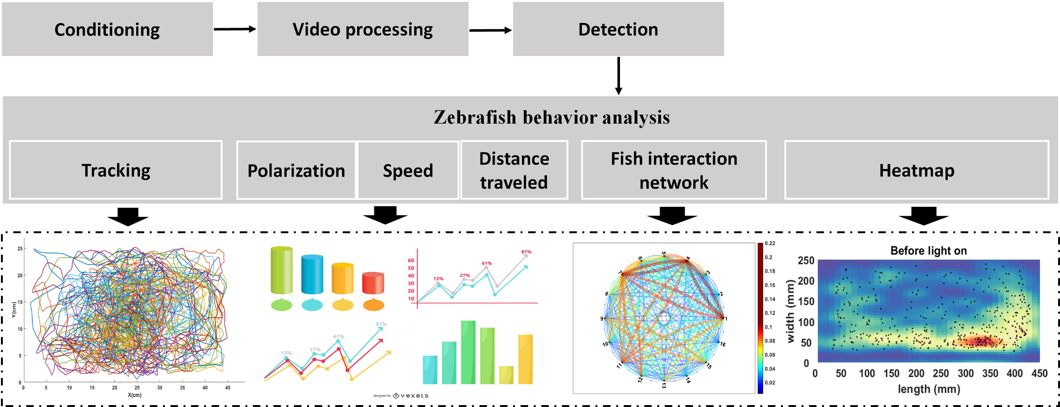
S2 - Zebrafish school interaction network. The interaction network of the fish school was created by mutual information of the difference in the angle of the fish's head during the movement between the frames. The arrow between the nodes indicates that the fish has triggered a locomotor change, and the thickness of this arrow is the value of the measure of mutual information between a pair of fish, measured by the frequency of interactions between the fish. Thus, the behavioral dynamics of the school shows that during the vibracall stimulus, the fish showed greater interaction of movement. A) Interaction between the fish during the conditioning period with a red LED light stimulus. B) Interaction between fish during the conditioning period with vibracall stimulus.
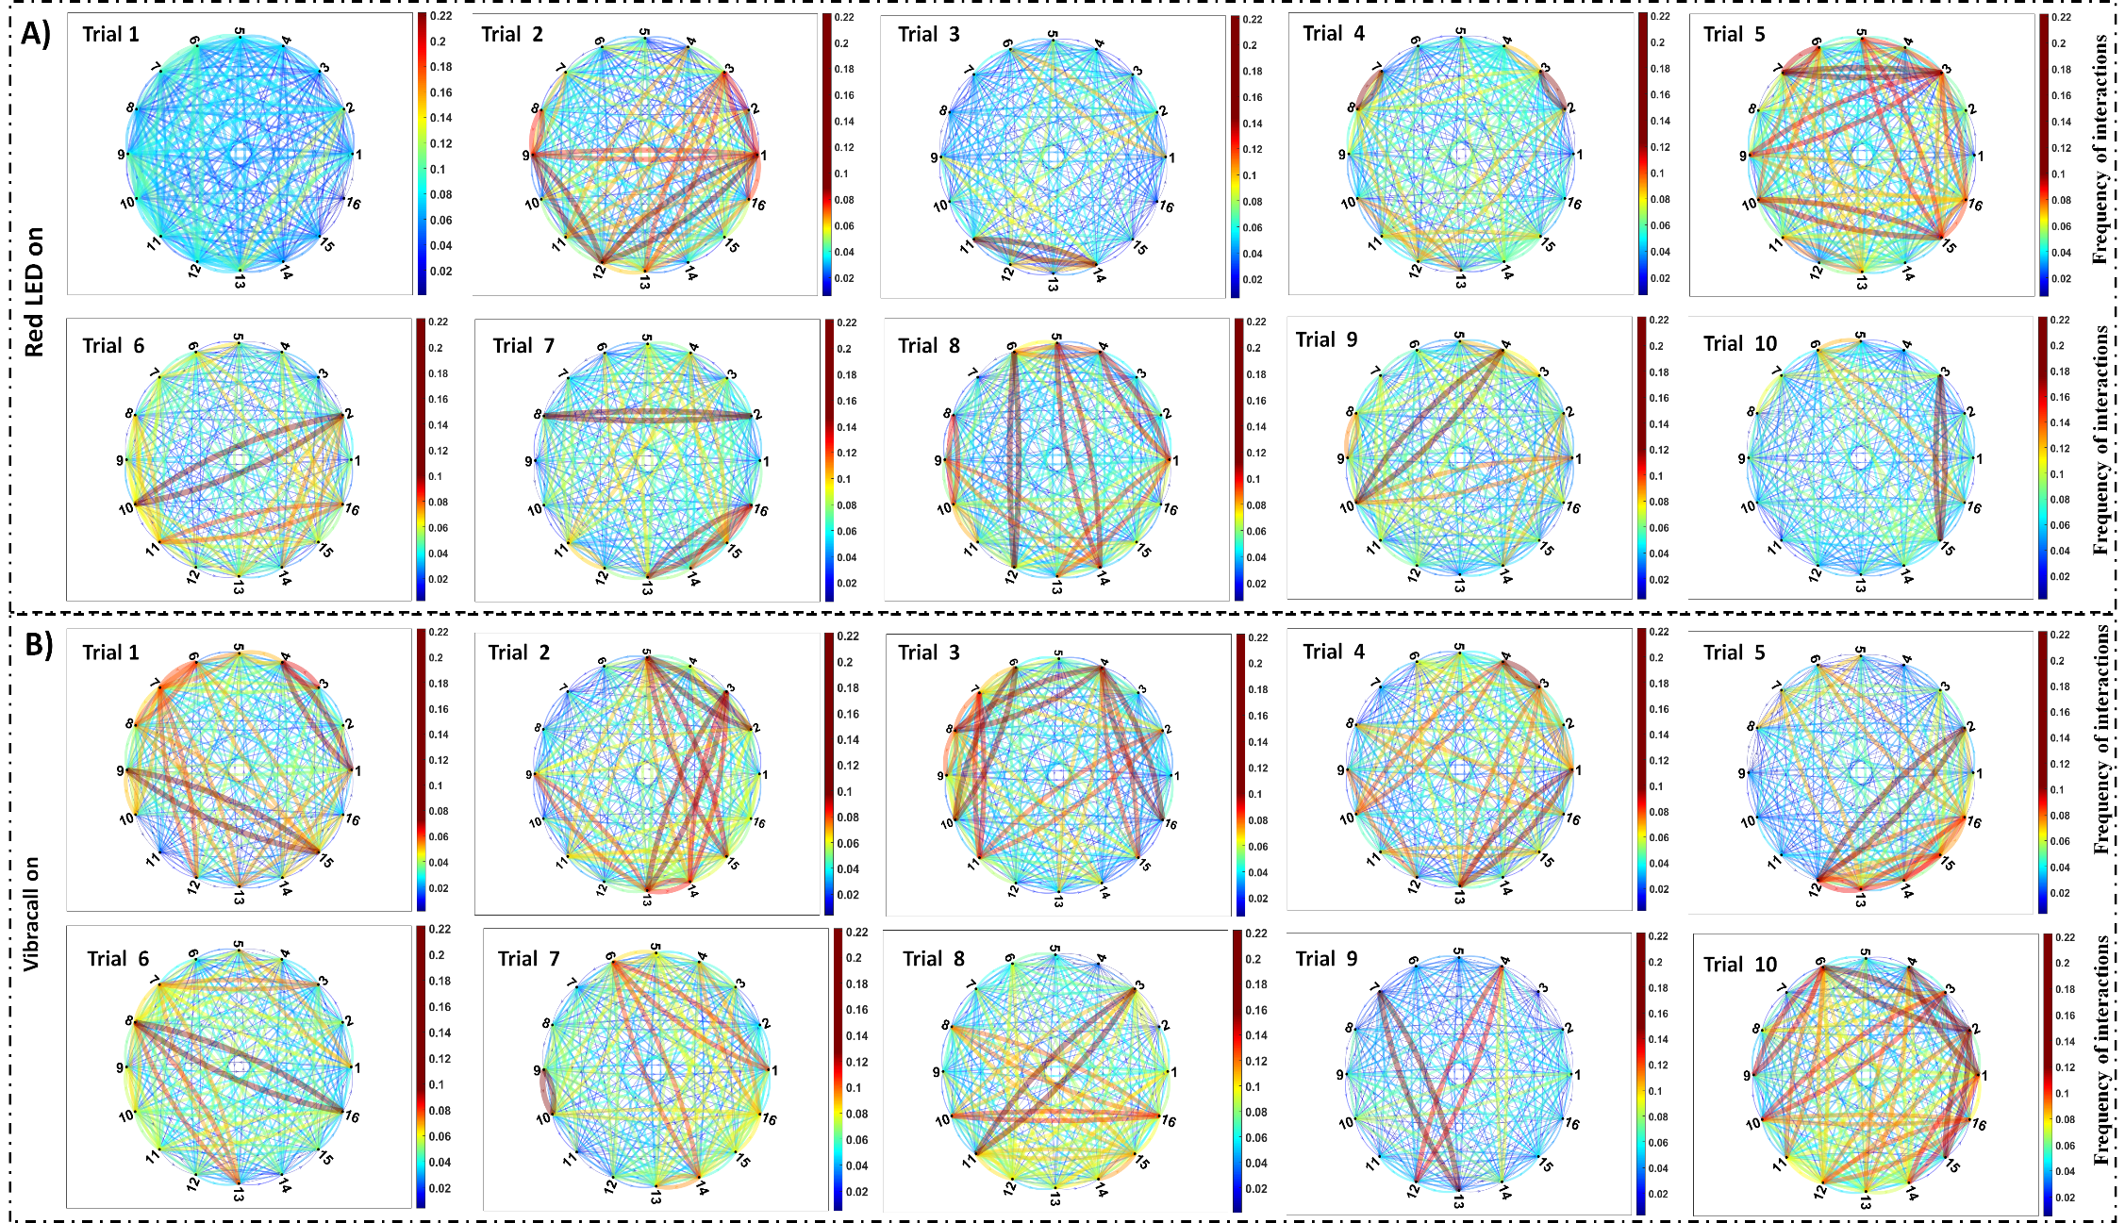

SUPPLEMENTARY VIDEO
V1 - Video of the online training system. The video shows a simulation of food control and video processing in real time, including detection and tracking.
https://drive.google.com/file/d/1PcyXhpnjGDrh__ObACRMkEyu7hEu8XUM/view?usp=sharing

V2-V11 - Food conditioning with red LED light stimulus in attempts 1 to 10.
https://drive.google.com/drive/folders/1rqBlZvGFuLU0mSdxGs9o2Tz63vVylVcf?usp=sharing

V12– V21 - Control group during red LED light stimulus in trial 1 to 10.
https://drive.google.com/drive/folders/1z5cp0ORenznDtAqNYy_3OJl7ldyO7Odq?usp=sharing

V22– 31 - Food conditioning with vibracall stimulus in trial 1 to 10.
https://drive.google.com/drive/folders/19p8AqgMk8CIOXpzmBP0ai9ZsA6YdyWgW?usp=sharing

V32– 41 - Control group during vibracall stimulus in trial 1 to 10.
https://drive.google.com/drive/folders/1C9plUjBVd30cjRDln1VrDp1FnbecmRr6?usp=sharing

All vídeos:
https://drive.google.com/drive/folders/1wBk4MkS03TWKUML4Gmy8WWktjf5-KgG5

