Olive leaf extract supplementation improves the vascular and metabolic alterations associated with aging in Wistar rats
González-Hedström D^{1,2}, García-Villalón AL¹, Amor S¹, de la Fuente-Fernández M¹, Almodóvar P², Prodanov M³, Priego T^{,4}, Martín AI^{,4}, Inarejos-García AM², Granado M^{1,5*}

¹ Departamento de Fisiología, Facultad de Medicina, Universidad Autónoma de Madrid, Madrid, Spain.

² Pharmactive Biotech Products S.L. Parque Científico de Madrid. Avenida del Doctor Severo Ochoa, 37 Local 4J, 28108 Alcobendas, Madrid

³ Departamento de Química Física Aplicada, Facultad de Ciencias, CIAL (CEI, CSIC-UAM), Universidad Autónoma de Madrid, Madrid, Spain

⁴ Departamento de Fisiología, Facultad de Medicina, Universidad Complutense de Madrid, Madrid, Spain.

⁵ CIBER Fisiopatología de la Obesidad y Nutrición. Instituto de Salud Carlos III, Madrid.

* Correspondence: miriam.granado@uam.es; Tel.: +34‐914‐976‐974

SUPPLEMENTARY INFORMATION
A
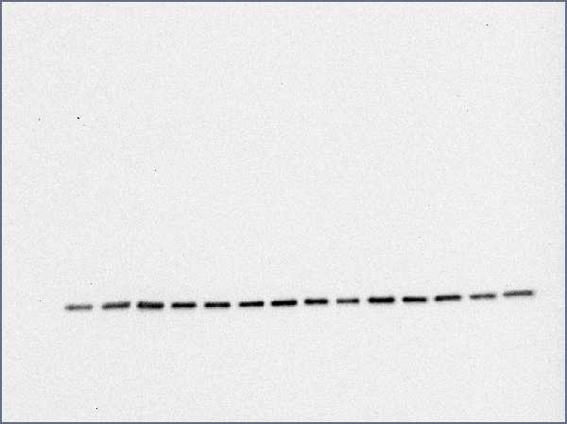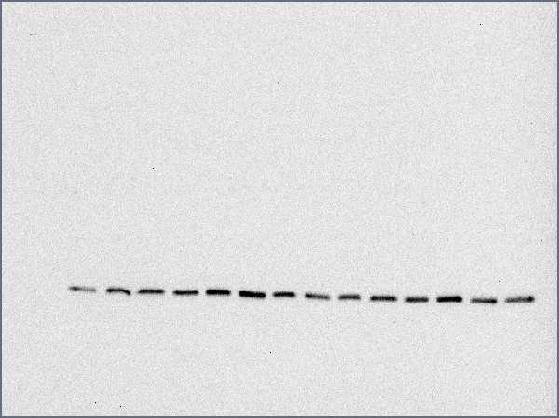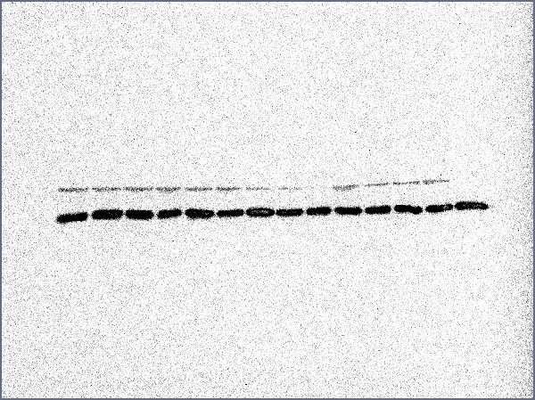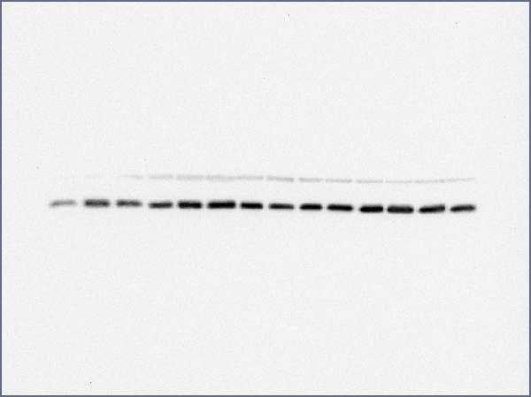
Young
Old
Old + OLE
C
I
C
I
C
I
B
Young
Old
Old + OLE
C
I
C
I
C
I
Supplementary Figure 1. Original and unprocessed blots of p-Akt western blot (A) analysis from Figure 6C and their control blots of GAPDH (B). Showed blots at Figure 6C are marked with red boxes. C = Control; I = Insulin; OLE = olive leaf extract.

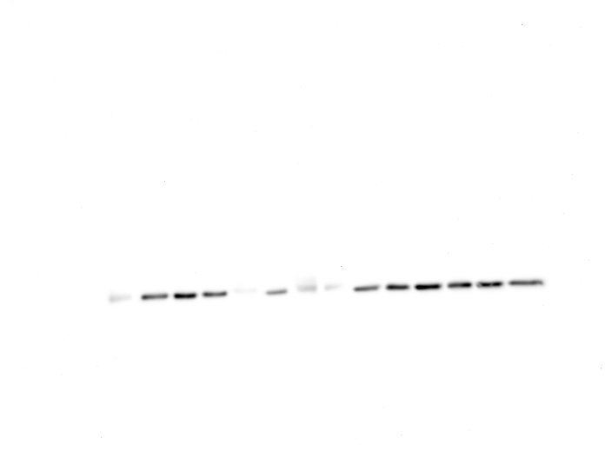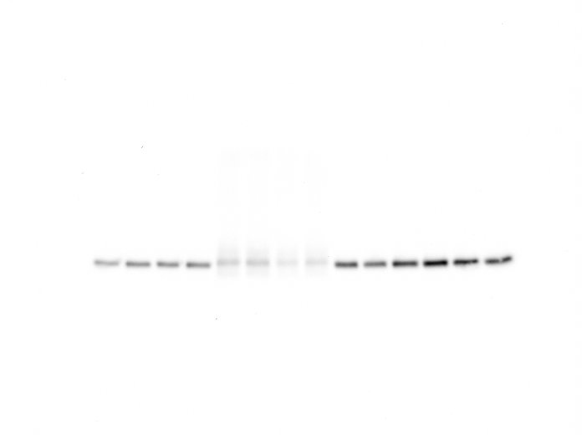
B
A
Old
Young
Old + OLE
C
I
C
I
C
I
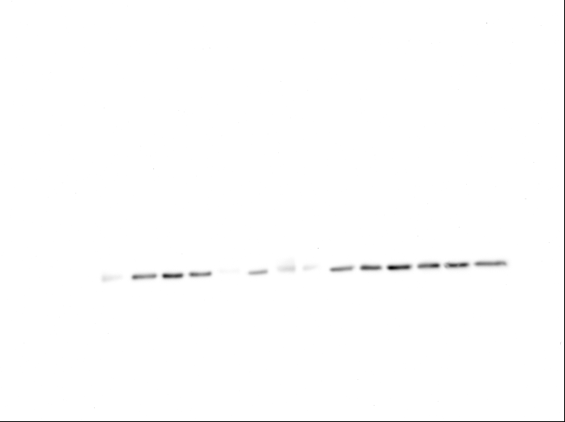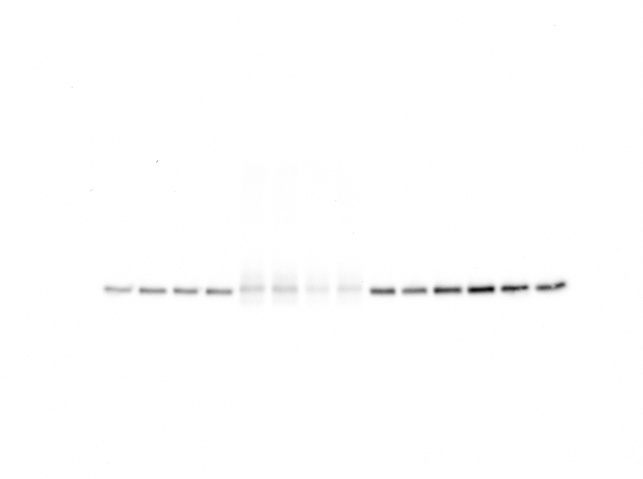
Young
Old
Old + OLE
C
I
C
I
C
I
C
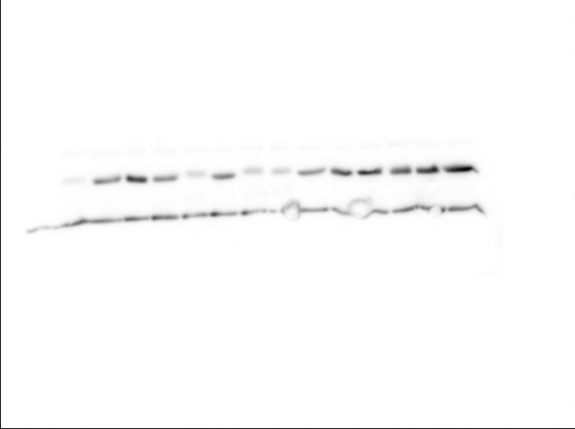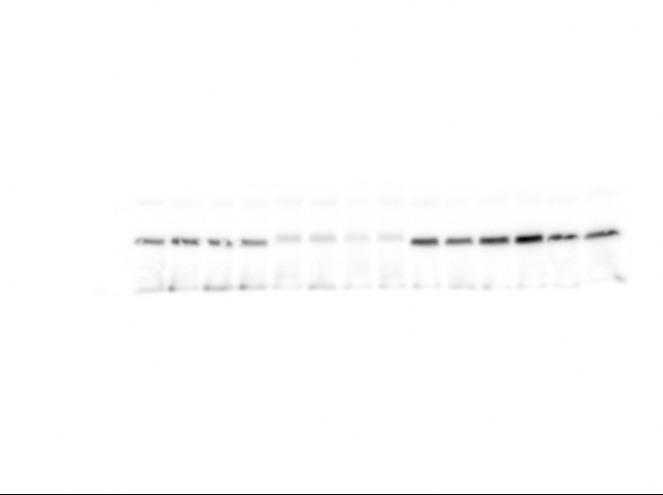
Young
Old
Old + OLE
I
C
I
C
I
C
D
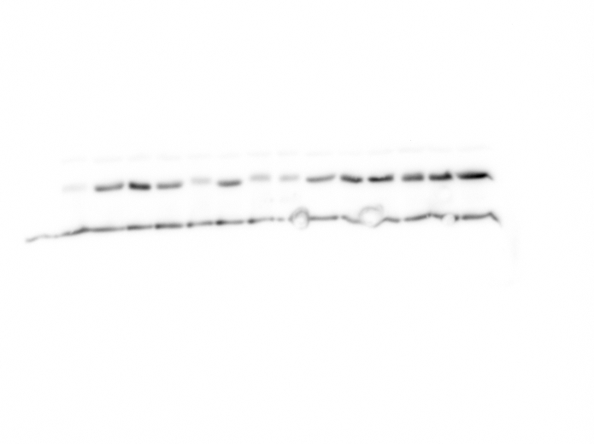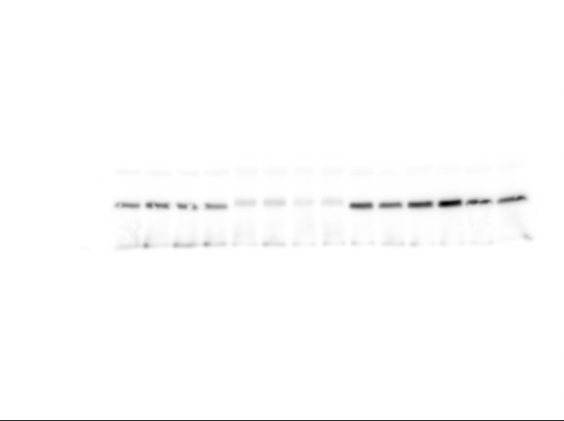
Young
Old
Old + OLE
I
C
I
C
I
C
Supplementary Figure 2. Original and unprocessed blots of Akt western blot analysis from Figure 6C with 9 (A) and 6 (B) seconds of exposure, and their control blots of GAPDH with 5 (C) and 12 (D) seconds of exposure. Showed blots at Figure 6C are marked with red boxes. C = Control; I = Insulin; OLE = olive leaf extract.

Supplementary Figure 3. Effects of aging and a 21-day treatment with the OLE on the ratio between protein levels of p-Akt and Akt (A) and on the ratio between protein levels of p-GSK3β and GSK3β (B) in the liver. Values are represented as mean ± SEM. * p < 0.05 vs. Young.

O
Ole
Y
B
A
Ole
O
Y
C
O
Ole
Y
D
O
Ole
Y
Supplementary Figure 4. Original and unprocessed blots of p-Akt (A), total Akt (B), p-GSK3β (C), and total GSK3β (D) western blot analysis from Supplementary Figure 3. Showed blots at Supplementary Figure 3 are marked with red boxes. Y = Young; O = Old; Ole = Old + olive leaf extract.

