Original article

Pattern of inflammatory immune response determines the clinical course and outcome of COVID-19: Unbiased clustering analysis.

Eunyoung Emily Lee, MD^{a*}, Kyoung-Ho Song, MD, PhD^{b*}, Woochang Hwang, PhD^{c}, Sin Young Ham, MD^{b}, Hyeonju Jeong, MD^{b}, Jeong-Han Kim, MD^{d}, Hong Sang Oh, MD, MPH^{d}, Yu Min Kang, MD^{e,f}, Eun Bong Lee, MD, PhD^{g}, Nam Joong Kim, MD, PhD^{h}, Bum Sik Chin, MD, PhD^{i**}, and Jin Kyun Park, MD, PhD^{g**}

ªDivision of Rheumatology, Department of Internal Medicine, Uijeongbu Eulji Medical Center, Gyeonggi-do, Korea, ^{b}Division of Infectious Diseases, Department of Internal Medicine, Seoul National University Bundang Hospital, Gyeonggi-do, Korea, ^{c}Data Science for Knowledge Creation Research Center, Seoul National University, Seoul, Korea, ^{d}Division of Infectious Diseases, Department of Internal Medicine, Armed Forces Capital Hospital, Gyeonggi-do, Korea, ^{e}Department of Infectious Diseases, Myongji hospital, Gyeonggi-do, Korea, ^{f}Department of Medical Education, Seoul National University College of Medicine, ^{g}Division of Rheumatology, Department of Internal Medicine, Seoul National University Hospital, Seoul, Korea, ^{h}Division of Infectious Diseases, Department of Internal Medicine, Seoul National University Hospital, Seoul, Korea, ^{i}Division of Infectious Diseases, Department of Internal Medicine, National Medical Center, Seoul, Korea
*Both authors contributed equally to the work.

**Corresponding authors:
Jin Kyun Park, MD, PhD
Division of Rheumatology, Department of Internal Medicine, Seoul National University Hospital, 101 Daehak-ro, Jongno-gu, Seoul, 03080, South Korea

E-mail: jinkyunpark@gmail.com; Telephone: +82-2-2072-4765; Fax: +82-10-2072-3198

Bum Sik Chin, MD, PhD
Division of Infectious Diseases, Department of Internal Medicine, National Medical Center, Euljiro 245, Jung-gu, Seoul, 04564, Seoul, Korea.

E-mail: moberrer@nmc.or.kr; Telephone: +82-22262-4748; Fax: +82-2-2268-0803

Supplementary Figure S1. Unbiased clustering of immune responses in patients ≥ 65 years old.
(A) Changes of SF ratio (B) Changes of C-reactive protein (C) Changes of absolute neutrophil counts (C) Changes of absolute lymphocyte count in each cluster. Illness day indicates days from the first symptom onset. Horizontal bars indicate normal range of the values. CRP, C-reactive protein; SF ratio, pulse oximetric saturation/fraction of inspired oxygen ratio.

Supplementary Figure S2. Unbiased clustering of immune responses in patients < 65 years old.
(A) Changes of SF ratio (B) Changes of C-reactive protein (C) Changes of absolute neutrophil counts (C) Changes of absolute lymphocyte count in each cluster. Illness day indicates days from the first symptom onset. Horizontal bars indicate normal range of the values. CRP, C-reactive protein; SF ratio, pulse oximetric saturation/fraction of inspired oxygen ratio.
Supplementary figure S3. Use of anti-viral agents (A) and corticosteroids (B) in each group.
A. Antiviral agents
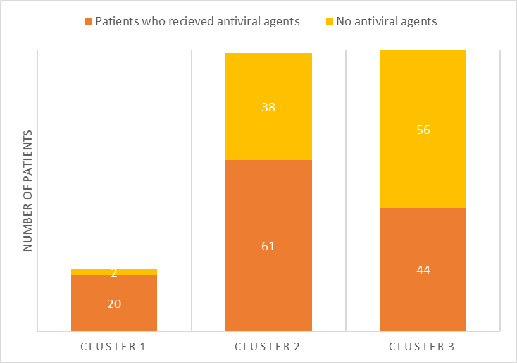

B. Corticosteroids

Supplementary Table S1. Clinical outcomes (by age group)
 | Discovery cohort |  |  | Validation cohort
 | Age <65 years  (N=68) | Age ≥65 years  (N=37) | P-value | Age <65 years  (N=83) | Age ≥65 years  (N=33) | P-value
Cluster, n (%) |  |  | <0.001* |  |  | 0.003*
Cluster 1 (hyper-inflammatory) | 3 (4.4) | 12 (32.4) |  | 2 (2.4) | 5 (15.2)
Cluster 2 (intermediate) | 32 (47.1) | 17 (45.9) |  | 32 (38.6) | 18 (54.5)
Cluster 3 (hypo-inflammatory) | 33 (48.5) | 8 (21.6) |  | 49 (59) | 10 (30.3)
Supplemental oxygen, n (%) | 19 (27.9) | 26 (70.3) | <0.001* | 18 (21.7) | 24 (72.7) | <0.001*
High flow nasal cannula, n (%) | 6 (8.8) | 10 (27.0) | 0.013* | 5 (6.0) | 7 (21.2) | 0.036**
Mechanical ventilator, n (%) | 3 (4.4) | 9 (24.3) | 0.002* | 3 (3.6) | 4 (12.1) | 0.100**
Extracorporeal membrane oxygenation, n (%) | 1 (1.5) | 1 (2.7) | 1.000** | 1 (1.2) | 2 (6.1) | 0.194**
Death, n (%) | 0 | 2 (5.4) | 0.122** | 1 (1.2) | 3 (9.1) | 0.069**
Results are presented as n (%). P values were generated by the *Chi-square test or **Fisher’s exact test.
Supplementary Table S2. Clinical outcomes of the patients in the discovery cohort and the validation cohort (according to the clusters)
A. Discovery cohort
 | Total | Cluster 1(n=15) | Cluster 2 (n=49) | Cluster 3 (n=41) | p-value
Length of hospital day | 19.0 [15.0;20.0] | 20.0 [20.0;27.5] | 17.0 [14.0;20.0] | 20.0 [18.0;20.0] | 0.001
Oxygen support, n (%) | 45 (42.9) | 15 (100.0) | 30 (61.2) | 0 | <0.001
HFNC | 16 (15.2) | 10 (66.7) | 6 (12.2) | 0 | < 0.001
Invasive MV | 13 (12.4) | 11 (73.3) | 1 (2.0) | 0 (0.0) | <0.001
ECMO | 2 (1.9) | 2 (13.3) | 0 (0.0) | 0 (0.0) | <0.001
Mortality | 2 (1.9) | 2 (13.3) | 0 | 0 | < 0.001

 | Total | Cluster 1 (n=7) | Cluster 2 (n=50) | Cluster 3 (n=59) | p-value
Length of hospital day | 15.0 [14.0;23.5] | 28.0 [25.5;31.5] | 17.5 [14.0;22.0] | 14.0 [14.0;22.0] | 0.001
Oxygen support, n (%) | 42 (36.2) | 7 (100.0) | 21 (42.0)* | 14 (23.7)* | < 0.001
HFNC | 12 (10.3) | 5 (71.4) | 6 (12.0)* | 1 (1.7)* | < 0.001
Invasive MV | 7 (6.0) | 5 (71.4) | 1 (2.0)* | 1 (1.7)* | < 0.001
ECMO | 3 (2.6) | 3 (42.9) | 0* | 0* | < 0.001
Mortality | 4 (3.4) | 4 (57.1) | 0 | 0 | < 0.001
B. Validation cohort

*p>=0.05. ECMO, extracorporeal membrane oxygenation; HFNC, high flow nasal cannula; MV, mechanical ventilation.

