-Title page-

Title: Analysis of BRCA1/2 variants of unknown significance in patients with breast cancer from a prospective KOHBRA study

Authors:
Joo Heung Kim^{1*}, Sunggyun Park^{2*}, Hyung Seok Park³, Ji Soo Park⁴, Seung-Tae Lee⁵, Sung-Won Kim⁶, Jong Won Lee⁷, Min Hyuk Lee⁸, Sue K. Park^{9,10}, Woo-Chul Noh¹¹, Doo Ho Choi¹², Wonshik Han¹³, Sung Hoo Jung¹⁴

Affiliations:
¹Department of Surgery, Yongin Severance Hospital, Yonsei University College of Medicine, Yongin, Gyeonggi, Republic of Korea
²Department of Laboratory Medicine, Keimyung University School of Medicine, Daegu, Republic of Korea
³Department of Surgery, Yonsei University College of Medicine, Seoul, Republic of Korea
⁴Hereditary Cancer Clinic, Cancer Prevention Center, Yonsei Cancer Center, Yonsei University College of Medicine, Seoul, Republic of Korea
⁵Department of Laboratory Medicine, Yonsei University College of Medicine, Seoul, Republic of Korea
⁶Department of Surgery, Daerim St. Mary’s Hospital, Seoul, Republic of Korea
⁷Department of Surgery, Asan Medical Center, University of Ulsan College of Medicine, Seoul, Republic of Korea
⁸Department of Surgery, Soonchunhyang University Seoul Hospital, Seoul, Republic of Korea
⁹Department of Preventive Medicine, Seoul National University College of Medicine, Seoul, Republic of Korea
¹⁰Cancer Research Institute, Seoul National University, Seoul, Republic of Korea
¹¹Department of Surgery, Korea Institute of Radiological & Medical Science, Korea Cancer Center Hospital, Seoul, Republic of Korea
¹²Department of Radiation Oncology, Samsung Medical Center, Sungkyunkwan University, Seoul, Republic of Korea
¹³Department of Surgery, Cancer Research Institute, Seoul National University College of Medicine, Seoul, Republic of Korea
¹⁴Department of Surgery, Chonbuk National University Hospital, Jeonju, Jeollabuk, Republic of Korea

Co-correspondence:
Hyung Seok Park, MD, PhD
Department of Surgery, Yonsei University College of Medicine
50-1 Yonseiro, Seodaemun-gu, Seoul 03722, Republic of Korea
Tel: +82-2-2228-2100, Fax: +82-2-323-8289
E-mail: imgenius@yuhs.ac

Ji Soo Park, MD, PhD
Hereditary Cancer Clinic, Cancer Prevention Center, Yonsei Cancer Center, Yonsei University College of Medicine
50-1 Yonseiro, Seodaemun-gu, Seoul 03722, Republic of Korea
Tel: +82-2228-4940
E-mail: PMJISU@yuhs.ac

*Both authors contributed equally to this manuscript.

Supplementary Fig. S1 Minor allele frequency (MAF) based on the KRGDB

BRCA1
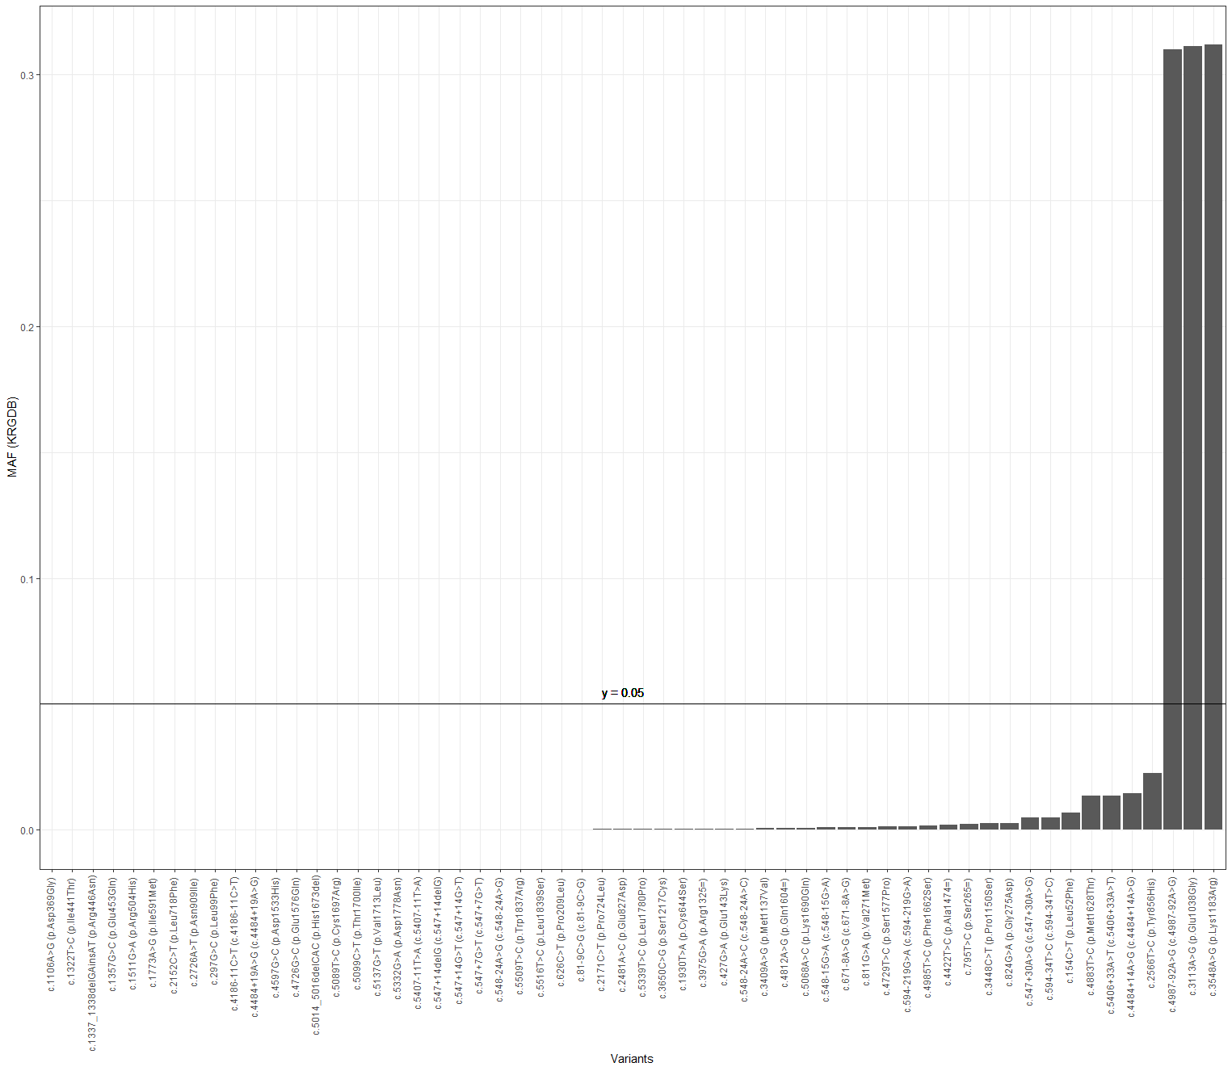

BRCA2
