Supplementary Materials

Cooperation among unrelated ant queens provides persistent growth and survival benefits during colony ontogeny

Madeleine M. Ostwald*, Xiaohui Guo, Tyler Wong, Armon Malaekeh, Jon F. Harrison, and Jennifer H. Fewell
School of Life Sciences, Arizona State University, Tempe, AZ, USA
*corresponding author
Corresponding author email: mostwald@asu.edu

Supplementary Table 1: Summarized results of GLMM predicting worker behavior as a function of worker number, queen number, and the interaction between queen and worker number (fixed effects), with colony ID as a random effect. P-values are Bonferroni-corrected for multiple comparisons. No significant effects of queen number or the interaction effect prompted us to remove them from the model reported in Table 1.
 | P-value
Behavior | Effect of Queen Number | Effect of Interaction Between Queen Number and Worker Number
Brood Care | 0.164 | 0.617
Social | 1 | 0.646
Idle | 1 | 1
Colony Maintenance | 1 | 1
Walking | 0.600 | 1
Food Processing | 0.918 | 1
Foraging | 1 | 0.815

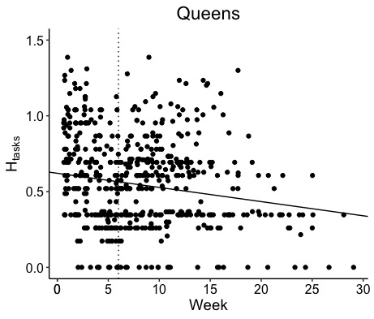
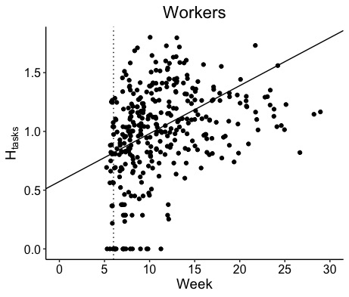
Supplementary Figure 1. The Shannon Index measuring task performance diversity (H_{tasks}) for queens (top) and workers (bottom) for all colonies measured until the tenth worker emerged. Queen task performance diversity decreased over time (LMM, P < 0.001, slope = -0.009, R² = 0.157), whereas worker task performance increased over time (LMM, P<0.001; slope = 0.041, R² = 0.358). Dashed vertical lines mark the week in which the majority of colonies experienced first-worker emergence.

