Multiscale investigation on the chemical and anatomical changes of lignocellulosic biomass for different severities of hydrothermal treatment

Julia P. Lancha¹, Patrick Perré^{1,2}, Julien Colin^{1,2}, Pin Lv¹, Nathalie Ruscassier², Giana Almeida^{3*}
¹ Université Paris-Saclay, CentraleSupélec, Laboratoire de Génie des Procédés et Matériaux, SFR Condorcet FR CNRS 3417, Centre Européen de Biotechnologie et de Bioéconomie (CEBB), 51110 Pomacle, France
² Université Paris-Saclay, CentraleSupélec, Laboratoire de Génie des Procédés et Matériaux, 8-10 rue Joliot-Curie, 91190 Gif-sur-Yvette, France
³ Université Paris-Saclay, INRAE, AgroParisTech, UMR SayFood, 91300 Massy, France

*giana.almeida@agroparistech.fr

Supplementary Information:
Figure S1. Preliminary tests performed to choose the sample preparation method prior to X-ray nano-tomography. Two samples have been scanned in their native state (air-dry state, Figures S1a and S1b). They were then saturated with water and hydrothermally treated at 180 °C for 40 minutes. After treatment, sample 1 was left under room conditions (air drying) for two days, whereas sample 2 was frozen at -80 °C and then freeze dried before returning to the air-dry state. Both samples were later re-scanned (Figures S1c and S1d, for samples 1 and 2 respectively). Sample 1 (Figure S1c) suffered extensive shrinkage and many of its cells collapsed after air drying. Sample 2 (Figure S2d) presented less shrinkage and only minor cell collapse (which was limited to the cells located between two vessels). The dashed lines highlight the changes in samples dimensions.
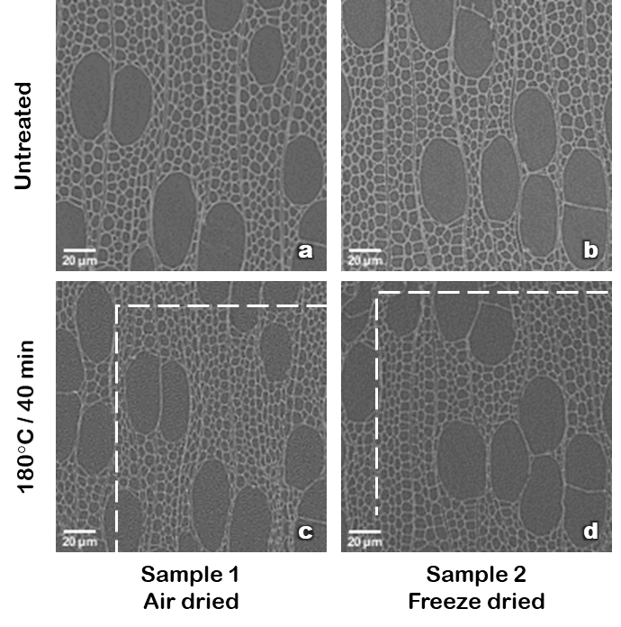

Figure S2. Steps of image processing using Image J applied to 2D cross-sectional slices obtained by X-ray nano-tomography: (a) Raw image; (b) Image after segmentation by the “Auto Threshold” tool using the “Moments” method for dark background; (c) Mask obtained using the “Particle analysis” tool, with a minimum particle size set to 5000 pixel²; (d) Final image after “Local thickness” analysis.
