Supplementary Materials
Occurrence of bioluminescent and nonbioluminescent species in the littoral earthworm genus Pontodrilus
Teerapong Seesamut¹, Daichi Yano¹, José Paitio¹, Ikuhiko Kin¹, Somsak Panha^{2, 3}, Yuichi Oba^{1*}

¹ Department of Environmental Biology, Chubu University, Kasugai 487-8501, Japan
² Animal Systematics Research Unit, Department of Biology, Faculty of Science, Chulalongkorn University, Bangkok 10330, Thailand
³ Academy of Science, The Royal Society of Thailand, Bangkok 10300, Thailand

*Corresponding Author: Yuichi Oba
Email address: yoba@isc.chubu.ac.jp

Supplementary Materials legends
Supplementary Figure S1. Full-size gel images of SDS-PAGE of the crude coelomic extract of Pontodrilus litoralis (bioluminescent), P. longissimus (non-bioluminescent) and Microscolex phosphoreus (bioluminescent). Detection by silver staining. Molecular weight marker sizes in kDa are provided on the left. 10 and 2 indicate loading volume (µl). Note, a comparison of the band patterns between two luminous earthworms, P. litoralis and M. phosphoreus which share the same bioluminescence mechanism, will also be useful to determine the bioluminescence components.

Supplementary Figure S2. Maximum likelihood phylogenetic tree based on COI sequence of Pontodrilus litoralis and longissimus with megascolecid genera Plutellus, Metaphire and Amynthas available from GenBank. COI sequences were aligned using the ClustalW algorithm in MEGA X. ML analysis in RAxML v. 8, where 1000 bootstraps were used to estimate the node reliability to obtain bootstrap support values. Numbers around nodes are bootstrap values. Tree was rooted with Diplocardia (Acanthodrilidae) as outgroup. As shown in this tree, the genetic distance between P. litoralis and longissimus are closely related when it is compared with the distances among the species of Metaphire.

Supplementary Video 1. Observation of the predation of littoral earthworm Pontodrilus litoralis by the littoral earwig Anisolabis maritima.

Supplementary Video 2. Anisolabis maritima struggled to remove the gluey luminescent mucus by frequent grooming.

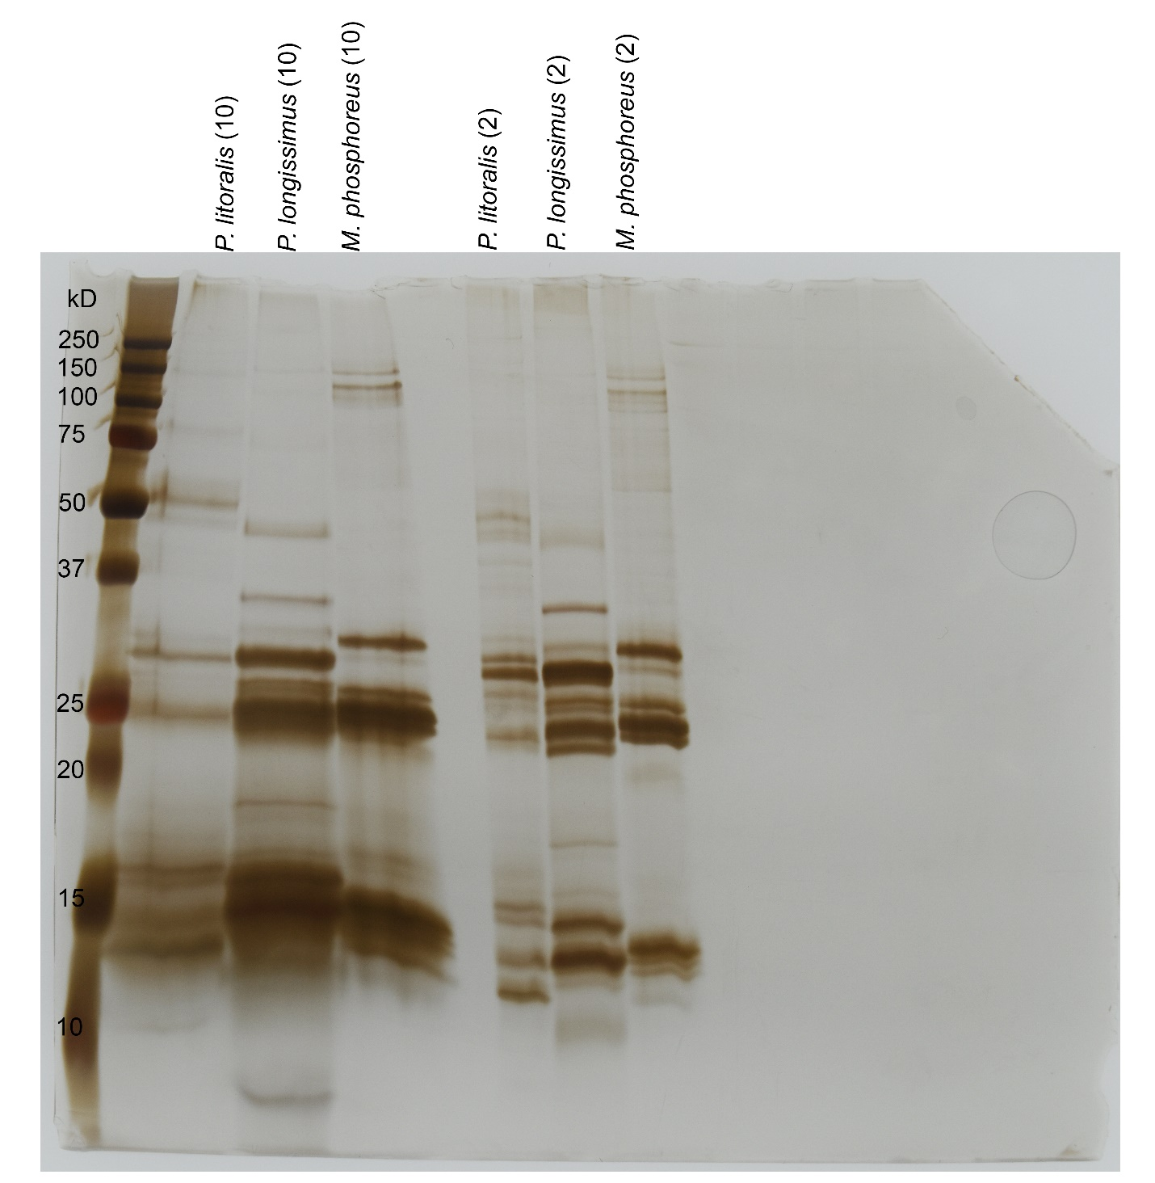
Supplementary Figure S1.

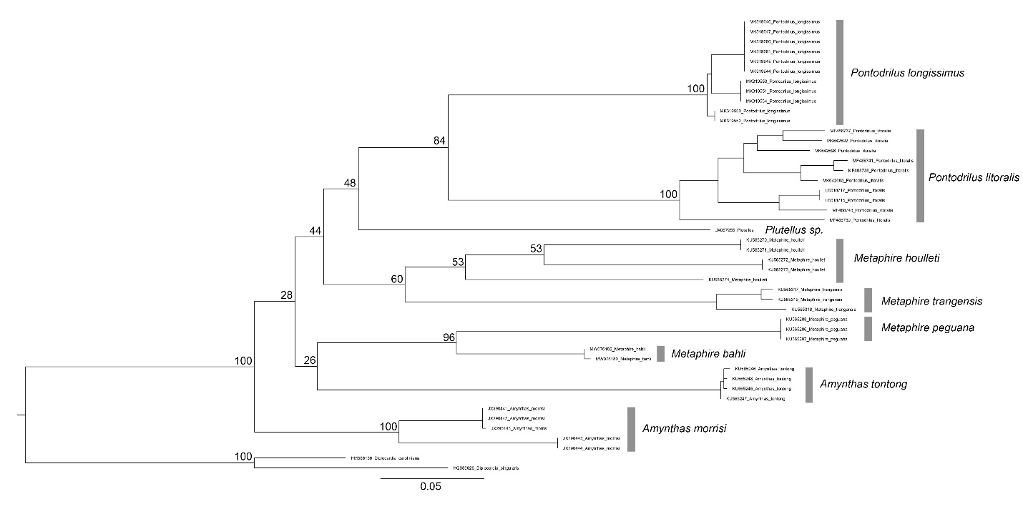
Supplementary Figure S2.

