TITLE: Whole genome analysis of Extensively Drug Resistant Mycobacterium tuberculosis strains in Peru

Authors:
- David Santos-Lazaro (edavid.sant@gmail.com) ¹
- Ronnie G. Gavilan (ronniegavilan@gmail.com) ^{1,3}
- Lely Solari (lelysol@hotmail.com) ¹
- Aiko N. Vigo (aiko.vt.anvt@gmail.com) ¹
- Zully M. Puyen (zpuyeng@gmail.com) ^{1,2,}*
* Corresponding author

Affiliations:
¹ Instituto Nacional de Salud, Lima, Peru.
² Escuela de Medicina, Universidad Peruana de Ciencias Aplicadas, Lima, Peru.

³ Escuela Profesional de Medicina Humana, Universidad Privada San Juan Bautista, Lima, Peru.

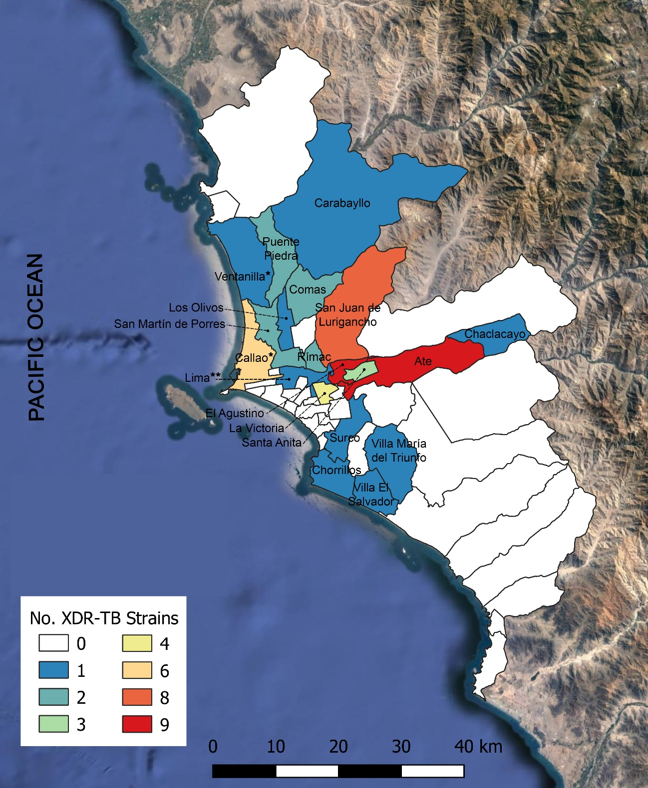
Supplementary Figure S1: Districts with XDR-TB strains in Lima region and Callao province. All XDR-TB strains from these places were distributed in 19 districts (shown in the figure) and 2 additional provinces (not shown). * Districts of the Callao province. ** Lima district. Map generated with QGIS v3.14.15 (http://www.qgis.org).

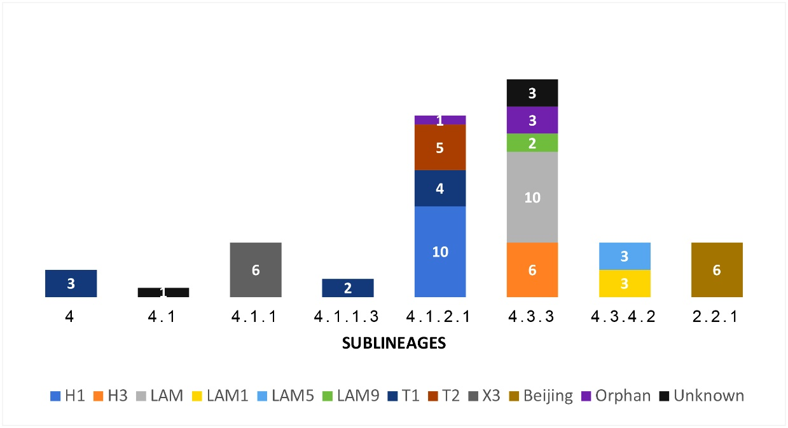
Supplementary Figure S2: Distribution of genetic families in the MTB lineages of the Peruvian XDR-TB strains. The number of strains of each family is specified inside the bars. Figure created with Excel v2019 (https://www.microsoft.com).

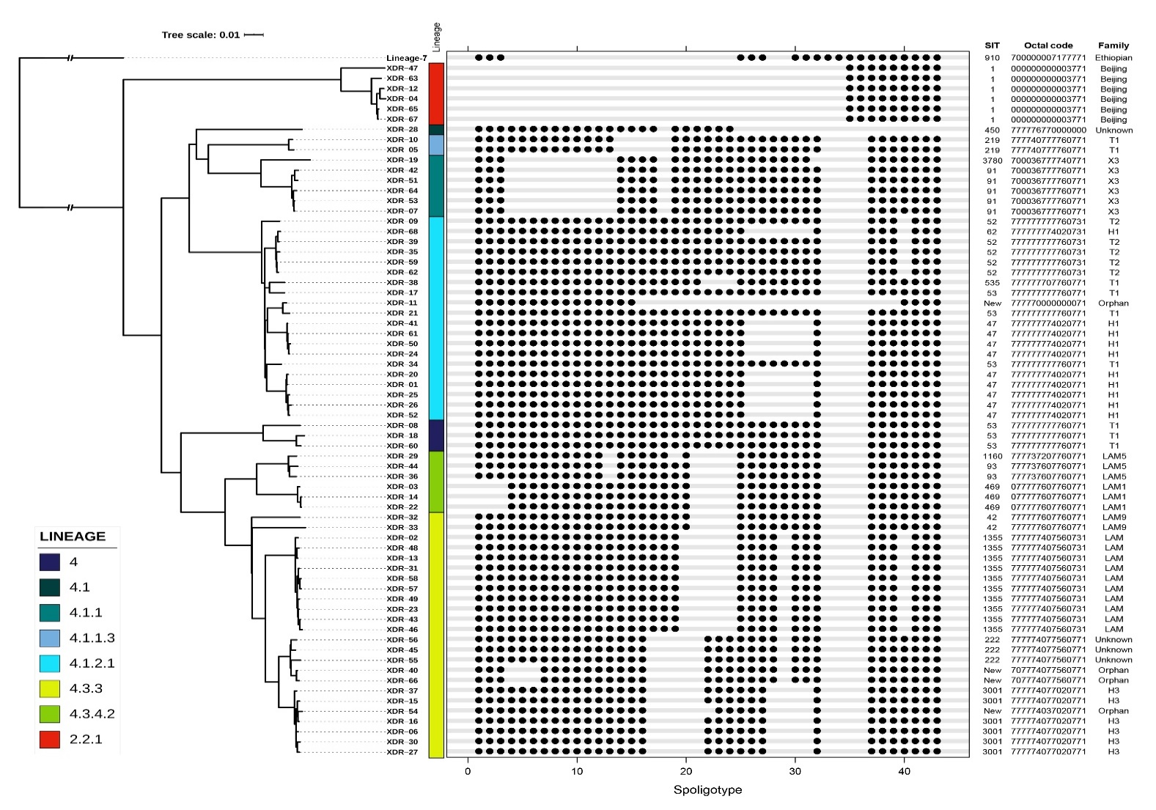
Supplementary Figure S3: In silico spoligotypes patterns (binary and octal codes) of Peruvian XDR-TB strains. SITs and families were annotated using the SITVIT2 database. The patterns are correlated with Lineages and the Maximum likelihood tree previously generated. SIT: spoligotype international type. The phylogenomic tree is the same one generated in Figure 2. Binary spoligotype patterns were generated with R package ggplot2 v3.3.2 (https://ggplot2.tidyverse.org).

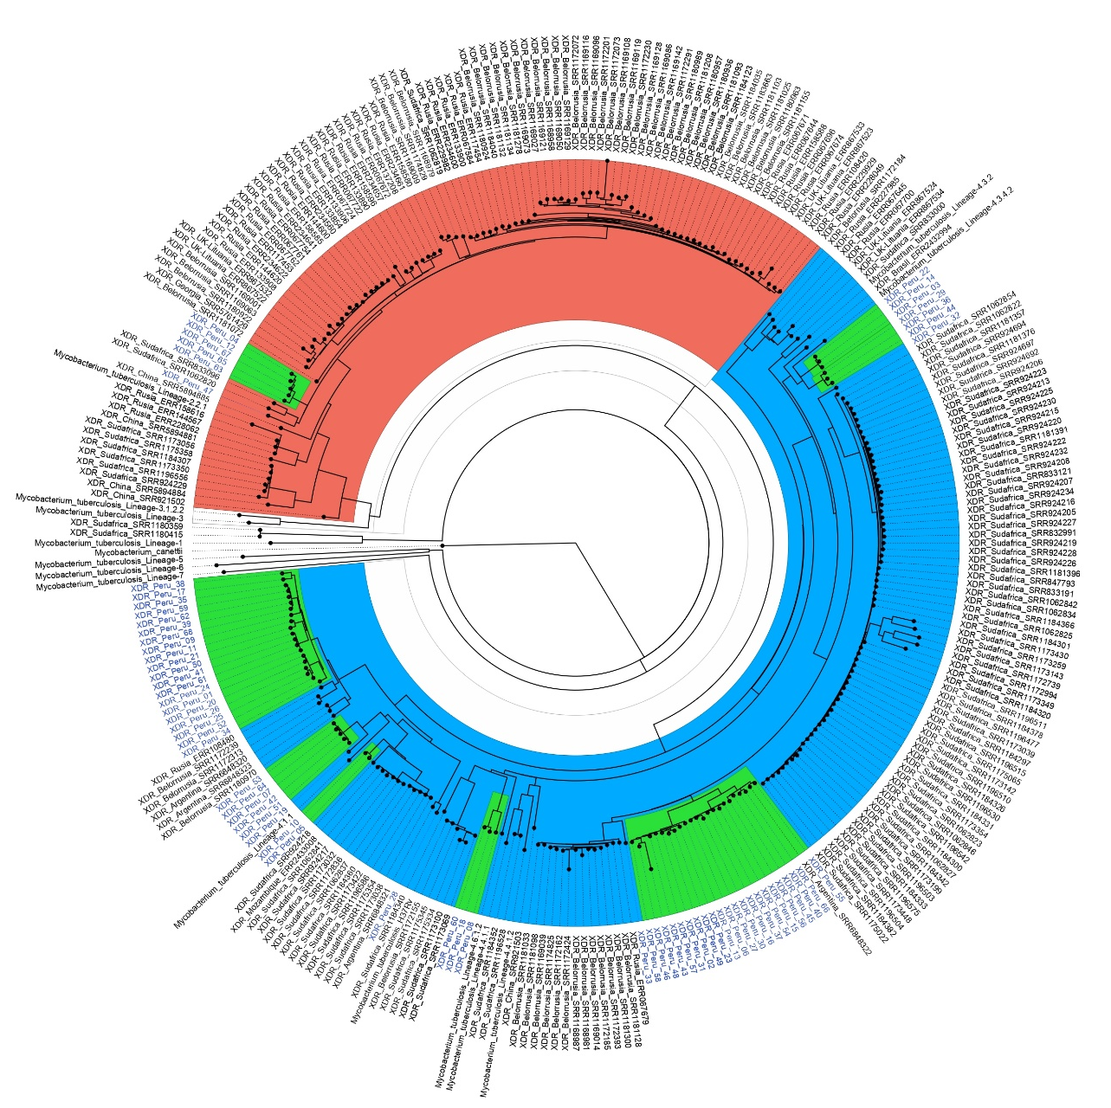

Supplementary Figure S4: Global phylogenomic tree of 289 XDR-TB strains belonging to South America, Europe, Africa and Asia. The tree was constructed using 16,798 genome-wide SNPs. Clusters containing Peruvian strains are highlighted in green. The tree was rooted at Mycobacterium canettii strain (GenBank, Access number: NC_019950.1). The figure was created using FigTree v1.4.4 (https://github.com/rambaut/figtree).
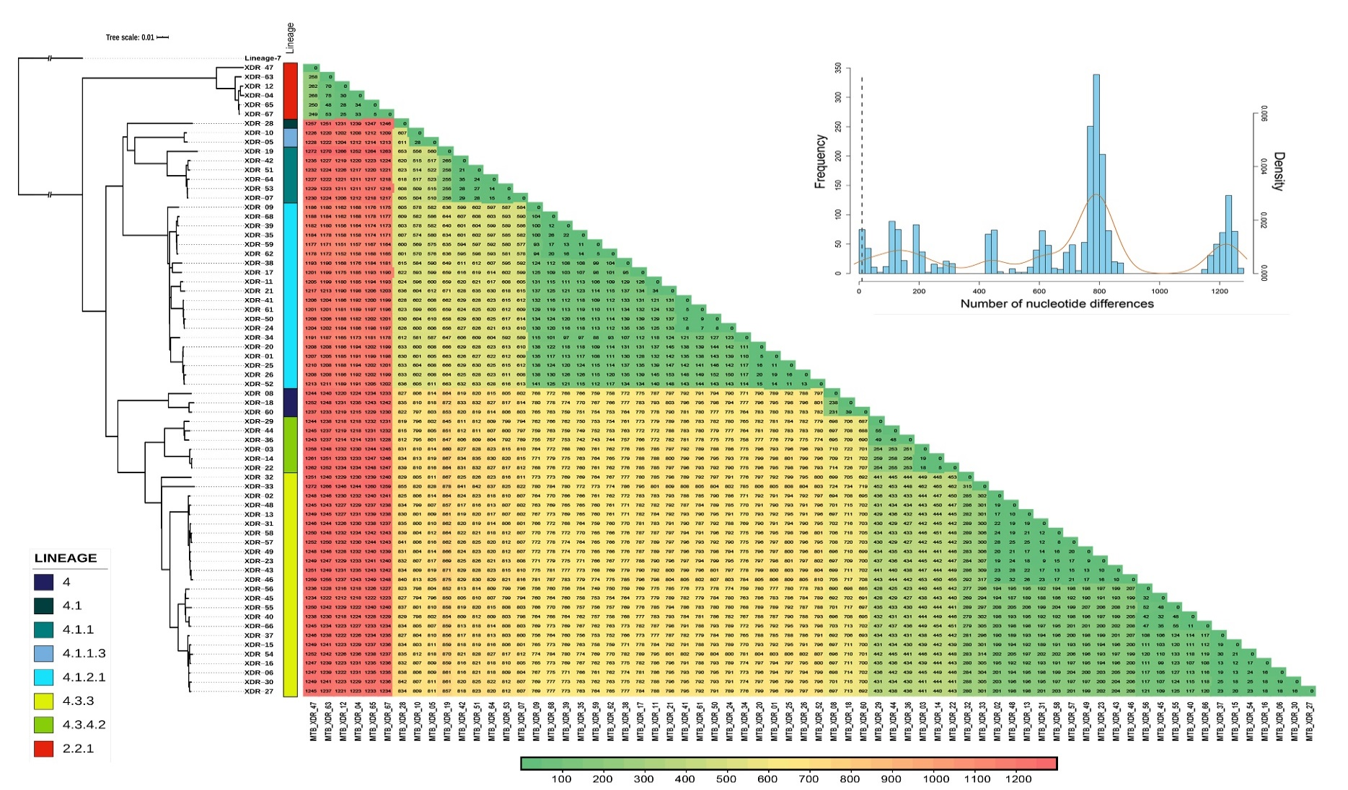
Supplementary Figure S5: Correlation between phylogenomic tree and nucleotide distance matrix of all XDR-TB strains. At top right is illustrated the histogram of pairwise distance (Hamming distance) and vertical dotted line indicates a cut point of 10 nucleotides differences. The phylogenomic tree is the same one generated in Figure 2. Distance matrix was created with R package Ape v5.4 (http://ape-package.ird.fr).

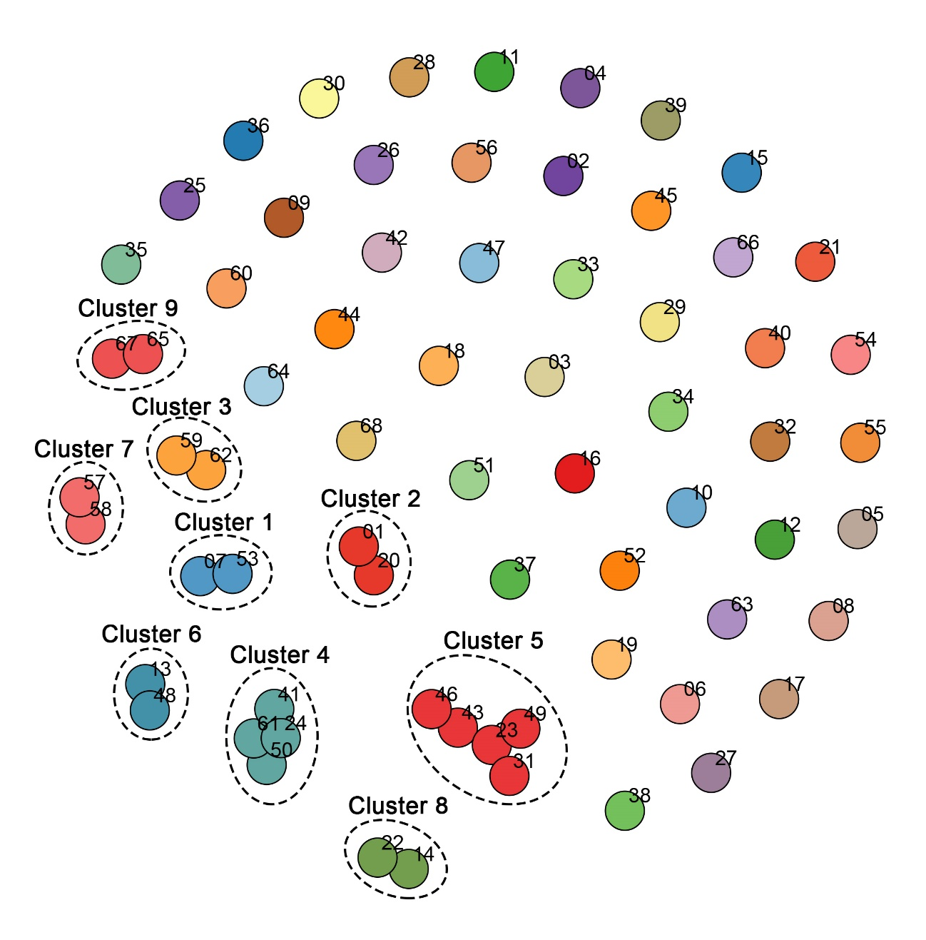
Supplementary Figure S6: Cluster determination of all XDR-TB strains. Potential recent transmission links were detected using a cut-off ≤ 10 SNPs. Strain’s numbering is according ‘XDR-#’ format used in the rest of figures (only the ‘#’ value is showed in the upper right of each node). The figure was generated with R package Adegenet v2.1.3 (https://github.com/thibautjombart/adegenet).

