Supplementary Information

Aggressive behaviour is affected by demographic, environmental and behavioural factors in purebred dogs

Salla Mikkola^{1,2,3}, Milla Salonen, ^{1,2,3} Jenni Puurunen^{1,2,3}, Emma Hakanen^{1,2,3}, Sini Sulkama^{1,2,3}, César Araujo^{1,2,3}, Hannes Lohi^{1,2,3*}

¹ Department of Medical and Clinical Genetics, University of Helsinki, Helsinki, Finland
² Department of Veterinary Biosciences, University of Helsinki, Helsinki, Finland
³ Folkhälsan Research Center, Helsinki, Finland

* Corresponding author:
Hannes Lohi, PhD, Professor
Email: hannes.lohi@helsinki.fi (HL)

Supplementary Table S1. Number of dogs in different breeds, sexes, and aggressive behaviour groups.
 | High aggressive behaviour |  |  | Low aggressive behaviour
Breed | Males | Females | Total | Males | Females | Total | Total
Finnish Lapponian Dog | 38 | 21 | 59 | 156 | 181 | 337 | 396
Labrador Retriever | 11 | 8 | 19 | 141 | 194 | 335 | 354
German Shepherd Dog | 36 | 37 | 73 | 123 | 143 | 266 | 339
Shetland Sheepdog | 21 | 14 | 35 | 108 | 145 | 253 | 288
Wheaten Terrier | 27 | 21 | 48 | 91 | 121 | 212 | 260
Lapponian Herder | 16 | 9 | 25 | 99 | 99 | 198 | 223
Border Collie | 15 | 15 | 30 | 77 | 101 | 178 | 208
Miniature Poodle | 39 | 22 | 61 | 54 | 80 | 134 | 195
Smooth Collie | 26 | 18 | 44 | 60 | 74 | 134 | 178
Lagotto Romagnolo | 22 | 18 | 40 | 47 | 76 | 123 | 163
Miniature Schnauzer | 36 | 22 | 58 | 47 | 51 | 98 | 156
Staffordshire Bull Terrier | 10 | 9 | 19 | 67 | 70 | 137 | 156
Spanish Water Dog | 22 | 19 | 41 | 45 | 59 | 104 | 145
Golden Retriever | 4 | 9 | 13 | 52 | 78 | 130 | 143
Rough Collie | 8 | 9 | 17 | 62 | 60 | 122 | 139
Jack Russell Terrier | 14 | 8 | 22 | 49 | 41 | 90 | 112
Chinese Crested Dog | 23 | 17 | 40 | 34 | 32 | 66 | 106
Medium size Spitz | 17 | 9 | 26 | 40 | 27 | 67 | 93
Coton de Tulèar | 10 | 14 | 24 | 27 | 34 | 61 | 85
Chihuahua | 14 | 6 | 20 | 32 | 29 | 61 | 81
Cairn Terrier | 7 | 10 | 17 | 26 | 26 | 52 | 69
Pembroke Welsh Corgi | 7 | 7 | 14 | 23 | 30 | 53 | 67
Other | 594 | 452 | 1046 | 1903 | 2365 | 4268 | 5314

Supplementary Table S2. Significant breed differences in the logistic regression analysis. N = 9,270. All P-values are FDR-controlled. OR = odds ratio, Cl = confidence limit.
Breed contrast | OR | Lower 95% Cl | Upper 95% Cl | P-value
Border Collie vs. Labrador Retriever | 2.957 | 1.590 | 5.499 | 0.0046
Cairn Terrier vs. Labrador Retriever | 3.058 | 1.421 | 6.581 | 0.0210
Chihuahua vs. Miniature Poodle | 0.424 | 0.226 | 0.794 | 0.0310
Chihuahua vs. Miniature Schnauzer | 0.428 | 0.227 | 0.808 | 0.0360
Chihuahua vs. Rough Collie | 0.400 | 0.206 | 0.780 | 0.0308
Chinese Crested Dog vs. Golden Retriever | 2.892 | 1.380 | 6.063 | 0.0228
Chinese Crested Dog vs. Labrador Retriever | 4.048 | 2.110 | 7.769 | 0.0011
Chinese Crested Dog vs. Lapponian Herder | 2.661 | 1.423 | 4.974 | 0.0127
Chinese Crested Dog vs. Shetland Sheepdog | 2.575 | 1.437 | 4.614 | 0.0095
Coton de Tulèar vs. Labrador Retriever | 3.400 | 1.671 | 6.921 | 0.0052
Finnish Lapponian Dog vs. Miniature Poodle | 0.473 | 0.304 | 0.737 | 0.0065
German Shepherd Dog vs. Finnish Lapponian Dog | 1.784 | 1.156 | 2.753 | 0.0360
German Shepherd Dog vs. Shetland Sheepdog | 2.759 | 1.691 | 4.501 | 0.0011
German Shepherd Dog vs. Staffordshire Bull Terrier | 2.298 | 1.268 | 4.164 | 0.0269
Golden Retriever vs. German Shepherd Dog | 0.323 | 0.169 | 0.617 | 0.0046
Golden Retriever vs. Lagotto Romagnolo | 0.333 | 0.162 | 0.686 | 0.0151
Golden Retriever vs. Miniature Poodle | 0.273 | 0.137 | 0.542 | 0.0022
Golden Retriever vs. Other | 0.441 | 0.242 | 0.802 | 0.0310
Jack Russell Terrier vs. German Shepherd Dog | 0.460 | 0.256 | 0.827 | 0.0374
Jack Russell Terrier vs. Miniature Poodle | 0.389 | 0.214 | 0.705 | 0.0118
Jack Russell Terrier vs. Miniature Schnauzer | 0.392 | 0.215 | 0.717 | 0.0130
Labrador Retriever vs. Finnish Lapponian Dog | 0.411 | 0.231 | 0.734 | 0.0144
Labrador Retriever vs. German Shepherd Dog | 0.231 | 0.134 | 0.397 | 0.0011
Labrador Retriever vs. Irish Soft Coated Wheaten Terrier | 0.299 | 0.164 | 0.545 | 0.0011
Labrador Retriever vs. Lagotto Romagnolo | 0.238 | 0.127 | 0.447 | 0.0011
Labrador Retriever vs. Medium size Spitz | 0.288 | 0.144 | 0.576 | 0.0036
Labrador Retriever vs. Miniature Poodle | 0.195 | 0.108 | 0.351 | 0.0011
Labrador Retriever vs. Other | 0.315 | 0.194 | 0.511 | 0.0011
Labrador Retriever vs. Pembroke Welsh Corgi | 0.316 | 0.143 | 0.696 | 0.0211
Lagotto Romagnolo vs. Lapponian Herder | 2.759 | 1.553 | 4.899 | 0.0041
Lagotto Romagnolo vs. Shetland Sheepdog | 2.670 | 1.575 | 4.525 | 0.0029
Lagotto Romagnolo vs. Staffordshire Bull Terrier | 2.224 | 1.189 | 4.159 | 0.0463
Lapponian Herder vs. German Shepherd Dog | 0.351 | 0.205 | 0.601 | 0.0011
Lapponian Herder vs. Irish Soft Coated Wheaten Terrier | 0.455 | 0.264 | 0.783 | 0.0217
Lapponian Herder vs. Miniature Poodle | 0.296 | 0.172 | 0.511 | 0.0011
Lapponian Herder vs. Other | 0.479 | 0.305 | 0.753 | 0.0093
Miniature Schnauzer vs. Finnish Lapponian Dog | 2.091 | 1.286 | 3.401 | 0.0153
Miniature Schnauzer vs. Golden Retriever | 3.632 | 1.797 | 7.341 | 0.0029
Miniature Schnauzer vs. Labrador Retriever | 5.084 | 2.766 | 9.344 | 0.0011
Miniature Schnauzer vs. Lapponian Herder | 3.342 | 1.867 | 5.980 | 0.0011
Miniature Schnauzer vs. Other | 1.601 | 1.107 | 2.316 | 0.0464
Miniature Schnauzer vs. Shetland Sheepdog | 3.234 | 1.890 | 5.534 | 0.0011
Miniature Schnauzer vs. Staffordshire Bull Terrier | 2.694 | 1.429 | 5.079 | 0.0127
Other vs. Miniature Poodle | 0.618 | 0.442 | 0.865 | 0.0233
Other vs. Shetland Sheepdog | 2.020 | 1.366 | 2.986 | 0.0036
Rough Collie vs. Finnish Lapponian Dog | 2.236 | 1.360 | 3.677 | 0.0095
Rough Collie vs. Golden Retriever | 3.885 | 1.944 | 7.764 | 0.0011
Rough Collie vs. Jack Russell Terrier | 2.725 | 1.444 | 5.143 | 0.0121
Rough Collie vs. Labrador Retriever | 5.438 | 2.997 | 9.865 | 0.0011
Rough Collie vs. Lapponian Herder | 3.574 | 1.978 | 6.456 | 0.0011
Rough Collie vs. Other | 1.712 | 1.169 | 2.509 | 0.0260
Rough Collie vs. Shetland Sheepdog | 3.459 | 2.002 | 5.975 | 0.0011
Rough Collie vs. Staffordshire Bull Terrier | 2.882 | 1.516 | 5.475 | 0.0082
Shetland Sheepdog vs. Irish Soft Coated Wheaten Terrier | 0.470 | 0.287 | 0.771 | 0.0149
Shetland Sheepdog vs. Miniature Poodle | 0.306 | 0.186 | 0.503 | 0.0011
Smooth Collie vs. Miniature Poodle | 0.422 | 0.224 | 0.795 | 0.0314
Smooth Collie vs. Miniature Schnauzer | 0.427 | 0.222 | 0.818 | 0.0404
Smooth Collie vs. Rough Collie | 0.399 | 0.210 | 0.756 | 0.0228
Spanish Water Dog vs. Golden Retriever | 3.016 | 1.463 | 6.219 | 0.0149
Spanish Water Dog vs. Labrador Retriever | 4.222 | 2.245 | 7.942 | 0.0011
Spanish Water Dog vs. Lapponian Herder | 2.775 | 1.558 | 4.941 | 0.0041
Spanish Water Dog vs. Shetland Sheepdog | 2.686 | 1.580 | 4.564 | 0.0029
Spanish Water Dog vs. Staffordshire Bull Terrier | 2.237 | 1.194 | 4.194 | 0.0459
Staffordshire Bull Terrier vs. Miniature Poodle | 0.367 | 0.202 | 0.670 | 0.0077

Supplementary Table S3. AIC model selection in the logistic regression analysis. N = 5,511. The bolded values indicate models that had the best fit in each model selection round.
Model | AIC | Fearfulness  added | Breed  added | Dogs in  the family  added | Body size  added
Basic model (sex, age) | 5315.0
Fearfulness | 4896.9
Breed | 5258.9 | 4850.5
Dogs in the family | 5290.9 | 4885.8 | 4838.7
Body size | 5256.2 | 4870.4 | 4841.0 | 4830.5
Owner’s dog experience | 5295.5 | 4887.1 | 4839.9 | 4834.2 | 4827.5
Urban environment score | 5309.2 | 4897.3 | 4851.2 | 4840.7 | 4832.5
Sterilisation | 5297.5 | 4894.5 | 4847.9 | 4836.5 | 4828.1
Weaning age | 5320.7 | 4900.9 | 4851.3 | 4839.0 | 4830.1
Daily exercise | 5295.8 | 4890.9 | 4845.4 | 4834.6 | 4828.2
Family size | 5313.7 | 4897.5 | 4852.1 | 4839.5 | 4831.0
Daily time spent alone | 5316.4 | 4899.6 | 4853.9 | 4842.6 | 4834.5
Final model: sex, age, fearfulness, breed, dogs in the family, body size, owner’s dog experience

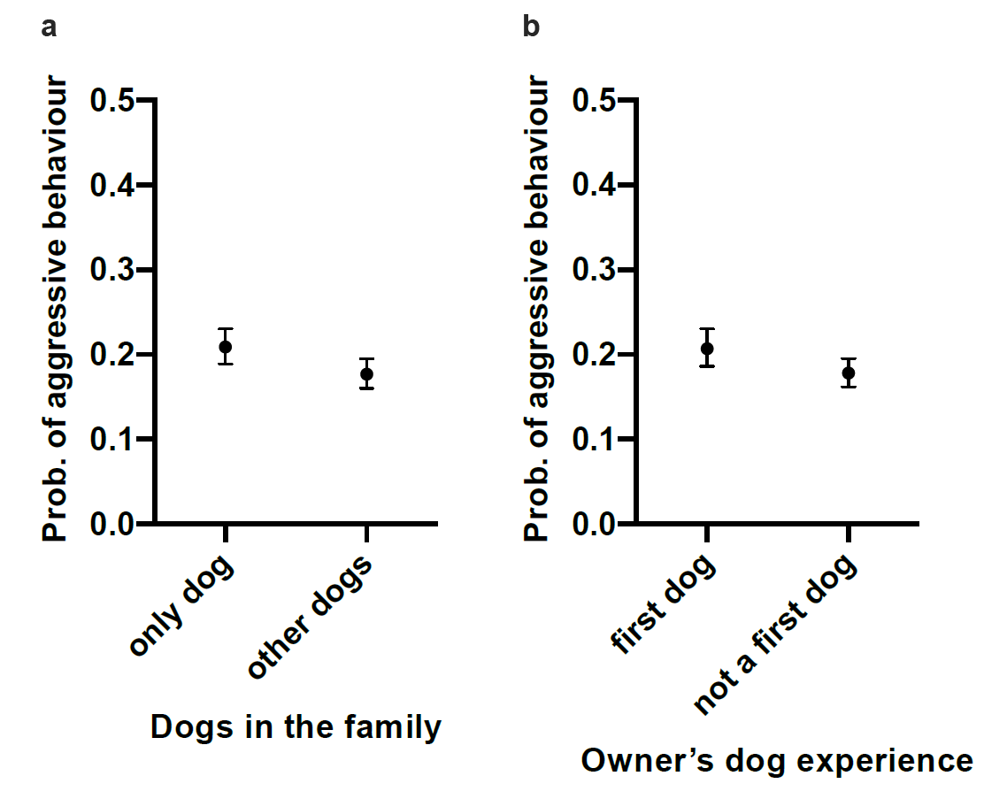

Supplementary Figure S1. The effect of dogs in the family and owner’s dog experience on aggressive behaviour in the logistic regression analysis. (a) Only dogs in the family had increased probability of aggressive behaviour. (b) Owner’s previous dog experience decreased the probability of aggressive behaviour. Error bars indicate 95% confidence limits. N = 9,270.

