THE EFFECTS OF THE EXPOSURE TO NEUROTOXIC ELEMENTS ON ITALIAN SCHOOLCHILDREN BEHAVIOR

Stefano Renzetti^{a,b,*}, Giuseppa Cagnaª, Stefano Calza^{b}, Michele Conversano^{c}, Chiara Fedrighiª, Giovanni Forte^{d}, Augusto Giorgino^{c}, Stefano Guazzetti^{a,f}, , Costanza Majorani^{e}, Manuela Oppiniª, Marco Peli^{a,g}, Francesco Petrucci^{d}, Anna Pino^{d}, Donatella Placidiª, Oreste Senofonte^{d}, Silvia Zoniª, Alessandro Alimonti^{d} Roberto G Lucchini^{a,h}

- Occupational Health, University of Brescia, Italy
- Department of Molecular and Translational Medicine, University of Brescia, Italy
- Department of Public Health, ASL, Taranto, Italy
- Italian National Institute of Health, Department of Environment and Health, Rome, Italy
- Italian National Institute of Health, National centre for Chemicals, Cosmetics and Consumer protection, Rome, Italy
- Department of Public Health, Azienda USL - IRCCS, Reggio Emilia, Italy
- Department of Civil, Environmental, Architectural Engineering and Mathematics, University of Brescia, Italy
- Icahn School of Medicine at Mount Sinai, New York, USA

*Corresponding Author: Stefano Renzetti, Department of Occupational Health, University of Brescia, Piazzale Spedali Civili, 1, 25123 Brescia BS. stefano.renzetti@unibs.it Tel +390303717715

Table1. Spearman correlation matrix among all 6 metal concentrations.
 | UCd | UAs | BPb | BSe | HMn
UAs | 0.253
BPb | -0.047 | 0.0953
BSe | -0.159 | 0.1081 | 0.058
HMn | 0.065 | 0.109 | 0.056 | -0.046
HHg | -0.133 | 0.276 | -0.035 | 0.173 | 0.049

Figure 1. Effects of BPb on anxious depressed, somatic complaints, social problems and rule breaking behavior. Effects of BPb on anxious depressed, somatic complaints, social problems and rule breaking behavior when considering the interaction with UAs. In each box the change of the β parameter is represented as a function of BPb concentration. Each line shows how the β varies across the different levels of UAs (the interacting metal).

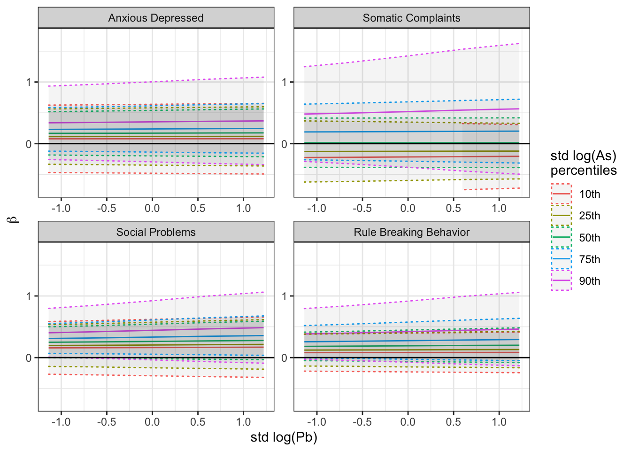

Figure 2. Effects of UAs on anxious depressed, somatic complaints, social problems and rule breaking behavior. Effects of UAs on anxious depressed, somatic complaints, social problems and rule breaking behavior when considering the interaction with BPb. In each box the change of the β parameter is represented as a function of UAs concentration. Each line shows how the β varies across the different levels of BPb (the interacting metal).

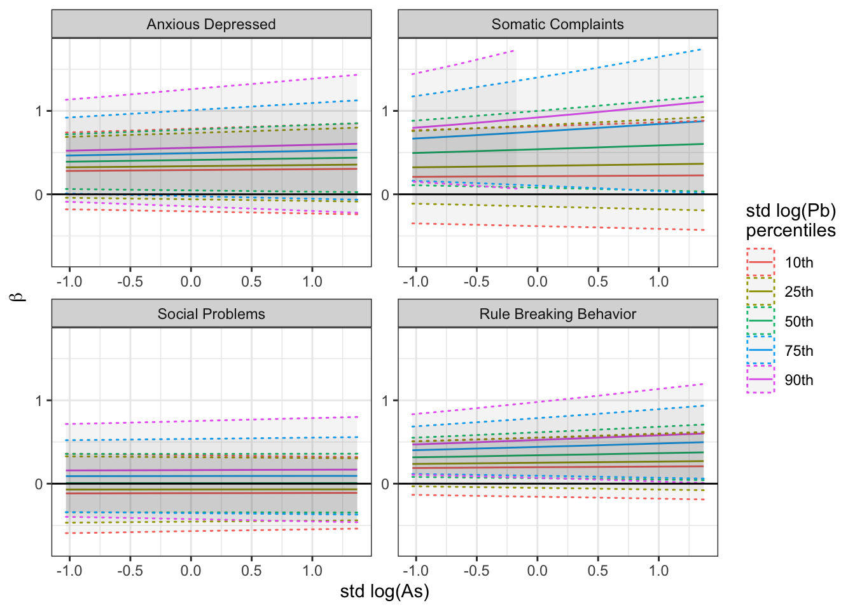

Figure 3. BPb and UAs interaction effect on CBCL externalizing problems. BPb and UAs effect on CBCL externalizing problems when an interaction term between the two metal concentrations is included in the linear mixed effects model. Blue color corresponds to low level of Pb or As concentrations while red corresponds to high concentration levels.

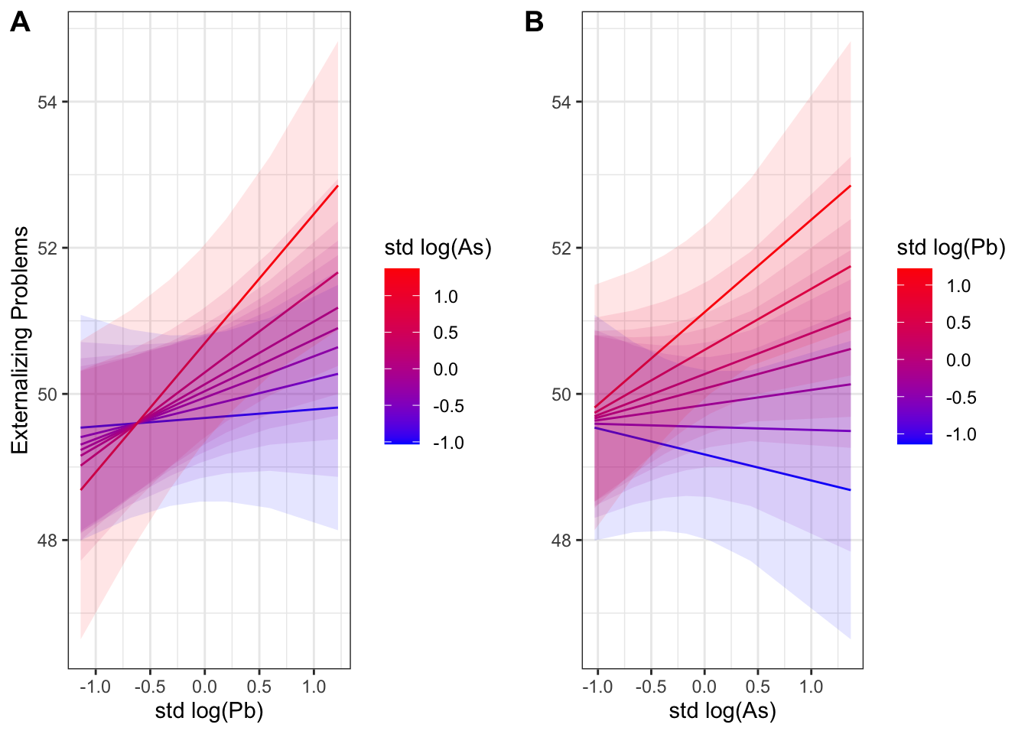

Figure 4. BPb and UAs interaction effect on SRS total T score. BPb and UAs effect on SRS total T score when an interaction term between the two metal concentrations is included in the linear mixed effects model. Blue color corresponds to low level of Pb or As concentrations while red corresponds to high concentration levels.

