Genome-wide simple sequence repeats (SSR) markers discovered from whole-genome sequence comparisons of multiple spinach accessions

- Gehendra Bhattarai¹, Ainong Shi^{1*}, Devi R. Kandel², Nora Solís-Gracia², Jorge Alberto da Silva^{2,3}, Carlos A. Avila^{2,4*}
¹Department of Horticulture, University of Arkansas, Fayetteville, AR 72701, USA.
²Texas A&M AgriLife Research and Extension Center, Weslaco, TX, 78596, USA.
³Department of Crop and Soil Sciences, Texas A&M University, College Station, TX, 77843, USA.
⁴Department of Horticultural Sciences, Texas A&M University, College Station, TX, 77843, USA.

*Corresponding authors:
Ainong Shi
University of Arkansas.
Fayetteville, AR 72701
Phone: 479-575-2670
Email: ashi@uark.edu

Carlos A. Avila
Texas A&M AgriLife Research and Extension Center
Weslaco, TX 78596
Phone: (956) 969-5636
Email: Carlos.Avila@ag.tamu.edu

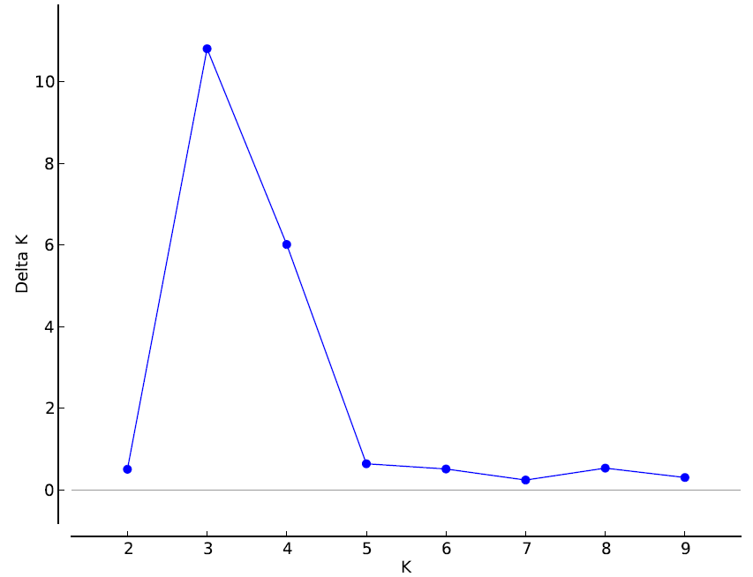
Supplementary Figure S1: Optimal K was determined using the delta K estimation method following STRUCTURE analysis.

