Supplementary Information
Neural networks for increased accuracy of allergenic pollen monitoring
Marcel Polling* and Chen Li, Lu Cao, Fons Verbeek, Letty A. de Weger, Jordina Belmonte, Concepción De Linares, Joost Willemse, Hugo de Boer, Barbara Gravendeel
* Corresponding author, marcel.polling@naturalis.nl

Supplementary Table S1
Probability scores for Urticaceae pollen grains scanned from aerobiological samples using the pre-trained VGG16 model with 5-fold cross-validation. U. mem = Urtica membranacea

Lleida (16-06-2019), n = 63
Image No. | Probability Parietaria | Probability Urtica | Probability  U. mem | Final ID (threshold 0.6) | Final ID (threshold 0.7)
1 | 0.95 | 0.05 | 0.00 | Parietaria | Parietaria
2 | 0.98 | 0.02 | 0.00 | Parietaria | Parietaria
3 | 0.29 | 0.70 | 0.01 | Urtica | Urtica
4 | 0.98 | 0.02 | 0.00 | Parietaria | Parietaria
5 | 0.24 | 0.76 | 0.00 | Urtica | Urtica
6 | 1.00 | 0.00 | 0.00 | Parietaria | Parietaria
7 | 0.94 | 0.06 | 0.00 | Parietaria | Parietaria
8 | 0.99 | 0.01 | 0.00 | Parietaria | Parietaria
9 | 0.12 | 0.88 | 0.00 | Urtica | Urtica
10 | 0.99 | 0.01 | 0.00 | Parietaria | Parietaria
11 | 0.99 | 0.01 | 0.00 | Parietaria | Parietaria
12 | 0.96 | 0.04 | 0.00 | Parietaria | Parietaria
13 | 1.00 | 0.00 | 0.00 | Parietaria | Parietaria
14 | 0.96 | 0.04 | 0.00 | Parietaria | Parietaria
15 | 1.00 | 0.00 | 0.00 | Parietaria | Parietaria
16 | 0.90 | 0.09 | 0.01 | Parietaria | Parietaria
17 | 0.90 | 0.01 | 0.09 | Parietaria | Parietaria
18 | 0.73 | 0.16 | 0.10 | Parietaria | Parietaria
19 | 0.95 | 0.04 | 0.00 | Parietaria | Parietaria
20 | 0.98 | 0.00 | 0.02 | Parietaria | Parietaria
21 | 0.16 | 0.83 | 0.00 | Urtica | Urtica
22 | 0.67 | 0.31 | 0.02 | Parietaria | unknown
23 | 0.02 | 0.98 | 0.00 | Urtica | Urtica
24 | 0.95 | 0.04 | 0.00 | Parietaria | Parietaria
25 | 0.99 | 0.01 | 0.00 | Parietaria | Parietaria
26 | 0.99 | 0.01 | 0.00 | Parietaria | Parietaria
27 | 0.95 | 0.05 | 0.00 | Parietaria | Parietaria
28 | 0.02 | 0.98 | 0.00 | Urtica | Urtica
29 | 0.34 | 0.66 | 0.00 | Urtica | unknown
30 | 1.00 | 0.00 | 0.00 | Parietaria | Parietaria
31 | 0.98 | 0.02 | 0.00 | Parietaria | Parietaria
32 | 1.00 | 0.00 | 0.00 | Parietaria | Parietaria
33 | 0.99 | 0.01 | 0.00 | Parietaria | Parietaria
34 | 0.92 | 0.02 | 0.06 | Parietaria | Parietaria
35 | 0.57 | 0.41 | 0.02 | unknown | unknown
36 | 1.00 | 0.00 | 0.00 | Parietaria | Parietaria
37 | 0.87 | 0.13 | 0.00 | Parietaria | Parietaria
38 | 0.99 | 0.00 | 0.00 | Parietaria | Parietaria
39 | 0.97 | 0.03 | 0.00 | Parietaria | Parietaria
40 | 0.58 | 0.41 | 0.01 | unknown | unknown
41 | 0.98 | 0.02 | 0.00 | Parietaria | Parietaria
42 | 0.70 | 0.29 | 0.00 | Parietaria | Parietaria
43 | 0.84 | 0.16 | 0.00 | Parietaria | Parietaria
44 | 0.97 | 0.02 | 0.01 | Parietaria | Parietaria
45 | 0.83 | 0.17 | 0.00 | Parietaria | Parietaria
46 | 0.99 | 0.00 | 0.00 | Parietaria | Parietaria
47 | 1.00 | 0.00 | 0.00 | Parietaria | Parietaria
48 | 0.99 | 0.00 | 0.00 | Parietaria | Parietaria
49 | 0.96 | 0.04 | 0.01 | Parietaria | Parietaria
50 | 0.00 | 1.00 | 0.00 | Urtica | Urtica
51 | 0.99 | 0.01 | 0.00 | Parietaria | Parietaria
52 | 0.99 | 0.00 | 0.01 | Parietaria | Parietaria
53 | 0.91 | 0.04 | 0.05 | Parietaria | Parietaria
54 | 0.95 | 0.04 | 0.00 | Parietaria | Parietaria
55 | 0.90 | 0.10 | 0.00 | Parietaria | Parietaria
56 | 0.95 | 0.05 | 0.00 | Parietaria | Parietaria
57 | 0.99 | 0.01 | 0.00 | Parietaria | Parietaria
58 | 1.00 | 0.00 | 0.00 | Parietaria | Parietaria
59 | 0.99 | 0.01 | 0.00 | Parietaria | Parietaria
60 | 0.17 | 0.82 | 0.00 | Urtica | Urtica
61 | 0.41 | 0.56 | 0.02 | unknown | unknown
62 | 0.98 | 0.02 | 0.00 | Parietaria | Parietaria
63 | 0.76 | 0.21 | 0.03 | Parietaria | Parietaria

Vielha, 09-08-2019, n = 26
Image No. | Probability Parietaria | Probability Urtica | Probability  U. mem | Final ID (threshold 0.6) | Final ID (threshold 0.7)
1 | 0.03 | 0.97 | 0.00 | Urtica | Urtica
2 | 0.07 | 0.86 | 0.07 | Urtica | Urtica
3 | 0.10 | 0.90 | 0.00 | Urtica | Urtica
4 | 0.02 | 0.98 | 0.00 | Urtica | Urtica
5 | 0.09 | 0.91 | 0.00 | Urtica | Urtica
6 | 0.26 | 0.74 | 0.00 | Urtica | Urtica
7 | 0.00 | 1.00 | 0.00 | Urtica | Urtica
8 | 0.41 | 0.04 | 0.55 | unknown | unknown
9 | 0.61 | 0.39 | 0.01 | Parietaria | unknown
10 | 0.81 | 0.10 | 0.09 | Parietaria | Parietaria
11 | 0.02 | 0.98 | 0.00 | Urtica | Urtica
12 | 0.01 | 0.99 | 0.00 | Urtica | Urtica
13 | 0.49 | 0.13 | 0.38 | unknown | unknown
14 | 0.00 | 1.00 | 0.00 | Urtica | Urtica
15 | 0.14 | 0.84 | 0.02 | Urtica | Urtica
16 | 0.63 | 0.10 | 0.27 | Parietaria | unknown
17 | 0.12 | 0.88 | 0.00 | Urtica | Urtica
18 | 0.09 | 0.90 | 0.00 | Urtica | Urtica
19 | 0.24 | 0.76 | 0.00 | Urtica | Urtica
20 | 0.04 | 0.96 | 0.00 | Urtica | Urtica
21 | 0.85 | 0.12 | 0.03 | Parietaria | Parietaria
22 | 0.80 | 0.14 | 0.07 | Parietaria | Parietaria
23 | 0.00 | 1.00 | 0.00 | Urtica | Urtica
24 | 0.17 | 0.83 | 0.00 | Urtica | Urtica
25 | 0.02 | 0.98 | 0.00 | Urtica | Urtica
26 | 0.57 | 0.43 | 0.00 | unknown | unknown

Leiden (23-08-2019), n = 112
Image No. | Probability Parietaria | Probability Urtica | Probability  U. mem | Final ID (threshold 0.6) | Final ID (threshold 0.7)
1 | 0.04 | 0.96 | 0.00 | Urtica | Urtica
2 | 0.01 | 0.99 | 0.00 | Urtica | Urtica
3 | 0.07 | 0.93 | 0.00 | Urtica | Urtica
4 | 0.16 | 0.83 | 0.00 | Urtica | Urtica
5 | 0.19 | 0.81 | 0.00 | Urtica | Urtica
6 | 0.02 | 0.98 | 0.00 | Urtica | Urtica
7 | 0.00 | 1.00 | 0.00 | Urtica | Urtica
8 | 0.28 | 0.72 | 0.00 | Urtica | Urtica
9 | 0.11 | 0.89 | 0.00 | Urtica | Urtica
10 | 0.34 | 0.66 | 0.00 | Urtica | unknown
11 | 0.04 | 0.96 | 0.00 | Urtica | Urtica
12 | 0.18 | 0.81 | 0.00 | Urtica | Urtica
13 | 0.00 | 1.00 | 0.00 | Urtica | Urtica
14 | 0.47 | 0.53 | 0.00 | unknown | unknown
15 | 0.11 | 0.89 | 0.00 | Urtica | Urtica
16 | 0.01 | 0.99 | 0.00 | Urtica | Urtica
17 | 0.20 | 0.80 | 0.00 | Urtica | Urtica
18 | 0.00 | 1.00 | 0.00 | Urtica | Urtica
19 | 0.00 | 1.00 | 0.00 | Urtica | Urtica
20 | 0.01 | 0.99 | 0.00 | Urtica | Urtica
21 | 0.75 | 0.25 | 0.00 | Parietaria | Parietaria
22 | 0.00 | 1.00 | 0.00 | Urtica | Urtica
23 | 0.03 | 0.97 | 0.00 | Urtica | Urtica
24 | 0.01 | 0.99 | 0.00 | Urtica | Urtica
25 | 0.69 | 0.31 | 0.00 | Parietaria | unknown
26 | 0.11 | 0.89 | 0.00 | Urtica | Urtica
27 | 0.12 | 0.88 | 0.00 | Urtica | Urtica
28 | 0.17 | 0.83 | 0.00 | Urtica | Urtica
29 | 0.09 | 0.91 | 0.00 | Urtica | Urtica
30 | 0.00 | 1.00 | 0.00 | Urtica | Urtica
31 | 0.48 | 0.52 | 0.00 | unknown | unknown
32 | 0.24 | 0.76 | 0.00 | Urtica | Urtica
33 | 0.06 | 0.94 | 0.00 | Urtica | Urtica
34 | 0.29 | 0.71 | 0.00 | Urtica | Urtica
35 | 0.14 | 0.86 | 0.00 | Urtica | Urtica
36 | 0.38 | 0.62 | 0.00 | Urtica | unknown
37 | 0.06 | 0.94 | 0.00 | Urtica | Urtica
38 | 0.55 | 0.45 | 0.00 | unknown | unknown
39 | 0.01 | 0.99 | 0.00 | Urtica | Urtica
40 | 0.00 | 1.00 | 0.00 | Urtica | Urtica
41 | 0.00 | 1.00 | 0.00 | Urtica | Urtica
42 | 0.02 | 0.98 | 0.00 | Urtica | Urtica
43 | 0.03 | 0.97 | 0.00 | Urtica | Urtica
44 | 0.21 | 0.79 | 0.00 | Urtica | Urtica
45 | 0.02 | 0.98 | 0.00 | Urtica | Urtica
46 | 0.00 | 1.00 | 0.00 | Urtica | Urtica
47 | 0.01 | 0.99 | 0.00 | Urtica | Urtica
48 | 0.79 | 0.20 | 0.00 | Parietaria | Parietaria
49 | 0.54 | 0.46 | 0.00 | unknown | unknown
50 | 0.01 | 0.99 | 0.00 | Urtica | Urtica
51 | 0.00 | 1.00 | 0.00 | Urtica | Urtica
52 | 0.01 | 0.99 | 0.00 | Urtica | Urtica
53 | 0.01 | 0.99 | 0.00 | Urtica | Urtica
54 | 0.00 | 1.00 | 0.00 | Urtica | Urtica
55 | 0.00 | 1.00 | 0.00 | Urtica | Urtica
56 | 0.00 | 1.00 | 0.00 | Urtica | Urtica
57 | 0.02 | 0.98 | 0.00 | Urtica | Urtica
58 | 0.00 | 1.00 | 0.00 | Urtica | Urtica
59 | 0.54 | 0.46 | 0.00 | unknown | unknown
60 | 0.45 | 0.55 | 0.00 | unknown | unknown
61 | 0.09 | 0.91 | 0.00 | Urtica | Urtica
62 | 0.00 | 1.00 | 0.00 | Urtica | Urtica
63 | 0.00 | 1.00 | 0.00 | Urtica | Urtica
64 | 0.00 | 1.00 | 0.00 | Urtica | Urtica
65 | 0.06 | 0.94 | 0.00 | Urtica | Urtica
66 | 0.05 | 0.95 | 0.00 | Urtica | Urtica
67 | 0.01 | 0.99 | 0.00 | Urtica | Urtica
68 | 0.23 | 0.77 | 0.00 | Urtica | Urtica
69 | 0.21 | 0.79 | 0.00 | Urtica | Urtica
70 | 0.72 | 0.28 | 0.00 | Parietaria | Parietaria
71 | 0.49 | 0.51 | 0.00 | unknown | unknown
72 | 0.06 | 0.94 | 0.00 | Urtica | Urtica
73 | 0.33 | 0.67 | 0.00 | Urtica | unknown
74 | 0.00 | 1.00 | 0.00 | Urtica | Urtica
75 | 0.28 | 0.72 | 0.00 | Urtica | Urtica
76 | 0.00 | 1.00 | 0.00 | Urtica | Urtica
77 | 0.03 | 0.97 | 0.00 | Urtica | Urtica
78 | 0.05 | 0.95 | 0.00 | Urtica | Urtica
79 | 0.21 | 0.79 | 0.00 | Urtica | Urtica
80 | 0.00 | 1.00 | 0.00 | Urtica | Urtica
81 | 0.00 | 1.00 | 0.00 | Urtica | Urtica
82 | 0.03 | 0.97 | 0.00 | Urtica | Urtica
83 | 0.02 | 0.98 | 0.00 | Urtica | Urtica
84 | 0.12 | 0.88 | 0.00 | Urtica | Urtica
85 | 0.17 | 0.83 | 0.00 | Urtica | Urtica
86 | 0.01 | 0.99 | 0.00 | Urtica | Urtica
87 | 0.90 | 0.10 | 0.00 | Parietaria | Parietaria
88 | 0.11 | 0.89 | 0.00 | Urtica | Urtica
89 | 0.02 | 0.98 | 0.00 | Urtica | Urtica
90 | 0.00 | 1.00 | 0.00 | Urtica | Urtica
91 | 0.29 | 0.71 | 0.00 | Urtica | Urtica
92 | 0.11 | 0.89 | 0.00 | Urtica | Urtica
93 | 0.12 | 0.88 | 0.00 | Urtica | Urtica
94 | 0.01 | 0.99 | 0.00 | Urtica | Urtica
95 | 0.01 | 0.99 | 0.00 | Urtica | Urtica
96 | 0.00 | 1.00 | 0.00 | Urtica | Urtica
97 | 0.00 | 1.00 | 0.00 | Urtica | Urtica
98 | 0.02 | 0.98 | 0.00 | Urtica | Urtica
99 | 0.00 | 1.00 | 0.00 | Urtica | Urtica
100 | 0.21 | 0.79 | 0.00 | Urtica | Urtica
101 | 0.55 | 0.45 | 0.00 | unknown | unknown
102 | 0.00 | 1.00 | 0.00 | Urtica | Urtica
103 | 0.48 | 0.52 | 0.00 | unknown | unknown
104 | 0.00 | 1.00 | 0.00 | Urtica | Urtica
105 | 0.00 | 1.00 | 0.00 | Urtica | Urtica
106 | 0.57 | 0.43 | 0.00 | unknown | unknown
107 | 0.11 | 0.89 | 0.00 | Urtica | Urtica
108 | 0.23 | 0.77 | 0.00 | Urtica | Urtica
109 | 0.26 | 0.74 | 0.00 | Urtica | Urtica
110 | 0.12 | 0.88 | 0.00 | Urtica | Urtica
111 | 0.58 | 0.42 | 0.00 | unknown | unknown
112 | 0.00 | 1.00 | 0.00 | Urtica | Urtica

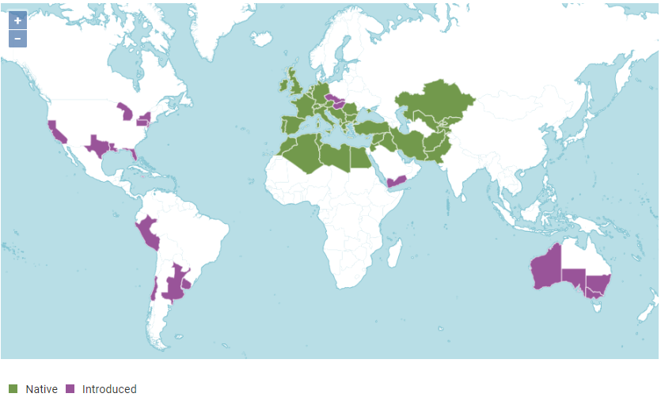
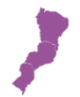

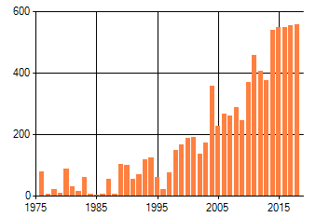
Supplementary Figure S1
(a)
(b)

Figure S1. (a) Global native (green) and introduced (purple) distribution of Parietaria judaica and P. officinalis (POWO (2019). "Plants of the World Online. Map taken from the Royal Botanic Gardens, Kew. http://www.plantsoftheworldonline.org/ Retrieved 05 October 2020"). (b) Trend in Pellitory of the wall (Parietaria judaica) plant sightings per square kilometre in the Netherlands over the past 45 years. Index number = 100 for 1990 © NEM (CBS & FLORON) 2019.

Supplementary Table S2
Locations of all Urticaceae specimens and number of images. NL = the Netherlands, SP = Spain and PO = Portugal. *collected in 2018 and 2019, deposited in the Naturalis Biodiversity Center herbarium.
Species  (n = total images) | Geographical origin | Collection date | No. of images used | Deposition number
Parietaria judaica L.  (n = 1670) | Montejaque (SP)  Leiden, Stationsweg (NL)  Huizen (NL)  Leiden, Robijnstraat (NL)  Den Haag (NL)  Leiden, Paterstraatje  Sassenplaat (NL)  Rotterdam, Hartelkanaal (NL) | 17/10/2011  19/11/2019  20/09/2014  23/07/2012  05/10/2018  09/10/2018  03/07/2013  27/09/2014 | 54  168  174  139  392  250  233  260 | WAG.1186948  L.3993376*  L.4303913  L.2071680  L.3993377*  L.3993378*  L.4304093  L.4304136
Parietaria officinalis L.  (n = 1359) | Middelburg (NL)  Haarlem (NL)  Wageningse Polder (NL)  Leiden (NL)  Den Haag, Escamplaan (NL)  Den Haag, Bosjes van Poot (NL) | 26/06/2014  13/07/2013  19/07/2012  07/2012  12/10/2018  01/08/2012 | 234  191  64  369  383  248 | L.3974371  L.2073373  WAG.1186992  L.3963901  L.3993379*  L.2071818
Urtica dioica L.  (n = 1055) | Leiden, Hogeschool 1 (NL)  Leiden, Hogeschool 2 (NL)  Den Haag (NL)  Leiden, Sandifortdreef (NL)  Arnhem (NL) | 06/11/2019  07/11/2019  17/11/2019  15/11/2019  29/05/2001 | 316  299  182  191  67 | L.3993380*  L.3993381*  L.3993382*  L.3993383*  WAG.1188104
Urtica membranacea Poir. ex Savigny  (n = 1118) | Amsterdam (NL)  Overloon (NL)  Cape st. Vincent (PO)  Den Haag (NL) | 11/2018  17/06/2014  03/1995  06/03/2019 | 521  135  87  375 | L.3993384*  L.3959964  L.1629741  L.3993385*
Urtica urens L.  (n = 1270) | Leiden (NL)  Castilla-la-Mancha (SP)  Zandvoort (NL)  Meijendel (NL)  Zwolle (NL)  Wassenaar (NL)  Den Haag (NL) | 01/11/2019  27/05/2016  05/08/2012  12/08/2011  29/04/2005  15/09/2002  13/03/2020 | 128  165  201  140  134  219  283 | L.3993386*  WAG.1962413  L.2071917  L.2074446  L.4271105  L.4233917  L.3993387*

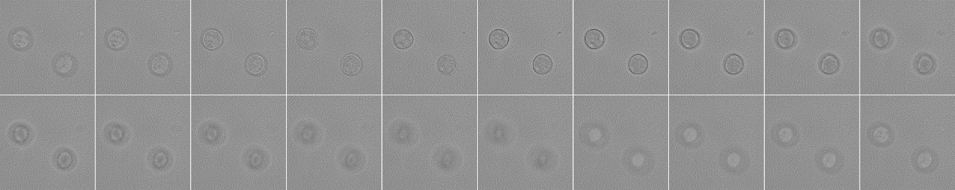
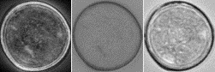
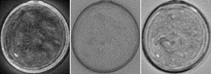
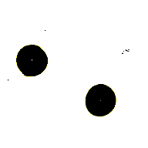
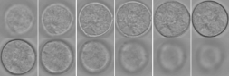
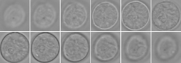
Supplementary Figure S2

Z=1
Z=10
Z=20
Z=11
Cropping out pollen in a stack, using only in-focus informative images
Output: Three Z-stack projections for each pollen grain (STD, MIN, EXT)

Input: Raw images (20 Z-slices) containing pollen

STD
MIN
EXT
STD
MIN
EXT
Figure S2. Pollen image acquisition and processing workflow carried out with in-house designed Pollen_Projector script. Once raw images are obtained at 20 different focal levels (‘Z-slices’), subsequent steps involve cropping of whole individual pollen grains and producing three different projections from the Z-stacks. Abbreviations of projections: STD = Standard Deviation, MIN = Minimum Intensity and EXT = Extended Focus.

Supplementary Figure S3
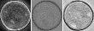
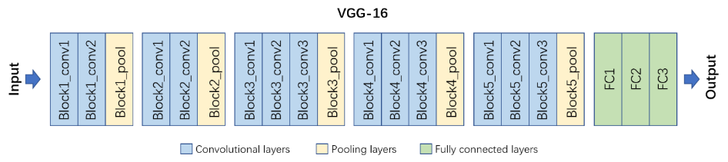
Figure S3. Schematic overview of the structure of VGG-16 with an example of three-channel input image of a Parietaria judaica pollen grain (known label) and the output generated, where it confidently identifies the images as Parietaria (98% probability). Adapted from Simonyan et al., (2014)¹
Parietaria (98.5%)
Urtica
(1.5%)

Supplementary Figure S4
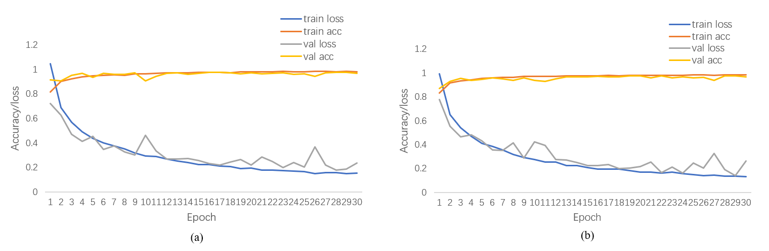
Figure S4. Figures showing the accuracy/loss plots for the VGG16 model with 5- and 10-fold cross-validation.

Supplementary Figure S5
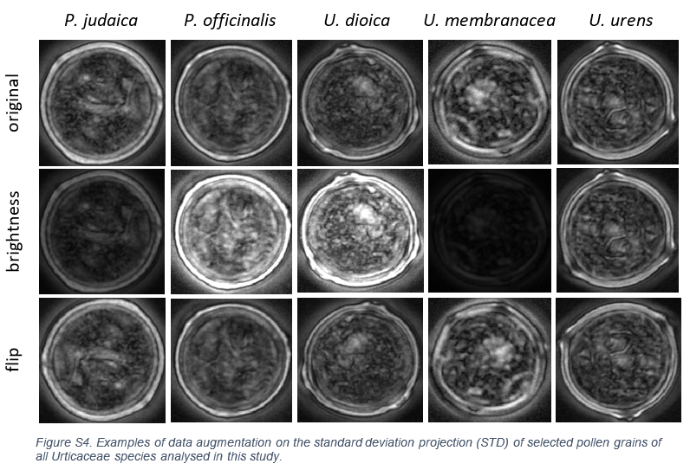

Figure S5. Examples of data augmentation on the Standard Deviation Projection (STD) of selected pollen grains of all Urticaceae pollen species used in this study.

Supplementary reference
1 Simonyan, K. & Zisserman, A. Very deep convolutional networks for large-scale image recognition. arXiv preprint arXiv:1409.1556 (2014).

