Supplementary Materials: Human immune system adaptations to simulated microgravity revealed by single-cell mass cytometry
Authors: J.M. Spatz,^{1‡} M. Hughes Fulford,^{1*‡} A. Tsai,² D. Gaudilliere,³ J. Hedou,² E. Ganio,² M. Angst,² N. Aghaeepour,^{2‡} B. Gaudilliere^{2*‡}

Supplementary Figure 1: Gating strategy
Supplementary Figure 2: 18h exposure to sµG did not alter peripheral immune cell frequency.
Supplementary Figure 3: Multivariable modeling of basal immune cell adaptions to sµG.
Supplemental Table 1: Mass cytometry antibody panel
Supplemental Table 2: Elastic Net model components differentiating the 1G and simulated microgravity conditions
Supplemental Table 3. Basal EN model components.

\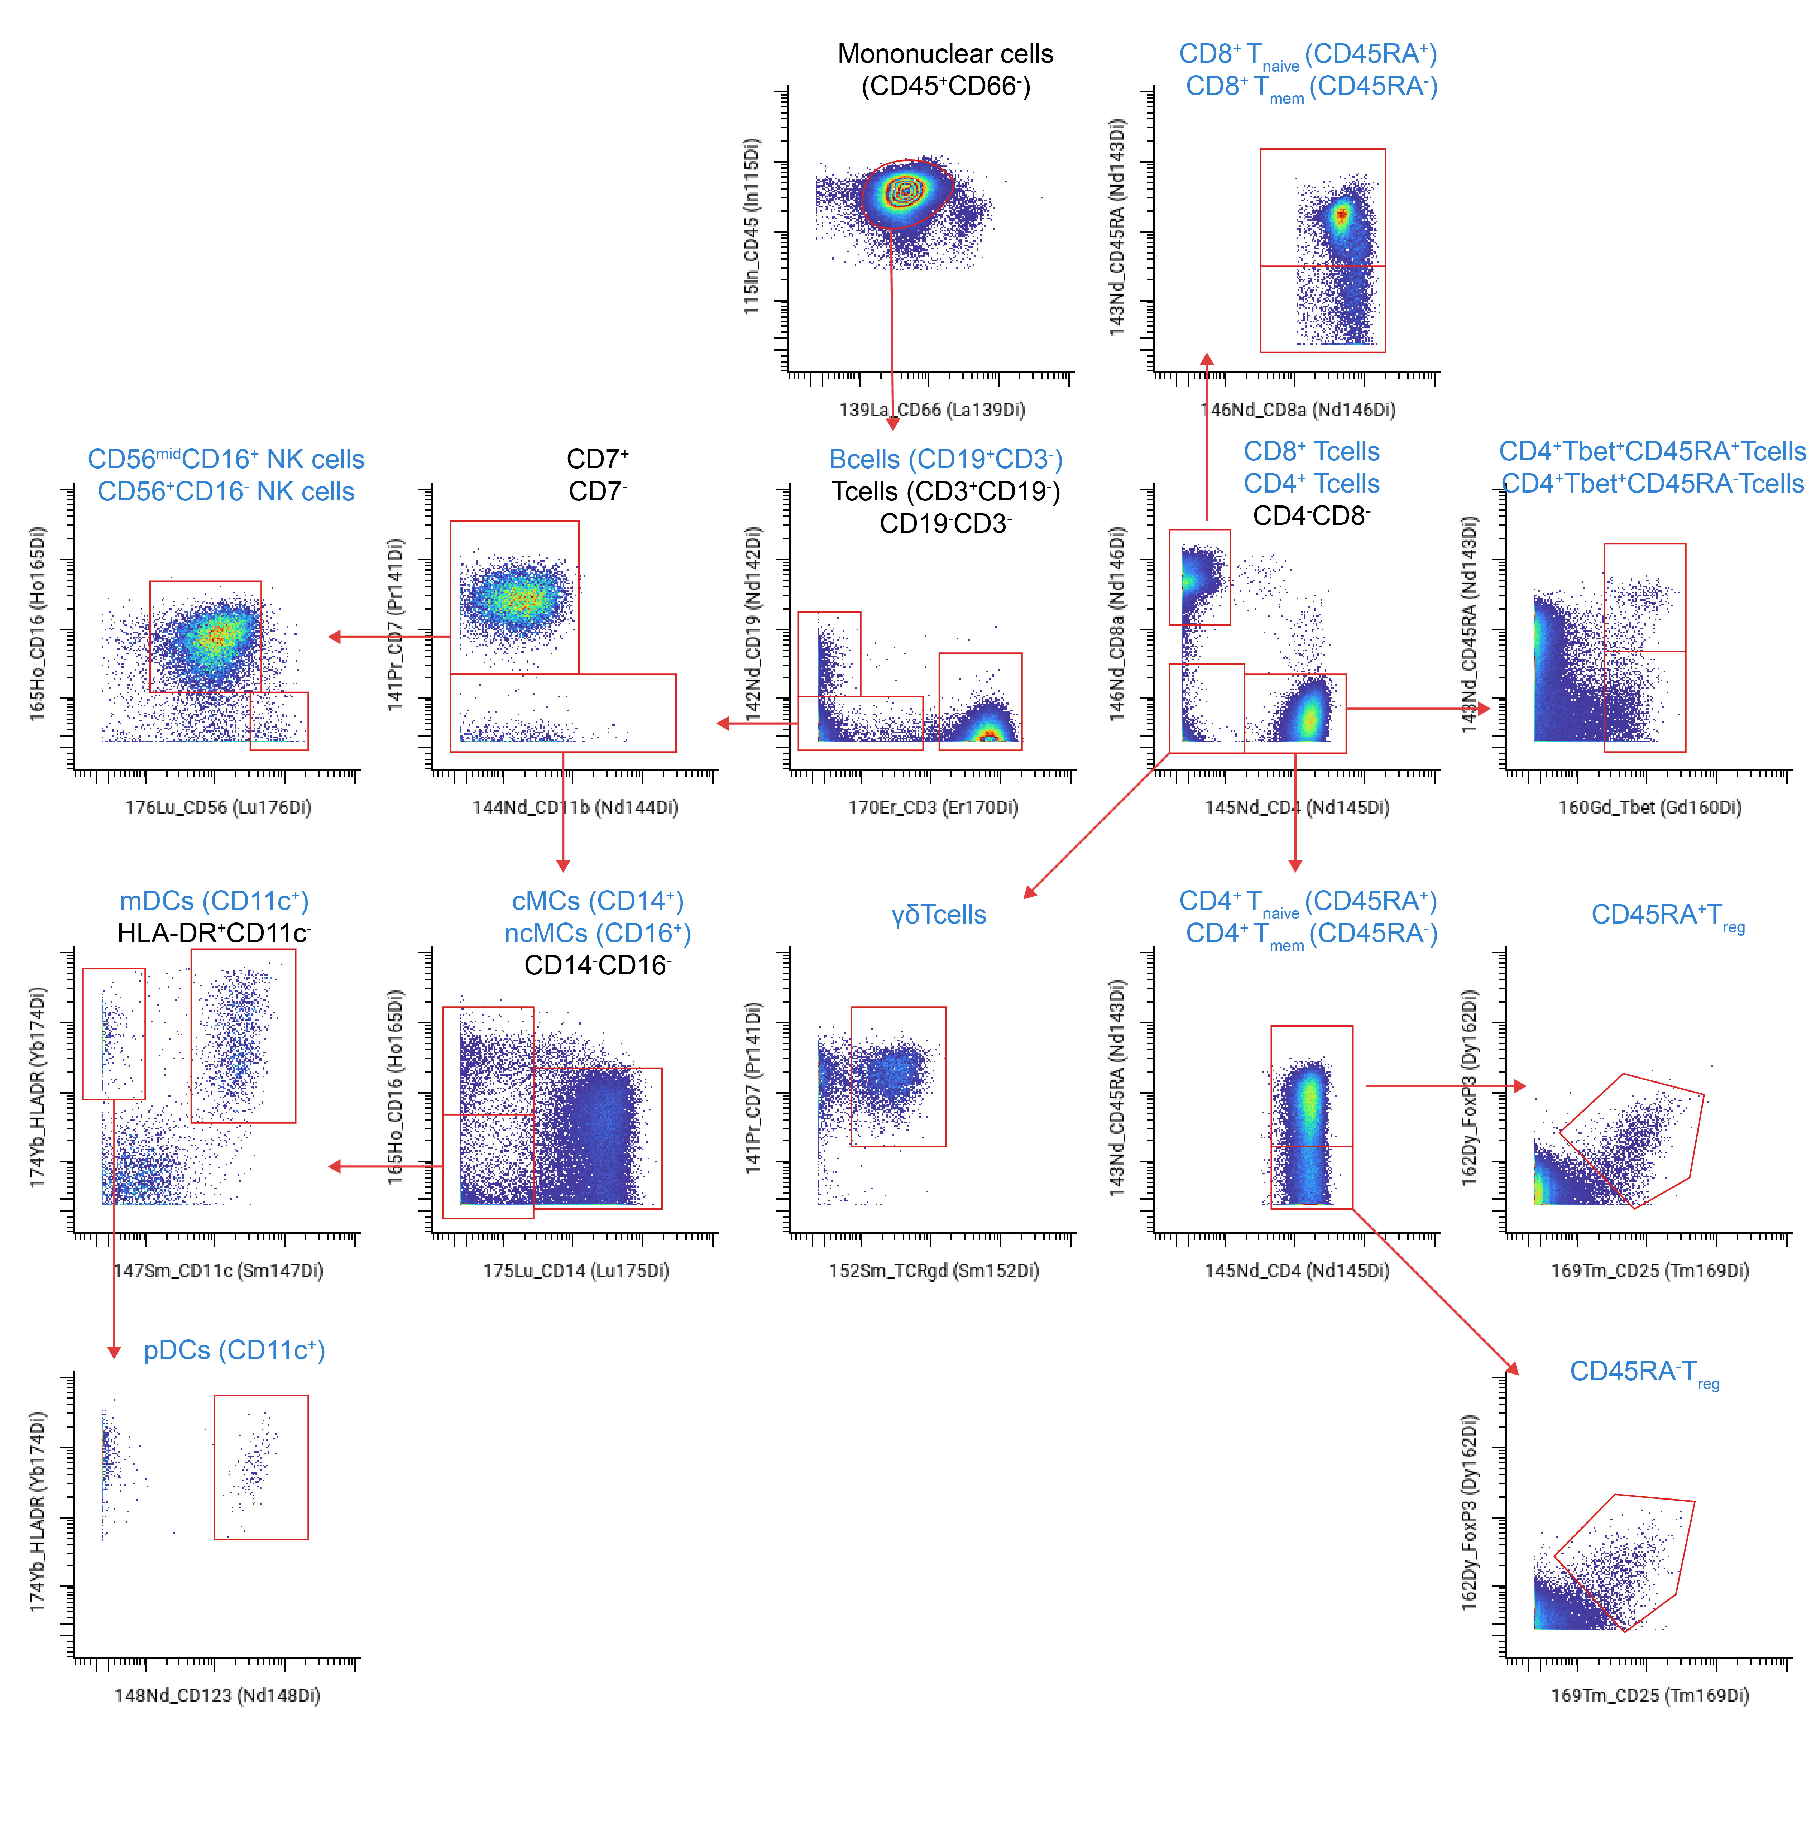

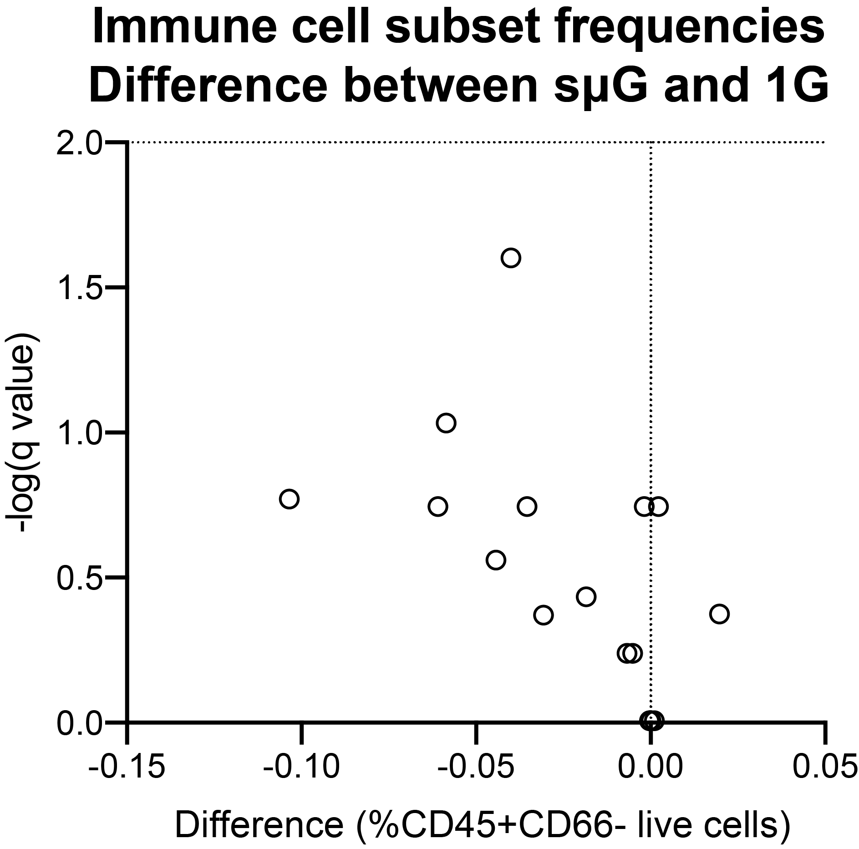
Supplemental Figure 1. Gating Strategy. Manual gates derived from 2-dimensional scatter plots in Immune Atlas (https://immuneatlas.org/). Cell subsets included in the analysis are highlighted in blue and include (CD4⁺ T, CD4⁺_{naïve}T, CD4⁺_{mem}T, CD45RA⁺T_{reg}, CD45RA⁻T_{reg}, TCRγδ T, Tbet⁺CD45RA⁺CD4⁺ T, Tbet⁺CD45RA⁻CD4⁺ T, CD8⁺ T, CD8⁺_{naïve}T, CD8⁺_{mem}T, CD56midCD16+ Natural Killer (NK), CD56+CD16-NK, classical monocytes (cMC), non-classical monocytes (ncMCs), myeloid (m) and plasmacytoid (p) dendritic (DCs), and B cells

Supplemental Figure 2. 18h exposure to sµG did not alter peripheral immune cell frequency. The frequency of the 18 Immune cell subsets included in the analysis were caculated as %CD45+CD66- live cells. The dot plot illustrates -log (q value) comparing the sµG and 1G conditions (18h exposure, unstimulated cells). All frequencies were below the horizontal line at y=2 (FDR q > 0.01, n=8).

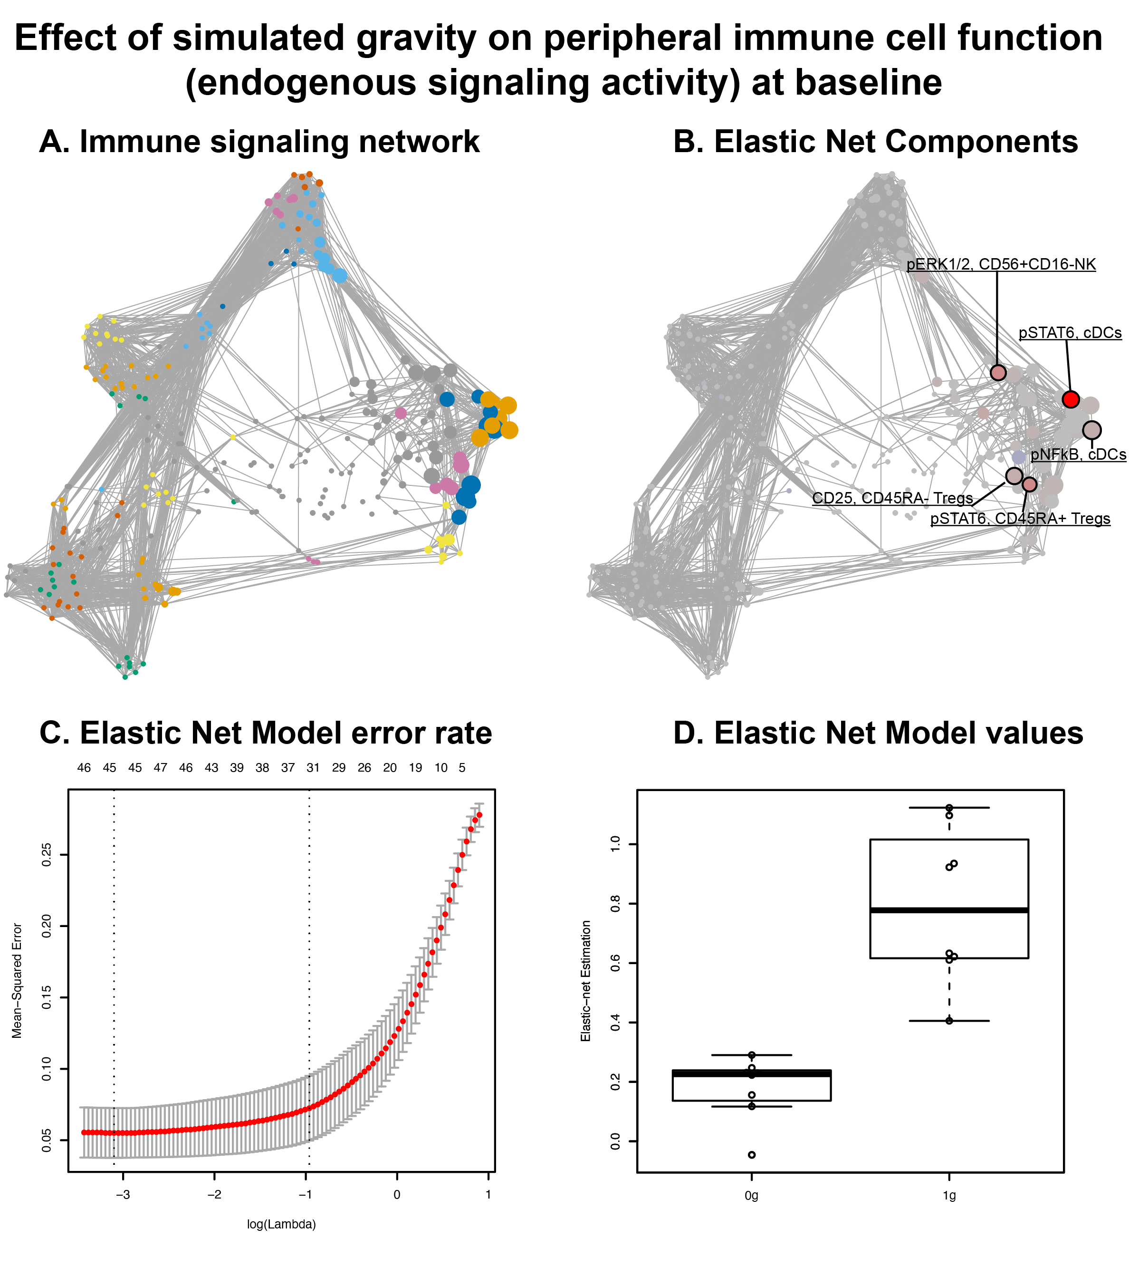
Supplemental Figure 3: Multivariable modeling of basal immune cell adaptions to sµG. A. Correlation network depicting single-cell immune responses at baseline. Nodes represent the protein expression or phosphorylation level of one of 14 functional proteomic markers for a given immune cell subset (asinh ratio relative to the 0h timepoint). Edges are proportional to the Spearman correlation between two nodes. The network segregates into communities that were characterized based on the functional attribute that appeared most frequently in each community. B. An EN method analysis of immune cell responses that differentiated samples exposed to sµG or 1G. C. The graph depicts model error rates after cross-validation across a range of regularization threshold [log(lambda)]. EN models with the lowest error rate (left vertical dotted line) and one standard deviation from the lowest error rate (right vertical line) are indicated. D. Output corresponding to the basal EN model one standard deviation from the lowest error rate (p-value=3.7E-4, cross-validation, n=8).

Supplemental Table 1. Mass cytometry antibody panel.
Antibody | Symbol | Atomic Mass | Comment
Barcode 1 | Pd | 102 | Barcode
Barcode 2 | Pd | 104 | Barcode
Barcode 3 | Pd | 105 | Barcode
Barcode 4 | Pd | 106 | Barcode
Barcode 5 | Pd | 108 | Barcode
Barcode 6 | Pd | 110 | Barcode
CD235ab* | In | 113 | Phenotype
CD61* | In | 113 | Phenotype
CD45 | In | 115 | Phenotype
CD66 | La | 139 | Phenotype
CD7 | Pr | 141 | Phenotype
CD19 | Nd | 142 | Phenotype
CD45RA | Nd | 143 | Phenotype
CD11b | Nd | 144 | Phenotype
CD4 | Nd | 145 | Phenotype
CD8a | Nd | 146 | Phenotype
CD11c | Sm | 147 | Phenotype
CD123 | Nd | 148 | Phenotype
pCREB | Sm | 149 | Function
pSTAT5 | Nd | 150 | Function
pp38 | Eu | 151 | Function
TCRγδ | Sm | 152 | Phenotype
pSTAT1 | Eu | 153 | Function
pSTAT3 | Sm | 154 | Function
pS6 | Gd | 155 | Function
CXCR3 | Gd | 156 | Phenotype
CD69 | Gd | 157 | Phenotype
CD33 | Gd | 158 | Phenotype
pMAPKAPK2 | Tb | 159 | Function
Tbet | Gd | 160 | Phenotype
cPARP | Dy | 161 | Function
FoxP3 | Dy | 162 | Phenotype
IκB | Dy | 164 | Function
CD16 | Ho | 165 | Phenotype
pNF-κB | Er | 166 | Function
pERK1/2 | Er | 167 | Function
pSTAT6 | Er | 168 | Function
CD25 | Tm | 169 | Phenotype
CD3 | Er | 170 | Phenotype
CCR7 | Yb | 171 | Phenotype
CD15 | Yb | 172 | Phenotype
CCR2 | Yb | 173 | Phenotype
HLA-DR | Yb | 174 | Phenotype
CD14 | Yb | 175 | Phenotype
CD56 | Yb | 176 | Phenotype
DNA1 | Ir | 191 | DNA
DNA2 | Ir | 192 | DNA

Supplemental Table 2. Model components. Discovery determined using the two-stage linear step-up procedure of Benjamini, Krieger and Yekutieli, with Q = 1% in Prism. Each row was analyzed individually, without assuming a consistent SD. Number of t tests: 252.

Feature | P value | Mean of uG | Mean of 1G | q value
CD8_T_cells_CD69 | 0.000001 | 0.936 | 2.86 | 0.000021
CD4__T_cell_naive_CD25 | 0.000001 | -0.0292 | 0.432 | 0.000021
CD56midCD16_NKcells_CD25 | 0.000001 | 0.0115 | 0.22 | 0.000022
Tbet_CD45RA-CD4__T_cells_CD69 | 0.000002 | 2.75 | 4.28 | 0.000032
CD45RA-_Tregs_STAT5 | 0.000004 | 2.41 | 0.369 | 0.00006
CD8__T_cells_naive_STAT1 | 0.000005 | 0.558 | 1.45 | 0.000061
CD4__T_cell_mem_CD69 | 0.000005 | 1.5 | 3.47 | 0.000061
CD8__T_cells_naive_STAT5 | 0.000013 | 0.199 | 1.17 | 0.000146
CD56_CD16-NKcells_CREB | 0.000015 | 0.662 | -0.11 | 0.000153
CD4_T_cells_CD25 | 0.000015 | -0.17 | 0.269 | 0.000153
CD4__T_cell_mem_CD25 | 0.000032 | -0.203 | 0.271 | 0.000309
CD45RA__Tregs_STAT5 | 0.000048 | 2.18 | 0.628 | 0.000437
CD8___T_cells_mem_STAT1 | 0.000076 | 0.114 | 0.575 | 0.000662
CD8__T_cells_naive_STAT3 | 0.000126 | 0.686 | 1.68 | 0.001058
Tbet_CD45RA_CD4__T_cells_CD69 | 0.00014 | 2.25 | 3.72 | 0.001122
CD8_T_cells_STAT1 | 0.000182 | 0.436 | 1.2 | 0.001406
CD4__T_cell_naive_S6 | 0.00019 | 0.193 | 1.03 | 0.001416
pDCs_STAT3 | 0.000273 | 0.259 | 1.85 | 0.001956
ncMCs_ERK | 0.00031 | -0.358 | -1.18 | 0.002147
Tbet_CD45RA_CD4__T_cells_CD25 | 0.000338 | 0.0371 | 0.491 | 0.002259
CD56_CD16-NKcells_STAT3 | 0.000348 | 0.756 | 1.26 | 0.002259
Tbet_CD45RA-CD4__T_cells_STAT1 | 0.000386 | 0.451 | 1.2 | 0.002423
Tbet_CD45RA-CD4__T_cells_pSTAT6 | 0.00041 | 0.304 | 1.32 | 0.002499
CD8___T_cells_mem_STAT3 | 0.000567 | 0.576 | 1.52 | 0.003349
CD8_T_cells_STAT5 | 0.000714 | 0.289 | 1.05 | 0.004101
CD8__T_cells_naive_p38 | 0.000765 | 0.01 | 0.178 | 0.004273
CD8__T_cells_naive_pSTAT6 | 0.000849 | 0.573 | 1.89 | 0.00461
CD56midCD16_NKcells_pSTAT6 | 0.000937 | 0.198 | 0.946 | 0.004787
CD56_CD16-NKcells_pSTAT6 | 0.000952 | 0.506 | 1.51 | 0.004787
CD8_T_cells_STAT3 | 0.000971 | 0.682 | 1.61 | 0.004787
CD56midCD16_NKcells_CD69 | 0.000977 | 0.764 | 1.42 | 0.004787
mDCs_ERK | 0.001 | -0.0489 | -0.499 | 0.004787
Tbet_CD45RA_CD4__T_cells_STAT3 | 0.001147 | 0.49 | 1.29 | 0.005359
Tbet_CD45RA_CD4__T_cells_pSTAT6 | 0.001226 | 0.444 | 1.61 | 0.005601
CD56midCD16_NKcells_STAT1 | 0.001448 | 0.0174 | 0.164 | 0.006466
mDCs_NFkB | 0.001512 | -0.0207 | -0.294 | 0.006605
CD8__T_cells_naive_S6 | 0.00155 | 0.285 | 0.903 | 0.006629
CD56midCD16_NKcells_STAT5 | 0.00165 | 0.268 | 0.86 | 0.00684
CD4__T_cell_naive_STAT5 | 0.001667 | 0.448 | 0.985 | 0.00684
CD8___T_cells_mem_CD69 | 0.001785 | 1.59 | 2.64 | 0.007177
mDCs_cPARP | 0.001893 | 0.0836 | 0.374 | 0.007461
CD45RA-_Tregs_CD25 | 0.001947 | -0.0872 | -0.454 | 0.007527
CD8___T_cells_mem_pSTAT6 | 0.002022 | 0.297 | 1.26 | 0.007668
CD45RA__Tregs_S6 | 0.002198 | 0.28 | 1.03 | 0.008183
CD45RA__Tregs_pSTAT6 | 0.002339 | 0.41 | 1.42 | 0.008548
CD4_T_cells_S6 | 0.002734 | 0.256 | 0.892 | 0.009662
B-cells_S6 | 0.00274 | 1.31 | 0.484 | 0.009662
CD8_T_cells_pSTAT6 | 0.002814 | 0.505 | 1.67 | 0.009751
Tbet_CD45RA-CD4__T_cells_STAT3 | <0.000001 | 0.377 | 1.8 | 0.000003
CD4__T_cell_naive_CD69 | <0.000001 | 0.543 | 3.15 | 0.000004
CD4_T_cells_CD69 | <0.000001 | 1 | 3.31 | 0.00001
CD45RA__Tregs_CD69 | <0.000001 | 0.603 | 3.23 | 0.000003
CD45RA-_Tregs_CD69 | <0.000001 | 1.4 | 3.21 | 0.000008
CD8__T_cells_naive_CD69 | <0.000001 | 0.688 | 2.89 | 0.000011
CD8___T_cells_mem_CD25 | <0.000001 | 0.00815 | 0.41 | 0.000006
CD8__T_cells_naive_CD25 | <0.000001 | 0.00235 | 0.379 | 0.000014
CD8_T_cells_CD25 | <0.000001 | -0.0121 | 0.375 | 0.000002
Tbet_CD45RA-CD4__T_cells_CD25 | <0.000001 | 0.0946 | 0.842 | 0.000019

Supplemental Table 3. Basal EN model components. Discovery determined using the two-stage linear step-up procedure of Benjamini, Krieger and Yekutieli, with Q = 1% in Prism. Each row was analyzed individually, without assuming a consistent SD. Number of t tests: 252.
Feature | P value | Mean of ug | Mean of 1g | q value
CD45RA__Tregs_STAT5 | 0.0001554 | 0.624 | 1.675 | 0.000248
CD45RA-_Tregs_STAT5 | 0.0001554 | 0.5876 | 2.033 | 0.000029
cDCs_MAPKAPK2 | 0.0001554 | 0.5475 | 1.405 | 0.000636
cDCs_p38 | 0.0001554 | 0.2208 | 0.6048 | 0.005287
cDCs_NFkB | 0.0003108 | 0.2065 | 0.5682 | 0.0018
cDCs_IkB | 0.0003108 | 0.2551 | 0.6422 | 0.005992
cDCs_ERK | 0.0003108 | 0.1755 | 0.6468 | 0.010597
cDCs_pSTAT6 | 0.0006216 | 0.06326 | 0.09285 | 0.003478
CD45RA-_Tregs_CD25 | 0.0006216 | 3.26 | 3.729 | 0.002129
B-cells_CD69 | 0.0006216 | 0.7704 | 1.101 | 0.010597
CD56_CD16-NKcells_ERK | 0.0010878 | 0.1235 | 0.2097 | 0.022266
CD45RA__Tregs_S6 | 0.0010878 | 0.4621 | 0.7473 | 0.021735
CD56_CD16-NKcells_STAT5 | 0.0010878 | 0.3699 | 0.6549 | 0.005346
cDCs_STAT5 | 0.0010878 | 0.3646 | 0.6591 | 0.005234
CD45RA__Tregs_CD69 | 0.0010878 | 0.5932 | 0.7557 | 0.013257
CD45RA__Tregs_pSTAT6 | 0.0018648 | 0.4868 | 0.5586 | 0.021735
cMCs_cPARP | 0.0018648 | 0.2144 | 0.1325 | 0.049144
CD45RA-_Tregs_STAT1 | 0.0029526 | 0.2785 | 0.425 | 0.01487
ncMCs_pSTAT6 | 0.00466201 | 0.08068 | 0.1151 | 0.028913
CD45RA__Tregs_STAT3 | 0.00466201 | 0.6975 | 1.225 | 0.022266
CD56_CD16-NKcells_CREB | 0.00466201 | 1.298 | 1.841 | 0.042431
ncMCs_ERK | 0.00466201 | 0.583 | 1.306 | 0.022266
cDCs_CD69 | 0.00699301 | 0.3329 | 0.6042 | 0.054422
CD45RA__Tregs_CREB | 0.00699301 | 1.188 | 1.69 | 0.035115
CD45RA-_Tregs_p38 | 0.01041181 | 0.3847 | 0.5652 | 0.031462
CD56_CD16-NKcells_CD69 | 0.01041181 | 1.403 | 1.781 | 0.054422
cMCs_S6 | 0.01476302 | 1.415 | 1.77 | 0.102331
CD56midCD16_NKcells_NFkB | 0.02066822 | 1.028 | 0.8083 | 0.109205
CD56midCD16_NKcells_IkB | 0.13038073 | 1.713 | 1.492 | 0.197484
B-cells_IkB | 0.13038073 | 1.834 | 1.6 | 0.208385
CD56midCD16_NKcells_STAT1 | 0.38228438 | 0.205 | 0.1903 | 0.554006

