Figure S1. (a) TEM image of the Au/CN catalyst and (b) Histograms of Au nanoparticle size distribution extracted from TEM image.
Figure S2. (a) XRD spectra and (b) XPS survey of the Au/CN catalyst.
Figure S3. CO₂ electrolyser configurations: (a) gas phase at the cathode, (b) CO₂-saturated 0.5 M KHCO₃ at the cathode, (c) gas phase at the cathode with a liquid buffer layer.
Figure S4. Current efficiencies of other gas products obtained with CO₂-saturated 0.5 M KHCO₃ as catholyte, as a function of the cell potential.
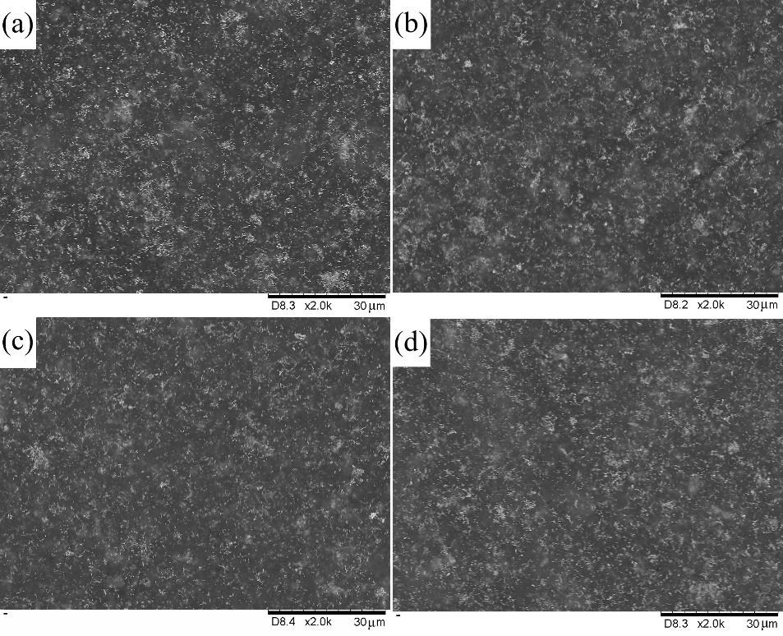
Figure S5. SEM images of gas diffusion electrodes with different PTFE additions (a) 3:1, (b) 5:1, (c) 7:1, (d) 10:1.
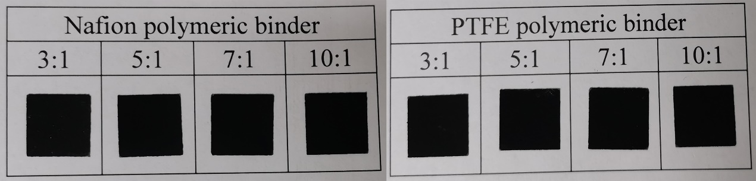
Figure S6. Digital photos of the air-sprayed electrodes with different polymeric binders.
Figure S7. Total current density as a function of time under different cell potential with 7:1 PTFE addition.
Figure S8. CV scans of Au/CN catalysts with different (a) Nafion and (b) PTFE contents in 0.1 M HClO₄ at 50 mV/s scan rate.
Figure S9. Tafel plots with different ionomer contents. (a) Nafion and (b) PTFE ionomer.
Table S1. The contact angles of the air-brushed electrodes with different ionomer contents, and the corresponding Tafel slope, i₀ and ECSA of gold obtained on glass carbon electrode.
Polymeric binder | Catalyst and ionomer mass ratio | Contact angle (º) | ECSA of gold (cm²) | Tafel slope (mV/dec) | i₀ (*10⁻⁵ mA/cm²)
Nafion | 3:1 | 140.2 | 3.56 | 187 | 4.95
Nafion | 5:1 | 138.8 | 3.61 | 165 | 5.62
Nafion | 7:1 | 138.0 | 3.58 | 152 | 4.65
Nafion | 10:1 | 114.4 | 3.55 | 159 | 5.79
PTFE | 3:1 | 140.6 | 3.57 | 155 | 5.31
PTFE | 5:1 | 139.8 | 3.59 | 151 | 5.20
PTFE | 7:1 | 138.9 | 3.60 | 150 | 4.64
PTFE | 10:1 | 118.0 | 3.58 | 143 | 5.15

Figure S10. EIS and the relevant equivalent circuit acquired with different membrane in CO₂ electrolyser under open-circuit level. Points and lines represent measured and fitted results, respectively. (b) j_{CO} as a function of the cell potential (after iR compensation).
Figure S11. (a) UV-visible spectra for various concentrations of potassium formate solutions, (b) the concentration of potassium formate vs absorbance at 230 nm wavelength.
Figure S12. Total current density as a function of time under different cell potential with different membranes. (a) FumasepⓇ FAA-3-50, (b) SustainionTM X37-50 Grade 60.
Figure S13. UV-visible spectra of water adsorption solution in cathode under different cell potential acquired with Nafion N115 membrane.
Figure S14. Current efficiencies of hydrogen and formate obtained with Nafion N115 membrane, as a function of the cell potential.
Figure S15. UV-visible spectra of water adsorption solution in cathode under different cell potential acquired with FumasepⓇ FAA-3-50 membrane.

