Supplementary Figure 4: Venn-diagram illustrating the distribution and overlap between AKI diagnosis according to different choices of baseline for the SCrea AKI criterion
[Trek de aandacht van uw lezer met een veelzeggend citaat uit het document of gebruik deze ruimte om een belangrijk punt te benadrukken. Sleep dit tekstvak als u het ergens anders op de pagina wilt plaatsen.]

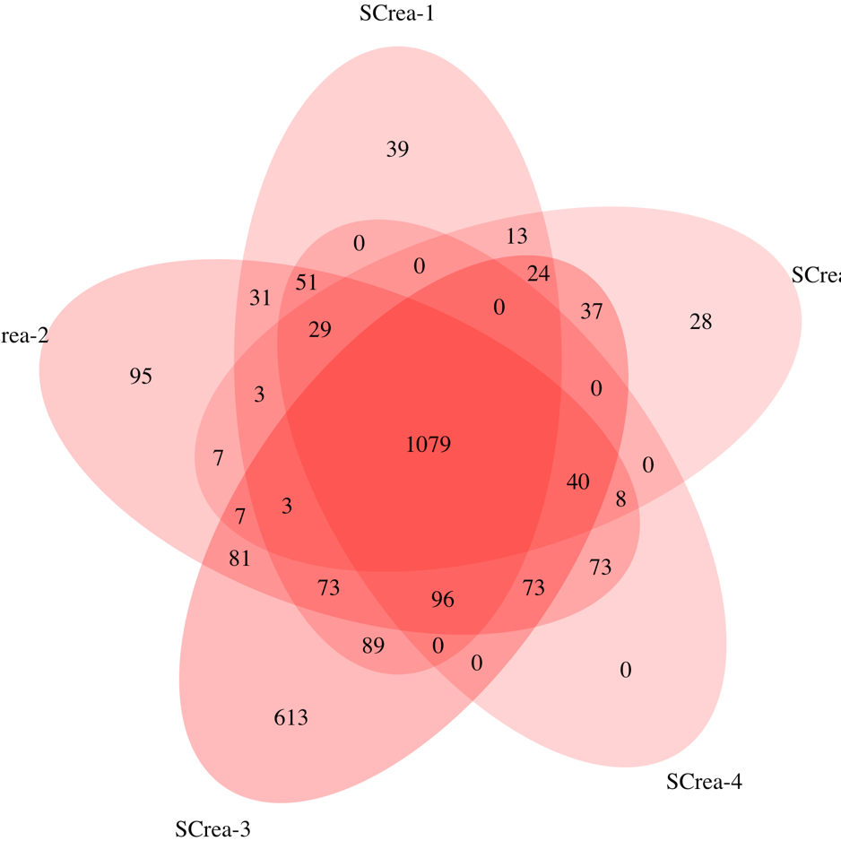

Screa-1 SCrea >4.0 mg/dl or >2x baseline as manually entered in ICIS by the treating physician at ICU admission; Screa-2 SCrea >4.0 mg/dl or >2x baseline defined as lowest pre-ICU measurement up to 365 days before ICU admission as extracted from the lab information system; Screa-3 SCrea >4.0 mg/dl or >2x back-calculated baseline calculated using the simplified 4-variable Modification of Diet in Renal Disease (MDRD) Study equation assuming an estimated glomerular filtration rate (eGFR) of 75 ml/min/1.73 m² for every patient; Screa-4 SCrea >4.0 mg/dl or >2x baseline defined as lowest pre-ICU measurement of the current hospitalization as extracted from the lab information system; Screa-5 SCrea >4.0 mg/dl or >2x baseline defined as the first measurement taken since ICU admission as extracted from the lab information system

