Visual mapping of body image disturbance in anorexia nervosa reveals objective markers of illness severity

Christina Ralph-Nearman, MS, PhD^{1,2 *}, Armen C. Arevian, MD, PhD³,
Scott Moseman, MD⁴, Megan Sinik¹, Sheridan Chappelle¹,
Jamie D. Feusner, MD³, and Sahib S. Khalsa, MD, PhD^{1,5}
¹Laureate Institute for Brain Research (LIBR), Tulsa, Oklahoma
²Department of Psychological and Brain Sciences, University of Louisville, Kentucky
³Jane and Terry Semel Institute for Neuroscience and Human Behavior, University of California Los Angeles
⁴Laureate Psychiatric Clinic and Hospital, Tulsa, Oklahoma
⁵Oxley College of Health Sciences, University of Tulsa, Tulsa, Oklahoma

Running head: VISUAL MAPPING OF BODY IMAGE DISTURBANCE

*Corresponding authors:
Dr. Christina Ralph-Nearman
University of Louisville
Department of Psychological & Brain Sciences
Louisville, Kentucky
United States
Email: ChristinaRalphNearman@gmail.com
Tel: +1 424-634-0920

Dr. Sahib Khalsa
Laureate Institute for Brain Research
Tulsa, Oklahoma
United States
Email: skhalsa@laureateinstitute.org

Supplement

Supplemental Discussion:
In contrast to the AN group’s body size overestimations, the observed HC underestimations of body size aligns with results reported in a prior study with women in the general population.³⁰ These findings support the self-serving bias theory that healthy individuals tend to underestimate their body size, which may preserve a more positive body attitude relative to AN.⁴⁶ It may be that HCs’ visual body perception adapts in correspondence to the body size exposure (the population around them), as visual attention toward body types with high or low adiposity manipulates body misperception in women with healthy BMI, distinctly from body dissatisfaction.⁴⁷ Presently, as the HC’s BMI was on average in the lower, ‘healthy’ range (M=22.61), and much slimmer than 66.9% of women in the general United States population,⁴⁸ it may be that these individuals calibrated to the larger general population, underestimating their own body size. In fact, the social norm hypothesis proposes that healthy, overweight, or obese individuals calibrate the perception of their own body size perception compared to the body size of the growing general population.⁴⁹

Supplementary Tables

Table S.1. Frequency and percentage of participants endorsing emotions (at least once) related to each area body concern.
Emotion type | AN  n (%) | HC  n (%)
Negative
Frustrated | 40 (72.7) | 19 (34.6)
Anxious, tense, worried, nervous | 51 (92.7) | 4 (7.3)
Disgusted | 48 (87.3) | 6 (10.9)
Ashamed | 45 (81.8) | 5 (9.1)
Sad | 31 (56.4) | 6 (10.9)
Depressed | 36 (65.5) | 2 (3.6)
Hopeless | 20 (36.4) | 2 (3.6)
Overwhelmed | 28 (50.9) | 1 (1.8)
Fearful | 21 (38.2) | 1 (1.8)
Angry | 15 (27.3) | 0 (0)
Rejected | 11 (20.0) | 0 (0)
Lonely | 7 (12.7) | 0 (0)
Numb/unreal/dead | 7 (12.7) | 0 (0)
Other (e.g., grossed out, annoyed, guilty, displeased, nasty, apathetic, self-conscious, insecure etc.) | 2 (3.6) | 3 (5.5)
Embarrassed | 2 (3.6) | 0 (0)
Neutral/positive
Looks ok/fine | 2 (3.6) | 33 (60.0)
Hopeful | 3 (5.5) | 10 (18.2)
Satisfied/content | 1 (1.8) | 3 (5.5)
Relieved | 1 (1.8) | 0 (0)

Table S.2. Actual body measurements in centimeters for the AN and HC groups. Statistically significant findings in bold.

Actual body MANCOVA: F^{b}(23, 83) = 33.73, Wilks Λ^{b} = 0.097, P^{b} < 0.001

Variable | HC, mean (SD) | AN, mean (SD) | P valueª | Partial η² | Cohen’s f
Neck Girth | 30.80 (2.41) | 28.64 (3.21) | 0.31 | .016 | 0.128
Neck Length | 13.91 (1.44) | 13.64 (1.60) | 0.79 | .0009 | 0.031
Shoulders | 31.69$($2.96) | 33.36 (4.33) | 0.14 | .031 | 0.178
Bust Girth | 87.00$($5.01) | 83.45$($6.60) | 0.002 | .123 | 0.374
Chest Girth | 85.87 (5.85) | 81.55 (6.04) | 0.003 | .109 | 0.350
Biceps Girth | 27.02$($3.04) | 22.25$($2.95) | 0.008 | .092 | 0.318
Upper Arms Length | 33.35 (2.41) | 31.09 (2.26) | 0.001 | .130 | 0.387
Forearms Girth | 19.98 (3.35) | 18.09 (1.78) | 0.97 | .00002 | 0.005
Lower Arms Length | 25.60 (1.68) | 25.11 (1.79) | 0.65 | .004 | 0.060
Wrists | 14.55 (0.81) | 14.15 (1.33) | 0.36 | .013 | 0.113
Waist | 71.67 (9.78) | 69.51$($8.33) | 0.015 | .076 | 0.288
Torso Length | 44.42 (3.49) | 43.55 (4.50) | 0.29 | .017 | 0.132
Hands Girth | 17.91 (0.99) | 17.35 (1.17) | 0.55 | .006 | 0.077
Hands Length | 17.40 (1.05) | 16.96 (0.96) | 0.44 | .010 | 0.098
Stomach Form | 38.16 (4.69) | 33.82 (5.65) | <0.001 | .114 | 0.405
Hips | 99.46$($6.71) | 88.93$($7.76) | 0.41 | .011 | 0.103
Thighs Girth | 56.49$($5.50) | 46.29$($6.79) | 0.002 | .118 | 0.367
Thighs Length | 48.78 (3.90) | 49.62 (4.54) | 0.72 | .002 | 0.045
Calves Girth | 35.31$($2.28) | 31.13$($3.28) | 0.011 | .082 | 0.299
Calves Length | 42.45 (3.64) | 40.49 (3.66) | 0.41 | .011 | 0.107
Ankles | 21.2 (1.47) | 20.36 (2.24) | 0.70 | .002 | 0.049
Feet Width | 8.44 (0.79) | 8.60 (0.68) | 0.89 | .0002 | 0.015
Feet Length | 22.8 (1.28) | 22.53 (1.43) | 0.44 | .001 | 0.037
Scaled Body Average | 0.987$($0.04) | 0.986$($0.05) | <0.001 | .488 | 0.958

ªP values corrected for multiple comparisons using the Benjamini-Hochberg procedure.
^{b}Measured using multivariate analysis of covariance.

Table S.3. Current perceived body measurements in centimeters for the AN and HC groups. Statistically significant findings in bold.

Current Perceived Body MANCOVA: F^{b}(23, 83) = 1.73, Wilks Λ^{b} = 0.675, P^{b} = 0.037
Variable | HC, mean (SD) | AN, mean (SD) | P-valueª | Partial η² | Cohen’s f
Neck Girth | 26.96 (1.66) | 29.15 (3.75) | 0.037 | .057 | 0.246
Neck Length | 15.80$($3.14) | 16.35$($3.30) | 0.67 | .003 | 0.054
Shoulders | 31.13$($2.99) | 32.40$($4.31) | 0.44 | .009 | 0.097
Bust Girth | 85.18$($5.08) | 85.75$($6.01) | 0.30 | .017 | 0.130
Chest Girth | 76.58$($8.30) | 79.85$($7.07) | 0.003 | .110 | 0.351
Biceps Girth | 23.16$($2.41) | 25.05$($4.03) | 0.003 | .113 | 0.358
Upper Arms Length | 33.44 (3.02) | 32.89 (3.54) | 0.62 | .004 | 0.063
Forearms Girth | 14.49 (2.43) | 16.15 (3.60) | 0.02 | .070 | 0.275
Lower Arms Length | 22.07 (4.13) | 22.29 (4.63) | 0.77 | .001 | 0.037
Wrists | 11.75 (1.60) | 12.47 (2.16) | 0.06 | .047 | 0.222
Waist | 61.60 (4.64) | 64.98 (6.14) | 0.003 | .114 | 0.359
Torso Length | 51.44 (6.69) | 50.53 (9.18) | 0.47 | .008 | 0.089
Hands Girth | 17.58 (1.05) | 17.73 (1.50) | 0.31 | .016 | 0.127
Hands Length | 17.47 (1.14) | 17.75 (1.40) | 0.98 | .00003 | 0.005
Stomach Form | 35.06 (5.74) | 37.96 (8.34) | 0.042 | .054 | 0.238
Hips | 89.36 (6.97) | 91.24 (9.00) | 0.016 | .074 | 0.282
Thighs Girth | 47.05 (4.55) | 50.27 (6.33) | 0.012 | .081 | 0.296
Thighs Length | 54.62 (4.79) | 56.00 (6.22) | 0.55 | .006 | 0.076
Calves Girth | 33.8 (5.13) | 37.75 (8.44) | 0.008 | .092 | 0.318
Calves Length | 43.69 (5.74) | 41.58 (8.00) | 0.06 | .047 | 0.221
Ankles | 18.87 (2.00) | 20.13 (2.10) | 0.003 | .109 | 0.350
Feet Width | 8.56 (1.21) | 9.20 (1.74) | 0.18 | .026 | 0.163
Feet Length | 24.53 (1.93) | 25.15 (2.11) | 0.11 | .035 | 0.191
Scaled Body Average | 0.98 (0.05) | 0.98 (0.07) | 0.68 | .002 | 0.044
ªP values corrected for multiple comparisons using the Benjamini-Hochberg procedure.
^{b}Measured using multivariate analysis of covariance.

Table S.4. Ideal body measurements in centimeters for the AN and HC groups. Statistically significant findings in bold.

Ideal Perceived Body MANCOVA: F^{b}(23, 83) = 3.40, Wilks Λ^{b} = 0.515, P^{b} < 0.001.
Variable | HC, mean (SD) | AN, mean (SD) |  | P-valueª | Partial η² | Cohen’s f
Neck Girth | 26.76(1.77) |  | 26.25(2.00) | 0.40 | .012 | .108
Neck Length | 16.53(3.18) |  | 17.20(3.11) | 0.27 | .019 | .138
Shoulders | 30.78(2.77) |  | 29.40(1.98) | 0.009 | .088 | .311
Bust Girth | 87.33(5.14) |  | 86.04(5.75) | 0.10 | .037 | .197
Chest Girth | 74.65(7.77) |  | 69.95(7.67) | 0.36 | .013 | .116
Biceps Girth | 22.62(2.38) |  | 21.35(3.08) | 0.27 | .019 | .138
Upper Arms Length | 33.51(2.86) |  | 33.64(3.20) | 0.44 | .010 | .098
Forearms Girth | 13.51(2.16) |  | 12.35(2.98) | 0.47 | .008 | .089
Lower Arms Length | 23.20(3.34) |  | 22.36(4.33) | 0.38 | .012 | .109
Wrists | 11.36(1.53) |  | 10.89(1.88) | 0.91 | .0001 | .012
Waist | 60.13(3.31) |  | 58.96(3.64) | 0.26 | .020 | .144
Torso Length | 52.29(6.34) |  | 55.38(7.99) | 0.039 | .056 | .243
Hands Girth | 17.04(0.88) |  | 16.95(1.13) | 0.98 | .000008 | .003
Hands Length | 17.38(1.03) |  | 18.02(1.16) | 0.069 | .044 | .215
Stomach Form | 31.67(5.00) |  | 30.16(5.56) | 0.89 | .0004 | .021
Hips | 89.20(5.75) |  | 84.11(4.76) | 0.023 | .067 | .269
Thighs Girth | 45.18(2.89) |  | 43.13(4.51) | 0.13 | .032 | .181
Thighs Length | 56.38(5.21) |  | 58.02(5.38) | 0.27 | .019 | .141
Calves Girth | 32.58(5.37) |  | 28.44(5.86) | 0.038 | .057 | .245
Calves Length | 43.67(5.73) |  | 45.35(7.44) | 0.44 | .009 | .096
Ankles | 18.69(1.65) |  | 18.84(2.23) | 0.91 | .0002 | .014
Feet Width | 8.22(1.18) |  | 7.55(1.33) | 0.03 | .062 | .258
Feet Length | 24.71(1.52) |  | 24.96(1.51) | 0.47 | .008 | .089
Scaled Body Average | 0.98 (0.05) |  | 0.98 (0.05) | 0.60 | .004 | .062
ªP values corrected for multiple comparisons using the Benjamini-Hochberg procedure.
^{b}Measured using multivariate analysis of covariance.

Table S.5. Current body discrepancy scores (perceived current minus actual body measurements) in centimeters for the AN and HC groups. Statistically significant findings in bold.

Current body discrepancy MANCOVA: F^{b}(23, 83) = 11.89, Wilks Λ^{b} = 0.232, P^{b} < 0.001

Variable | HC, mean (SD) | AN, mean (SD) | P-valueª | Partial η² |  | Cohen’s f
Neck Girth | –3.78 (2.58) | +0.53 (4.64) | 0.015 | .077 | 0.289
Neck Length | +1.89$($3.23) | +2.71 (3.35) | 0.62 | .004 | 0.064
Shoulders | –0.56 (3.83) | -0.93$($5.68) | 0.65 | .003 | 0.057
Bust Girth | –1.80 (6.76) | +2.29 (7.10) | 0.42 | .001 | 0.100
Chest Girth | –9.29$($8.25) | -1.64$($9.50) | 0.14 | .031 | 0.180
Biceps Girth | –3.85 (3.65) | +2.80 (4.57) | <.001 | .188 | 0.481
Upper Arms Length | +0.09$($2.87) | +1.80$($3.22) | 0.18 | .027 | 0.167
Forearms Girth | -5.49 (3.92) | -1.95 (4.03) | 0.07 | .044 | 0.216
Lower Arms Length | -3.53 (4.28) | -2.82 (5.09) | 0.70 | .003 | 0.051
Wrists | -2.80 (1.67) | -1.67 (2.24) | 0.23 | .022 | 0.151
Waist | -10.05 (10.31) | -4.49 (9.09) | 0.77 | .001 | 0.036
Torso Length | +7.02 (6.38) | +6.98 (9.87) | 0.89 | .0003 | 0.018
Hands Girth | -0.33 (1.43) | +0.38 (1.78) | 0.23 | .022 | 0.151
Hands Length | +0.07 (1.27) | +0.78 (1.54) | 0.66 | .003 | 0.055
Stomach Form | -3.11 (7.04) | +4.15 (9.74) | <.001 | .166 | 0.447
Hips | -10.05 (7.97) | +2.33 (10.30) | 0.009 | .087 | 0.308
Thighs Girth | -9.44 (6.56) | +3.98 (8.18) | <.001 | .197 | 0.495
Thighs Length | +5.84 (4.83) | +6.38 (7.93) | 0.77 | .001 | 0.035
Calves Girth | -1.51 (5.17) | +6.62 (8.71) | <0.001 | .140 | 0.403
Calves Length | +1.24 (6.32) | +1.09 (8.38) | 0.23 | .023 | 0.152
Ankles | -2.33 (2.58) | -0.24 (2.36) | 0.026 | .065 | 0.264
Feet Width | +0.18 (1.39) | +0.60 (1.80) | 0.27 | .019 | 0.140
Feet Length | +1.71 (1.82) | +2.62 (1.89) | 0.036 | .024 | 0.157
Scaled Body Average | –0.26$($0.29) | +0.19$($0.43) | .016 | .066 | 0.266
ªP values corrected for multiple comparisons using the Benjamini-Hochberg procedure.
^{b}Measured using multivariate analysis of covariance.

Table S.6. Ideal body discrepancy scores (ideal minus actual body measurements) in centimeters for the AN and HC groups. Statistically significant findings in bold font.

Ideal body discrepancy MANCOVA: F^{b}( 23, 83) = 6.37, Wilks Λ^{b} = 0.362, P^{b} < 0.001.

Variable | HC, mean (SD) | AN, mean (SD) | P-valueª | Partial η² | Cohen’s f
Neck Girth | -3.96(3.25) | -2.31(3.35) | 0.75 | .002 | .039
Neck Length | +2.62(3.22) | +3.56(3.19) | 0.26 | .020 | .142
Shoulders | -0.91(3.59) | -3.91(4.88) | 0.008 | .091 | .316
Bust Girth | +0.33(6.82) | +2.64(9.27) | 0.002 | .123 | .374
Chest Girth | -11.24(9.15) | -11.76(10.01) | 0.04 | .054 | .240
Biceps Girth | -4.40(3.80) | -0.91(4.16) | 0.42 | .010 | .101
Upper Arms Length | +0.16(2.89) | +2.55(3.57) | 0.009 | .086 | .306
Forearms Girth | -6.47(3.79) | -5.75(3.16) | 0.57 | .005 | .071
Lower Arms Length | -2.40(3.42) | -2.75(4.51) | 0.32 | .015 | .124
Wrists | -3.18(1.63) | -3.25(2.07) | 0.70 | .003 | .051
Waist | -11.53(10.22) | -10.51(8.61) | 0.005 | .101 | .335
Torso Length | +7.87(6.39) | +11.84(8.32) | 0.009 | .086 | .307
Hands Girth | -0.87(1.14) | -0.40(1.68) | 0.68 | .003 | .054
Hands Length | -0.02(1.21) | +1.05(1.61) | 0.042 | .054 | .238
Stomach Form | -6.49(6.26) | -3.66(8.45) | 0.011 | .083 | .302
Hips | -10.24(7.84) | -4.78(9.04) | 0.18 | .027 | .165
Thighs Girth | -11.31(5.71) | -3.16(9.06) | 0.20 | .024 | .158
Thighs Length | +7.60(5.32) | +8.40(7.18) | 0.49 | .007 | .085
Calves Girth | -2.73(5.50) | -2.69(7.21) | 0.31 | .016 | .126
Calves Length | +1.22(6.31) | +4.85(7.96) | 0.29 | .018 | .134
Ankles | -2.51(1.70) | -1.53(3.27) | 0.72 | .002 | .045
Feet Width | +0.53(1.33) | -1.06(1.37) | 0.033 | .060 | .252
Feet Length | +1.89(1.58) | +2.44(1.74) | 0.27 | .016 | .040
Scaled Body Average | –0.30$($0.30) | -0.13$($0.31) | 0.45 | .010 | .099
ªP values corrected for multiple comparisons using the Benjamini-Hochberg procedure.
^{b}Measured using multivariate analysis of covariance.

Table S.7. Body Dissatisfaction Score (ideal minus current perceived) in female anorexia nervosa and healthy comparison groups. Statistically significant findings in bold font.

Body dissatisfaction MANCOVA: F^{b}( 23, 83) = 2.59, Wilks Λ^{b} = 0.582, P^{b} < 0.001.

Variable | HC, mean (SD) | AN, mean (SD) | P-valueª | Partial η² | Cohen’s f
Neck Girth | -0.18(2.25) | -2.78(4.26) | 0.036 | .060 | .252
Neck Length | +0.71(2.91) | +0.85(3.00) | 0.44 | .009 | .096
Shoulders | -0.40(3.65) | -2.91(4.71) | 0.042 | .054 | .238
Bust Girth | +2.09(5.57) | +0.42(9.13) | 0.061 | .048 | .224
Chest Girth | -1.98(10.03) | -10.05(10.38) | 0.003 | .108 | .348
Biceps Girth | -0.45(3.14) | -3.71(5.63) | 0.003 | .106 | .345
Upper Arms Length | +0.02(2.17) | +0.71(3.72) | 0.26 | .020 | .144
Forearms Girth | -1.02(3.10) | -3.75(5.00) | 0.039 | .056 | .243
Lower Arms Length | +1.09(4.02) | +0.13(4.64) | 0.65 | .003 | .056
Wrists | -0.42(1.72) | -1.65(2.70) | 0.10 | .039 | .202
Waist | -1.42(4.12) | -6.02(7.60) | <0.001 | .139 | .401
Torso Length | +0.89(7.56) | +4.96(11.54) | 0.03 | .062 | .257
Hands Girth | -0.55(1.17) | -0.76(1.70) | 0.36 | .013 | .116
Hands Length | -0.11(1.18) | +0.29(1.42) | 0.12 | .034 | .188
Stomach Form | -3.38(6.74) | -7.80(11.04) | 0.15 | .030 | .176
Hips | -0.20(7.27) | -7.07(9.62) | <0.001 | .150 | .420
Thighs Girth | -1.87(4.67) | -7.11(8.13) | 0.003 | .110 | .351
Thighs Length | +1.80(4.27) | +1.93(6.50) | 0.71 | .002 | .048
Calves Girth | -1.22(5.91) | -9.31 (10.28) | <0.001 | .154 | .426
Calves Length | -0.04(5.98) | +3.75(10.31) | 0.036 | .059 | .251
Ankles | -0.05(2.37) | -1.15(3.13) | 0.02 | .070 | .273
Feet Width | -0.35(1.49) | -1.66(2.25) | 0.012 | .081 | .296
Feet Length | +0.15(1.77) | -0.20(2.17) | 0.46 | .008 | .092
Scaled Body Average | –0.07$($0.33) | -0.27$($0.40) | .019 | .060 | .254
ªP values corrected for multiple comparisons using the Benjamini-Hochberg procedure.
^{b}Measured using multivariate analysis of covariance.

Table S.8. Somatomap 2D usability assessment results.

Question | ANs  (n=38)ª,  mean (SD) | HCs  (n=55),  mean (SD)
1. How easy was the 2D app to use? (1 - extremely difficult to 10 - extremely easy) Please explain. | 7.76 (2.54)^{b} | 8.85 (1.72)^{b}
2. Was your experience using the 2D app? (1 - extremely frustrating to 10 - extremely enjoyable) Please explain. | 6.00 (2.04)^{c} | 7.75 (2.06)^{c}
3. How well did the 2D app indicate your body concerns? (0 - Not at all to 10 - Completely) Please explain. | 7.79 (2.00) | 7.95 (2.35)
ªOnly 38 of the 55 AN participants completed the 2D user experience questionnaire, because it was not available prior.
^{b}P=0.015; ^{c}P=0.001.

Table S.9. Somatomap 3D usability assessment results.

Question | ANs  (n=55),  mean (SD) | HCs  (n=55),  mean (SD)
1. How easy was this app to use? (1 - Extremely difficult to 10 - Extremely easy) Please explain. | 6.71 (2.62)ª | 7.93 (2.10)ª
2. What was your experience using this app? (1 - Extremely frustrating to 10 - Extremely enjoyable) Please explain. | 5.80 (2.37)^{b} | 7.42 (2.23)^{b}
3. How much did you identify with the original 3D avatar? (0 - Not at all to 10 - Completely) Please explain. | 3.95 (3.44) | 3.45 (3.82)
4. How closely did the final 3D avatar you created reflect your body? (0 - Not at all to 10 - Completely) Please explain. | 5.6 (3.5)^{c,d} | 7.2 (2.3)^{c,d}
ªP=0.008; ^{b}P<0.001; ^{c}P=0.004; ^{d}This measure was collected on a 0 to 100 visual analogue scale, but the numbers have been converted to 0 to 10 scale to facilitate comparisons with other measures.

Supplementary Figures

Figure S.1. Consort Diagram

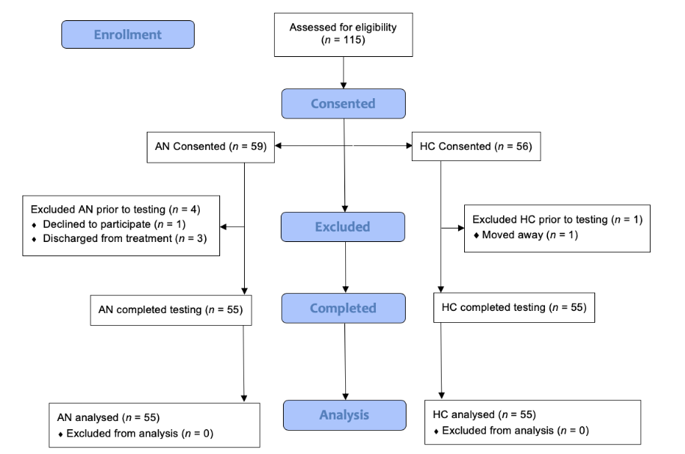

Figure S.2. 3D Body dissatisfaction parts (ideal perceived minus current perceived cms) were significantly associated with participants’ eating disorder symptom severity on the EDE-Q, across groups. 3D Body Dissatisfaction with negative values indicates ideal body is thinner than current perceived body part size, positive values indicate ideal body is larger than current perceived body part size, and zero indicates ideal body and current perceived body are similar. Body dissatisfied toward the thin-ideal was related to higher eating disorder severity, across groups.

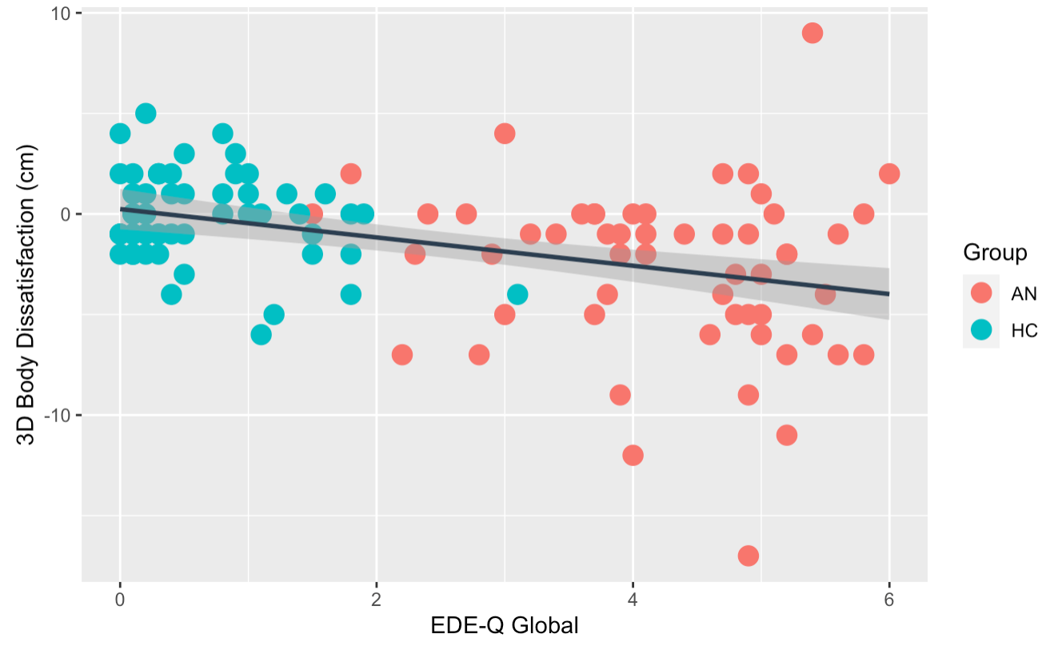
R² = .50, F (23,86) = 3.71, P < 0.001

Figure S.3. 3D Current Body discrepancy (perceived current minus actual body measurements) in centimeters were significantly associated with participants’ eating disorder symptom severity on the EDE-Q, across groups. 3D Current Body Discrepancies with positive values indicate overestimation of true body part size, negative values indicate underestimation, and zero indicates correct estimation. Over-estimation of body parts was related to increased eating disorder severity, across groups.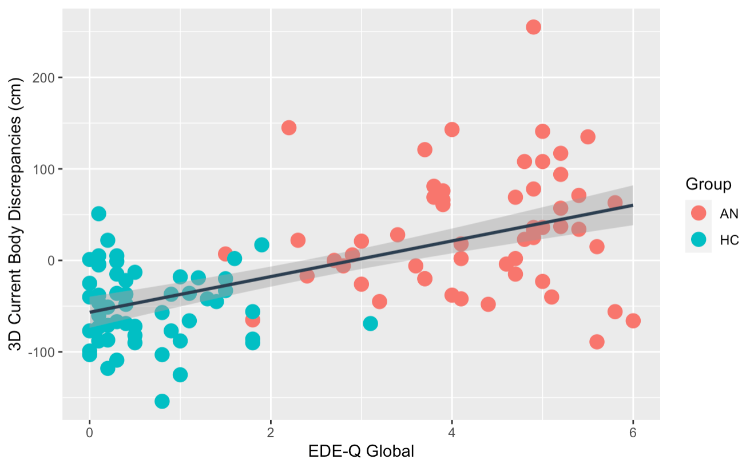
R² = .67; F (23,86) = 7.57, P < 0.001

