Electronic supplementary materials
Januszewski AS†*^{1,2}, Cho YH†^{3,4}, Joglekar MV†^{1,5}, Farr R¹, Scott E¹, Wong WKM^{1,5}, Carroll LM¹, Loh YW¹, Benitez-Aguirre PZ^{3,4}, Keech AC¹, O’Neal DN², Craig ME^{3,4}, Hardikar AA‡^{1,5,6}, Donaghue KC‡^{3,4}, Jenkins AJ‡*^{1,2}

Insulin micro-secretion in Type 1 diabetes and related microRNA profiles

† - equal First Authors
‡ - equal Senior Authors

Affiliations
¹NHMRC Clinical Trials Centre, University of Sydney, Sydney, Australia
²Department of Medicine, University of Melbourne, Melbourne, Australia
³Discipline of Paediatrics and Child Health, University of Sydney, Sydney, Australia
⁴Institute of Endocrinology and Diabetes, The Children’s Hospital at Westmead, Sydney, Australia
⁵School of Medicine, Western Sydney University, Sydney, Australia
⁶Department of Science and Environment, Roskilde University, Copenhagen, Denmark

ESM Table 1
Spearman correlation coefficients of associations between miRs and C-peptide levels in CON and participants with diabetes (with detectable C-peptide).

 | CON |  | Diabetes
 | R | p | R | p
miR-9 | 0.20 | 0.004
miR-15b | -0.15 | 0.03 | -0.17 | 0.03
miR-22 | 0.25 | 0.0002
miR-24 | -0.29 | <0.0001 | -0.21 | 0.005
miR-29a | -0.25 | 0.0003
miR-125a-5p | -0.14 | 0.046
miR-125b | 0.23 | 0.0007
miR-126 | -0.25 | 0.0002 | -0.17 | 0.03
miR-127 | 0.14 | 0.047
miR-146a | -0.22 | 0.002 | -0.15 | 0.049
miR-155 | -0.25 | 0.0002 | -0.16 | 0.04
miR-186 | -0.18 | 0.007
miR-199a-3p | -0.15 | 0.03 | -0.17 | 0.03
miR-222 | -0.17 | 0.01 | -0.15 | 0.049
miR-223 | -0.26 | 0.0001 | -0.20 | 0.01
miR-375 | 0.17 | 0.01 | -0.18 | 0.02

ESM Table 2
Multiple regression coefficients for best linear model of determinants for C-peptide level in CON and participants with diabetes with detectable C-peptide.

 | CON |  | Diabetes
miR | Standardized coefficient | p-value | Standardized coefficient | p-value
miR-7 | -0.12 | 0.05 | 0.12 | 0.14
miR-125a-5p | -0.16 | 0.04 | 0.32 | 0.005
miR-125b | 0.11 | 0.13 | 0.26 | 0.02
miR-126 | -0.68 | 0.003
miR-127 | 0.21 | 0.02 | 0.25 | 0.02
miR-145 | 0.10 | 0.23
miR-146a |  |  | 0.46 | 0.15
miR-148a | -0.18 | 0.01 | 0.16 | 0.07
miR-152 | -0.10 | 0.19
miR-16 | 0.24 | 0.31 | 0.42 | 0.14
miR-199a-3p |  |  | -0.30 | 0.01
miR-200a |  |  | -0.08 | 0.28
miR-20a | 0.20 | 0.18
miR-210 |  |  | -0.19 | 0.05
miR-22* | 0.29 | 0.02
miR-223 | -0.23 | 0.05
miR-24 | -0.25 | 0.13
miR-26a | 0.20 | 0.12
miR-27a |  |  | -0.24 | 0.07
miR-27b | -0.22 | 0.01
miR-29a | -0.16 | 0.11
miR-301b | 0.07 | 0.28
miR-30a-5p | -0.30 | 0.05
miR-30e-3p | -0.08 | 0.30
miR-326 |  |  | -0.14 | 0.17
miR-340* | 0.13 | 0.04
miR-374 | 0.15 | 0.08
miR-375 | 0.15 | 0.03 | -0.25 | 0.008
miR-9 |  |  | -0.08 | 0.26
miR-92a | 0.36 | 0.15
miR-93 | 0.28 | 0.17 | -0.76 | 0.01

ESM Table 3
Predictors of detectable C-peptide status (yes/no) in participants with diabetes (logistic regression). Data shown: Odds ratio (OR), -95%/+95% confidence interval (CI) and p-value.

Model | Standardized coefficient | OR | -95% CI | +95% CI | p
Detectable C-peptide (p<0.0001, Negelkerke R²=0.46)
miR-24 | 0.30 | 1.22 | 1.02 | 1.45 | 0.03
miR-29a | -0.39 | 0.94 | 0.87 | 1.01 | 0.08
miR-146a | -0.88 | 0.87 | 0.73 | 1.04 | 0.12
miR-155 | 0.44 | 1.06 | 1.01 | 1.11 | 0.02
miR-199a-3p | 0.46 | 1.07 | 0.99 | 1.16 | 0.09
miR-222 | -0.20 | 0.97 | 0.91 | 1.04 | 0.44
miR-374 | -0.27 | 0.96 | 0.91 | 1.01 | 0.08
miR-223 | 0.44 | 1.05 | 0.98 | 1.13 | 0.16
miR-409-5p | 0.30 | 1.23 | 1.01 | 1.51 | 0.04
miR-625 | 0.20 | 1.07 | 0.97 | 1.18 | 0.19
miR-103 | -0.45 | 0.93 | 0.89 | 0.98 | 0.008
miR-7 | -0.23 | 0.90 | 0.77 | 1.04 | 0.14
miR-210 | -0.29 | 0.96 | 0.92 | 1.00 | 0.06
miR-181a | -0.27 | 0.96 | 0.91 | 1.01 | 0.09

ESM Table 4
miRs with different expression in subject with vs. without detectable C-peptide (see Fig. 2) and its levels/function reported in Type 1 diabetes.

miR | Expression in people with diabetes | Expression in people with diabetes with detectable C-peptide vs people with non-detectable C-peptide (this manuscript)
miR-016 | Lower in diabetes vs. CON [24] | Higher
miR-022 | Lower in diabetes vs. CON [24] | Lower
miR-024 | Lower in diabetes vs. CON [24,25] | Higher
miR-027b | Higher in diabetes vs. CON [25] | Lower
miR-030c | Higher in diabetes protects against diabetic cardiomyopathy [34] | Higher
miR-034a | Higher in diabetes vs. CON [24] | Lower
miR-092a | Lower in diabetes increasing glucose-induced insulin secretion [32] | Higher
miR-125b | Higher in diabetes vs. CON [24] | Lower
miR-126 | Higher in diabeets enhances cardiac repair after injury [33] | Higher
miR-127 | Downregulated during differentiation into insulin-producing cells [31] | Lower
miR-146a | Lower in diabetes vs. CON [26] | Higher
miR-152 | Higher in diabetes vs. CON [25] | Lower
miR-155 | Higher in diabetes vs. CON [26] | Higher
miR-181a | Higher in diabetes vs. CON [24,25] | Lower
miR-186 | Lower muscle expression in diabetes [30] | Higher
miR-199a-3p | Higher in diabetes vs. CON [27] | Higher
miR-222 | Lower in diabetes vs. CON [24] | Higher
miR-223 | Lower in diabetic nephropathy [29] | Higher
miR-326 | Lower in diabetes vs. CON [26] | Lower

ESM Figure 1.
Comparison of proportion of detectable C-peptide in participants with diabetes stratified by age of diabetes diagnosis (cut-off 13 yrs) and duration.

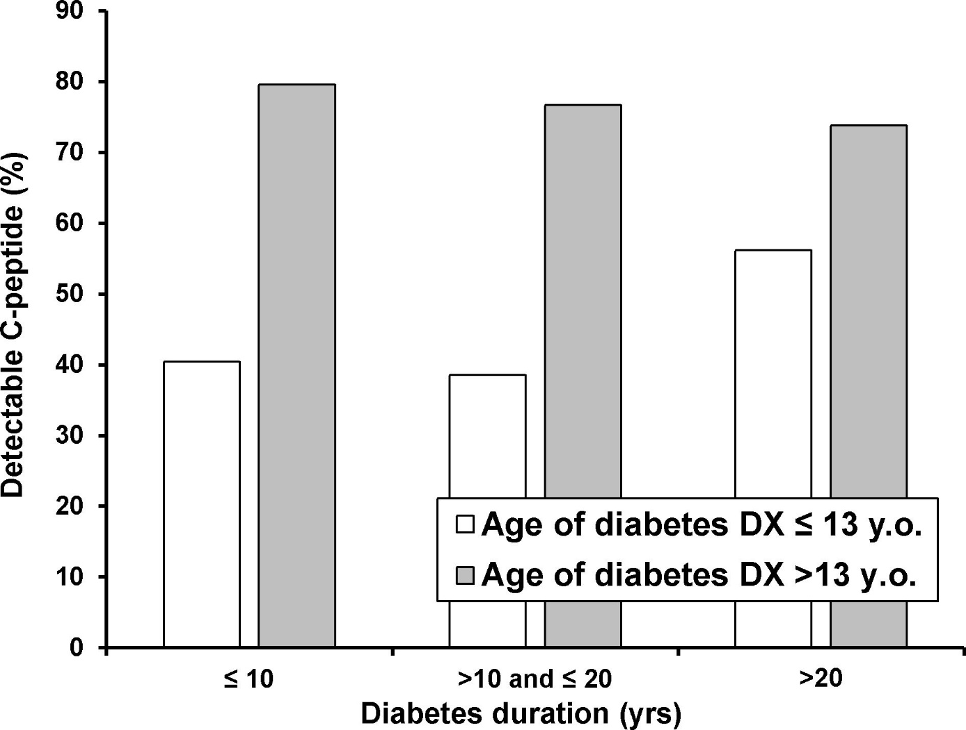

ESM Figure 2.
Panel A. Volcano plot of miRs expression (Ct) in participants with and without diabetes. The horizontal line indicates p=0.05 after Bonferroni correction and vertical lines indicate a one cycle threshold (Ct) difference. Comparison using parametric tests.
Panels B-D. Volcano plots of miRs expression (Ct) in between participants with diabetes with young/old diabetes diagnosis and short/long diabetes duration. Horizontal line indicating p=0.05 after Bonferroni correction and vertical lines indicating one Ct (i.e. two-fold) difference. Comparisons using parametric test.

ESM Figure 3.
ROC curve of C-peptide detectability status using miRs identified by penalized logistic regression as significant determinants of C-peptide status.

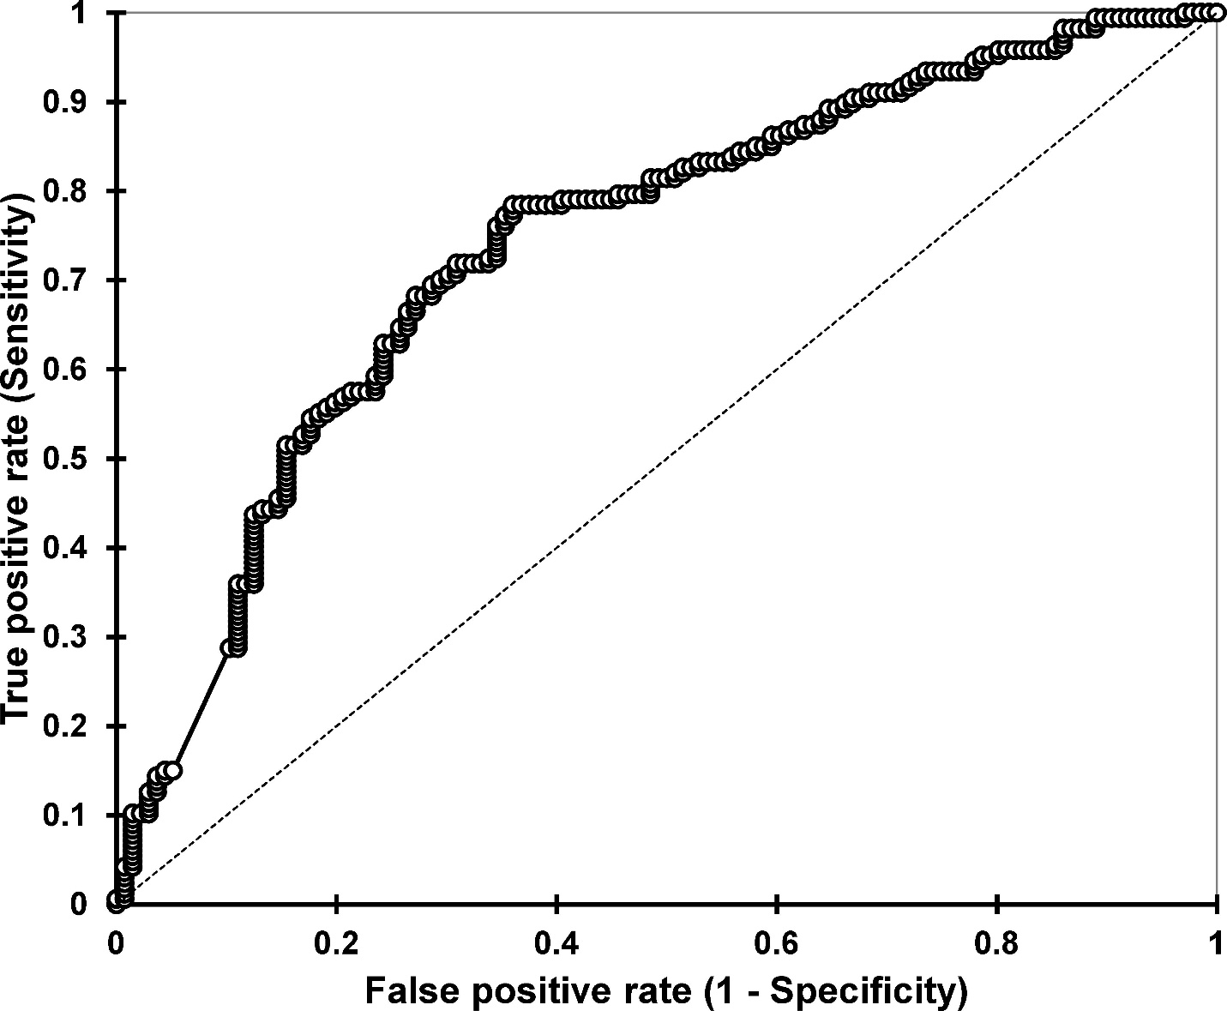

ESM Figure 4.
MiRs associated with presence of C-peptide (detectable level yes/no) in people with diabetes. Importance (difference between Z-score of a feature and a maximum Z-score of its shadow feature) represent the relative importance of miRs in the determination of detectable C-peptide presence in diabetes. White and grey boxplots represent confirmed and rejected features, respectively. Black boxplots represent minimum, average and maximum Z-score of a shadow feature.

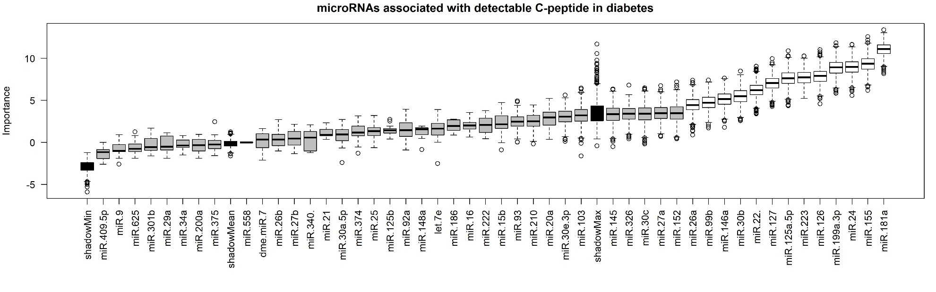

ESM Figure 5.
MiRs associated with presence of C-peptide (detectable level yes/no) in participants with diabetes. Figure setup as ESM Fig 4.

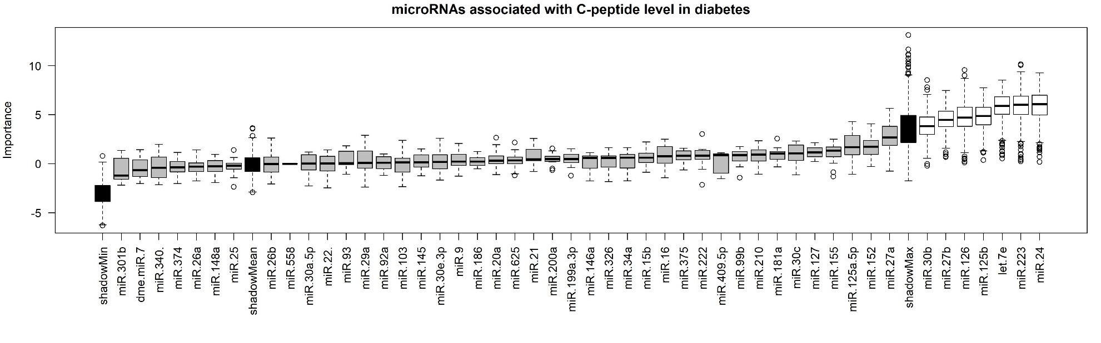

ESM Figure 6.
MiRs associated with C-peptide level in CON. Figure setup as ESM Fig 4.

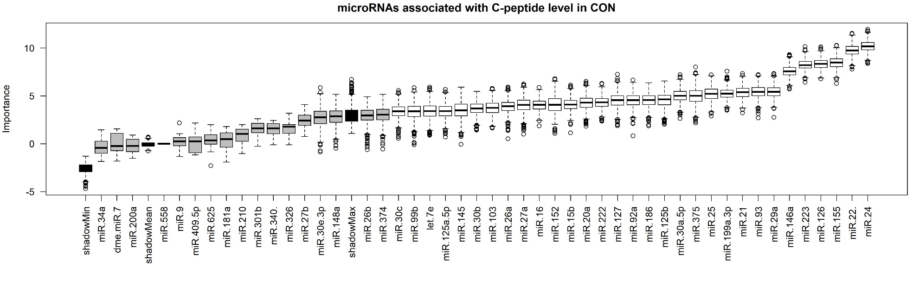

ESM Figure 7.
Venn diagram of miRs selected by the Boruta algorithm as non-redundant for determination of C-peptide status and level in people with and without diabetes.

