Supplementary figures
Differential gene expression in Drosophila melanogaster and D. nigrosparsa infected with the same Wolbachia strain

Matsapume Detcharoen, Martin P. Schilling, Wolfgang Arthofer, Birgit C. Schlick-Steiner, Florian M. Steiner
Molecular Ecology Group, Department of Ecology, University of Innsbruck

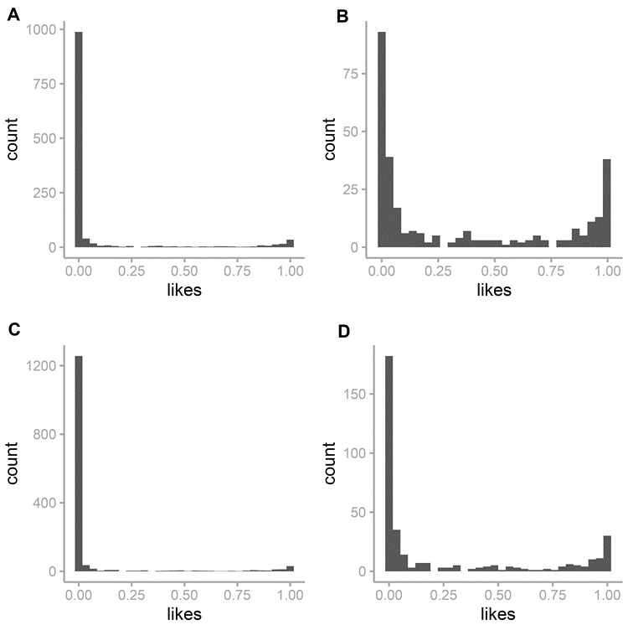
Figure S1. Histograms of posterior likelihoods of all orthologous genes and genes in the top quartile in Drosophila melanogaster (A and B, respectively) and for Drosophila nigrosparsa (C and D, respectively).

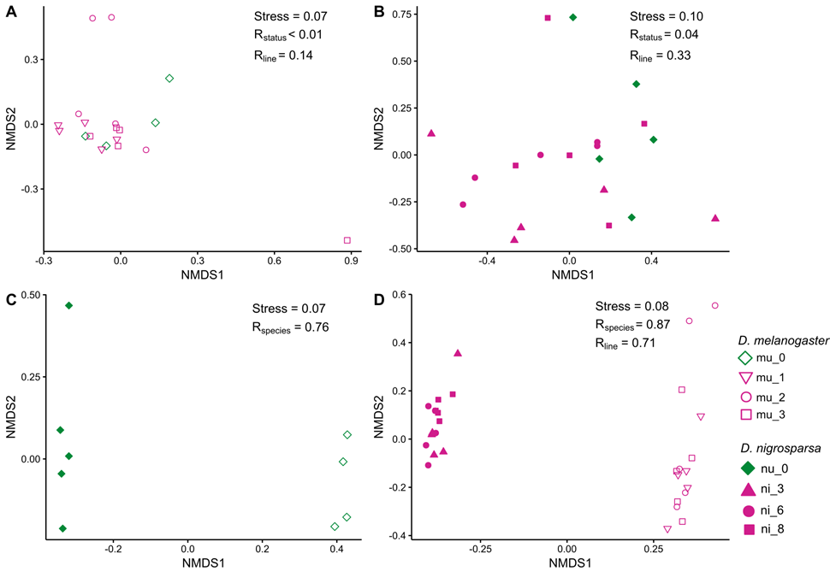
Figure S2. Non-metric multidimensional scaling (NMDS) plot using Bray-Curtis dissimilarities with square root transformation used to cluster samples of Drosophila melanogaster uninfected (mu_0) and infected (mi_1, mi_2, and mi_3) (A), Drosophila nigrosparsa (B) uninfected (nu_0) and infected (ni_3, ni_6, and ni_8), only uninfected samples of both species (C), only infected samples of both species (D). Stress (standardized residual sum of squares) values of NMDS and R-values of each group comparison calculated from ANOSIM (R_{status} is between uninfected and infected lines, R_{line} is among lines, and R_{species} is between species) are shown.

