SUPPLEMENTARY INFORMATION
Biomechanical forces enhance directed migration and activation of bone marrow-derived dendritic cells
Ji-Hun Kang¹⁺, Hyun Joo Lee²⁺, Ok-Hyeon Kim^{3,4}, Yong Ju Yun^{2*}, Young-Jin Seo^{1*}, and Hyun Jung Lee^{3,4*}
¹Department of Life Science, Chung-Ang University, Seoul 06974, Republic of Korea
²Graduate School of Energy and Environment (KU-KIST Green School), Korea University, Seoul 02841, Republic of Korea
³Department of Anatomy and Cell Biology, College of Medicine, Chung-Ang University, Seoul 06974, Republic of Korea
⁴Department of Global Innovative Drugs, Graduate School of Chung-Ang University, Seoul 06974, Republic of Korea

*corresponding authors
Yong Ju Yun, Ph.D.
Graduate School of Energy and Environment (KU-KIST Green School), Korea University, Seoul 02841, South Korea, Tel: +82-2-3290-5973, E-mail: yjyun0@korea.ac.kr
Young-Jin Seo, Ph.D.
Department of Life Science, Chung-Ang University, 84 Heuksuk-ro, Dongjak-ku, Seoul 06974, South Korea, Tel: +82-2-820-5925, E-mail: yjseo@cau.ac.kr
Hyun Jung Lee, Ph.D.
Department of Anatomy and Cell Biology, College of Medicine, Chung-Ang University, 84 Heuksuk-ro, Dongjak-ku, Seoul 06974, South Korea, Tel: +82-2-820-5434, E-mail.: pluto38@cau.ac.kr

Computational simulation of fluid flow velocity and shear stress in microfluidic channels using COMSOL software (5.5 version).
  - Geometry 1
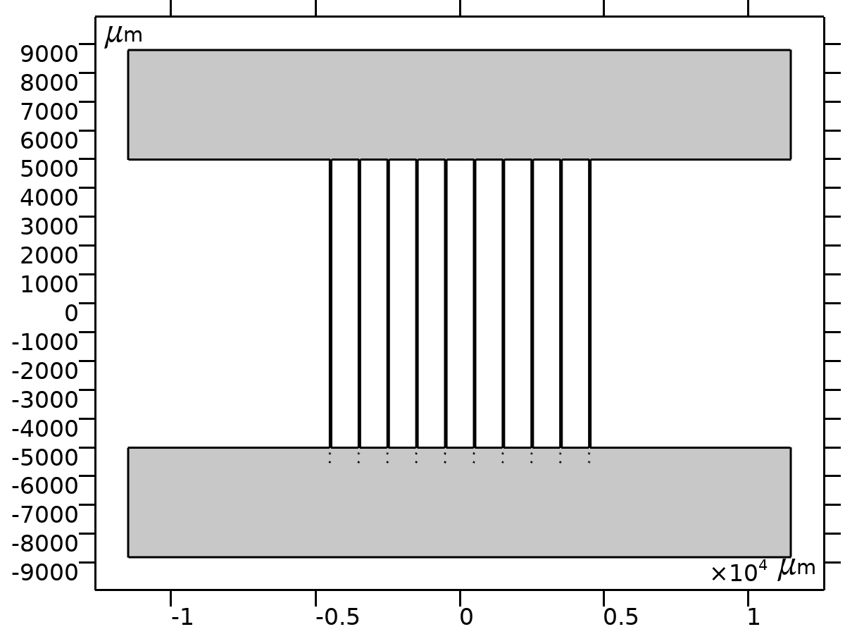
Units
Length unit | µm
Angular unit | Deg
  - Modeling Parameters
Parameter | Value | Description
ρ | 998.2 kg/m³ | Density of water
µ | 1.003e-3 Pa*s | Dynamic viscosity of water

  - Laminar Flow
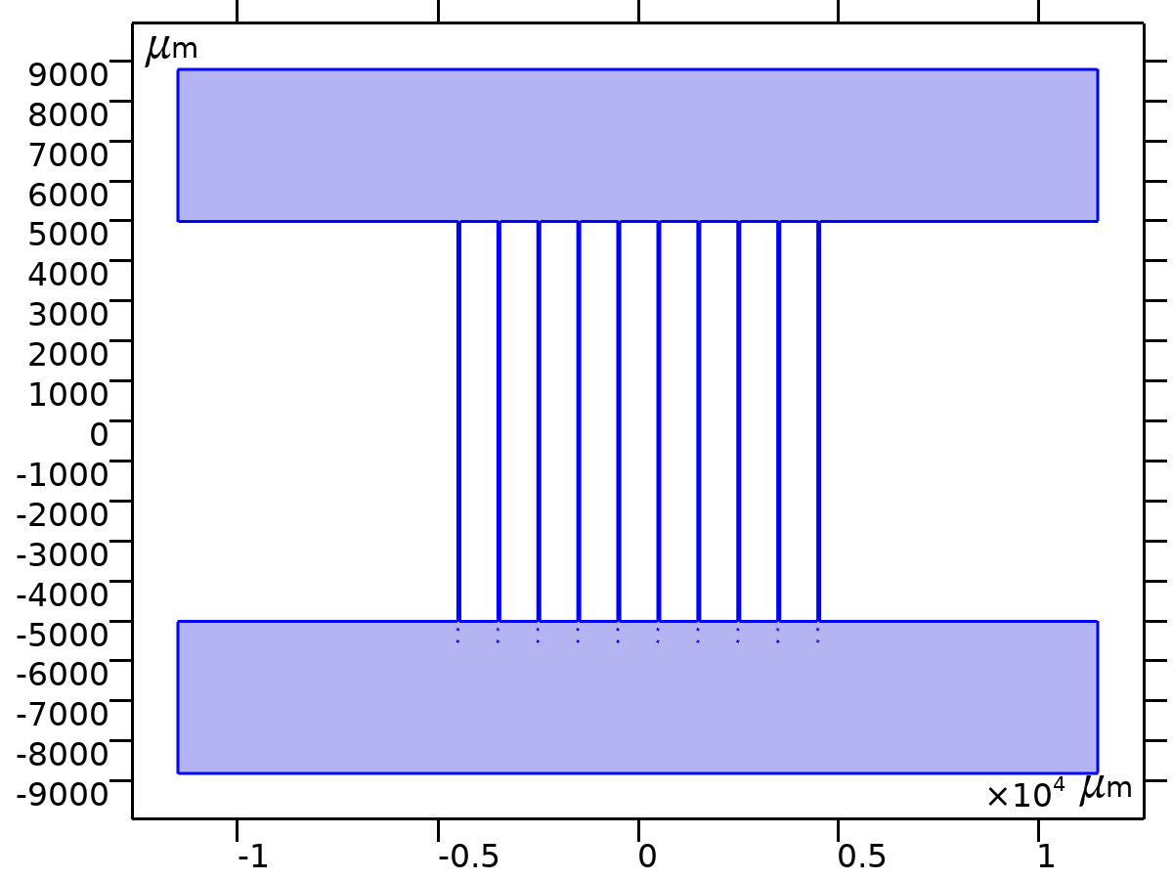
Equations
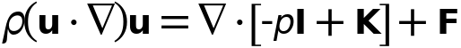
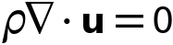
    - Fluid Properties 1
Equations
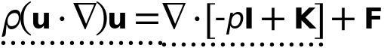
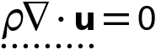
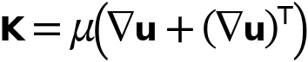
    - Wall 1
Equations

Boundary condition
Wall condition: No slip
    - Inlet 1
Equations

Boundary condition
Velocity

    - Outlet 2
Equations
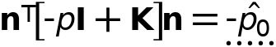
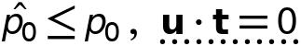
    - Outlet 3
Equations
    - Outlet 4
Equations

