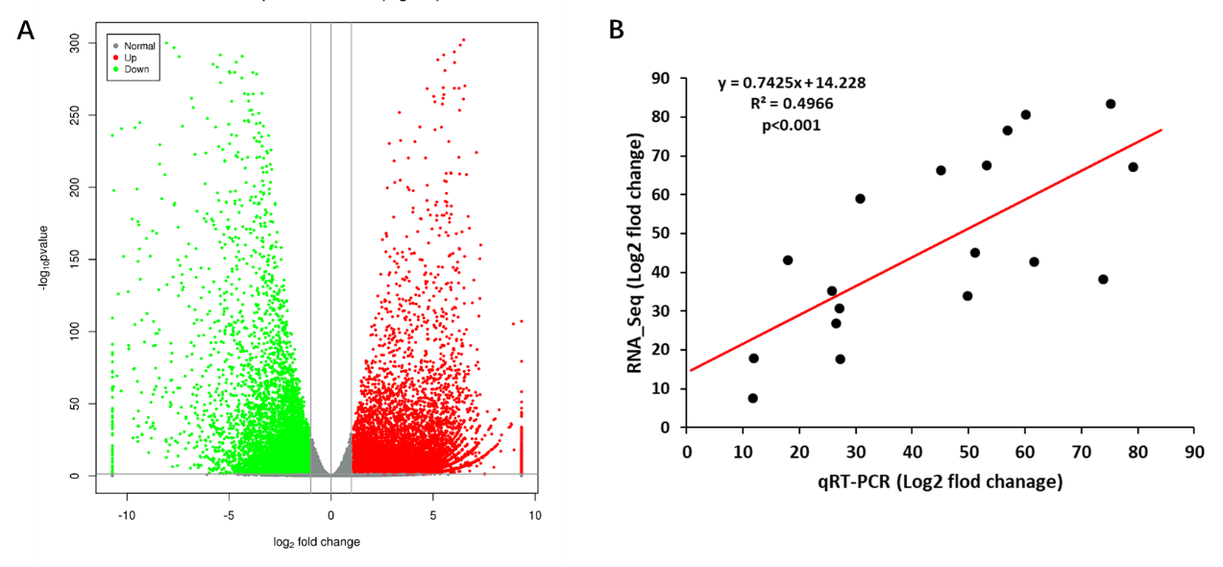
Figure S1. Volcano plots of differentially expressed unigenes (DEGs) between germinated and control seeds in Polygonatum cyrtonema Hua (A); and correlation between qRT-PCR and RNA_seq for the 18 genes (B). Each point represents a fold change value of gene expression level in Polygonatum cyrtonema Hua.

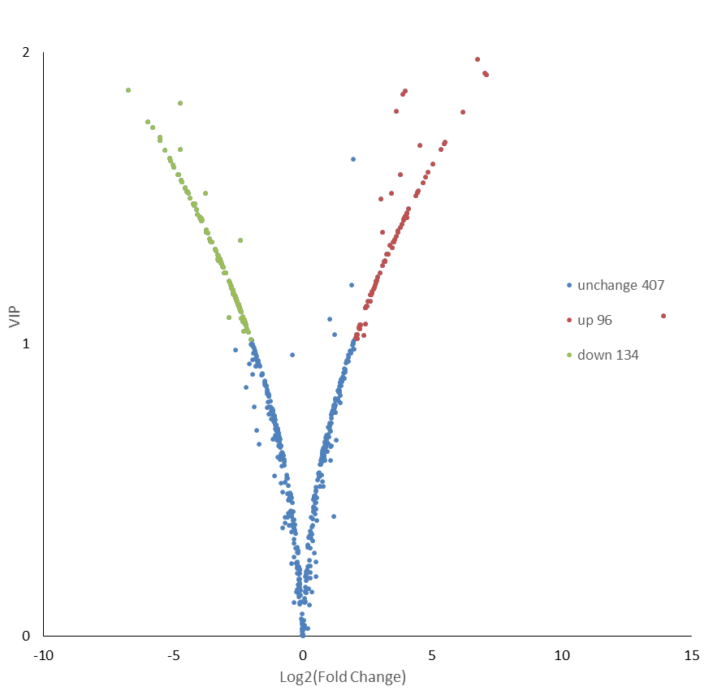
Figure S2. Volcano plots of differentially metabolites between germinated and control seeds in Polygonatum cyrtonema Hua.

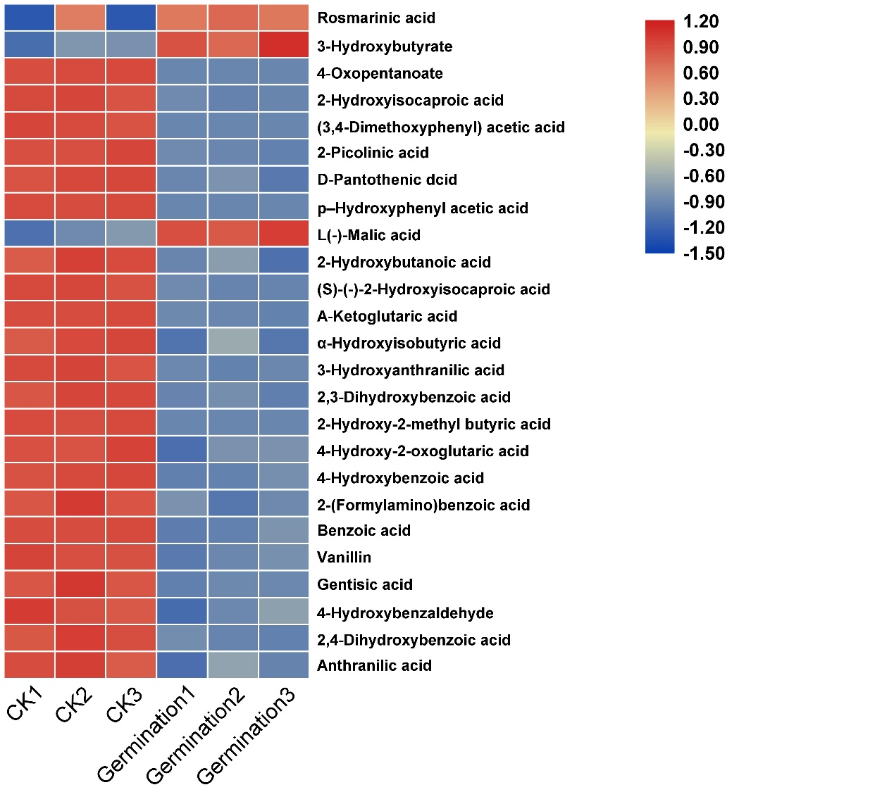
Figure S3. The differentially metabolites of organic acid between germinated and control seeds in Polygonatum cyrtonema Hua.

