SUPPL TABLES. LEGENDS.

Suppl. Table 1. Clinical manifestations of CVID patients. The median of evolution of the disease was 15.9 years (range, 1-31).

Suppl. Table 2. Description of known mutations in genetic studies of CVID patients.

SUPPL. FIGURE LEGENDS.

Suppl. Fig. 1. Density plots of: A. Ameratunga´s severity score versus VISUAL score, B. Grimbacher´s severity score versus VISUAL score.

Suppl. Fig. 2. Silhouette plots for the analysis of the two different clusters against VISUAL. Taking as reference both Ameratunga’s and Grimbacher’s severity score applied in our cohort. VISUAL presented a median of 10 points (range, 4 to 16), Ameratunga’s severity score disclosed a median of 14 points (range, 8 to 21) and Grimbacher’s severity score with a median of 5 points (range, 2 to 10). Patients with severe complications or more than one moderate complication amounted to 14 or more score points in Ameratunga’s severity score and to 3 or more score points in Grimbacher’s severity score. The cohort was divided according to the clustering algorithm using the medians of both severity scores, into Cluster A (no severe clinical evolution) and Cluster B (severe clinical evolution). Created with BioRender.com.

SUPPL. TABLES.

Suppl. Table 1.

Patients | Clinical Manifestation
1 | Asymptomatic splenomegaly, mild bronchiectasis, mild lymphadenopathy, acute sinusitis, uncomplicated pneumonia
2 | Severe infectious enteritis, acute sinusitis, moderate asthma.
3 | Complicated pneumonia, mild bronchiectasis, asymptomatic splenomegaly, mild asymptomatic cytopenia, Giardia, acute sinusitis
4 | Uncomplicated pneumonia, mild bronchiectasis, symptomatic splenomegaly, otitis externa, mild asymptomatic cytopenias.
5 | Uncomplicated vitamin deficiency associated with Intestinal Parasitosis (Oxyuriasis), mild asymptomatic cytopenias, uncomplicated pneumonia, mild bronchiectasis, acute sinusitis.
6 | Cytopenia requiring treatment, complicated pneumonia, uncomplicated shingles, asymptomatic splenomegaly, acute sinusitis.
7 | Lung surgery (left-lower lobectomy), asymptomatic splenomegaly, uncomplicated pernicious anemia, mild lymphadenopathy.
8 | Severe eczema, symptomatic splenomegaly, mild lymphadenopathy, mild asymptomatic cytopenia.
9 | Food and antibiotic allergies, complicated pneumonia, chronic rhinosinusitis, asymptomatic splenomegaly, Helicobacter pylori responding to treatment.
10 | Non-life threatening abscesses, autoimmune gastritis, complicated pneumonia, autoimmune thyroiditis
11 | Mild bronchiectasis, complicated pneumonia, asymptomatic splenomegaly, chronic rhinosinusitis.
12 | Complicated pneumonia, non-life threatening abscesses, mild eczema, uncomplicated shingles.
13 | Complicated pneumonia, sinusitis, mild bronchiectasis, Helicobacter pylori responding to treatment, symptomatic increase in liver enzymes, external otitis.
14 | Malignancy (recurrent non-Hodgkin lymphoma plus Hodgkin lymphoma)
15 | Splenectomy (due to idiopathic thrombocytopenic purpura), acute sinusitis, arthralgia, asymptomatic increase in liver enzymes.
16 | Arthritis, enteropathy celiac disease-like, splenectomy, acute sinusitis, mild eczema.
17 | Pericarditis, chronic rhinosinusitis, mild asthma, uncomplicated pneumonia, asymptomatic splenomegaly.
18 | Severe GLILD, viral hepatitis responding to treatment, symptomatic splenomegaly, mild asymptomatic cytopenia
19 | Mild inflammatory bowel disease, Addison´s disease, otitis media, uncomplicated pneumonia, asymptomatic splenomegaly, mild asymptomatic cytopenias.
20 | Reaction to IVIG, cytopenias requiring treatment, asymptomatic splenomegaly, otitis media, uncomplicated UTI´s, uncomplicated pneumonia.
21 | Addison´s disease, multiple antibiotic allergies, osteomyelitis, asymptomatic splenomegaly.
22 | Severe SLE, cytopenias requiring treatment, Giardia, uncomplicated UTI´s, arthralgia
23 | Meningitis with no sequelae, symptomatic splenomegaly, oral ulceration, mild lymphadenopathy, mild asthma, acute sinusitis.
24 | Splenectomy (due to idiopathic thrombocytopenic purpura), acute sinusitis, rhinitis.
25 | Mild inflammatory bowel disease responding to budesonide, asymptomatic increase in liver enzymes, asymptomatic splenomegaly, mild asymptomatic cytopenias.
26 | Symptomatic splenomegaly, cytopenias requiring treatment, uncomplicated pneumonia.
27 | Primary biliary cirrhosis with liver transplantation, cytopenias requiring treatment, asymptomatic splenomegaly, uncomplicated pneumonia.
28 | Malignancy (non-Hodgkin lymphoma), uveitis responding to treatment, uncomplicated pneumonia, arthralgia.
29 | Malignancy (gastric cancer), cytopenias requiring treatment, uncomplicated pneumonia.
30 | Uncomplicated pneumonia, acute sinusitis, uncomplicated EBV viremia.
31 | Uncomplicated singles, chronic rhinosinusitis, arthralgia, mild asymptomatic cytopenia, mild lymphadenopathy.
32 | Extensive incl. Sarcoid-like granulomatous disorder, splenectomy (due to symptomatic splenomegaly)
33 | Granulomatous involvement of urinary tract, lichen planus, type 1 diabetes, uncomplicated pneumonia
34 | Poorly responsive treatment cytopenia required Rituximab, asymptomatic splenomegaly, Giardia.
35 | Severe pulmonary dysfunction with extensive bronchiectasis, complicated pneumonia
36 | Extensive incl. Sarcoid-like granulomatous disorder, cholecystitis, uncomplicated vitamin deficiency.
37 | Poorly responsive treatment cytopenia required Rituximab, asymptomatic splenomegaly, uncomplicated pneumonia, acute sinusitis.
38 | Extensive incl. Sarcoid-like granulomatous disorder, Giardia, asymptomatic increase in liver enzymes.
39 | Severe malabsorption protein-losing enteropathy, cytopenias requiring treatment, Giardia, mild lymphadenopathy.
40 | Malignancy (non-Hodgkin lymphoma), connective tissue disorder, uncomplicated pneumonia
41 | Complicated pneumonia, mild bronchiectasis, chronic rhinosinusitis.
42 | Poorly responsive treatment cytopenia required Rituximab, asymptomatic splenomegaly, uncomplicated pneumonia, acute sinusitis.
43 | Mild cellulitis, otitis media, uncomplicated pneumonia.
44 | Cytopenias requiring treatment, symptomatic splenomegaly, Helicobacter pylori responding to treatment, uncomplicated vitamin deficiency, uncomplicated CMV viremia, otitis externa.
45 | Sjogren’s syndrome, rhinitis, asthma, complications from long-term steroids, mild lymphadenopathy.
46 | Cytopenias requiring treatment, multiple allergies antibiotics and reactions to IVIG, complicated pneumonia.
47 | Viral meningitis with no sequelae, chronic rhinosinusitis.
48 | Uncomplicated pneumonia, mild bronchiectasis, Severe cutaneous lupus, Malignancy (non-Hodgkin lymphoma).
49 | Complicated pneumonia, mild bronchiectasis, reactions to IVIG.
50 | Viral hepatitis responding treatment, cutaneous vasculitis, cytopenias requiring treatment, complicated pneumonia.

Suppl. Table 2.

Patients | Genetic Study
Patient 1 | Mutation in PLCG2 and LRBA (both in heterozygosis).
Patient 2. | Mutations in VPS13B, AIRE, NLRP12, CHD7, NCF2 (all in heterozygosis).
Patients 3 and 4 (consanguineous patients) | Mutation c.310 T>C (p.Cys104Arg) and c.512 T > G (p.Leu171Arg in heterozygosis of the TNFRSF13B gene.
Patient 5. | Homozygous mutations in PLCG2 and TACI (TNFRSF13B), and heterozygous mutation in LRBA.

SUPPL. FIGURE.
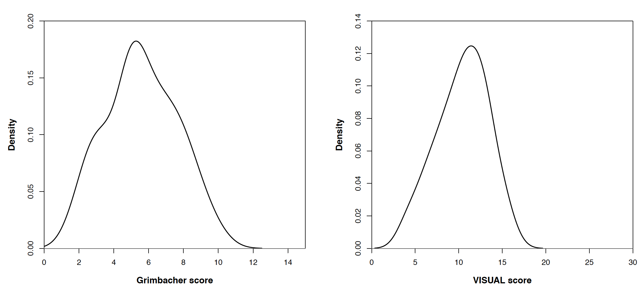
Suppl. Fig. 1.
A
B
median 14 pts.
median 10 pts.
median 10 pts.
median 5 pts.

Suppl. Fig. 2.

