Plasma metabolomic profiles as affected by diet and stress in Spanish goats

Phaneendra Batchu, Thomas H. Terrill, Brou Kouakou, Zaira M. Estrada-Reyes, Govind Kannan*

Supplementary Information

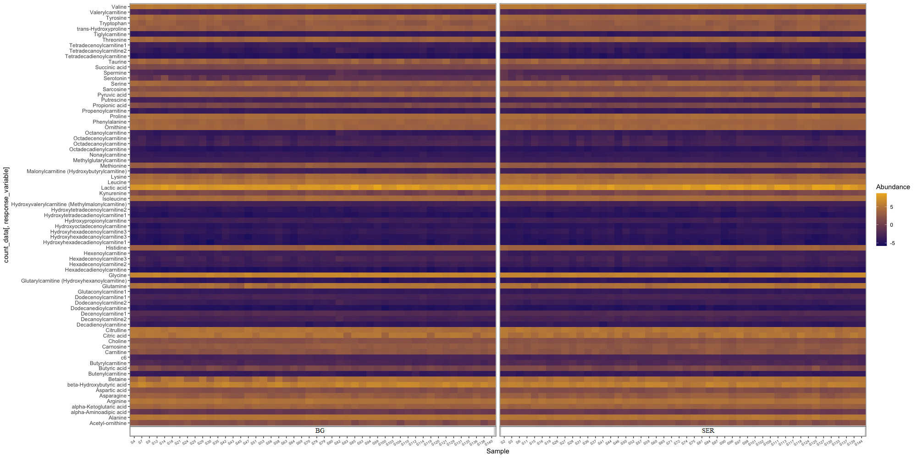

Supplementary Fig. S1. Heat map showing the relative abundance of metabolites when comparing Diet Treatments (BG: Bermudagrass hay-fed; SER: sericea hay-fed) in goats. The name of each metabolite is provided in the list to the left of the heat map.

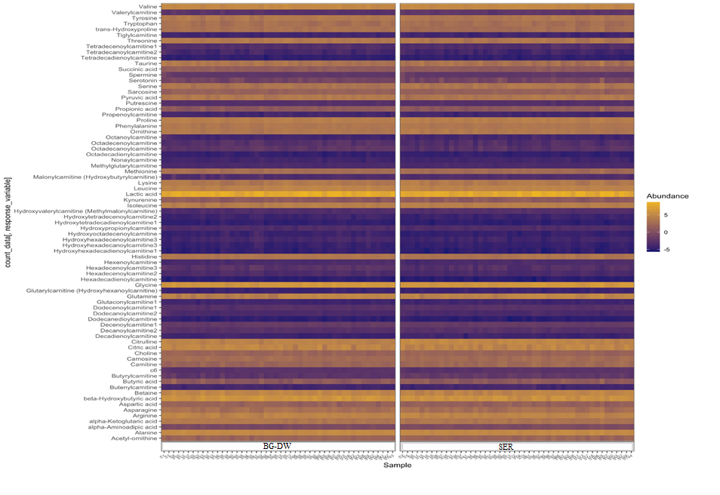

Supplementary Fig. S2. Heat map showing the relative abundance of metabolites when comparing Diet Treatments (BG-DW: Bermudagrass hay-fed dewormed; SER: sericea hay-fed) in goats. The name of each metabolite is provided in the list to the left of the heat map.

