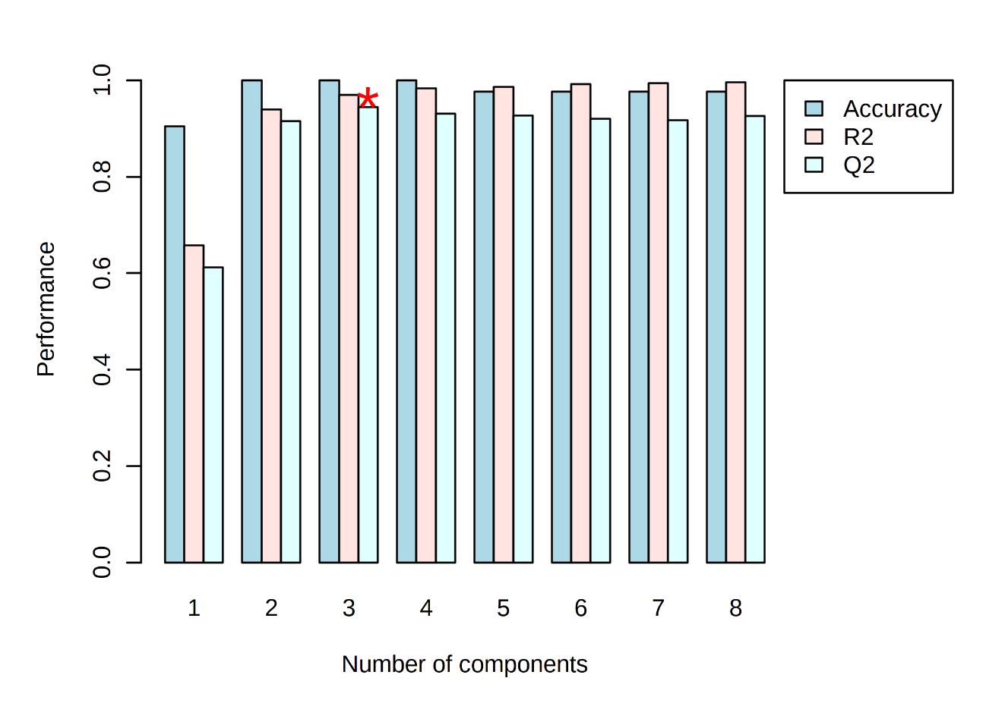Supplementary Figure 1. Cross validation of the PLS-DA models. Bar plots showing the three performance measures (prediction accuracy, R² and Q²) using different number of components. The red * indicates the best values of the currently selected measures (Q²).

