Interaction of genetic and environmental factors for body fat mass control: observational study for lifestyle modification and genotyping
Joon Ho Kang^{1,2, ¶}, Heewon Kim^{2, ¶}, Jinki Kim^{4, ¶}, Jong-Hwa Seo⁴, Soyeon Cha², Hyunjung Oh², Kyunga Kim⁶, Seong-Jin Park⁴, Eunbin Kim⁸, Sunga Kong⁹, Jae-Hak Lee², Joon Seol Bae², Hong-Hee Won⁵, Je-Gun Joung⁶, Yoon Jung Yang^{*,3}, Jinho Kim^{*,2}, and Woong-Yang Park^{*,1,2,5,6,7}
¹Department of Molecular Cell Biology, Sungkyunkwan University School of Medicine, 2066 Seobu-ro, Jangan-gu, Suwon, Gyeonggi-do 16419, South Korea
²Samsung Genome Institute, Samsung Medical Center, Ilwon-ro 81, Gangnam-gu, Seoul 06351, South Korea
³Department of Foods and Nutrition, College of Natural Sciences, Dongduk Women’s University, 60, Hwarang-ro 13-gil, Seongbuk-gu, Seoul 02748, Korea
⁴AI&SW Center, SAIT, SEC, 130, Samsung-ro, Yeongtong-gu, Suwon-si, Gyeonggi, 16678, South Korea
⁵Samsung Advanced Institute for Health Sciences and Technology, Sungkyunkwan University of Medicine, Seoul 06351, South Korea
⁶Samsung Medical Center, Gangnam-gu, Seoul 06351, South Korea
⁷Geninus Inc. Seoul, 5th floor, Jeongeu-ro 70, Songpa-gu, Seoul 05836, South Korea
⁸Department of Clinical Nutrition, School of Public Health, Dongduk Women’s University, Seoul 02748, Korea
⁹Department of Clinical Research Design and Evaluation, SAIHST, Sungkyunkwan University, Seoul, South Korea
¶These authors contributed equally to this work.
* Correspondence should be addressed to Yoon jung Yang (yjyang@dongduk.ac.kr), Jinho Kim (jinho.jk.kim@samsung.com), or Woong-Yang Park (woongyang.park@samsung.com).

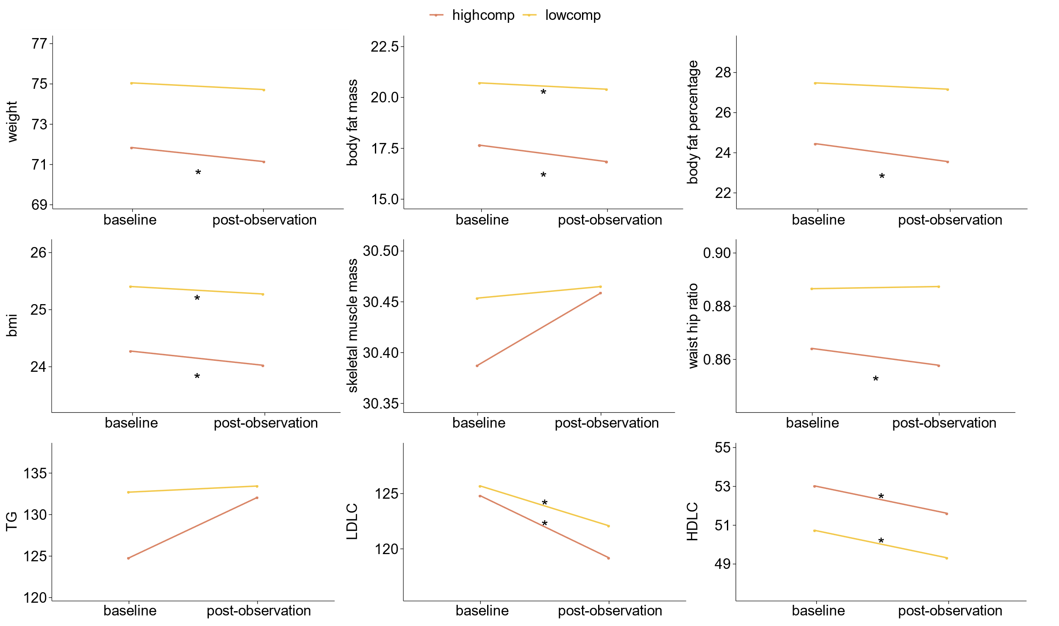
Supplementary Figure 1. Differences in the anthropometric measurements and serologic markers between the baseline and post-observation period according to compliance The health indicators improved further through lifestyle modification. Each indicator showed healthier values in the high compliance group both during the baseline and post-observation periods.

 |  | Adjustment Groups
 |  | Low carbohydrate  (n = 35) |  |  | Low fat  (n = 34) |  |  | Moderate exercise  (n = 99) |  |  | Intense exercise  (n = 83)
 |  | Mean | s.d. |  | Mean | s.d. |  | Mean | s.d. |  | Mean | s.d.
Age |  | 39.66 | 7.50 |  | 37.24 | 6.32 |  | 36.92 | 7.10 |  | 36.58 | 7.96
Body fat mass (kg) |  | 22.81 | 4.99 |  | 24.47 | 4.08 |  | 17.55 | 6.28 |  | 16.77 | 4.53
Body fat percentage (%) |  | 28.23 | 6.20 |  | 29.23 | 3.79 |  | 24.95 | 6.53 |  | 24.51 | 5.53
Body mass index (kg/m²) |  | 27.27 | 1.75 |  | 27.77 | 1.80 |  | 23.87 | 3.18 |  | 23.39 | 2.46
Skeletal muscle mass (kg) |  | 32.93 | 4.94 |  | 33.41 | 3.42 |  | 29.37 | 6.61 |  | 28.91 | 5.66
 |  | Baseline | Observation |  | Baseline | Observation |  | Baseline | Observation |  | Baseline | Observation
Carbohydrate intake (g/day) |  | 200.41 | 176.40 |  | 210.64 | 198.27 |  | 200.50 | 200.50 |  | 204.96 | 193.20
Fat intake (g/day) |  | 57.68 | 53.95 |  | 56.91 | 40.04 |  | 54.23 | 52.12 |  | 53.06 | 50.12
Total calorie (cal/day) |  | 1699.00 | 1545.00 |  | 1717.00 | 1459.30 |  | 1658.00 | 1631.70 |  | 1694.60 | 1602.10
Exercise amount (cal/day) |  | 252.20 | 213.60 |  | 202.80 | 194.18 |  | 177.79 | 200.54 |  | 228.92 | 260.13
Supplementary Table 1. Demographic information and lifestyle of the participants during the baseline and observation periods Anthropometric measurements of each adjustment group are measured. The nutrient intake during the observation period got reduced compared to the baseline period. The exercise amount of the exercise modification group increased throughout the observation period.

SNP set for GRS consturction
Category | SNP | Gene
Carbohydrate | rs206936 | RPS10-NUDT3
Carbohydrate | rs7578465 | ALK
Carbohydrate | rs7920888 | intergenic
Carbohydrate | rs13041126 | intergenic
Carbohydrate | rs2198776 | FAM19A2
Carbohydrate | rs2391518 | intergenic
Carbohydrate | rs7143963 | TRAF3
Carbohydrate | rs2972167 | PPARG
Carbohydrate | rs17036333 | PPARG
Carbohydrate | rs253664 | MRAS
Carbohydrate | rs492400 | USP37
Carbohydrate | rs1557765 | intergenic
Carbohydrate | rs148679664 | AGT
Carbohydrate | rs10742752 | intergenic
Carbohydrate | rs11997175 | intergenic
Carbohydrate | rs9856151 | CPNE4
Carbohydrate | rs4061073 | SSBP3
Carbohydrate | rs11603334 | ARAP1
Carbohydrate | rs13077495 | PPARG
Carbohydrate | rs17793951 | PPARG
Carbohydrate | rs189428681 | PPARG
Carbohydrate | rs191018871 | PPARG
Carbohydrate | rs6782178 | PPARG
Carbohydrate | rs6810295 | OSBPL10
Carbohydrate | rs10132280 | intergenic
Carbohydrate | rs2920502 | PPARG
Carbohydrate | rs5050 | AGT
Carbohydrate | rs10760279 | intergenic
Carbohydrate | rs2972164 | PPARG
Carbohydrate | rs12885454 | intergenic
Carbohydrate | rs12646911 | GLRA3
Carbohydrate | rs11677911 | intergenic
Carbohydrate | rs12518350 | intergenic
Carbohydrate | rs652722 | DKFZp686K1684
Carbohydrate | rs12401322 | APOA2
Carbohydrate | rs11142387 | intergenic
Carbohydrate | rs2237892 | KCNQ1
Fat | rs2237892 | KCNQ1
Fat | rs11122577 | AGT
Fat | rs7551318 | intergenic
Fat | rs4243830 | PLEKHG5
Fat | rs4144743 | intergenic
Fat | rs2478545 | AGT
Fat | rs10889850 | intergenic
Fat | rs1413020 | intergenic
Fat | rs2972165 | PPARG
Fat | rs2389438 | intergenic
Fat | rs2938398 | PPARG
Fat | rs11142387 | intergenic
Fat | rs9473924 | intergenic
Fat | rs1546924 | FAM212B
Fat | rs10136789 | KCNH5
Fat | rs2972164 | PPARG
Fat | rs2365389 | FHIT
Fat | rs10769908 | STK33
Fat | rs11603334 | ARAP1
Exercise | rs7164727 | intergenic
Exercise | rs11583200 | ELAVL4
Exercise | rs1205 | CRP
Exercise | rs2845885 | MACROD1
Exercise | rs3093059 | CRP
Exercise | rs13076933 | PPARG
Exercise | rs1555543 | intergenic
Exercise | rs10136789 | KCNH5
Exercise | rs2124499 | ADCY5
Exercise | rs657452 | AGBL4
Exercise | rs7481311 | BDNF-AS1
Exercise | rs11568020 | AGT
Exercise | rs4432245 | EIF2AK4
Exercise | rs10929925 | intergenic
Exercise | rs4762 | AGT
Exercise | rs2770102 | LINC00340
Exercise | rs2228213 | HIVEP1
Exercise | rs2921186 | PPARG
Exercise | rs7611238 | ACAP2
Exercise | rs12143241 | APOA2
Exercise | rs5085 | APOA2
Exercise | rs10913469 | SEC16B
Exercise | rs6465468 | ASB4
Exercise | rs206936 | RPS10-NUDT3
Exercise | rs11787111 | intergenic
Supplementary Table 2. SNP for constructing GRS-C, F and E SNP sets used for GRS construction.

