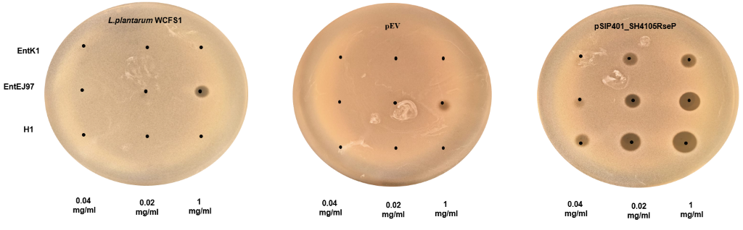

Figure S1. Heterologous expression of S. haemolyticus RseP in L. plantarum WCFS1. Spot-on-lawn assay on the wild-type L. plantarum WCFS1 (A), WCSF1 expressing the empty expression vector pEV (B) or pSIP401-SH4106RseP (a derivative of pEV) containing the S. haemolyticus rseP (C). rsep was derived from S. haemolyticus LMGT 4106. The antimicrobials were EJ97, K1 and H1, each at three concentrations (0.04, 0.2 and 1.0 mg/ml). Five ul of each concentration was applied to each spot. Inhibition is seen as dark zones around the white dots.

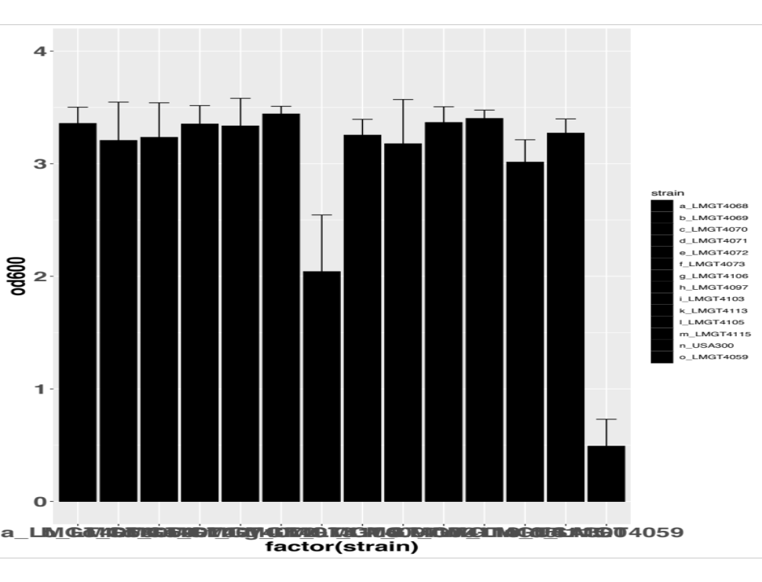
LMGT4068
LMGT4069
LMGT4070
LMGT4071
LMGT4072
LMGT4073
7068_4_63
7067_4_28
7067_4_21
7067_4_60
SH14
7067_4_39
USA300
LMGT4059
0
1
2
3
4
OD600nm

Figure S2. Evaluation of S. haemolyticus biofilm formation abilitiy. The indicated S. haemolyticus strains were allowed to form for 24 hours prior to staining with a crystal violet solution. The amount of dye bound to the cells is an indirect measure of the biofilm-forming ability and was quantified by optical density readings at 600 nm (OD₆₀₀) for each strain. The bar chart shows the average values (± s.d.) obtained from three independent experiments. S. aureus USA300 and S.arlettae (4059) served as a positive and negative control for biofilm formation, respectively. Cut-off OD values for biofilm formation were set to 1.

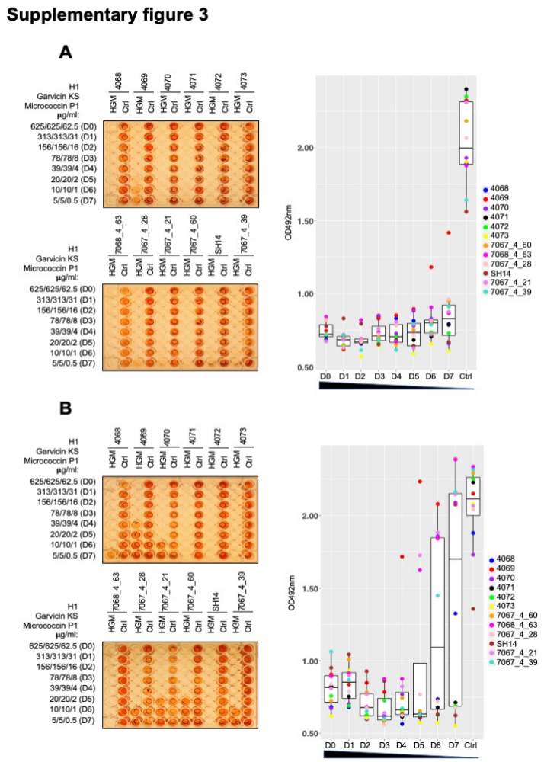

Figure S3. Evaluation of the three-component combination antibiofilm activity. Representative images of BOAT assays (left panels) obtained after a 5 hour treatment (A) or after a 48 hours treatment (B) with the tricomponent antimicrobial combination (HGM - short for H1, GarKS and MP1) or with the control (Ctrl) vehicle. The assays were performed as described in Figure 4A. The boxplot in the right panel describes the recovery of metabolic activity after the antimicrobial treatment (refer to figure 4A for details). Note that the metabolic activity after a 5 hours treatemtn with the antimicrobials remained below detectable levels up to D6 for most stains. Increased levels of metabolic activity were seen when the treatment was extended to 48 hours, especially at high dilution factors (D5-D7).

Table S1. Inhibition spectrum of K1, EJ97 and H1 as assessed by the spot-on-lawn assay against a collection of indicator species (n=50).
Indicator species | Source or reference (*) | Bacteriocins (**)
Indicator species | Source or reference (*) | K1 | EJ97 | H1
Bacillus cereus LMG 2805 | LMG | + | - | +
B. cereus LMG 2711 | LMG | + | - | +
B. cereus LMG 2731 | LMG | + | - | -
Carnobacterium divergens NCDO 2306 | NCDO | - | - | -
C. piscicola LMG 2332 | LMG | + | - | +
Enterococcus avium LMG 3465 | LMG | + | +++ | +++
E. faecalis V583 | ¹ | + | + | ++
E. faecalis LMG 2333 | LMG | + | +++ | +++
E. faecalis LMG 3331 | LMG | + | +++ | +++
E. faecalis LMG 3330 | LMG | + | +++ | +++
E. faecalis LMG 3332 | LMG | + | +++ | ++
E. faecium L50 | ² | ++ | +++ | ++
E. faecium P13 | ³ | +++ | +++ | +++
E. faecium P21 | ⁴ | ++ | +++ | +++
E. faecium AL41 | ⁵ | ++ | +++ | +++
Esherichia coli DH5α | ThermoFischer Scientific | - | - | -
E. coli TG1 | LMG | - | - | -
Lactobacillus curvatus LTH 1174 | ⁶ | +++ | +++ | ++
L. curvatus LMG 2353 | LMG | +++ | +++ | ++
L. plantarum LMG 2352 | LMG | + | ++ | -
L. sakei LMG 2380 | LMG | ++ | - | -
L. sakei 148 | ⁷ | +++ | - | -
L. salivarius UCC118 | ⁸ | - | - | -
Lactococcus garvieae DCC43 | ⁹ | +++ | + | +++
L. lactis LMG 2081 | LMG | - | - | -
L. lactis IL1403 | ¹⁰ | +++ | +++ | +++
L. gelidum LMG 2386 | LMG | - | - | -
L. innocua LMG 2785 | LMG | +++ | - | +++
L. innocua LMG 2710 | LMG | ++ | +++ | +++
L. ivanovii Li4 | Nofima | + | + | +
L. monocytogenes 400 | VET | - | - | -
L. monocytogenes 223 | VET | - | - | +
L. monocytogenes 279 | VET | - | - | +
L. monocytogenes EDGe | ¹¹ | + | +++ | +++
L. monocytogenes 403 | VET | - | - | +
Staphylococcus arlettae LMG 4134 | LMG | - | + | -
S. epidermidis LMG 3522 | LMG | - | + | ++
S. haemolyticus LMG 4133 | LMG | + | ++ | +++
S. homonis LMG 3129 | LMG | ++ | +++ | +++
S. simulans LMG 3233 | LMG | - | - | -
S. aureus LMG 3326 | LMG | - | + | ++
S. aureus LMG 3328 | LMG | - | - | +
S. aureus LMG 3263 | LMG | - | + | +
S. aureus LMG 3325 | LMG | - | - | -
S. aureus LMG 3329 | LMG | - | - | +
S. aureus ATCC14458 | Nofima | - | - | -
Streptococcus dysgalactiae 7649-3 | MLM | - | - | -
S. thermophilus Sfi13 | ¹² | - | - | +++
S. uberis 8008-1 | MLM | - | - | ++
S. uberis 7904-3 | MLM | + | - | ++
*LMG: Laboratory of Microbial Gene Technology, Norwegian University of Life Sciences
NCDO: National Collection of Dairy Organisms, United Kingdom
Nofima: Norwegian Food Research Institute, Norway
VET: Faculty of Veterinary Medicine, Norwegian University of Life Science
MLM: Mastitis laboratorium in Molde, Norway
** 5 µl of each bacteriocin at 1 mg/ml. Average inhibition score (n=3) indicates: “-“ = No inhibition; “+” = Unclear zone; “++” = zone < 1 cm; “+++”= zone > 1 cm.

Table S2. Minimal inhibitory concentration (MIC) values (µg/ml) of H1 towards clinical and commensial S. haemolyticus isolates.

S.haemolyticus strain | Isolation source (*) | MIC₅₀  H1 ( μg/ml) | ENA  Acc. No. | Reference
7067_4_39 | Blood culture, OUH | 0.78 | ERS066281 | ⁽¹³⁾
SH20 | Commensal, skin, UNN | 0.78 | GCA_903969795 | ⁽¹³⁾
SH14 | Commensal, skin, UNN | 0.78 | GCA_903969855 | ⁽¹³⁾
SH47 | Commensal, skin, UNN | 0.10 | GCA_903969995 | ⁽¹³⁾
SH10 | Commensal, skin, UNN | 0.10 | GCA_903969755 | ⁽¹³⁾
SH04 | Commensal, skin, UNN | 0.78 | GCA_903969785 | ⁽¹³⁾
SH09 | Commensal, skin, UNN | 0.78 | GCA_903969725 | ⁽¹³⁾
SH01 | Commensal, skin, UNN | 0.78 | GCA_903969685 | ⁽¹³⁾
SH46 | Commensal, skin, UNN | 0.78 | GCA_903969985.1 | ⁽¹³⁾
7067_4_60 | Blood, Switzerland | 0.10 | ERS066392 | ⁽¹⁴⁾
7067_4_21 | Commensal, Japan | 0.39 | ERS066353 | ⁽¹⁴⁾
7067_4_48 | Blood, OUH | 0.78 | ERS066290 | ⁽¹⁴⁾
7067_4_28 | Blood, OUH | 0.78 | ERS066270 | ⁽¹⁴⁾
7067_4_71 | Urine, OUH | 0.78 | ERS066313 | ⁽¹⁴⁾
7076_4_67 | Blood, UNN | 0.78 | ERS066309 | ⁽¹⁴⁾
7067_4_84 | Blood, United Kingdom | 0.78 | N/A | ⁽¹⁴⁾
7067_4_49 | Blood, OUH | 0.78 | ERS066291 | ⁽¹⁴⁾
7067_4_66 | Blood, UNN | 0.78 | ERS066308 | ⁽¹⁴⁾
7067_4_63 | Blood, Switzerland | 0.78 | ERS066395 | ⁽¹⁴⁾
7067_4_56 | Blood, OUH | 0.78 | ERS066298 | ⁽¹⁴⁾
7068_7_48 | Blood, Switzerland | 0.78 | ERS066380 | ⁽¹⁴⁾
4068 | Leprosy-associated plantar skin ulcers, BPHRC | 0.39 | N/A | This study
4069 | Leprosy-associated plantar skin ulcers, BPHRC | 0.78 | N/A | This study
4070 | Leprosy-associated plantar skin ulcers, BPHRC | 0.78 | N/A | This study
4071 | Leprosy-associated plantar skin ulcers, BPHRC | 0.78 | N/A | This study
4072 | Leprosy-associated plantar skin ulcers, BPHRC | 0.78 | N/A | This study
4073 | Leprosy-associated plantar skin ulcers, BPHRC | 0.78 | N/A | This study
* OUH: Oslo University Hospital, Rikshospitalet, Norway; UNN: University hospital of North Norway; BPHRC: Blue Peter Public Health and Research Centre, India

Table S3. MIC values (μg/ml) determined for planktonic cells after 5, 24 or 48 hour exposure to H1, GarKS, MP1 or the indicated combinations.
Antimicrobial | Strains
 | 4068 | 4069 | 4070 |  |  | 4071 |  |  | 4072 |  |  | 4073
Individual component
H1 5h  24h  48h | 0.78  >100  >100 | 0.78  0.78  >100 |  | 0.78  >100  >100 |  |  | 0.78  >100  >100 |  |  | 0.78  >100  >100 |  |  | 0.78  >100  >100
GarKS 5h  24h  48h | 6.5  24  25 | 3.3  13  26 | 12  48  51 |  |  | 12.5  51  100 |  | 23.6  49  52 |  |  |  | 12.5  51  51
MP1 5h  24h  48h | 0.02  0.023  0.078 | 0.15  >10  >10 | 0.02  0.33  0.13 |  |  | 0.043  >10  >10 |  | 0.039  >10  0.63 |  |  |  | 0.022  0.072  0.14
Combination
H1 5h  24h  48h | 0.83  3.1  6 | 1.4  6  6.5 | 0.72  3.3  6.3 |  | 1.6  12  24 |  |  | 1.5  12  13 |  |  | 1.7  6.3  12
GarKS 5h  24h  48h | 0.83  3.1  6 | 1.4  6  6.5 | 0.72  3.3  6.3 |  |  | 1.6  12  24 |  |  | 1.5  12  13 |  |  | 1.7  6.3  12
FIC* 5h  24h  48h | 1.2  0.16  0.3 | 2.2  8.16  0.3 | 1.0  0.1  0.2 |  |  | 2.2  0.36  4.8 |  |  | 2.0  0.36  1.6 |  |  | 2.3  0.19  1.4
Combination
H1 5h  24h  48h | 0.2  0.78  0.72 | 1.5  23  48 | 0.2  2.8  6 |  |  | 0.42  1.4  3 |  |  | 0.36  1.5  1.6 |  |  | 0.2  0.36  0.85
MP1 5h  24h  48h | 0.02  0.078  0.072 | 0.15  2.3  4.8 | 0.02  0.28  0.6 |  |  | 0.042  0.14  0.3 |  |  | 0.036  0.15  0.16 |  |  | 0.02  0.036  0.01
FIC* 5h  24h  48h | 0.36  0.35  0.1 | 2.0  29.7  5.3 | 0.36  0.11  0.1 |  |  | 0.64  0.028  0.06 |  |  | 0.55  0.03  0.04 |  |  | 0.36  0.05  0.01
Combination
GarKS 5h  24h  48h | 0.2  0.32  0.68 | 1.6  25  50 | 0.2  3.3  6.3 |  |  | 0.68  6.3  6.5 |  |  | 0.73  1.6  3.1 |  |  | 0.2  0.73  0.83
MP1 5h  24h  48h | 0.02  0.032  0.068 | 0.16  2.5  5 | 0.02  0.33  0.63 |  |  | 0.068  0.63  0.65 |  |  | 0.073  0.16  0.31 |  |  | 0.02  0.073  0.083
FIC* 5h  24h  48h | 0.13  0.15  0.12 | 0.6  2.2  1.3 | 0.12  0.17  0.2 |  |  | 0.06  0.19  0.13 |  |  | 0.2  0.05  0.1 |  |  | 0.1  0.12  0.7
Combination
H1 5h  24h  48h | 0.32  0.78  2.8 | 0.68  3.3  5.8 | 0.32  2.8  5.8 |  |  | 0.72  1.6  3.3 |  |  | 0.68  1.6  5.8 |  |  | 0.33  0.78  1.6
GarKS 5h  24h  48h | 0.32  0.78  2.8 | 0.68  3.3  5.8 | 0.32  2.8  5.8 |  |  | 0.72  1.6  3.3 |  |  | 0.68  1.6  5.8 |  |  | 0.33  0.78  1.6
MP1 5h  24h  48h | 0.032  0.078  0.28 | 0.068  0.33  0.58 | 0.032  0.28  0.58 |  |  | 0.072  0.16  0.33 |  |  | 0.068  0.16  0.58 |  |  | 0.033  0.078  0.16
FIC** 5h  24h  48h | 0.62  0.38  0.5 | 1.12  4.5  0.4 | 0.6  0.17  0.2 |  |  | 1.2  0.06  0.1 |  |  | 1.1  0.06  0.26 |  |  | 0.6  0.14  0.15
* Synergy with fractional inhibition concentration (FIC) ≤ 0.5.
** Synergy with fractional inhibition concentration (FIC) ≤ 0.75.

Table S4. Bacterial strains and plasmids used for heterologous expression of RseP.
Strain or plasmid | Relevant characteristics (*) | Reference
Strain
S.haemolyticus hi7076_4_21 | Template for rseP | ¹⁴
E. coli TOP10 | Cloning host | ThermoFischer Scientific
L. plantarum WCFS1 | Host strain | ¹⁵
Plasmid
pEV | Em^{r}; empty expression vector, a derivative of pSIP401 | ¹⁶
pLp1261_InvS | Em^{r}; a derivative of the spp-based expression vector pSIP401. | ^{16,17}
pSIP401_SHRseP | Em^{r}; a derivative of pLp1261_InvS, containing a S. haemolyticus rseP | This study
*Em^{r}: Erythromycin resistant

Table S5. Bacteriocins used in this study
Bacteriocins (*) |  | Amino acid sequence | Reference
K1 |  | MKFKFNPTGTIVKKLTQYEIAWFKNKHGYYPWEIPRC | ¹⁸
Ej97 |  | MLAKIKAMIKKFPNPYTLAAKLTTYEINWYKQQYGRYPWERPVA | ¹⁹
H1 |  | MKFKFNPTGTIVKKLTQYEINWYKQQYGRYPWERPVA | This study
GakA*  GakB*  GakC* |  | MGAIIKAGAKIVGKGVLGGGASWLGWNVGEKIWK | ²⁰  ²⁰  ²⁰
GakA*  GakB*  GakC* |  | MGAIIKAGAKIIGKGLLGGAAGGATYGGLKKIFG | ²⁰  ²⁰  ²⁰
GakA*  GakB*  GakC* |  | MGAIIKAGAKIVGKGALTGGGVWLAEKLFGGK | ²⁰  ²⁰  ²⁰
Micrococcin P1** |  | SCTTCVCTCSCCTT | ²¹
* Components of garvicin KS; ** Micrococcin P1 has exstensive post-translational modifications

Table S6 Primers used in this study
Primer and category | Sequence (5’-3’)
RseP amplification
SH_7076_4_21 _RseP_F | GGA GTA TGA TTC ATA TGA GCT ATT TAA TCA CTA TTG TCT CAT TT
SH_7076_4_21 _RseP_R | TCG AAC CCG GGG TAC CTT ACA AGA AAT AAC GTT GTA TAT CGT TC
Sequencing
SH_7076_4_21_RseP_Seq_F1 | TTG AGT GCA CAT TTG ACT AGA C
SH_7076_4_21_RseP_Seq_F2 | ATC GCT CCA CGA CAT CGA C
SH_7076_4_21_RseP_Seq_F3 | GAA CGA AAC TTT GTA TAC CAT CCG
SH_7076_4_21_RseP_Seq_R1 | ACT CAA TGC TTC TGC TTC AGC
SH_7076_4_21_RseP_Seq_R2 | GCT GCA GAC TGA ATG TCA TC
SH_7076_4_21_RseP_Seq_R3 | ATG TAC TGG CAC TAA CAA ACT G
SH_7076_4_21_RseP_Seq_R4 | AAA TTC GAC CAC CAT CAA GTG C

Supplementary references
1 McShan, W. M. & Shankar, N. in The Enterococci 409-415 (2002).
2 Cintas, L. M. et al. Enterocins L50A and L50B, two novel bacteriocins from Enterococcus faecium L50, are related to staphylococcal hemolysins. J Bacteriol 180, 1988-1994, doi:10.1128/JB.180.8.1988-1994.1998 (1998).
3 Cintas, L. M., Casaus, P., Havarstein, L. S., Hernandez, P. E. & Nes, I. F. Biochemical and genetic characterization of enterocin P, a novel sec-dependent bacteriocin from Enterococcus faecium P13 with a broad antimicrobial spectrum. Appl Environ Microbiol 63, 4321-4330, doi:10.1128/AEM.63.11.4321-4330.1997 (1997).
4 Herranza C, P. C. P., Mukhopadhyaya S, Martı́nez JM, Rodrı́guez JM, Nes IF, Hernández PE, Cintas LM. Enterococcus faecium P21: a strain occurring naturally in dry-fermented sausages producing the class II bacteriocins enterocin A and enterocin B. Food Microbiology 18, 115-131, doi:https://doi.org/10.1006/fmic.2000.0382 (2001).
5 Marekova, M., Laukova, A., Skaugen, M. & Nes, I. Isolation and characterization of a new bacteriocin, termed enterocin M, produced by environmental isolate Enterococcus faecium AL41. J Ind Microbiol Biotechnol 34, 533-537, doi:10.1007/s10295-007-0226-4 (2007).
6 Petra S.Tichaczek, J.-M., Ingolf F.Nes, Rudi F.Vogel, Walter P.Hammes. Characterization of the Bacteriocins Curvacin A from Lactobacillus curvatus LTH1174 and Sakacin P from L. sake LTH673. Systematic and Applied Microbiology 15, 460-468, doi:https://doi.org/10.1016/S0723-2020(11)80223-7 (1992).
7 Sobrino, O. J. et al. Sakacin M, a bacteriocin-like substance from Lactobacillus sake 148. Int J Food Microbiol 16, 215-225, doi:10.1016/0168-1605(92)90082-e (1992).
8 Claesson, M. J. et al. Multireplicon genome architecture of Lactobacillus salivarius. Proc Natl Acad Sci U S A 103, 6718-6723, doi:10.1073/pnas.0511060103 (2006).
9 Sanchez, J. et al. Antimicrobial and safety aspects, and biotechnological potential of bacteriocinogenic enterococci isolated from mallard ducks (Anas platyrhynchos). Int J Food Microbiol 117, 295-305, doi:10.1016/j.ijfoodmicro.2007.04.012 (2007).
10 Bolotin, A. et al. The complete genome sequence of the lactic acid bacterium Lactococcus lactis ssp. lactis IL1403. Genome Res 11, 731-753, doi:10.1101/gr.gr-1697r (2001).
11 Hechard, Y., Pelletier, C., Cenatiempo, Y. & Frere, J. Analysis of sigma(54)-dependent genes in Enterococcus faecalis: a mannose PTS permease (EII(Man)) is involved in sensitivity to a bacteriocin, mesentericin Y105. Microbiology (Reading) 147, 1575-1580, doi:10.1099/00221287-147-6-1575 (2001).
12 Marciset, O., Jeronimus-Stratingh, M. C., Mollet, B. & Poolman, B. Thermophilin 13, a nontypical antilisterial poration complex bacteriocin, that functions without a receptor. J Biol Chem 272, 14277-14284, doi:10.1074/jbc.272.22.14277 (1997).
13 Pain, M., Hjerde, E., Klingenberg, C. & Cavanagh, J. P. Comparative Genomic Analysis of Staphylococcus haemolyticus Reveals Key to Hospital Adaptation and Pathogenicity. Front Microbiol 10, 2096, doi:10.3389/fmicb.2019.02096 (2019).
14 Cavanagh, J. P. et al. Whole-genome sequencing reveals clonal expansion of multiresistant Staphylococcus haemolyticus in European hospitals. J Antimicrob Chemother 69, 2920-2927, doi:10.1093/jac/dku271 (2014).
15 Kleerebezem, M. et al. Complete genome sequence of Lactobacillus plantarum WCFS1. Proc Natl Acad Sci U S A 100, 1990-1995, doi:10.1073/pnas.0337704100 (2003).
16 Sorvig, E. et al. Construction of vectors for inducible gene expression in Lactobacillus sakei and L. plantarum. FEMS Microbiol Lett 229, 119-126, doi:10.1016/S0378-1097(03)00798-5 (2003).
17 Sorvig, E., Mathiesen, G., Naterstad, K., Eijsink, V. G. H. & Axelsson, L. High-level, inducible gene expression in Lactobacillus sakei and Lactobacillus plantarum using versatile expression vectors. Microbiology (Reading) 151, 2439-2449, doi:10.1099/mic.0.28084-0 (2005).
18 Ovchinnikov, K. V. et al. The Leaderless Bacteriocin Enterocin K1 Is Highly Potent against Enterococcus faecium: A Study on Structure, Target Spectrum and Receptor. Front Microbiol 8, 774, doi:10.3389/fmicb.2017.00774 (2017).
19 Frank, K. L. et al. Use of recombinase-based in vivo expression technology to characterize Enterococcus faecalis gene expression during infection identifies in vivo-expressed antisense RNAs and implicates the protease Eep in pathogenesis. Infect Immun 80, 539-549, doi:10.1128/IAI.05964-11 (2012).
20 Ovchinnikov, K. V. et al. Novel Group of Leaderless Multipeptide Bacteriocins from Gram-Positive Bacteria. Appl Environ Microbiol 82, 5216-5224, doi:10.1128/AEM.01094-16 (2016).
21 Ciufolini, M. A. & Lefranc, D. Micrococcin P1: structure, biology and synthesis. Nat Prod Rep 27, 330-342, doi:10.1039/b919071f (2010).

