supplementary material (Original Images)
1. Supplementary figure 1
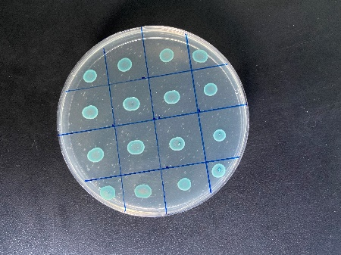
Figure 1. Identification of Escherichia coli strains by CHROMagar orientation medium
2. Supplementary figure 2

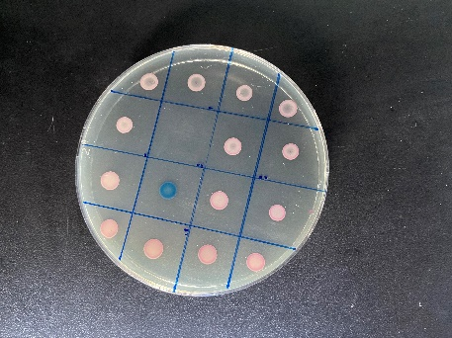
Figure 2. Identification of ESBL-producing E. coli strain by CHROMagar orientation medium
3. Supplementary figure 3
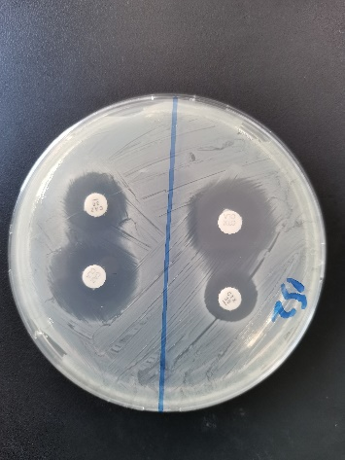
Figure 3. Identification of ESBL-producing E. coli strain by double disk synergy test

4. Supplementary figure 4
Figure 4. Genotypic identification of bla_{CTX-M} gene via PCR in E. coli strains

5. Supplementary figure 5
Figure 5. Genotypic identification of bla_{SHV} gene via PCR in E. coli strains

6. Supplementary figure 6
Figure 6. Genotypic identification of bla_{TEM} gene via PCR in E. coli strains

