Prediction of Non-Responsiveness to Pre-dialysis Care Program in Patients with Chronic Kidney Disease: A Retrospective Cohort Analysis

Emily K. King, M.S., Ming-Han Hsieh, M.D., David R. Chang, M.D., Cheng-Ting Lu, M.D., I-Wen Ting, M.D., Charles C.N. Wang, Ph.D., Pei-Shan Chen, M.S., Hung-Chieh Yeh, M.D., Hsiu-Yin Chiang, Ph.D., Chin-Chi Kuo, M.D. Ph.D

Supplementary Material

Table S1. Missing proportion of variables listed in table 1 (N=7135).
Table S2. Baseline Demographic and Clinical Characteristics Based on the Responsiveness of Patients With Stages 3 and 4 CKD at Baseline to Pre-ESRD Care
Table S3. Subgroup analysis for associations between non-responsiveness to pre-ESRD program (reference group: responsive) and adverse outcomes according to baseline characteristics. aHR, adjusted hazard ratio; ETR, event time ratio (parametric survival modeling under Weibull regression).
Figure S1. The selection process of the study population
Figure S2. The eGFR slope (red line), with the light red shaded area representing the 95% confidence interval, before and after enrollment of the study population into the pre-ESRD program stratified by CKD stage. The eGFR slope was modeled using the growth piecewise linear mixed model through the incorporation of random effects. Blue and orange points represent eGFR measurements before and after enrollment into pre-ESRD program, respectively. The estimated value of eGFR slope (mL/min/1.73m²/y) is shown.

Supplementary Methods
Co-variables
Sociodemographic variables collected during the enrollment interview included age, race/ethnicity, sex, education, cigarette smoking, and alcohol consumption. Smoking and alcohol consumption were categorized as current, former, and never. Body mass index (BMI) was calculated as weight in kilograms divided by height in meters squared. Diabetes mellitus and hypertension were defined based on physicians’ clinical diagnoses according to International Classification of Diseases, ninth revision (ICD-9) codes or the use of blood-pressure- and glucose-lowering agents. A history of cardiovascular disease (CVD) was defined as documented coronary artery disease, myocardial infarction, stroke, or heart failure based on ICD-9 codes in EMRs 1 year before enrollment to the pre-ESRD program.

Table S1. Missing proportion of variables listed in table 1 (N=7135).
Variables | Missing N (%)
Body mass index (kg/m²) | 164 (2.3%)
Initial CKD stage | 12 (0.2%)
Diabetes | 10 (0.1%)
Hypertension | 10 (0.1%)
Cardiovascular disease | 10 (0.1%)
Baseline medication profiles | 163 (2.3%)
Pentoxifylline | 163 (2.3%)
NSAIDs | 163 (2.3%)
Contrast media | 163 (2.3%)
Anti-platelet | 163 (2.3%)
Urate-lowering agents | 163 (2.3%)
Anti-hypertension agents | 163 (2.3%)
Anti-diaetes agents | 163 (2.3%)
Baseline biochemical profiles | 163 (2.3%)
Blood urea nitrogen (mg/dL) | 522 (7.3%)
Serum uric acid (mg/dL) | 839 (11.8%)
Sodium (mmol/L) | 1224 (17.2%)
Potassium (mmol/L) | 691 (9.7%)
Calcium (mg/dL)) | 1816 (25.5%)
Phosphate (mg/dL) | 2200 (30.8%)
Serum Albumin (g/dL) | 1278 (17.9%)
Hemoglobin (g/dL) | 1657 (23.2%)
Total cholesterol (mg/dL) | 1115 (15.6%)
Triglyceride (mg/dL) | 863 (12.1%)
Urine creatinine (mg/dL) | 1270 (17.8%)
Urine PCR (mg/g) | 2001 (28.0%)
Urine ACR (mg/g) | 5002 (70.1%)
Abbreviations: ACR, albumin/creatinine ratio; CKD, chronic kidney disease; NSAID, nonsteroidal anti-inflammatory drugs; PCR, protein/creatinine ratio.

Table S2. Baseline Demographic and Clinical Characteristics Based on the Responsiveness of Patients With Stages 3 and 4 CKD at Baseline to Pre-ESRD Care

 | Agreement / Improving  (n= 3016, 60.8%) | Disagreement-deteriorating  (n= 1941, 39.2%) | P-value
Demographic
Age, median (IQR) | 70.4 (60.4, 77.8) | 68.0 (57.1, 76.4) | <.0001
BMI, median (IQR) | 24.4 (22.2, 27.0) | 24.5 (22.2, 27.2) | 0.396
Gender, n (%)
Female | 1069 (35.4) | 804 (41.4) | <.0001
Male | 1947 (64.6) | 1137 (58.6)
CKD stage, n (%)
3 | 1994 (66.1) | 1126 (58.0) | <.0001
4 | 1022 (33.9) | 815 (42.0)
Diabetes, n (%) | 929 (30.8) | 853 (44.0) | <.0001
Hypertension, n (%) | 1893 (62.8) | 1351 (69.6) | <.0001
Cardiovascular disease, n (%) | 1228 (40.8) | 812 (41.8) | 0.452
Medication, n (%)
Pentoxifylline | 747 (25.4) | 540 (28.3) | 0.025
NSAIDs | 872 (29.6) | 503 (26.4) | 0.014
Contrast | 309 (10.5) | 182 (9.5) | 0.278
Anti-platelet | 1096 (37.2) | 735 (38.5) | 0.371
Aspirin | 908 (30.8) | 596 (31.2) | 0.781
Dipyridamole | 133 (7.0) | 330 (0.0) | 0.710
other Anti-platelet agents | 987 (33.5) | 650 (34.1) | 0.706
Urate-lowering agents | 906 (30.8) | 526 (27.6) | 0.016
Allopurinol | 379 (12.9) | 238 (12.5) | 0.678
Febuxostat | 64 (2.2) | 39 (2.0) | 0.757
Benzbromarone | 412 (14.0) | 238 (12.5) | 0.127
Colchicine | 401 (13.6) | 234 (12.3) | 0.169
Sulfinpyrazone | 39 (1.3) | 22 (1.2) | 0.599
Anti-hypertension agents | 2312 (78.5) | 1634 (85.6) | <.0001
ACEI | 543 (18.4) | 442 (23.2) | <.0001
ARBs | 1264 (42.9) | 945 (49.5) | <.0001
Trichlorethiazide | 272 (9.2) | 214 (11.2) | 0.026
Furosemide , Spironolactone, Amizide, Indapamide | 1135 (38.6) | 911 (47.7) | <.0001
α blocker | 593 (20.1) | 457 (23.9) | 0.002
β blocker | 1057 (35.9) | 791 (41.4) | 0.000
CCB | 1280 (43.5) | 1019 (53.4) | <.0001
Anti-diabetes agents | 967 (32.9) | 876 (45.9) | <.0001
Oral hypoglycemic agents | 807 (27.4) | 694 (36.4) | <.0001
Insulin | 436 (14.8) | 450 (23.6) | <.0001
Baseline biochemical parameters, median (IQR)
eGFR (mL/min/1.73m²) | 37.0 (25.7, 47.8) | 32.4 (20.5, 46.1) | <.0001
Serum creatinine (mg/dL) | 1.71 (1.41, 2.23) | 1.92 (1.45, 2.66) | <.0001
Blood urea nitrogen (mg/dL) | 25.0 (19.0, 35.0) | 29.0 (21.0, 40.0) | <.0001
Serum uric acid (mg/dL) | 7.30 (6.10, 8.60) | 7.40 (6.30, 8.60) | 0.303
Sodium (mmol/L) | 138 (136, 140) | 138 (136, 140) | 0.041
Potassium (mmol/L) | 4.20 (3.80, 4.60) | 4.20 (3.90, 4.60) | 0.067
Calcium (mg/dL)) | 9.00 (8.70, 9.30) | 8.90 (8.50, 9.20) | <.0001
Phosphate (mg/dL) | 3.80 (3.30, 4.30) | 4.00 (3.50, 4.40) | <.0001
Serum Albumin (g/dL) | 4.00 (3.70, 4.40) | 3.80 (3.40, 4.20) | <.0001
Hemoglobin (g/dL) | 12.0 (10.4, 13.6) | 11.1 (9.8, 12.7) | <.0001
T-CHO (mg/dL) | 179 (154, 209) | 185 (156, 216) | <.0001
TG (mg/dL) | 129 (88, 190) | 134 (91, 201) | 0.002
Urine creatinine (mg/dL) | 96 (63, 143) | 82 (54, 118) | <.0001
Urine PCR (mg/g) | 271 (114, 845) | 1,200 (330, 3,541) | <.0001
Urine ACR (mg/g) | 97 (21, 485) | 988 (147, 3,247) | <.0001
p-values are calculated by Kruskal-Wallis test for continuous variables and Chi-square test for categorical variables
Abbreviations: ACEIs, angiotensin-converting-enzyme in inhibitors; ACR, albumin-to-creatinine ratio; ARBs, angiotensin receptor blockers; BMI, body mass index; CCB, calcium channel blocker; CKD, chronic kidney disease; eGFR, estimated glomerular filtration rate; GBTM, group-based trajectory modelling; IQR, inter-quartile range; NSAID, nonsteroidal anti-inflammatory drugs; PCR, protein-to-creatinine ratio; T-CHO, total cholesterol; TG, triglyceride.

Table S3. Subgroup analysis for associations between non-responsiveness to pre-ESRD program (reference group: responsive) and adverse outcomes according to baseline characteristics. aHR, adjusted hazard ratio; ETR, event time ratio (parametric survival modeling under Weibull regression).
 | Dialysis |  | All-cause mortality
 | aHR  (95% CI) | ETR  (95% CI) | aHR  (95% CI) | ETR  (95% CI)
Age
<65 years | 1.65 (1.37 - 1.99) | 0.74 (0.67 - 0.83) | 1.39 (1.1 - 1.75) | 0.79 (0.67 - 0.93)
≧65 years | 2.79 (2.22 - 3.5) | 0.52 (0.45 - 0.6) | 1.38 (1.21 - 1.57) | 0.82 (0.75 - 0.89)
Sex
Women | 1.66 (1.33 - 2.06) | 0.75 (0.66 - 0.85) | 1.53 (1.27 - 1.84) | 0.77 (0.68 - 0.86)
Men | 2.54 (2.11 - 3.07) | 0.55 (0.49 - 0.62) | 1.31 (1.13 - 1.51) | 0.83 (0.76 - 0.92)
BMI
<24 kg/m² | 1.9 (1.55 - 2.34) | 0.66 (0.58 - 0.76) | 1.35 (1.15 - 1.58) | 0.82 (0.73 - 0.91)
24-27 kg/m² | 2.32 (1.72 - 3.13) | 0.62 (0.53 - 0.74) | 1.27 (1.01 - 1.6) | 0.86 (0.75 - 0.99)
>27 kg/m² | 1.81 (1.36 - 2.42) | 0.73 (0.63 - 0.85) | 1.48 (1.15 - 1.9) | 0.78 (0.67 - 0.91)
Smoking
Never | 2.07 (1.77 - 2.42) | 0.63 (0.57 - 0.7) | 1.48 (1.31 - 1.68) | 0.77 (0.71 - 0.84)
Former | 2.6 (1.48 - 4.55) | 0.63 (0.48 - 0.83) | 0.81 (0.49 - 1.33) | 1.14 (0.84 - 1.53)
Current | 1.84 (1.2 - 2.83) | 0.74 (0.59 - 0.92) | 1.36 (0.95 - 1.96) | 0.83 (0.66 - 1.04)
Initial CKD stage
3 | 183.93 (10.64 - 3179.09) | 0.16 (0.06 - 0.45) | 2.43 (1.35 - 4.37) | 0.61 (0.43 - 0.86)
4-5 | 2.37 (2.05 - 2.74) | 0.58 (0.53 - 0.64) | 1.43 (1.27 - 1.61) | 0.79 (0.73 - 0.85)
PCR
< 500 mg/g creatinine | 7.56 (4.15 - 13.79) | 0.46 (0.36 - 0.58) | 1.29 (1.03 - 1.62) | 0.85 (0.74 - 0.98)
≧ 500 mg/g creatinine | 1.72 (1.48 - 2) | 0.71 (0.64 - 0.78) | 1.27 (1.11 - 1.46) | 0.85 (0.78 - 0.93)
Diabetes
Non-diabetes | 2.11 (1.7 - 2.61) | 0.65 (0.57 - 0.74) | 1.39 (1.18 - 1.63) | 0.81 (0.73 - 0.9)
Diabetes | 2.04 (1.69 - 2.46) | 0.64 (0.56 - 0.72) | 1.4 (1.19 - 1.64) | 0.8 (0.72 - 0.89)
Hypertension
Non-hypertension | 1.91 (1.43 - 2.57) | 0.68 (0.57 - 0.81) | 1.32 (1.06 - 1.65) | 0.82 (0.7 - 0.96)
Hypertension | 2.29 (1.95 - 2.69) | 0.59 (0.53 - 0.66) | 1.46 (1.28 - 1.66) | 0.79 (0.72 - 0.86)
Cardiovascular disease
Non-CVD | 1.97 (1.65 - 2.34) | 0.65 (0.58 - 0.73) | 1.34 (1.14 - 1.57) | 0.82 (0.74 - 0.92)
CVD | 2.33 (1.84 - 2.95) | 0.62 (0.54 - 0.71) | 1.47 (1.25 - 1.73) | 0.79 (0.71 - 0.87)
Serum uric acid
< 7 mg/dL | 2.18 (1.7 - 2.8) | 0.61 (0.51 - 0.71) | 1.49 (1.24 - 1.79) | 0.78 (0.7 - 0.88)
≧ 7 mg/dL | 2 (1.67 - 2.4) | 0.68 (0.61 - 0.75) | 1.31 (1.12 - 1.53) | 0.83 (0.75 - 0.93)
Serum Phosphorus
< 4 mg/dL | 3.44 (2.58 - 4.6) | 0.51 (0.44 - 0.6) | 1.48 (1.22 - 1.8) | 0.77 (0.68 - 0.88)
≧ 4 mg/dL | 1.79 (1.47 - 2.18) | 0.71 (0.64 - 0.8) | 1.19 (0.99 - 1.43) | 0.89 (0.79 - 1.01)

Adjusted model: adjusted for age at entry, gender, BMI, smoking status, alcohol consumption, education, diabetes, hypertension, cardiovascular disease, baseline medication for NSAIDs, anti-platelet agents, urate-lowering agents, ACEI/ARBs, Diuretics, baseline biochemical parameters for PCR, and eGFR (Sample size: 5430 patients with all co-variables available except for subgroups of serum uric acid and phosphorus, which is 4951 and 3946 in sample size, respectively).
Abbreviations: ACEI, angiotensin-converting-enzyme in inhibitors; ARBs, angiotensin receptor blockers; BMI, body mass index; CI, confidence interval; CKD, chronic kidney disease; eGFR, estimated glomerular filtration rate; ETR, event time ratio; ESRD, end stage renal disease; HR, hazard ratio; IQR, inter-quartile range,; NSAID, nonsteroidal anti-inflammatory drugs; PCR, protein-to-creatinine ratio.

Figure S1. The selection process of the study population

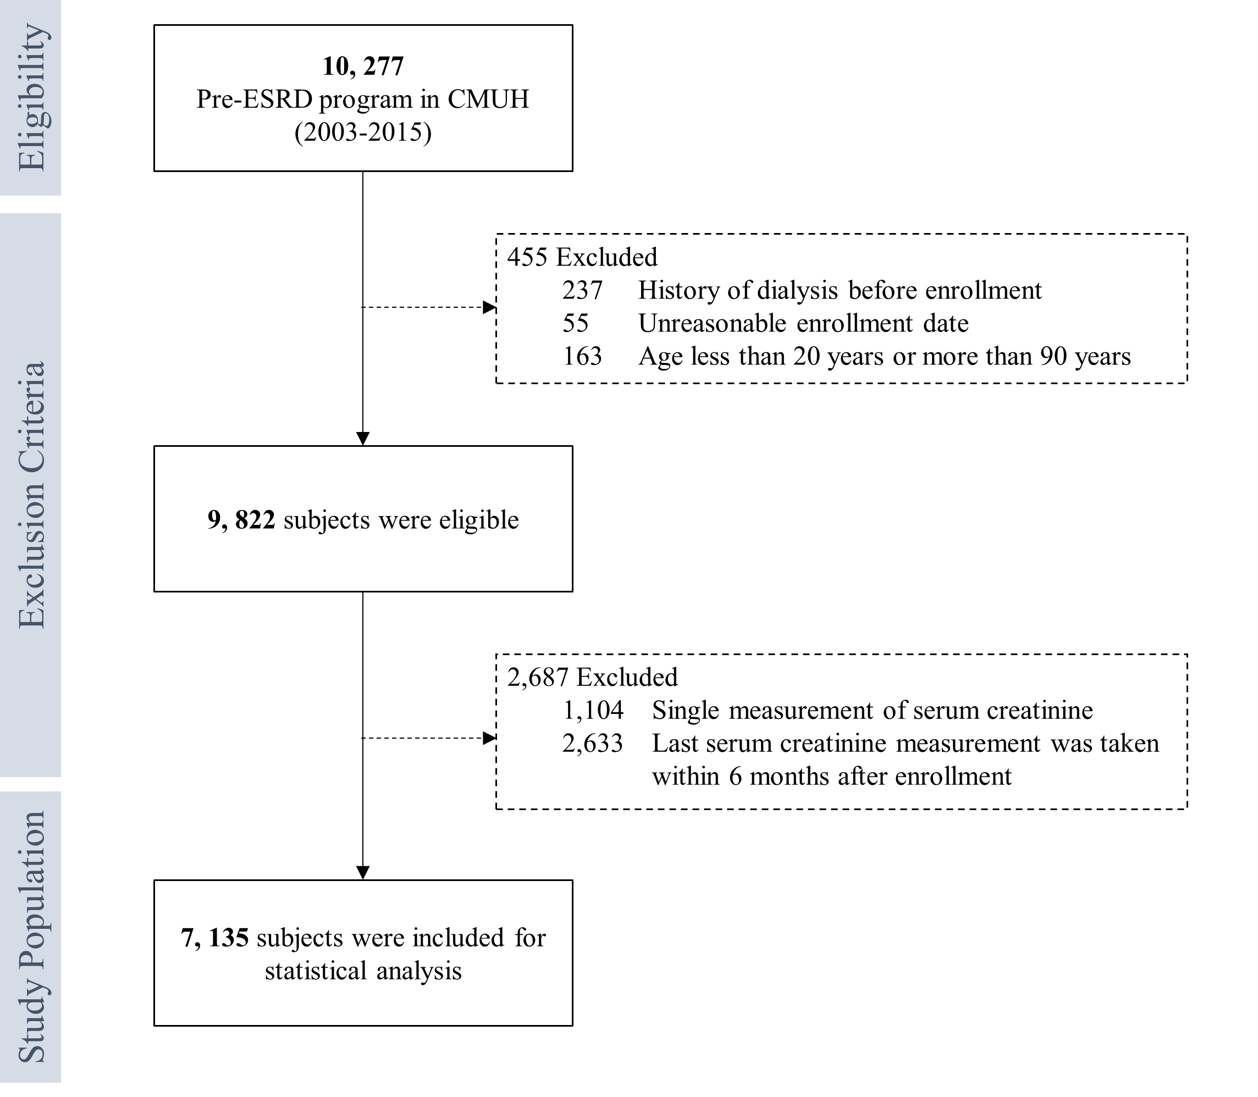

Figure S2. The eGFR slope (red line), with the light red shaded area representing the 95% confidence interval, before and after enrollment of the study population into the pre-ESRD program stratified by CKD stage. The eGFR slope was modeled using the growth piecewise linear mixed model through the incorporation of random effects. Blue and orange points represent eGFR measurements before and after enrollment into pre-ESRD program, respectively. The estimated value of eGFR slope (mL/min/1.73m²/y) is shown.

