Supplementary Information for

Microstructure and composition dependence of mechanical characteristics of nanoimprinted AlCoCrFeNi high-entropy alloys

Dinh-Quan Doan^{1,2}, Te-Hua Fang^{1,*}, Tao-Hsing Chen¹

¹Department of Mechanical Engineering, National Kaohsiung University of Science and Technology, Kaohsiung 807, Taiwan
²Faculty of Mechanical Engineering, Hung Yen University of Technology and Education, Khoai Chau District, Hung Yen Province, Vietnam
* Te-Hua Fang; fang.tehua@msa.hinet.net

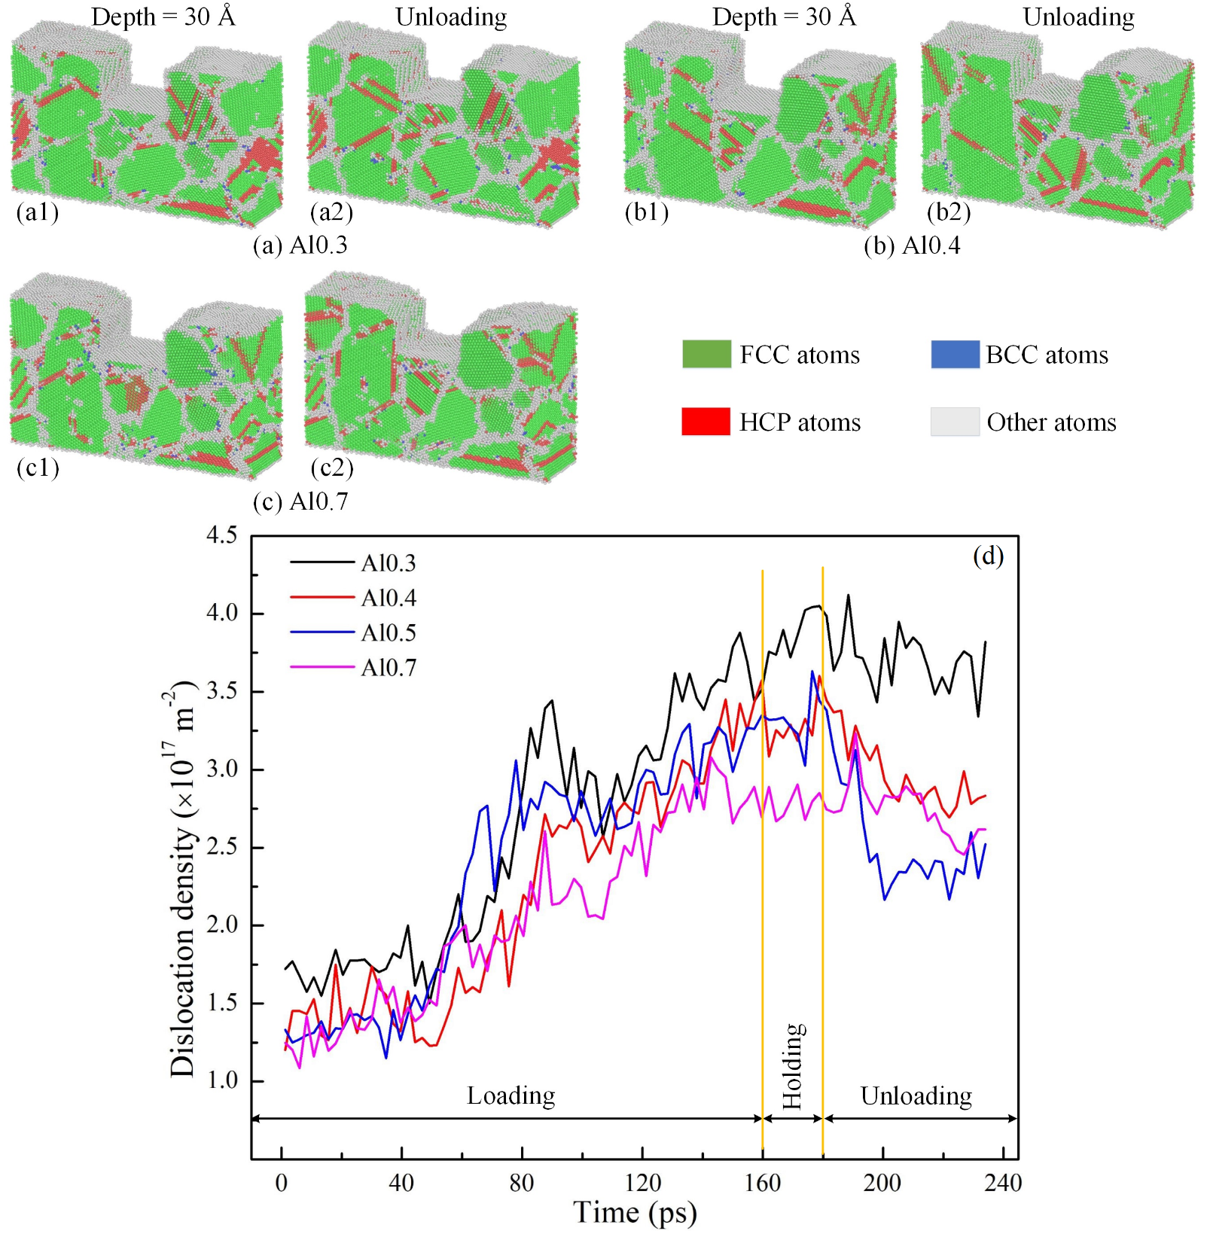
Supplementary Fig. 1. The microstructure snapshots at an imprinting depth of 30 Å and the unloading stage for the polycrystalline structure of the Al_{x}CoCrFeNi HEA with different alloy compositions: Al0.3 (a); Al0.4 (b); and Al0.7 (c). Development of the total dislocation density of the Al_{x}CoCrFeNi HEA during the nanoimprinting with different alloy compositions (d).

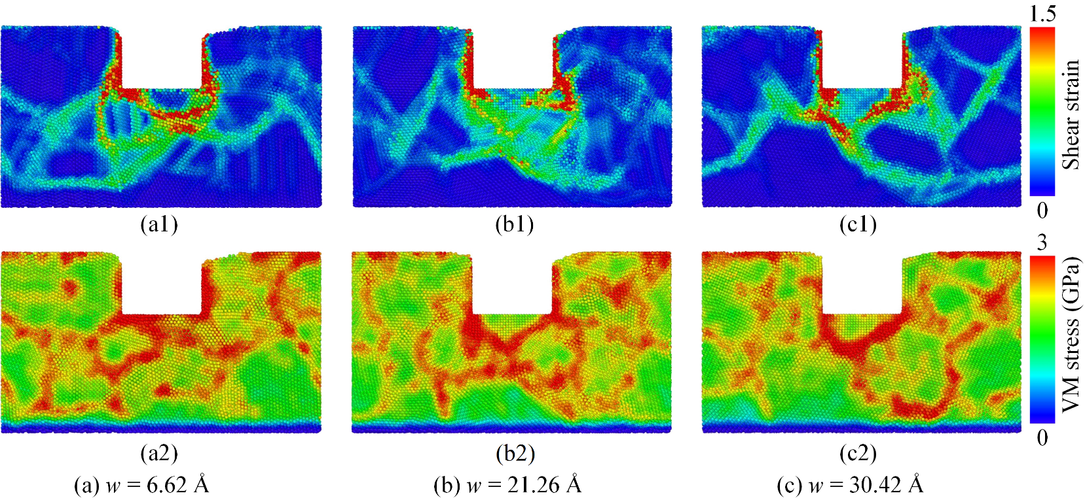
Supplementary Fig. 2. The cross-section of atomic shear strain distributions (a1-c1) and the local stress distributions of atoms (a2-c2) for NT-polycrystalline structure of the Al0.5 HEA at an imprinting depth of 30 Å with various TB distances: 6.61 Å (a); 21.26 Å(b); and 30.42 Å (c).

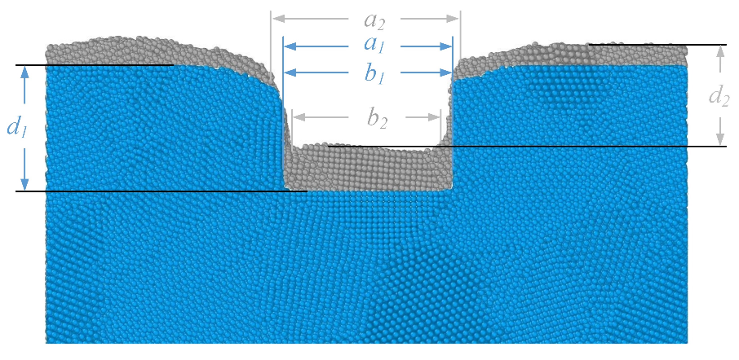
Supplementary Fig. 3. Definition of the sample parameters before and after elastic recovery.

