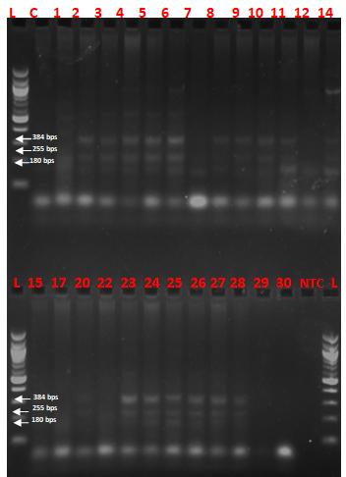

Figure 3a (Supplementary) : Characterization of E coli strains by multiplex PCR assay strains were classified based on the visible banding patterns expected mobilities for the various specific PCR products (see Table 1).

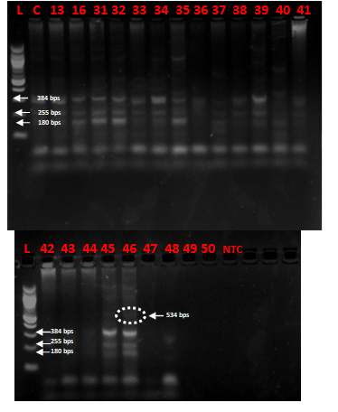

Figure 3b (Supplementary): Characterization of E coli strains by multiplex PCR assay strains were classified based on the visible banding patterns expected mobilities for the various specific PCR products (see Table 1). The lone sample with faint band showing at 534 bps was selected for sequencing, see sequencing result on Figure 4.

180 bps
255 bps
384 bps
384 bps
255 bps
180 bps
534 bps
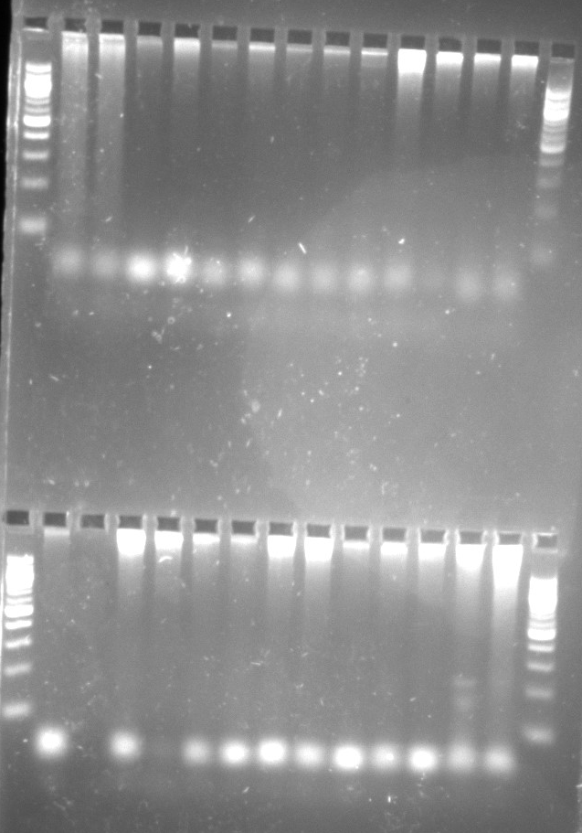
L 14 15 16 17 18 19 20 21 22 23 24 25 26
Figure 3c (Supplementary): Characterization of E coli strains by multiplex PCR assay (2) strains were classified based on the visible banding patterns expected mobilities for the various specific PCR products (see Table 1). No bands were observed in the expected band sizes.
L 1 2 3 4 5 6 7 8 9 10 11 1213
L 14 15 16 17 18 19 20 21 22 23 24 25 26

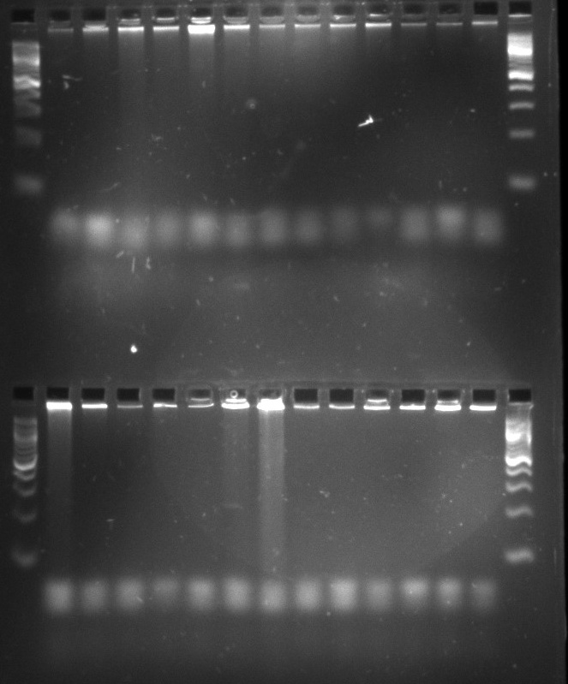
L 27 28 29 30 31 32 33 34 35 36 37 38 39 L
L 40 41 42 43 44 45 46 47 48 49 50 L

Figure 3d (Supplementary): Characterization of E coli strains by multiplex PCR assay (2) strains were classified based on the visible banding patterns expected mobilities for the various specific PCR products (see Table 1). No bands were observed in the expected band sizes.

Legend: The lane numbers are matched with the corresponding isolate Identification numbers and the sample sources as follows, 1-Alh-A3-3 (Al-maleek, hands); 2- Alh-B3-5 (Al-maleek, hands); 3- Alh-A3-5 (Al-maleek, hands); 4- Alh-C3-1 (Al-maleek, hands); 5- Alh-B5-4 (Al-maleek, hands); 6- Alh-A3-4 (Al-maleek, hands); 7- Se2h-C1-1 (Sekona-2, hands); 8- Se1h-A5-1 (Sekona-1, hands); 9- Se1h-C3-4 (Sekona-1, hands); 10- Se1h-A1-4 (Sekona-1, hands); 11- Se1h-A1-4 (Sekona-1, hands); 12- Se1h-B3-5 (Sekona-1, hands); 13- Se1FA3-4 (sekona-1, floor); 14- Se2FC1-2 (Sekona-2, floor); 15- Se2FC1-5 (Sekona-2, floor); 16- Se1F3-1 (Sekona-1, floor); 17- Se2FA3-3 (Sekona-2, floor); 18- Se1FC1-3 (Sekona-1, floor); 19- Se1FA3-1 (Sekona-1, floor); 20- Se2FC5-3 (Sekona-2, floor); 21- Se1FC1-3 (Sekona-1, floor); 22- AlFA-3 (Al-maleek, floor); 23- AlfC5-3 (Al-maleek, floor); 24- AlFC3-4 (Al-maleek, floor); 25- AlF-3-2 (Al-maleek, floor); 26- Al-3-W3 (Al-maleek, water); 27- Al-3-W4 (Al-maleek, water); 28- Al-1-W2 (Al-maleek, water); 29- Se2-3-W3 (Sekona-2, water); 30- Se2-5-W1 (Sekona-2, water); 31- Se2-3W1 (Sekona-2, water); 32- Se1kA-3-2 (Sekona-1, knife); 33- ALTB-1 (Al-maleek, table); 34- AlTC-5 (Al-maleek, table); 35- AlTA-5 (Al-maleek, table); 36- AlTC-1 (Al-maleek, table); 37- ALTB-5 (Al-maleek, table); 38- Se2TC-3-4 (Sekona-2, table); 39- Se1TC-3-3 (Sekona-1, table); 40- Se2-TB-1-4 (Sekona-2, table); 41- Se1TB-3-1 (Sekona-1, table); 42- Se1TA-3-2 (Sekona-1, table); 43- Alk-B3-1 (Al-maleek, knife); 44- AlkB3-2 (Al-maleek, knife); 45- Se2K-C3-2 (Sekona-2, knife); 46- Se1-5-W5 (Sekona-1, water); 47- Se2K-BC-2 (Sekona-2, knife); 48- Se1KB5-5 (Sekona-1, knife); 49- Se2K-A3-3 (Sekona-2, knife); 50- Al-1-W1 (Al-maleek, water).

