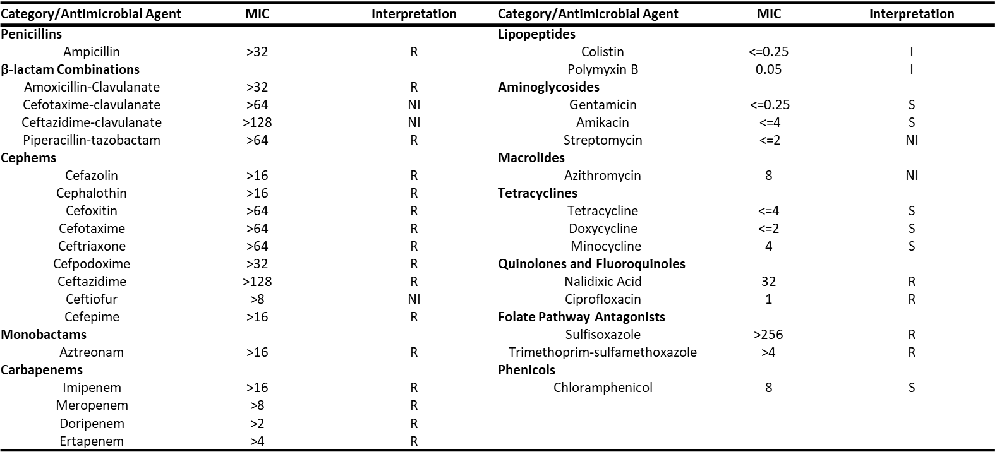
Supplemental Table 1. The antimicrobial minimal inhibitory concentration breakpoint values and their interpretations for the Raoultella ornithinolytica harboring both bla_{KPC-2} and bla_{NDM-5}. Abbreviations: R=resistant, I=Intermediate, S=susceptible, NI=no interpretation for the given antimicrobial tested.

