SF1. Genetic alterations in ZICs were associated with poor DFS in LGG patients.
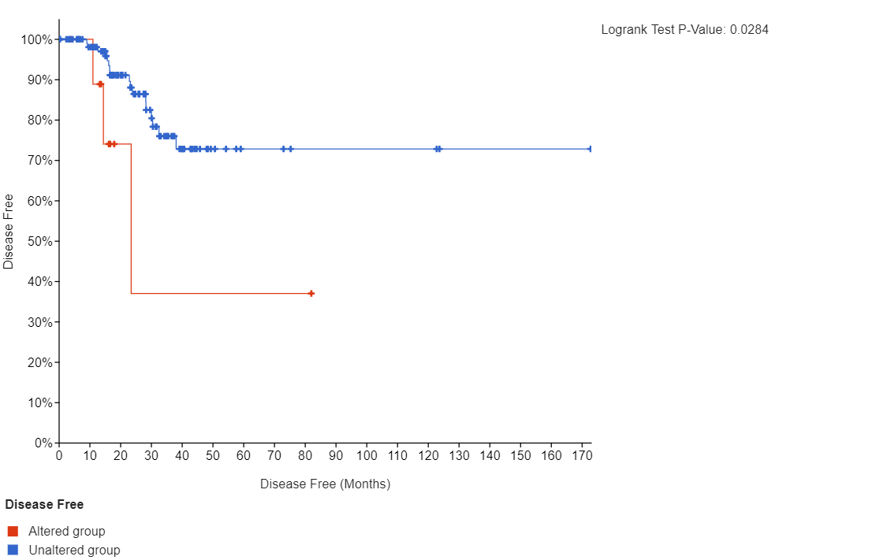

SF2. Enrichment analysis of ZIC3/5 and similar genes in glioma via Metascape. Heatmap of enriched terms across ZIC3/5, coloured by p-values(Top). Interactive networks of enriched terms(Bottom).
