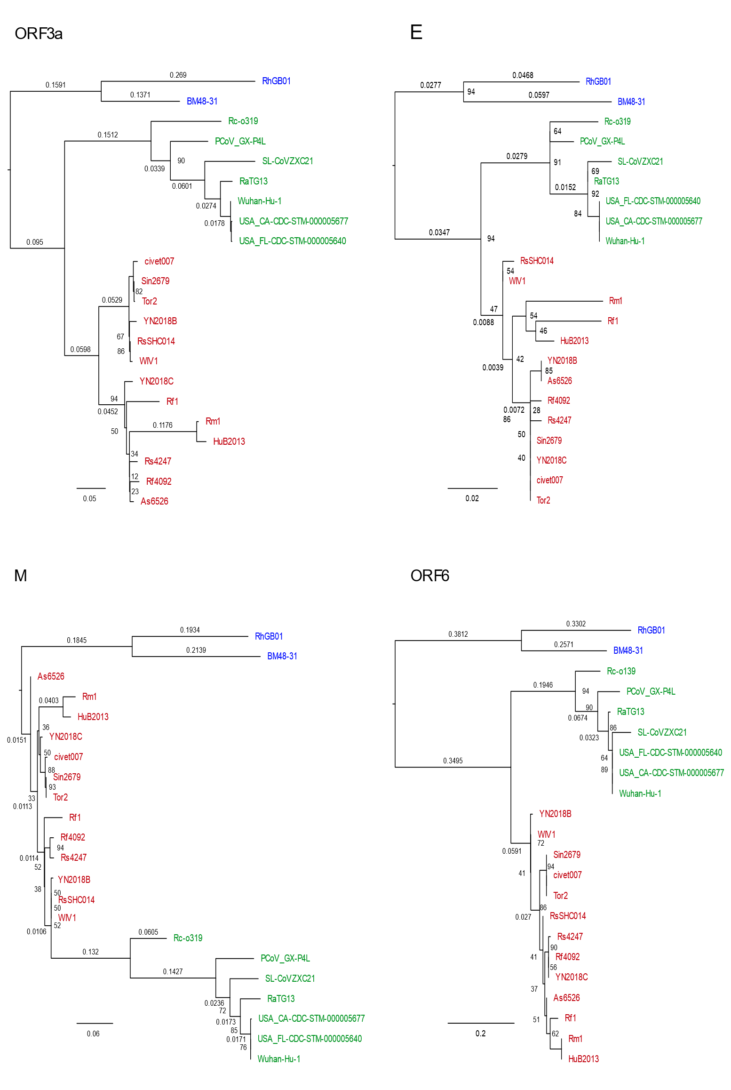
A.
ORF3a
E
M
ORF6

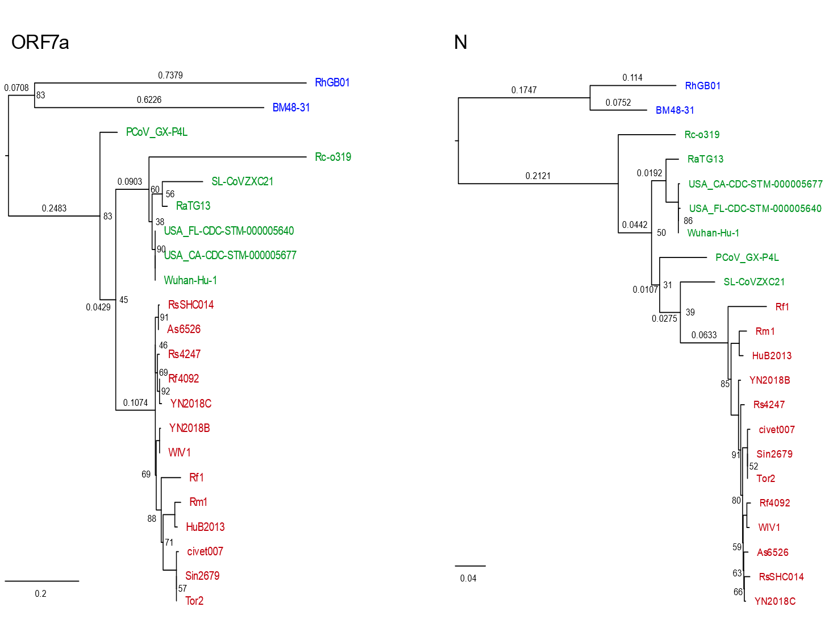
ORF7a
N

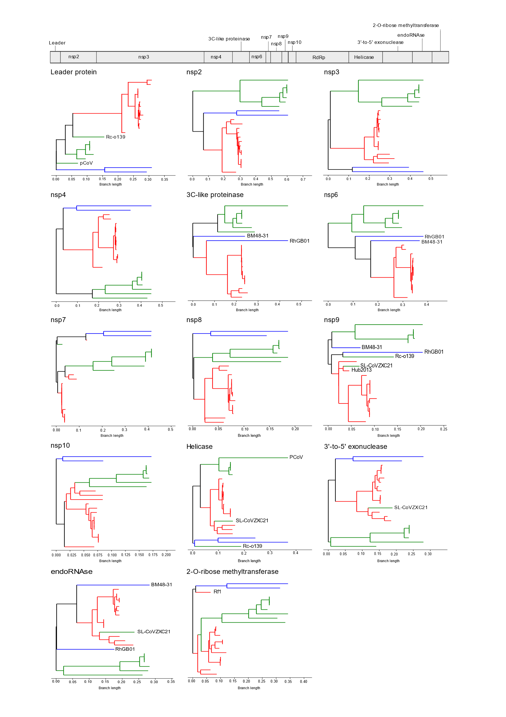
B.
Leader protein
nsp2
nsp3
nsp4
3C-like proteinase
nsp6

Supplementary figure 1.
Maximum likelihood phylogenies from nucleotide sequences of A) structural and accessory proteins and B) non-structural proteins. All phylogenies are midpoint rooted and for visualisation purposes, bootstrap support values >95 and branch lengths on closely related terminal branches are removed. Scales provided are substitutions per site per year. In all phylogenies, taxa in blue represent RhGB01 and BM48-31/BGR/2008, green are SARS-CoV and related and red are SARS-CoV-2 and related. ORF7b and ORF10 are omitted as the sequence is not long enough for meaningful phylogenetic inference.

nsp7
nsp8
nsp9
nsp10
Helicase
3’-to-5’ exonuclease
EndoRNAse
2’-O-ribose methyltransferase

