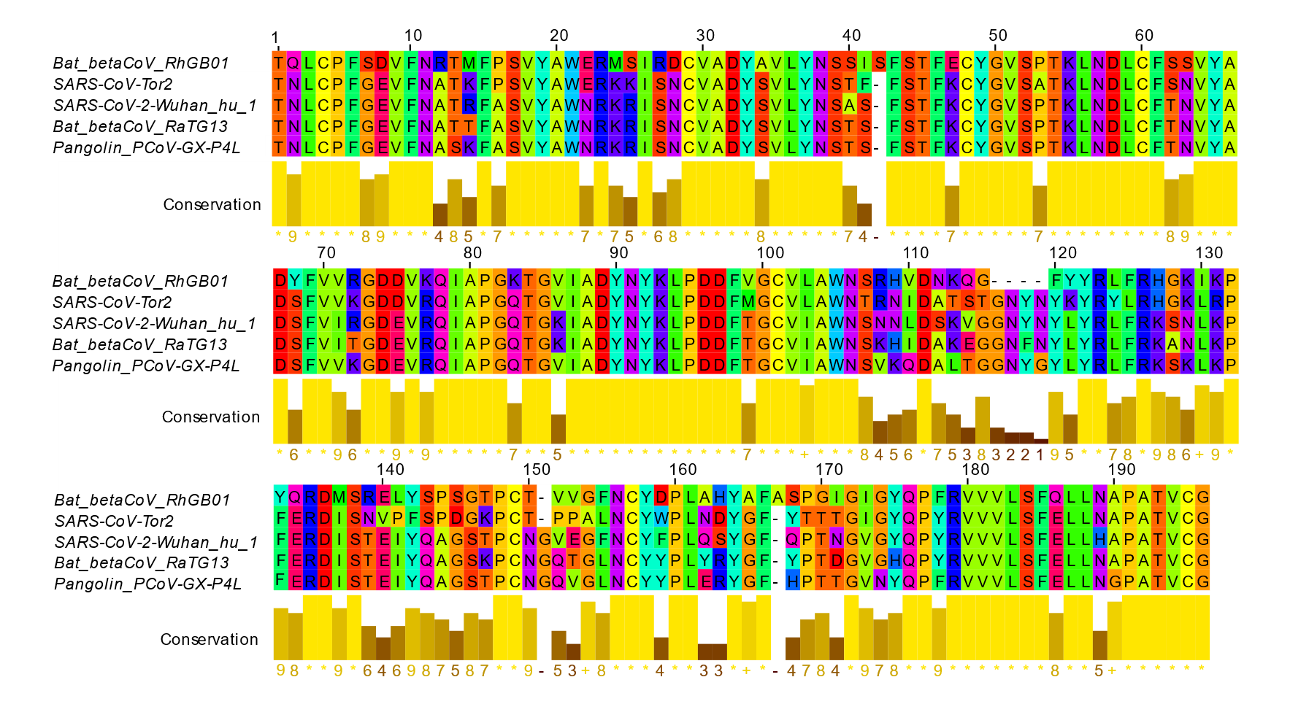
Supplementary Figure 2.
Amino acid homology between RhGB01, zoonotic SARSr-CoV, SARS-CoV and SARS-CoV-2 vary between the RBD and RBM. Conservation represents physiochemical properties of amino acid residues at that site.

