Additional Information

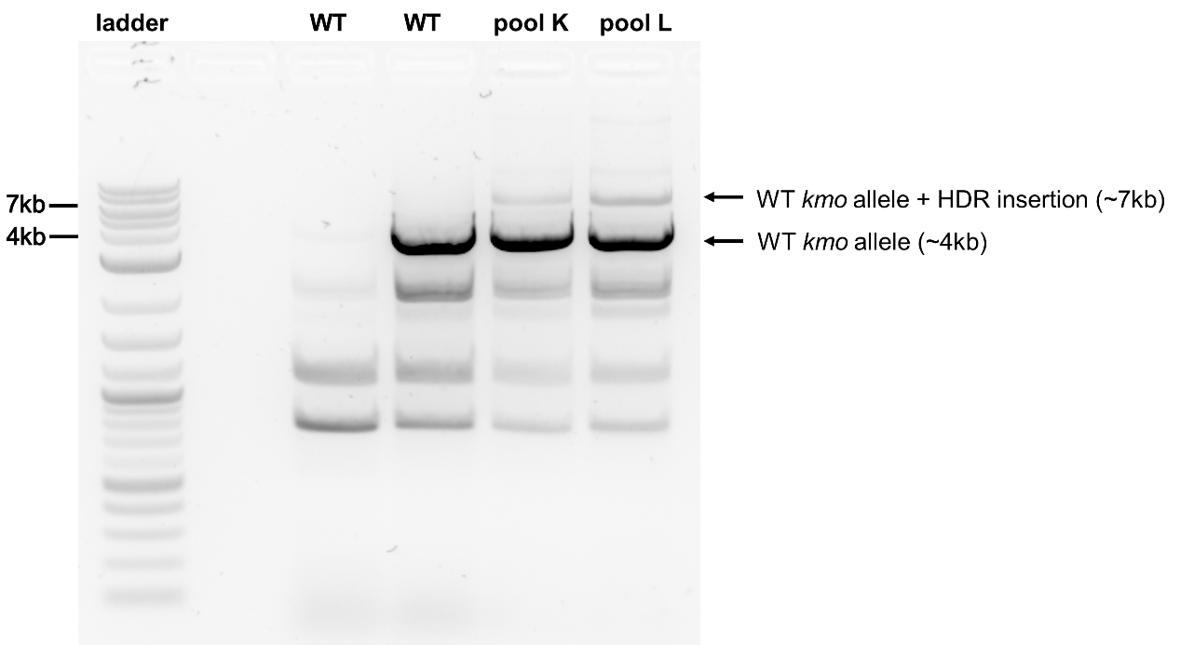

Figure S1. PCR confirmation of the kmo knock-in. Successful integration of the HDR construct into the kmo locus produced expected banding patterns along with additional seemingly non-specific amplicons. The amplicons of expected size for the kmo alleles were excised and sequence confirmed.

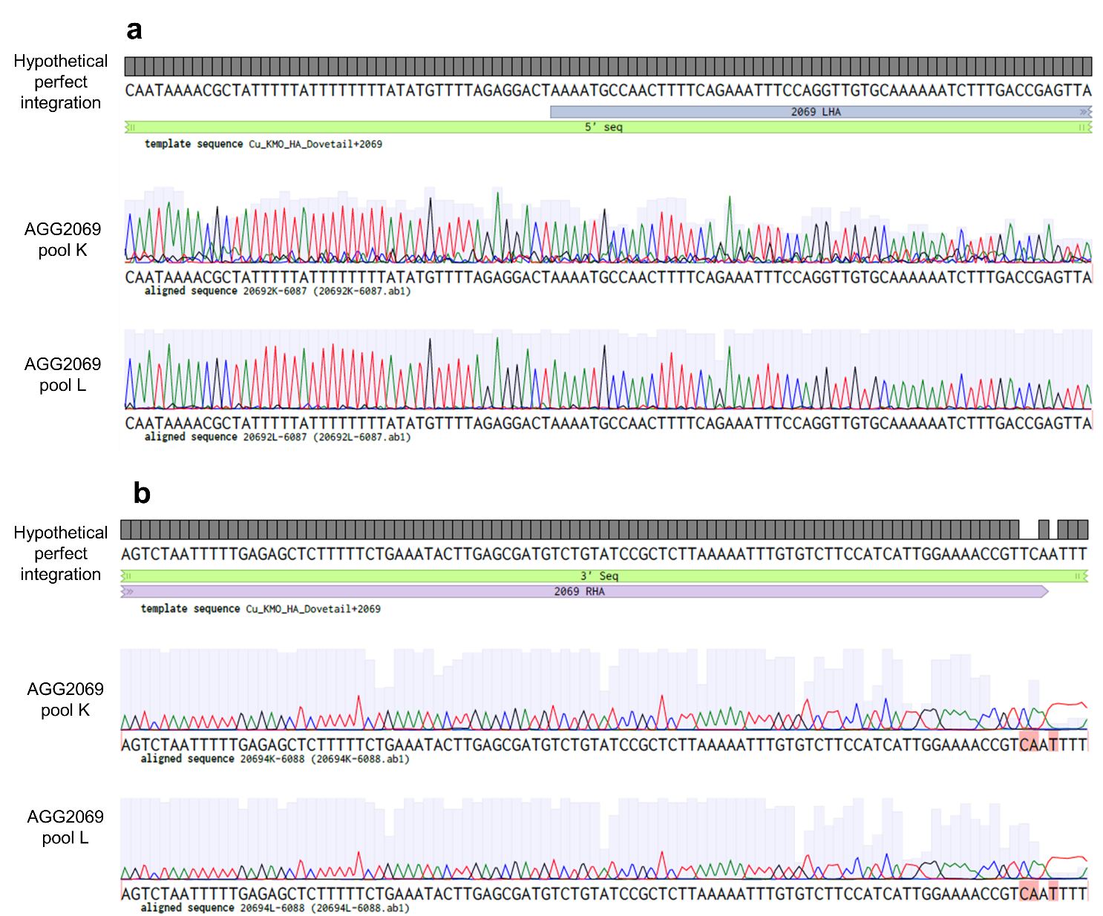

Figure S2. Sequence confirmation of the kmo knock-in. Sanger sequencing traces showing (a) the 5’ and (b) the 3’ junctions of the kmo knock-in cassette within the genome. In the 3’ junction, the reverse primer binds to the genomic region immediately adjacent to the right homology arm which resulted in poor quality basecalling (red highlighted bases) at the junction of the homology arm with the genome (b).

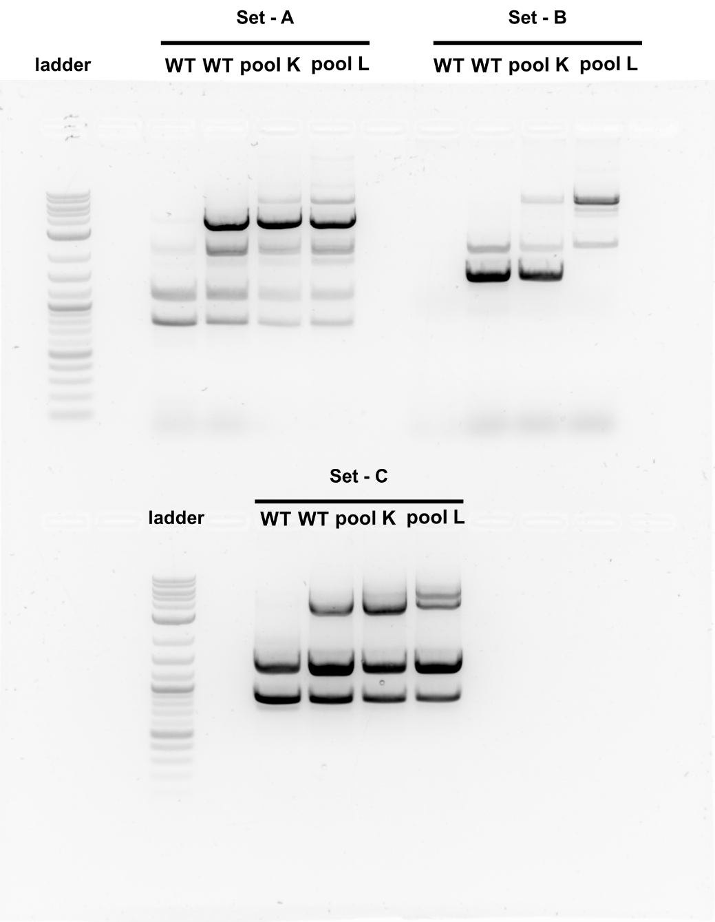

Figure S3. Testing of wild type kmo PCR primers. Set A, B & C – three different pairs of primers. PCR Primer Set-A gave the amplicons of expected size and the cropped image shown in supplementary figure S1.

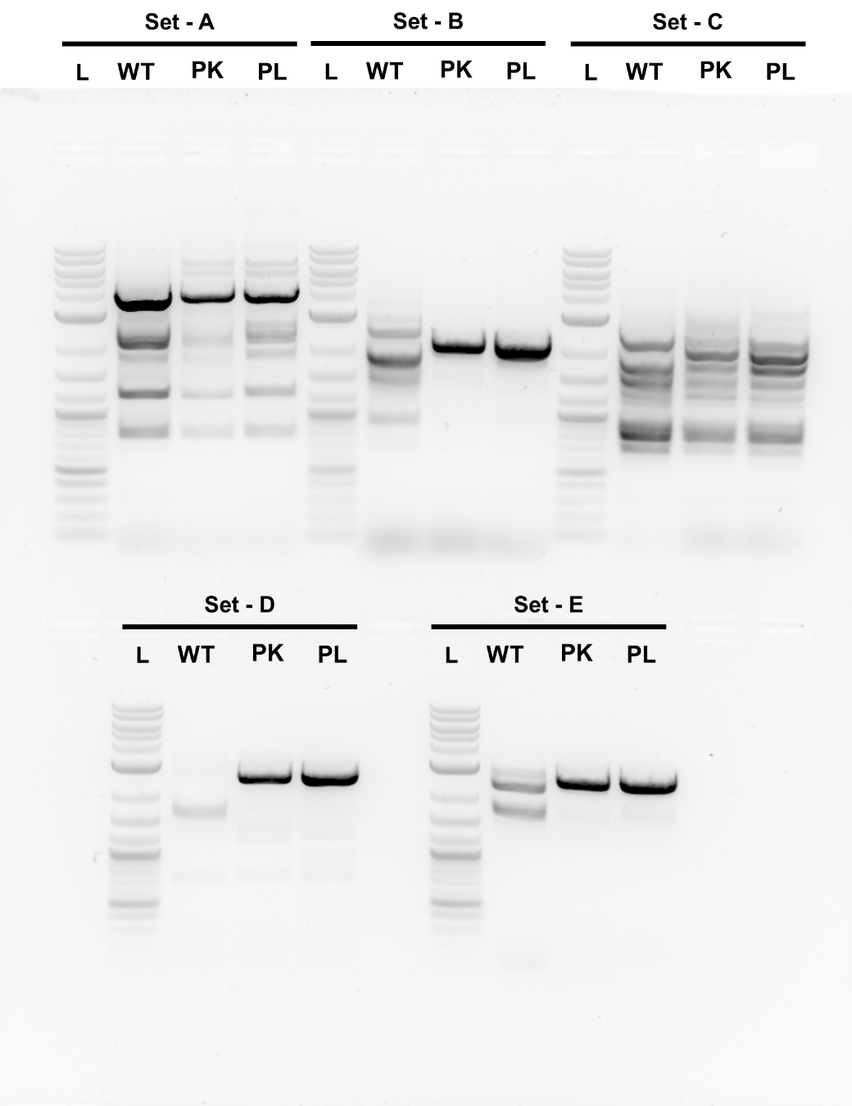
Figure S4. Testing of PCR primers of kmo knock-in. Set A, B & C – three different pairs of primers for amplification of Left Homology arm. Set – D & E – PCR primer pairs for amplifying RHA arm. PCR primer Set – B & D gave the amplicons of expected size and the cropped image shown in the figure 2.
Competing interests

The authors declare no competing interests.

