Circulating miRNA is a useful diagnostic biomarker for nonalcoholic steatohepatitis in nonalcoholic fatty liver disease

Tae Hyung Kim^{1,†}, Yoonseok Lee^{1, †}, Young-Sun Lee^{1,*}, Jeong-An Gim^{2,*}, Eunjung Ko¹, Sun Young Yim¹, Young Kul Jung¹, SeongHee Kang³, Moon Young Kim³, Hayeon Kim⁴, Baek-hui Kim⁴, Ji Hoon Kim¹, Yeon Seok Seo¹, Hyung Joon Yim¹, Jong Eun Yeon¹, Soon Ho Um¹, and Kwan Soo Byun¹

¹Department of Internal Medicine, Korea University Medical Center, Republic of Korea
²Medical Science Research Center, Korea University Medical Center, Republic of Korea
³Department of Internal Medicine, Wonju Severance Christian Hospital, Republic of Korea
⁴Department of Pathology, Korea University Medical Center, Republic of Korea

† These authors contributed equally to this work as first author.
*These authors contributed equally to this work as corresponding author.

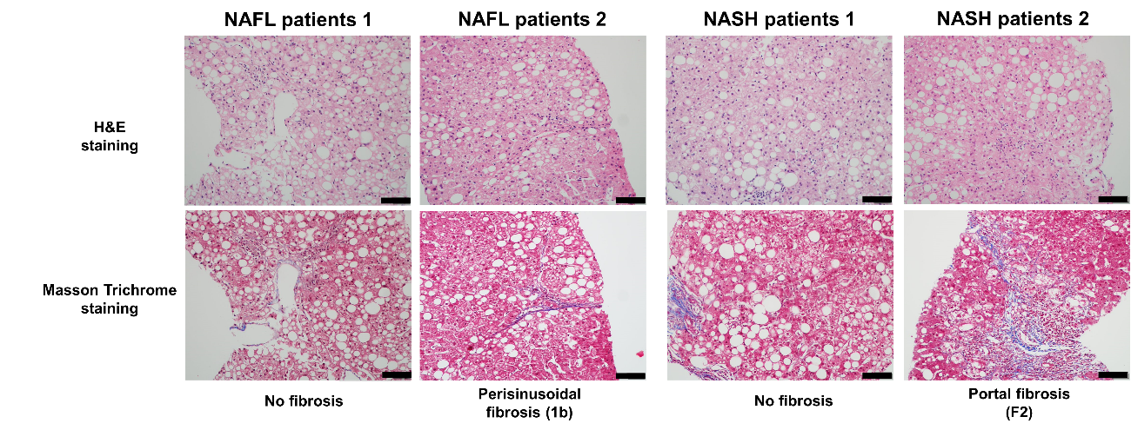
Supplementary Figure 1. Histopathological findings for NAFL and NASH groups. The bars in each micrograph represent 100μm.
NAFL, nonalcoholic fatty liver; NASH, nonalcoholic steatohepatitis; H&E, hematoxylin and eosin staining.

miRNA with significant difference of expression
(n = 38)
Abundant expression in NASH group
(n = 26)
miRNA with the top 25% expression in NASH group
(n = 8)
Expression ≥50% samples
(n = 435)
Total analyzed miRNA
(n = 2588)

Supplementary Figure 2. The selection process for miRNAs as a diagnostic biomarker for NASH.

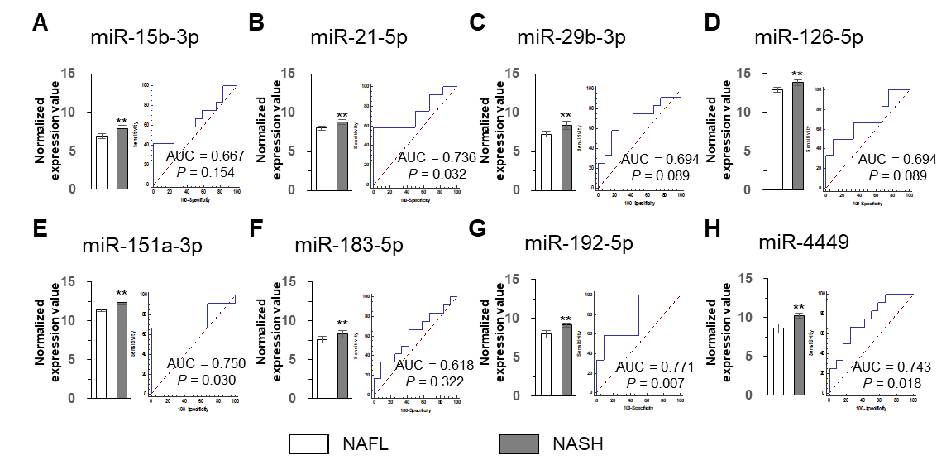
Supplementary Figure 3. Expression level and diagnostic receiving operating characteristic (ROC) curve of eight miRNAs for NASH diagnosis. The expression level of each miRNA represents normalized expression value.
** indicates P < 0.01 compared with the corresponding control.

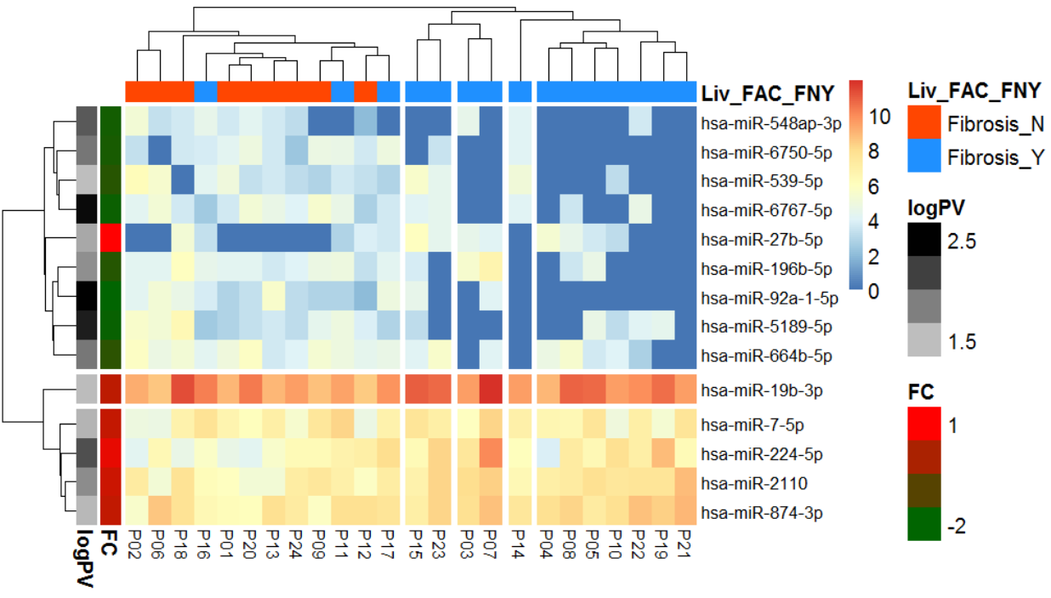
Supplementary Figure 4. Heatmap of miRNA expression profile in the sera of patients with and without fibrosis. Column annotation bar indicates two groups of disease (fibrosis and without fibrosis), and two-row annotation bars indicate P-value and fold change between two groups. In row annotation bars, black and red colors indicate the high significance and higher expression in the fibrosis group.

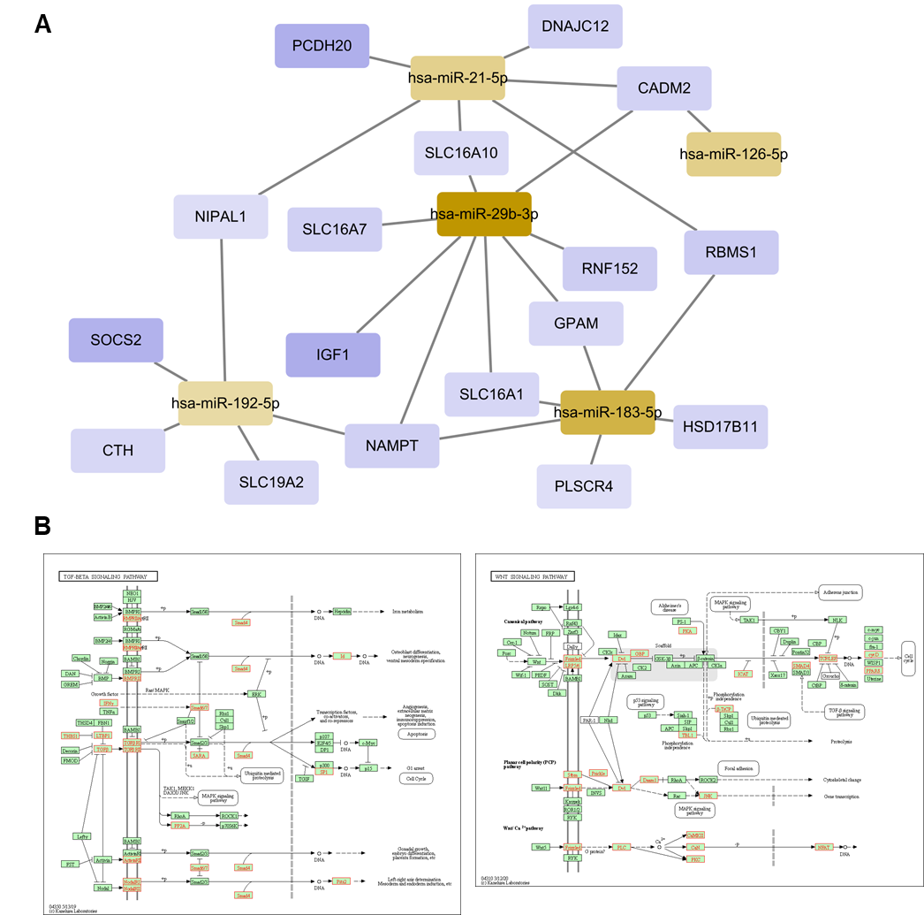
Supplementary Figure 5. Construction of miRNA–mRNA network. Global scheme of the network between patients with NAFL and patients with NASH are depicted (A). The ocherous color nodes denote highly expressed miRNAs, whereas the purple color nodes denote downregulated mRNAs in NASH. TGF-β and Wnt signaling pathways are indicated, and red nodes denote inhibited factors by eight miRNAs (B).
We received permission from Kanehisa Laboratories to use KEGG pathway map.

Supplementary Table 1. Baseline characteristics of validation cohort
Characteristics | NAFL  (n = 11) | NASH  (n = 26) | p- value
Age, median (IQR), years | 41.0 (37.0–43.5) | 48.5 (35.0–58.0) | 0.200
Male/Female | 9/2 (81.8/18.2) | 17/9 (65.4/34.6) | 0.544
DM, No. (%) | 1 (9.1) | 9 (34.6) | 0.233
HTN, No. (%) | 3 (27.3) | 12 (46.2) | 0.482
Dyslipidemia, No. (%) | 3 (27.3) | 10 (38.5) | 0.783
BMI, median (IQR), kg/m² | 25.90 (25.15–30.05) | 29.65 (26.89–35.60) | 0.144
Hb, median (IQR), g/dL | 14.70 (14.25–15.30) | 14.60 (13.60–15.20) | 0.752
PLT, median (IQR), × 10³/μL | 280 (262–287) | 240 (215–281) | 0.056
AST, median (IQR), IU/L | 29 (24–45) | 55 (33–72) | 0.029
ALT, median (IQR), IU/L | 53 (44–82) | 94 (45–129) | 0.207
ALP, median (IQR), IU/L | 75 (60–78) | 81 (72–90) | 0.096
GGT, median (IQR), IU/L | 38 (34–45) | 43 (30–94) | 0.352
Bilirubin, median (IQR), mg/dL | 0.90 (0.70–1.00) | 0.70 (0.60–0.90) | 0.202
Albumin, median (IQR), g/dL | 4.4 (4.2–4.5) | 4.3 (4.0–4.4) | 0.399
PT, median (IQR), INR | 0.91 (0.91–0.95) | 0.93 (0.91–0.98) | 0.472
Creatinine (IQR), mg/dL | 0.87 (0.73–0.91) | 0.87 (0.69–1.00) | 0.702
CRP (mg/L) | 1.40 (0.70–5.25) | 1.95 (1.10–3.70) | 0.653
Histological finding*
Steatosis score,  n (%) 0/1/2/3 | 0 (0%)/ 7 (63.6%)/  3 (27.3%)/ 1 (9.1%) | 0 (0%)/ 14 (53.8%)/  8 (30.8%)/ 4 (15.4%) | 0.823
Lobular inflammation score,  n (%) 0/1/2/3 | 0 (0.0%)/ 8 (72.7%)/  3 (27.3%)/ 0 (0%) | 0 (0.0%)/ 22 (84.6%)/  4 (15.4%)/ 0 (0%) | 0.281
Ballooning score,  n (%) 0/1/2 | 11 (100%)/  0 (0%)/ 0 (0%) | 0 (0%)/  22 (84.6%)/ 4 (15.4%) | < 0.001
NAFLD activity score  n (%) 2/3/4/5/6/7/8 | 7 (63.6%)/ 0 (0%)/ 3 (27.3%)/ 1 (9.1%)/ 0 (0%)/ 0 (0%)/ 0 (0%) | 1 (3.8%)/ 13 (50.0%)/ 3 (11.5%)/7 (26.9%)/2 (7.7%)/ 0 (0%)/ 0 (0%) | 0.001
Fibrosis stage,  n (%) 0/1/2/3/4 | 4 (36.4%)/ 7 (63.6%)/  0 (0%)/ 0 (0%)/ 0 (0%) | 6 (23.1%)/ 15 (57.7%)/  5 (19.2%)/ 0 (0%)/ 0 (0%) | 0.264
IQR, interquartile range; BMI, body mass index; DM, diabetes mellitus; HTN, hypertension; Hb, hemoglobin; PLT, platelet; AST, aspartate transaminase; ALT, alanine transaminase; ALP, alkaline phosphatase; PT, prothrombin time; INT, international normalized ratio; GGT, gamma glutamyl transferase; CRP, C-reactive protein
* Histological findings were analyzed based on NAFLD activity scores developed by NASH clinical research network.
Supplementary Table 2. The main KEGG pathways of the screened eight miRNAs
KEGG Term | Total genes of the term | Union targets in the term | Union miRNAs in the term | Score
Focal adhesion | 199 | 47 | 5 | 2.700
Pathway in cancer | 325 | 70 | 5 | 2.698
Small-cell lung cancer | 84 | 26 | 5 | 2.253
MAPK signaling pathway | 272 | 49 | 5 | 2.137
Amoebiasis | 105 | 32 | 4 | 2.106
Regulation of actin cytoskeleton | 213 | 40 | 5 | 2.006
ECM receptor interaction | 84 | 23 | 4 | 1.887
TGF-β signaling pathway | 84 | 19 | 4 | 1.867
Wnt signaling pathway | 150 | 31 | 5 | 1.824
Melanoma | 71 | 18 | 5 | 1.652
KEGG, Kyoto encyclopedia of genes and genomes; MAPK, mitogen-activated protein kinase; ECM, extracellular matrix; TGF, transforming growth factor

Supplementary Table 3. Primers used in quantitative real-time PCR
Name | Sequence (5′-3′)
miRNA
miR-21-5p | UAGCUUAUCAGACUGAUGUUGA
miR-151a-3p
  CUAGACUGAAGCUCCUUGAGG
miR-192-5p | CUGACCUAUGAAUUGACAGCC
miR-4449 | CGUCCCGGGGCUGCGCGAGGCA
U6 | GTGCTCGCTTCGGCAGCACATATACTAAAATTGGAACGATACAGAGAAGATTAGCATGGCCCCTGCGCAAGGATGACACGCAAATTCGTGAAGCGTTCCATATTTT

