Supplementary Information

Figure S1. Analysis of the spinosad production in S. spinosa ATCC_49460 and S3-3.

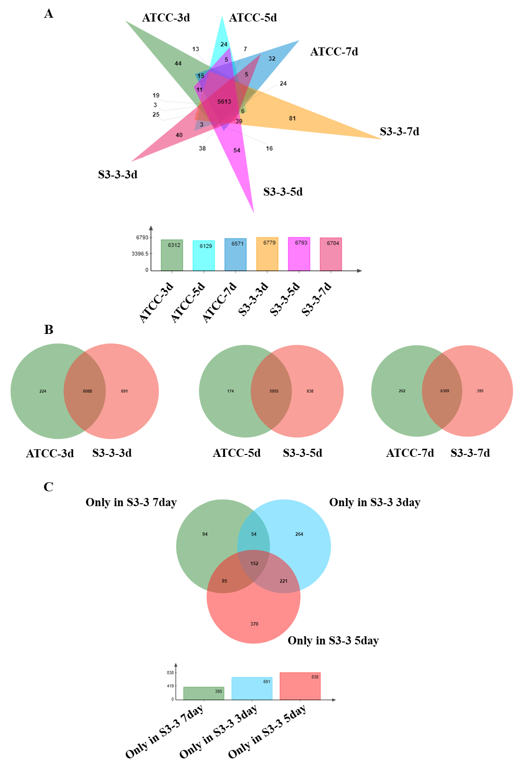Figure S2. The identification of the genes specifically expressed in S. spinosa S3-3 during fermentation periods.
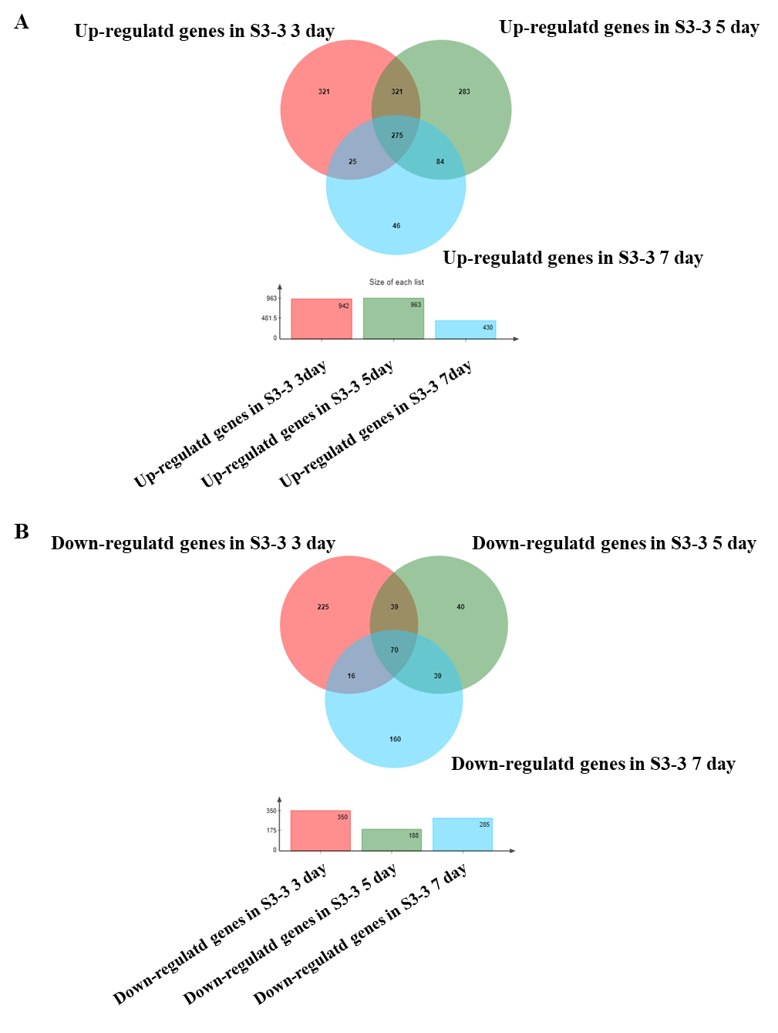
Figure S3. The identification of genes differentially expressed in S. spinosa S3-3.

