Supplementary Information

Solar UV–B/A Radiation is Highly Effective in Inactivating SARS-CoV-2

Authors:
Fabrizio Nicastro^{1*}, Giorgia Sironi², Elio Antonello², Andrea Bianco², Mara Biasin³, John R. Brucato⁴, Ilaria Ermolli¹, Giovanni Pareschi², Marta Salvati⁵, Paolo Tozzi⁴, Daria Trabattoni³, Mario Clerici⁶

Affiliations:

1 Italian National Institute for Astrophysics (INAF) – Rome Astronomical Observatory, Rome, Italy
2 Italian National Institute for Astrophysics (INAF) – Brera Astronomical Observatory, Milano/Merate, Italy
3 Department of Biomedical and Clinical Sciences L. Sacco, University of Milano, Milano, Italy
4 Italian National Institute for Astrophysics (INAF) – Arcetri Astrophysical Observatory, Firenze, Italy
5 Regional Agency for Environmental Protection of Lombardia (ARPA Lombardia), Milano, Italy
6 Department of Pathophysiology and Transplantation, University of Milano and Don C. Gnocchi Foundation, IRCCS, Milano, Italy

* E-mail: fabrizio.nicastro@inaf.it

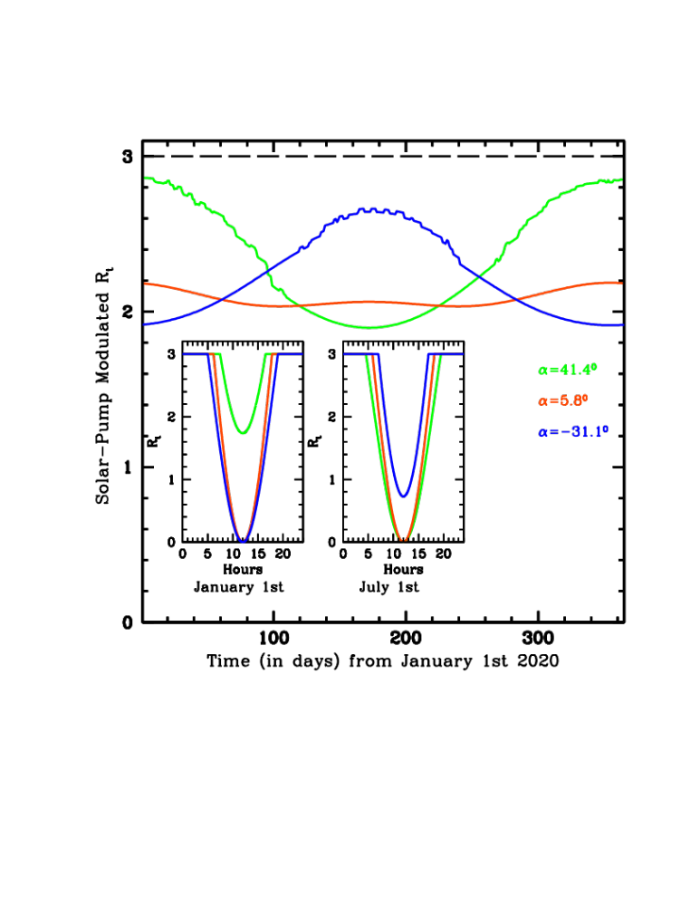
Supplementary Figure S1 Main panel: day-by-day yearly modulation imprinted by the solar mechanism on the intrinsic reproduction number R₀=3 of the epidemic (black horizontal dashed line), at the three average latitudes of the countries of our N (green curves), T (orange curves) and S (blue curves) groups. Onsets: infra-day solar-pump modulation of R_{o} at the three latitudes on January 1st (left onset) and July 1st (right onset) 2020, as labeled (see Methods for details).
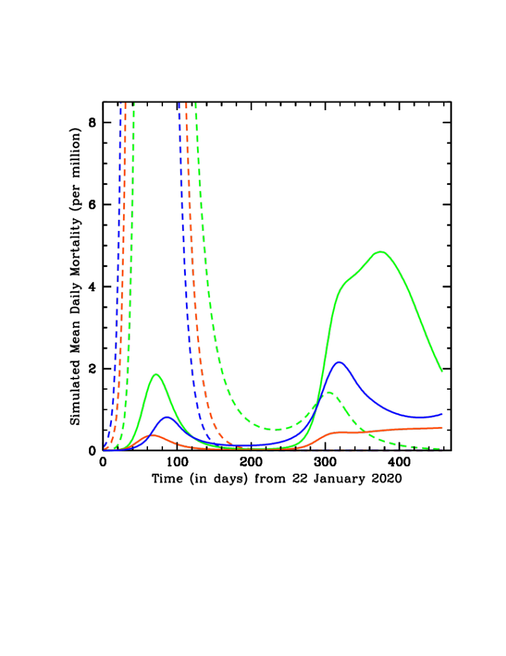
Supplementary Figure S2 Simulated mean daily mortality curves as a function of time, from 22 January 2020 through April 2021, with (solid curves) and without (dashed curves) the effect of the Solar-Pump (see Methods for details).

