Supplemental Figures 1

Clinical Utility of a Serum Biomarker Panel in Distinguishing Prostate Cancer from Benign Prostate Hyperplasia
Michael A. Kiebish¹, Poornima Tekumalla¹, Shobha Ravipaty¹, Albert Dobi^{2,3}, Shiv Srivastava^{2,4}, Wenfang Wu¹, Saurabh Patel¹, Tracey Friss¹, Allison Klotz¹, Alagarsamy Srinivasan^{2,3,5}, Jennifer Cullen^{2,3,6}, Inger L. Rosner^{2,7}, Amina Ali^{2,3}, Sandra Laszlo⁸, Michele Petrovic⁸, Neil Fleshner⁸, Jeonifer Garren¹, Greg Miller¹, Nischal Mahaveer Chand¹, Leonardo Rodrigues¹, Elder Granger¹, Mark D. Kellogg^{1,9}, Shen Luan¹, Eleftherios Diamandis¹⁰, Viatcheslav R. Akmaev¹, Rangaprasad Sarangarajan¹, Chas Bountra¹¹, Stephen Freedland¹², David G. McLeod^{2,14}, Niven R. Narain¹

¹BERG, Framingham, MA 01701, USA
² Center for Prostate Disease Research, John P. Murtha Cancer Center Research Program, Department of Surgery, Uniformed Services University of the Health Sciences and the Walter Reed National Military Medical Center, Bethesda, MD 20817, USA
³ Henry M. Jackson Foundation for the Advancement of Military Medicine Bethesda, Maryland, 20817 USA
⁴ Current: Department of Biochemistry and Molecular & Cell Biology, Georgetown University School of Medicine, Washington DC, 20057, USA
⁵ Current: Nano Bio Diagnostics LLC, West Chester, PA 19382, USA
⁶ Current: Case Comprehensive Cancer Center, Cleveland, OH 44106, USA
⁷ Current: Inova Health System, Fairfax, VA 22031, USA
⁸University Health Network, Toronto, ON M5G 2C4, Canada
⁹Department of Laboratory Medicine and Pathology, Harvard Medical School, Boston Children’s Hospital, Boston, MA, 02115, USA
¹⁰Mount Sinai Hospital, Toronto, ON, Canada M5T 3L9, Canada
¹¹Department of Clinical Medicine, University of Oxford, Oxford OX3 7LF, UK
¹²Center for Integrated Research in Cancer and Lifestyle, Cedar-Sinai, Los Angeles, CA 90048, USA
¹³Durham VA Medical Center, Durham, NC 27705, USA
¹⁴The co-author has passed away in December 2020

Supplemental Figure 1
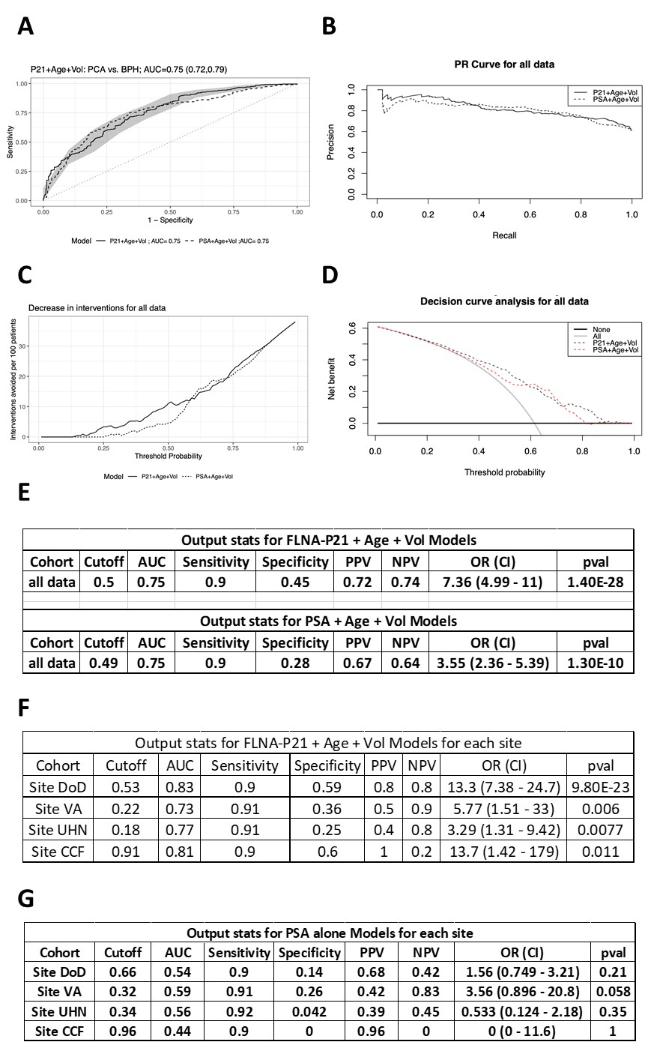
Supplemental Figure 1: FLNA Prostate Cancer Biomarker Panel Performs Better Than PSA combined with prostate volume and age.in Differentiating Patients with Lower Urinary Tract Symptoms (LUTS) or Benign Prostate Hyperplasia (BPH) from Prostate Cancer (PCa). (A) Combined ROC curve assessment. (B) Precision analysis, (C) Intervention analysis, and (D) decision curve analysis (E) statistical assessment comparing FLNA, prostate volume, and age with PSA, prostate volume, and age. (F) Comparison of FLNA, prostate volume and age panel across sites. (G) Comparison of PSA alone across sites.
Supplemental Figure 2
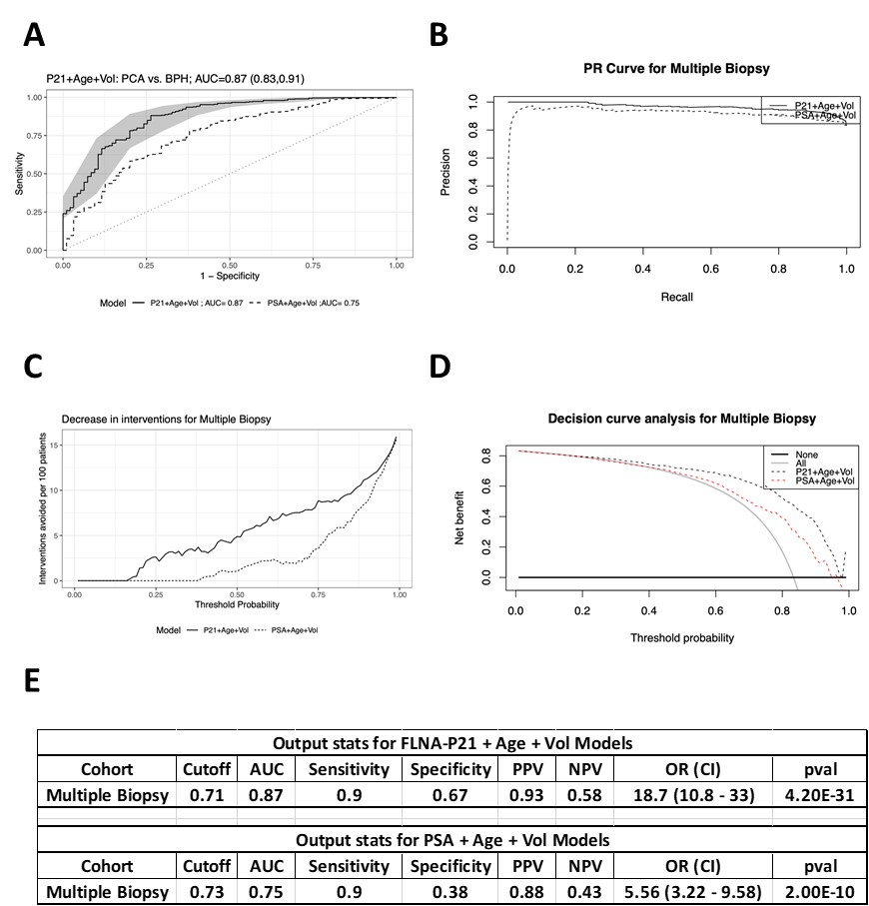

Supplemental Figure 2: FLNA Prostate Cancer Biomarker Panel Performs Better Than PSA combined with prostate volume and age.in preventing men with BPH/LUTS from having multiple biopsies. (A) Combined ROC curve assessment. (B) Precision analysis, (C) Intervention analysis, and (D) decision curve analysis (E) statistical assessment comparing FLNA, prostate volume, and age with PSA, prostate volume and age.

Supplemental Figure 3
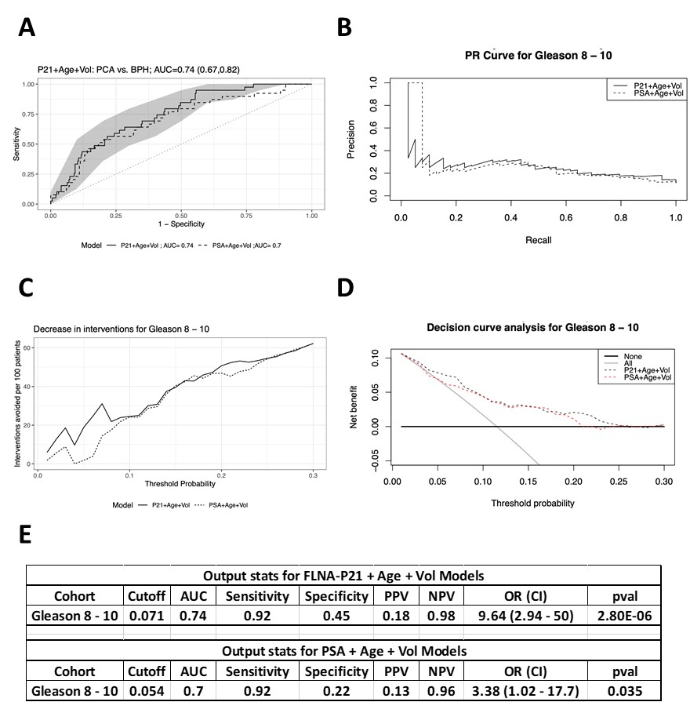

Supplemental Figure 3: FLNA Prostate Cancer Biomarker Panel Performs Better Than PSA combined with prostate volume and age.in detecting BPH/LUTS compared to Gleason 8-10 prostate cancers. (A) Combined ROC curve assessment. (B) Precision analysis, (C) Intervention analysis, and (D) decision curve analysis (E) statistical assessment comparing FLNA, prostate volume, and age with PSA, prostate volume, and age.

