Supplementary Figure 1.
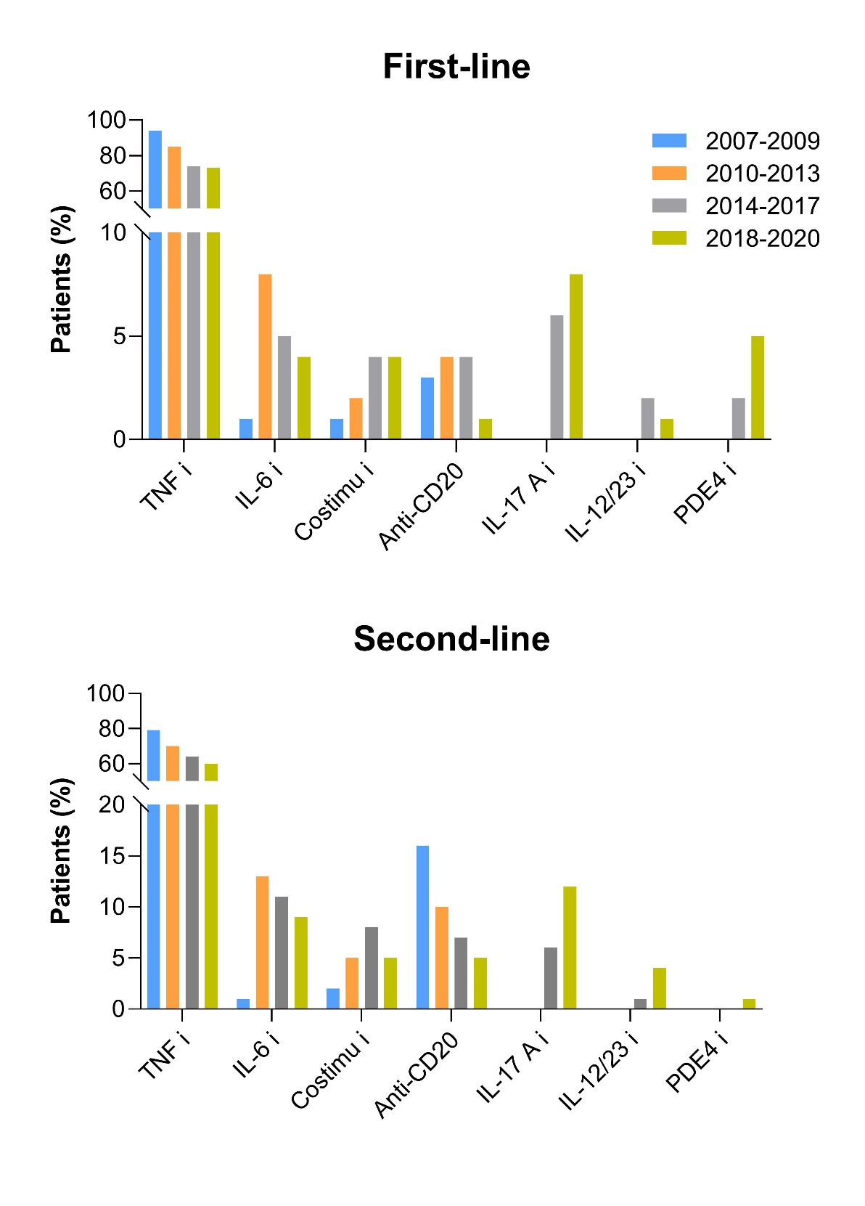
Figure legend: Distribution of bDMARD families used as first and second line of treatment over different time periods. Data are expressed as percentage of patients treated with each group of biologics in each period.
bDMARD, biologic disease-modifying anti-rheumatic drugs; IL-6 i, interleukin-6 inhibitors; TNF i, tumor necrosis factor inhibitors; Costimu i, costimulation inhibitors; IL-17A i : interleukin-17A inhibitors; IL-12/23 i, interleukin-12/23 inhibitor.

