Supplementary Figure 2.
A
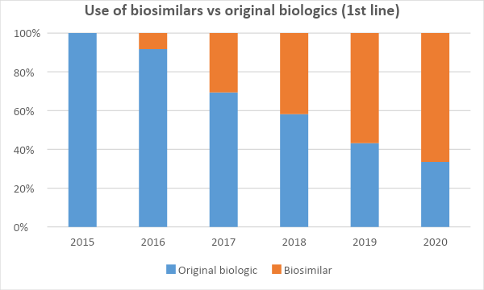
B
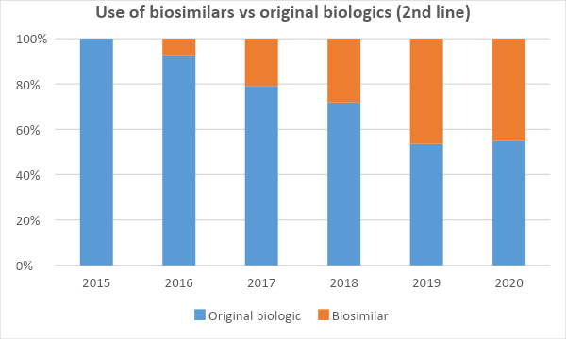

Figure legend: Evolution in the use of biosimilars since 2015. First- and second-line trends in the use of biological treatments. A) Impact of biosimilars on the use of bDMARDs as a first-line treatment. B) Impact of biosimilars on the use of bDMARDs as a second-line treatment.

