Local intestinal microbiota response and systemic effects of feeding black soldier fly larvae to replace soybean meal in growing pigs
Soumya K. Kar^{1*}, Dirkjan Schokker², Amy C. Harms^{3,4}, Leo Kruijt², Mari A. Smits², Alfons J. M. Jansman¹

¹ Wageningen Livestock Research, Animal Nutrition, Wageningen University & Research, Wageningen, The Netherlands
² Wageningen Livestock Research, Animal Breeding and Genomics, Wageningen University & Research, Wageningen, The Netherlands
³Netherlands Metabolomics Centre, Leiden University, Leiden, the Netherlands
⁴Department of Analytical Biosciences, Leiden University, Leiden, the Netherlands

* Correspondence: Dr. Soumya Kanti Kar, soumya.kar@wur.nl

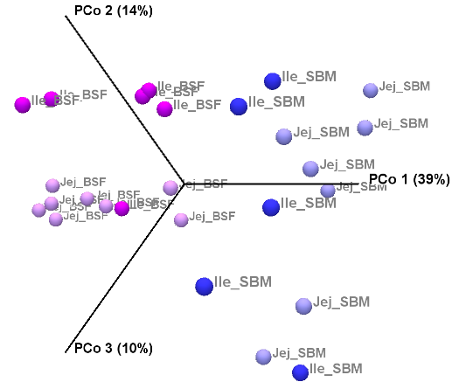

Supplementary figure S1. Beta diversity of intestinal microbiota seen as a 3D Principal Coordinate Analysis (PCoA). Relative abundance of the microbiome at genus level in jejunum (Jej) and ileum (Ile) digesta of pigs fed soybean meal (SBM) or black soldier fly (BSF) based diets.

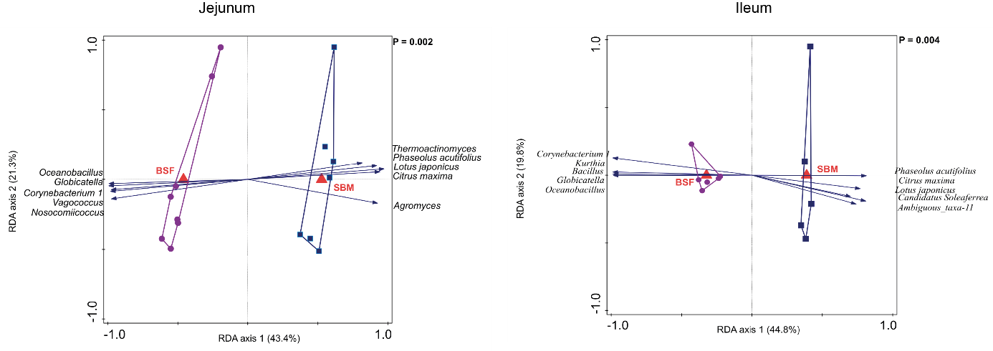
Supplementary figure 2. Redundancy analysis with microbial abundance at genus level in small intestinal digesta of pigs fed a diet with either soybean meal (SBM) or black soldier fly (BSF) as single protein source. Left panel depicts jejunum, where RDA axis 1 explains 43.4% and RDA axis 2 explains 21.3% of the variation. The right panel depicts ileum, where RDA axis 1 explains 44.8% and RDA axis 2 explains 19.8% of the variation). Samples are depicted by filled purple circles representing the BSF diet or filled blue squares representing the SBM diet, the averages are depicted by red triangles with their corresponding diet also in red.

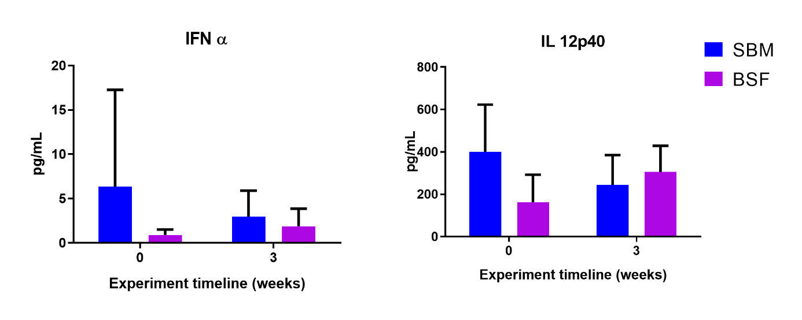
Supplementary figure S3. Cytokine and chemokine concentrations in blood plasma in response to diets with insect protein (BSF) or SBM as dietary protein source. Bar plots are mean values of the measured level of cytokine and chemokine in the treatment groups (n=8); whiskers are standard error mean. No significant (P<0.05) difference was observed in the experimental diets compared to SBM based diet. SBM, soybean meal; BSF, Black solider fly.

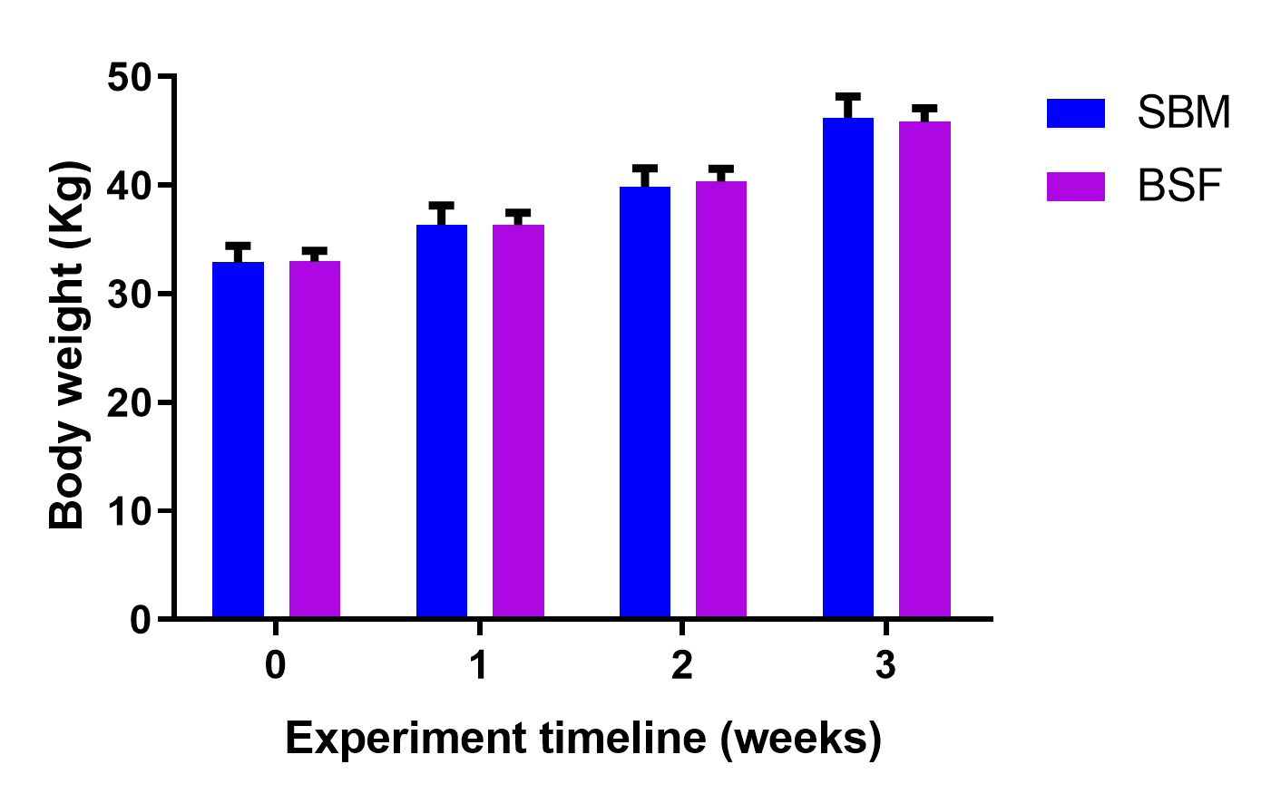

Supplementary figure S4. Average body weight in response to diets prepared with SBM or BSF as single protein source. Bar plots are mean values of the body weight (in kg) in the treatment groups (n=8); whiskers are standard error mean. No significant (P < 0.05) difference was observed in the experimental diets compared to SBM based diet. SBM, soybean meal; BSF, Black solider fly.

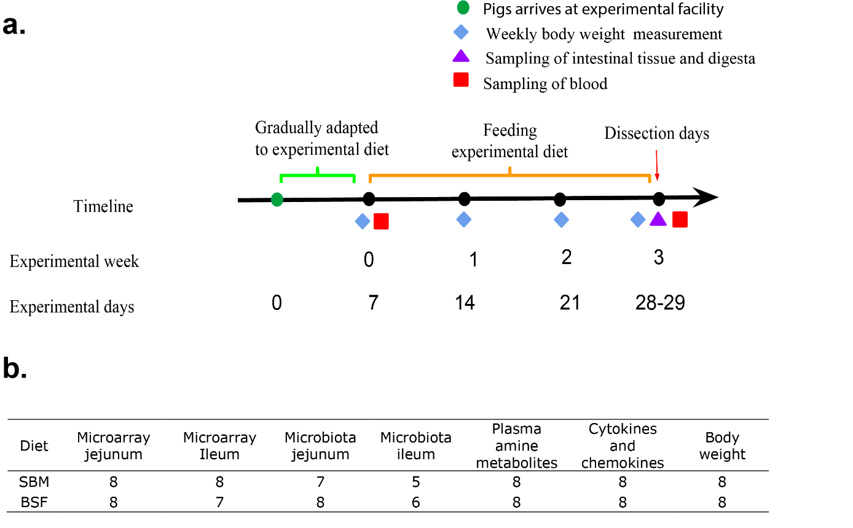
Supplementary figure S5. Schematic representation of the experimental design. (a) The solid black dot in the timeline represents the corresponding experimental days/age of the pig (weeks). Jejunal and ileal tissue and its digesta were used for transcriptome and microbiota analysis. Blood serum was collected for analysis of systemic immune signaling molecules and blood plasma collected on dissection day was analyzed for systemic amine metabolites. (b) The number of animals (biological replicates) per treatment in respective read-out parameters considered for this study.
Supplementary table S1. Table with sample information, read, and OTU counts. Number of reads after quality control and removal of chimeric sequences Number of OTUs at an identity threshold of 97%. SBM, soybean meal; BSF, Black solider fly.
Sample | Diet | Location | Total number of reads | Reads in OTUs | Number of OTUs
I15A_TAGGCATG-GCGTAAGA | SBM | Ileum | 438,002 | 354,966 | 516
J20E_CGTACTAG-AAGGAGTA | BSF | Jejunum | 599,160 | 334,287 | 976
I19A_CTCTCTAC-ACTGCATA | SBM | Ileum | 707,455 | 390,245 | 981
J21A_CGTACTAG-GCGTAAGA | SBM | Jejunum | 608,011 | 405,192 | 1400
J28E_AGGCAGAA-GTAAGGAG | BSF | Jejunum | 841,564 | 490,573 | 1534
J3E_TAAGGCGA-TATCCTCT | BSF | Jejunum | 444,095 | 241,863 | 1109
I22E_CTCTCTAC-AGAGTAGA | BSF | Ileum | 561,539 | 348,458 | 843
J12E_CGTACTAG-ACTGCATA | BSF | Jejunum | 520,804 | 276,556 | 926
I9E_TAGGCATG-TATCCTCT | BSF | Ileum | 334,667 | 216,817 | 832
I28E_CAGAGAGG-ACTGCATA | BSF | Ileum | 479,381 | 250,771 | 1031
J44E_GGACTCCT-CTCTCTAT | BSF | Jejunum | 497,480 | 261,455 | 967
J39A_TCCTGAGC-AAGGAGTA | SBM | Jejunum | 468,835 | 341,179 | 929
J2A_TAAGGCGA-CTCTCTAT | SBM | Jejunum | 496,854 | 346,390 | 1235
I21A_CTCTCTAC-TATCCTCT | SBM | Ileum | 510,098 | 287,637 | 792
J33E_TCCTGAGC-ACTGCATA | BSF | Jejunum | 624,328 | 402,230 | 1779
J15A_CGTACTAG-CTCTCTAT | SBM | Jejunum | 572,887 | 411,952 | 932
J42A_GGACTCCT-ACTGCATA | SBM | Jejunum | 592,991 | 451,847 | 1273
J9E_TAAGGCGA-GCGTAAGA | BSF | Jejunum | 541,928 | 285,271 | 1076
J19A_CGTACTAG-GTAAGGAG | SBM | Jejunum | 651,260 | 434,419 | 1374
I44E_GCTACGCT-CTCTCTAT | BSF | Ileum | 603,518 | 348,273 | 965
I20E_CTCTCTAC-CTCTCTAT | BSF | Ileum | 343,837 | 186,720 | 667
J22E_CGTACTAG-CTAAGCCT | BSF | Jejunum | 582,332 | 315,315 | 1273
J29A_AGGCAGAA-AAGGAGTA | SBM | Jejunum | 875,336 | 668,299 | 1886
I2A_GGACTCCT-AAGGAGTA | SBM | Ileum | 981,218 | 714,818 | 1041
I3E_GGACTCCT-GCGTAAGA | BSF | Ileum | 322,523 | 215,476 | 733
I39A_CAGAGAGG-GCGTAAGA | SBM | Ileum | 783,424 | 595,225 | 1298

Supplementary table S2. Transcriptomics response in the jejunal and ileal mucosa of pig fed diets with BSF relative to a diet with SBM
Tissue | Biological processes and pathways
 | Up-regulated (6) | Down-regulated (188)
Jejunum | KEGG metabolism of xenobiotics by cytochrome p450 | KEGG ECM receptor interaction
Jejunum | KEGG metabolism of xenobiotics by cytochrome p450 | KEGG focal adhesion
Jejunum | KEGG metabolism of xenobiotics by cytochrome p450 | Potassium ion transport
Jejunum | KEGG metabolism of xenobiotics by cytochrome p450 | Generation of neurons
Jejunum | KEGG metabolism of xenobiotics by cytochrome p450 | KEGG ribosome
Jejunum | KEGG metabolism of xenobiotics by cytochrome p450 | Neurite development
Jejunum | KEGG metabolism of xenobiotics by cytochrome p450 | Neurogenesis
Jejunum | KEGG metabolism of xenobiotics by cytochrome p450 | Cell-cell adhesion
Jejunum | KEGG metabolism of xenobiotics by cytochrome p450 | Neuron development
Jejunum | KEGG metabolism of xenobiotics by cytochrome p450 | Neuron differentiation
Jejunum | KEGG metabolism of xenobiotics by cytochrome p450 | Synaptic transmission
 | Up-regulated (31) | Down-regulated (55)
Ileum | KEGG tryptophan metabolism  KEGG PPAR signalling pathway | KEGG ECM receptor interaction
Ileum | KEGG tryptophan metabolism  KEGG PPAR signalling pathway | Neuron differentiation
Ileum | KEGG tryptophan metabolism  KEGG PPAR signalling pathway | Generation of neurons
Ileum | KEGG tryptophan metabolism  KEGG PPAR signalling pathway | Neurogenesis
Ileum | KEGG tryptophan metabolism  KEGG PPAR signalling pathway | Neurite development
Ileum | KEGG tryptophan metabolism  KEGG PPAR signalling pathway | Neuron development
Ileum | KEGG tryptophan metabolism  KEGG PPAR signalling pathway | Axonogenesis
Ileum | KEGG tryptophan metabolism  KEGG PPAR signalling pathway | Negative regulation of cellular protein metabolic process

Differential gene-sets enriched in Gene Set Enrichment Analysis (GSEA) corresponds to the biological processes and pathways. The number within parenthesis represents the core enriched genes (full list in File S2) within the differential enriched gene-sets in GSEA.

Supplementary table S3. T-test and fold changes values of differentially abundant amine metabolites increased in blood plasma of pigs fed a BSF diet compared to a SBM diet, based upon the results of heatmap and metabolic pathway analysis.
Amine metabolites | P-value | FDR | Fold change
Sarcosine | 6.67E-08 | 6.45E-07 | 5.6
Homocitrulline | 2.65E-06 | 1.92E-05 | 5.5
L-Alpha-aminobutyric acid | 5.71E-10 | 1.10E-08 | 5.0
L-Methionine | 5.60E-09 | 7.39E-08 | 2.8
S-Methylcysteine | 2.57E-11 | 1.49E-09 | 2.6
O-Acetyl-L-serine | 6.37E-09 | 7.39E-08 | 2.3
L-Valine | 1.30E-10 | 3.78E-09 | 2.1
L-Methionine sulfoxide | 1.30E-06 | 1.07E-05 | 2.1
Taurine | 0.0011426 | 0.0047336 | 1.6

