Genomic insights into the antibiotic resistance pattern of the tetracycline-degrading bacterium, Arthrobacter nicotianae OTC-16
Xin Zhang^{a,#,*}, Rongrong Zhu^{a,b,#}, Weilin Li^{a,b}, Junwei Ma^{b} , Hui Lin^{b,*},
ª College of Forest and Biotechnology, Zhejiang A & F University, Hangzhou 311300, China
^{b} The Institute of Environment, Resources, Soil and Fertilizers, Zhejiang Academy of Agricultural Sciences, Hangzhou 310021, China

# Equal contributions thus sharing first authorship.
* Corresponding authors at: College of Forest and Biotechnology, Zhejiang A&F University, Tel: +86-571-61069780, E-mail address: zhangxins@126.com (X. Zhang); The Institute of Environment, Resources, Soil and Fertilizers, Zhejiang Academy of Agricultural Sciences, Tel: +86-571-86404302, Fax: +86-571-86404302, E-mail address: linhui@zaas.ac.cn (H. Lin)

Captions
Table S1 ARGs information of strain OTC-16
Table S2. The distribution of ARGs among sequenced Arthrobacter nicotianae strains
Figure S1 GO function annotation distribution map of strain OTC-16

Table S1 ARGs information of strain OTC-16
Location | Gene_id | Subject_id | Gene_  type | Antibiotic_  resistance | Original_  Resistance_Type
Chromosome | ZAF-05GL000241 | ardb_2199 | tetv | tetracycline | tet_efflux
Chromosome | ZAF-05GL000615 | ardb_115 | vanre | vancomycin | vane
Chromosome | ZAF-05GL000913 | ardb_1951 | cml_e6 | chloramphenicol | cml
Chromosome | ZAF-05GL001175 | ardb_2604 | cara | lincosamide,streptogrammacrolide | mls_abc
Chromosome | ZAF-05GL001392 | ardb_2322 | bcra | bacitracin | bcr
Chromosome | ZAF-05GL001549 | ardb_2778 | catb3 | chloramphenicol | catb
Chromosome | ZAF-05GL002124 | ardb_2395 | vanrc | vancomycin | vanc
Chromosome | ZAF-05GL003407 | ardb_2606 | bcra | bacitracin | bcr
Plasmid1 | ZAF-05GL003435 | ardb_598 | tet33 | tetracycline | tet_efflux
Plasmid1 | ZAF-05GL003441 | ardb_571 | sul1 | sulfonamide | sul
Plasmid1 | ZAF-05GL003442 | ardb_2203 | ant2ia | tobramycin,kanamycin,  sisomicin,dibekacin,  gentamicin | ant
Plasmid1 | ZAF-05GL003445 | ardb_598 | tet33 | tetracycline | tet_efflux
Plasmid1 | ZAF-05GL003450 | ardb_571 | sul1 | sulfonamide | sul
Plasmid1 | ZAF-05GL003451 | ardb_2203 | ant2ia | tobramycin,kanamycin,  sisomicin,dibekacin,  gentamicin | ant
Plasmid1 | ZAF-05GL003527 | ardb_1888 | cml_e8 | chloramphenicol | cml
Plasmid2 | ZAF-05GL003540 | ardb_598 | tet33 | tetracycline | tet_efflux
Plasmid2 | ZAF-05GL003544 | ardb_571 | sul1 | sulfonamide | sul
Plasmid2 | ZAF-05GL003545 | ardb_2200 | ant2ia | tobramycin,kanamycin,  sisomicin,dibekacin,  gentamicin | ant
Plasmid2 | ZAF-05GL003548 | ardb_598 | tet33 | tetracycline | tet_efflux
Plasmid2 | ZAF-05GL003552 | ardb_571 | sul1 | sulfonamide | sul
Plasmid2 | ZAF-05GL003553 | ardb_2200 | ant2ia | tobramycin,kanamycin,  sisomicin,dibekacin,  gentamicin | ant
Plasmid2 | ZAF-05GL003556 | ardb_598 | tet33 | tetracycline | tet_efflux
Plasmid2 | ZAF-05GL003560 | ardb_571 | sul1 | sulfonamide | sul

Table S2 The distribution of ARGs among sequenced Arthrobacter nicotianae strains
Gene_id | Gene_  type | Gene_Location (gene identity)
Gene_id | Gene_  type | Strain OTC-16 |  | Strain ZM05 |  | StrainNBRC14234
Gene_id | Gene_  type | Chromosome | Plasmid | Chromosome  （Identities %） | Plasmid | Chromosome  （Identities %）
ZAF-05GL000241 | tv | + |  | + (96.78%)
ZAF-05GL000615 | vanre | + |  | + (100% )
ZAF-05GL000913 | cml_e6 | + |  | + ( 98.56%)
ZAF-05GL001175 | cara | + |  | + (99.24% )
ZAF-05GL001392 | bcra | + |  | + (94.25% ) |  | + (94.17% )
ZAF-05GL001549 | catb3 | + |  | + (98.44% ) |  | + (98.23% )
ZAF-05GL002124 | vanrc | + |  | + (99.41% )
ZAF-05GL003407 | bcra | +
ZAF-05GL003435 | tet33 |  | +
ZAF-05GL003441 | sul1 |  | +
ZAF-05GL003442 | ant2ia |  | +
ZAF-05GL003445 | tet33 |  | +
ZAF-05GL003450 | sul1 |  | +
ZAF-05GL003451 | ant2ia |  | +
ZAF-05GL003527 | cml_e8 |  | +
ZAF-05GL003540 | tet33 |  | +
ZAF-05GL003544 | sul1 |  | +
ZAF-05GL003545 | ant2ia |  | +
ZAF-05GL003548 | tet33 |  | +
ZAF-05GL003552 | sul1 |  | +
ZAF-05GL003553 | ant2ia |  | +
ZAF-05GL003556 | tet33 |  | +
ZAF-05GL003560 | sul1 |  | +
+：The ARGs exist in the location; Identities %: the homology of ARGs of other sequenced Arthrobacter nicotianae strains compared with the strain OTC-16.

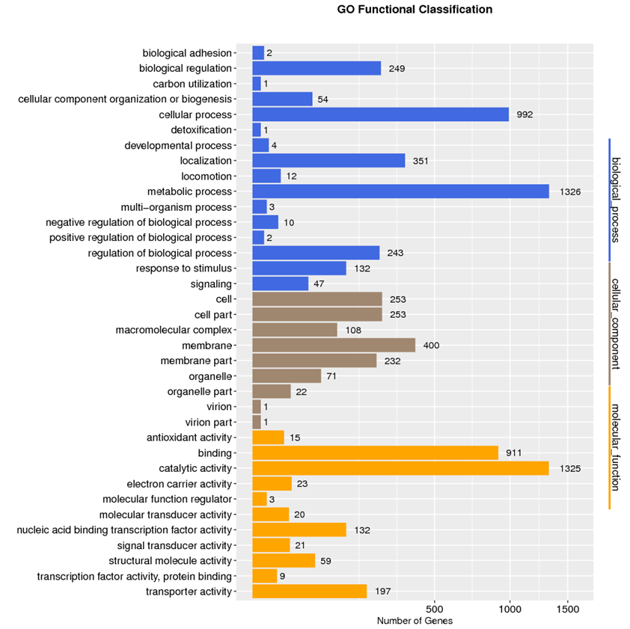
Figure S1 GO function annotation distribution map of strain OTC-16

