Heavy-Ion Production of ⁷⁷Br and ⁷⁶Br
Sean R. McGuinness¹⁺, John T. Wilkinson¹, and Graham F. Peaslee¹
⁺Corresponding Author, smcguinn@nd.edu
¹Department of Physics, University of Notre Dame, Notre Dame, IN 46556

Supplemental

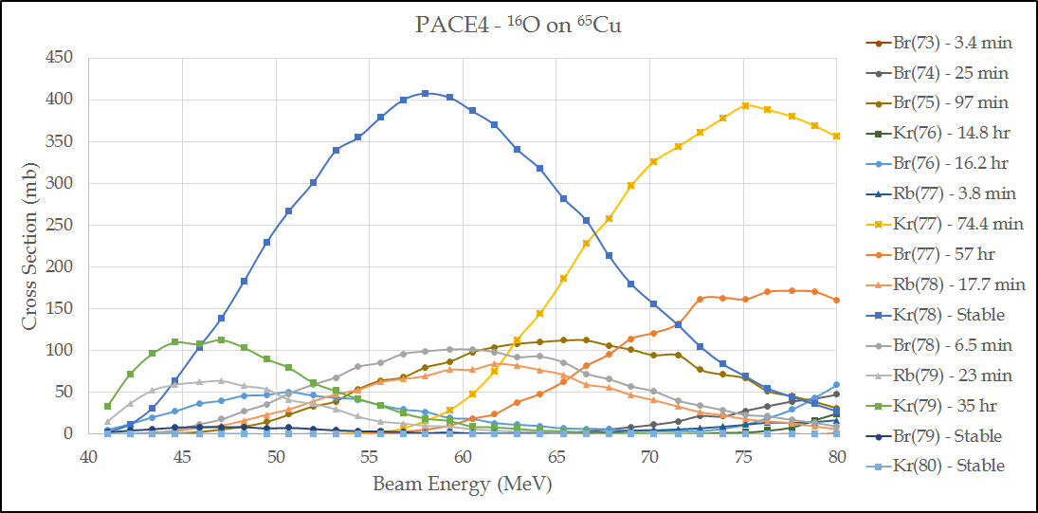
Figure 10 - PACE4 predicted cross sections for ¹⁶O on ⁶⁵Cu.

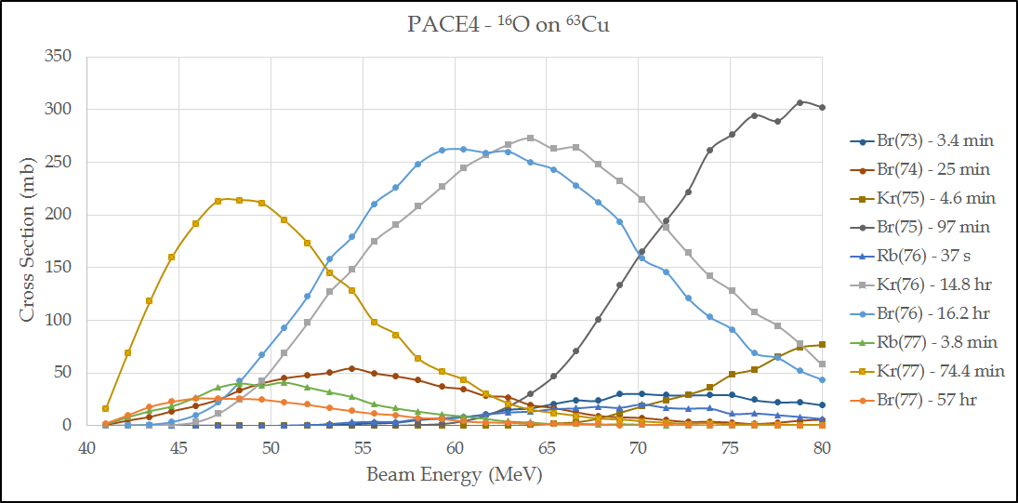
Figure 11 - PACE4 predicted cross sections for ¹⁶O on ⁶³Cu.
Table 4 - Residual Gamma Peaks
Radionuclide | Energies (keV) | Runs
^{77/77m}Br | 105.9, 249.8, 281.7, 297.2 | 1,2
⁷⁶Kr | 45.5, 252.0, 406.5 | 2
⁷⁵Se | 136, 264.7, 400.7 | 1,2
⁶⁷Cu | 93.3, 184.6 | 2
^{78/78m}Rb | 455.0, 664.4 | 1,2,3
⁷⁹Kr | 261.3, 306.1 | 1,2
⁷⁷Rb | 66.5 | 1,2,3
⁷⁴Br | 634.8 | 3
⁷⁵Br | 286.5 | 3
⁷⁶Br | 559.1 | 3
⁷⁷Kr | 311.9 | 3
^{77m}Se? | 161.9 | 1
¹³⁷CS | 661.7 | 1,2,3
²²⁴Th? | 409.8 | 1,2
Atomic Pb | 88.0 | 1
Unknown | 176 | 1,2,3
Unknown | 201 | 1,2
Unknown | 387.7 | 1
Unknown | 443 | 1,2
Unknown | 564 | 1

