Supplementary Information

Supplementary Table 1: Correlation analysis between various SARS-CoV-2 assays used in the study
Targets | CDC_N1Ct | CDC_N2Ct | LDT_N1 | LDT_N3 | IVD_N | IVD_orf
CDC_N1Ct | 1.000 | 0.995 | 0.958 | 0.957 | 0.958 | 0.893
CDC_N2Ct |  | 1.000 | 0.969 | 0.968 | 0.970 | 0.914
LDT_N1 |  |  | 1.000 | 0.999 | 0.997 | 0.911
LDT_N3 |  |  |  | 1.000 | 0.997 | 0.906
IVD_N |  |  |  |  | 1.000 | 0.921
IVD_orf |  |  |  |  |  | 1.000

Supplementary Table 2: Comparison of Ct values of the study samples from three independent SARS-CoV-2 assays

Samples | Ct values for
Samples | CDC |  | LDT * |  | IVD *
Samples | N1 | N2 | N1 | N3 | N | orf
KY-9A06 | 18.09 | 17.38 | 17.5 | 16.6 | NT | NT
KY-9A10 | 13.3 | 11.58 | 14 | 12.9 | NT | NT
KY-28D08 | 14.34 | 14.84 | 15.7 | 14.1 | 17.1 | 15.3
KY-28F11 | 15.66 | 15.4 | 16.4 | 15.3 | 19.1 | 17.3
KY-29G02 | 15.38 | 15.77 | NT | NT | NT | NT
KY-50G10 | 14.08 | 12.87 | 18.1 | 16.6 | 19.9 | 18.3
KY-52D08 | 14.53 | 13.01 | 18.6 | 17 | 19.3 | 17.6
KY-63G09 | 15.18 | 13.21 | NT | NT | NT | NT
KY-37H09 | 18.52 | 19.05 | 20.5 | 19.4 | 21.6 | 19.9
KY-39C07 | 18.53 | 18.39 | 20.1 | 18.8 | 21.3 | 19.4
KY-48H07 | 19.91 | 19.96 | NT | NT | 24.3 | 22.7
KY-51C11 | 17.76 | 17.41 | 19.2 | 18.4 | 22.1 | 20.4
KY-03G06 | 18.48 | 17.57 | 20.9 | 19.7 | 22.9 | 21
KY-48D04 | 21.13 | 21.93 | 24.1 | 22.9 | 24.4 | 22.6
KY-48E10 | 20.02 | 20.45 | NT | NT | NT | NT
KY-51C03 | 22.97 | 23.43 | 23.5 | 22.9 | 25.2 | 23.2
KY-52F02 | 21.85 | 20.96 | 26.1 | 24.9 | 25.9 | 23.7
KY-53C10 | 20.89 | 20.27 | 23 | 21.7 | 23.3 | 21.3
KY-9E09 | 25.59 | 25.3 | 25.5 | 24.2 | NT | NT
KY-39C10 | 28.36 | 29.49 | 29.5 | 28.3 | 31.5 | 45
KY-50F07 | 25.89 | 25.46 | NT | NT | NT | NT
KY-51H11 | 26.78 | 26.59 | 29.5 | 28.5 | 29.7 | 26.6
KY-52D06 | 27.33 | 27.97 | NT | NT | NT | NT
KY-53B02 | 28.65 | 30.01 | 31.3 | 29.6 | 32.2 | 45
KY-37A05 | 33.55 | 35.65 | 37 | 36.9 | 36.5 | 45
KY-37D02 | 34.06 | 37.63 | Neg | Neg | Neg | Neg
KY-37F04 | 29.43 | 30.93 | 31.4 | 30 | 32.2 | 28.4
KY-39H02 | 33.89 | 35.82 | Neg | Neg | Neg | Neg
KY-51H03 | 35 | 37.54 | NT | NT | NT | NT
KY-37A01 | Neg | Neg | Neg | Neg | Neg | Neg
KY-37A03 | Neg | Neg | Neg | Neg | Neg | Neg
KY-37A07 | Neg | Neg | NT | NT | NT | NT
KY-37A09 | Neg | Neg | NT | NT | NT | NT
KY-37B01 | Neg | Neg | NT | NT | NT | NT

Samples for LDT and IVD analysis were 2-fold diluted in media (DMEM with 2% FBS)
NT : Not tested
Neg : Negative. For CDC and IVD assays, Ct > 39 were considered negative samples. For the LDT assays cut-offs of 38 and 37 were used for N1 and N3, respectively.

Supplementary Table 3: Top 20 down-regulated genes for Top50% groups compared to the NegCtrl groups

Ensembl ID | Gene Symbol|Description | Log₂FC | P-value | Q-value
ENSG00000130176 | CNN1|calponin 1 | -4.750 | 3.904e-11 | 9.102e-07
ENSG00000140332 | TLE3|transducin like enhancer of split 3 | -1.193 | 2.399e-07 | 0.001
ENSG00000236969 | GGT8P|gamma-glutamyltransferase 8 pseudogene | -3.810 | 1.566e-06 | 0.003
ENSG00000164778 | EN2|engrailed homeobox 2 | -2.838 | 6.194e-06 | 0.009
ENSG00000142910 | TINAGL1|tubulointerstitial nephritis antigen like 1 | -2.163 | 7.893e-06 | 0.009
ENSG00000167751 | KLK2|kallikrein related peptidase 2 | -2.504 | 1.174e-05 | 0.013
ENSG00000108387 | SEPT4|septin 4 | -2.491 | 1.323e-05 | 0.014
ENSG00000167748 | KLK1|kallikrein 1 | -2.830 | 2.042e-05 | 0.020
ENSG00000124493 | GRM4|glutamate metabotropic receptor 4 | -2.573 | 2.078e-05 | 0.020
ENSG00000226979 | LTA|lymphotoxin alpha | -3.045 | 2.690e-05 | 0.024
ENSG00000132879 | FBXO44|F-box protein 44 | -1.623 | 3.512e-05 | 0.027
ENSG00000140479 | PCSK6|proprotein convertase subtilisin/kexin type 6 | -2.032 | 4.393e-05 | 0.029
ENSG00000160951 | PTGER1|prostaglandin E receptor 1 | -3.183 | 5.042e-05 | 0.030
ENSG00000105419 | MEIS3|Meis homeobox 3 | -2.408 | 5.768e-05 | 0.032
ENSG00000211895 | IGHA1|immunoglobulin heavy constant alpha 1 | -3.016 | 5.877e-05 | 0.032
ENSG00000143297 | FCRL5|Fc receptor like 5 | -2.455 | 5.903e-05 | 0.032
ENSG00000012124 | CD22|CD22 molecule | -2.665 | 6.155e-05 | 0.032
ENSG00000116337 | AMPD2|adenosine monophosphate deaminase 2 | -1.407 | 7.689e-05 | 0.038
ENSG00000224373 | IGHV4-59|immunoglobulin heavy variable 4-59 | -3.121 | 8.641e-05 | 0.041
ENSG00000124772 | CPNE5|copine 5 | -2.270 | 8.732e-05 | 0.041

Supplementary Table 4: Top 20 Enriched Gene Ontology biological processes identified using Cluster Profiler.
GO ID | Description | P Value | Q Value | Count
GO:0007611 | learning or memory | 1.25E-08 | 5.04E-05 | 92
GO:0023061 | signal release | 1.80E-08 | 5.04E-05 | 143
GO:0048167 | regulation of synaptic plasticity | 3.07E-08 | 5.04E-05 | 68
GO:0060337 | type I interferon signaling pathway | 4.83E-08 | 5.04E-05 | 43
GO:0071357 | cellular response to type I interferon | 4.83E-08 | 5.04E-05 | 43
GO:0042391 | regulation of membrane potential | 6.62E-08 | 5.04E-05 | 125
GO:0034340 | response to type I interferon | 7.10E-08 | 5.04E-05 | 44
GO:0050804 | modulation of chemical synaptic transmission | 7.16E-08 | 5.04E-05 | 130
GO:0099177 | regulation of trans-synaptic signaling | 8.44E-08 | 5.28E-05 | 130
GO:0007215 | glutamate receptor signaling pathway | 1.08E-07 | 6.09E-05 | 41
GO:0050890 | cognition | 1.20E-07 | 6.13E-05 | 100
GO:0006836 | neurotransmitter transport | 1.58E-07 | 7.44E-05 | 87
GO:1903305 | regulation of regulated secretory pathway | 1.97E-07 | 8.56E-05 | 56
GO:0034765 | regulation of ion transmembrane transport | 2.24E-07 | 9.03E-05 | 144
GO:0099643 | signal release from synapse | 2.48E-07 | 9.32E-05 | 60
GO:0007269 | neurotransmitter secretion | 4.67E-07 | 0.000 | 59
GO:0034341 | response to interferon-gamma | 5.05E-07 | 0.000 | 66
GO:1902803 | regulation of synaptic vesicle transport | 5.42E-07 | 0.000 | 36
GO:0045069 | regulation of viral genome replication | 6.76E-07 | 0.000 | 42
GO:2000300 | regulation of synaptic vesicle exocytosis | 8.09E-07 | 0.000 | 34

Supplementary Table 5: Kruskal Wallis analysis of the microbial composition at the phylum level in four patient groups. Bayesian Q-value and FDR values: *<0.05, Trending= (0.051-0.07) and NS – not significant
Phylum | Mild vs. NegCtrl |  | Mild vs. Severe |  | Moderate vs. NegCtrl |  | Severe vs. NegCtrl |  | Mild vs. Moderate |  | Moderate vs. Severe
Phylum | Q-value | FDR | Q-value | FDR | Q-value | FDR | Q-value | FDR | Q-value | FDR | Q-value | FDR
Actinobacteria | * | NS | * | Trending | NS | NS | NS | NS | NS | NS | NS | NS
Viruses_noname | * | * | * | Trending | NS | NS | NS | NS | NS | NS | NS | NS
Pisuviricota | * | NS | * | Trending | NS | NS | NS | NS | NS | NS | NS | NS
Bacteroidetes | * | NS | Trending | NS | NS | NS | NS | NS | NS | NS | NS | NS
Synergistetes | * | NS | NS | NS | NS | NS | NS | NS | NS | NS | NS | NS
Proteobacteria | * | Trending | NS | NS | NS | NS | NS | NS | NS | NS | NS | NS
Firmicutes | * | * | Trending | NS | NS | NS | NS | NS | NS | NS | NS | NS
Ascomycota | NS | NS | * | Trending | NS | NS | NS | NS | NS | NS | NS | NS
Spirochaetes | NS | NS | NS | NS | NS | NS | NS | NS | NS | NS | NS | NS
Candidatus_  Saccharibacteria | NS | NS | * | Trending | NS | NS | NS | NS | NS | NS | NS | NS
Fusobacteria | NS | NS | * | Trending | NS | NS | NS | NS | NS | NS | NS | NS

Supplementary Table 6: Kruskal Wallis analysis for microbial families in four patient groups. Bayesian Q-value and FDR values: *<0.05, Trending= (0.051-0.07) and NS – not significant
Families | Mild vs. NegCtrl |  | Mild vs. Moderate |  | Mild vs. Severe |  | Moderate vs. NegCtrl |  | Severe vs. NegCtrl |  | Moderate vs. Severe
Families | Q-value | FDR | Q-value | FDR | Q-value | FDR | Q-value | FDR | Q-value | FDR | Q-value | FDR
Pseudomonadaceae | * | Trending | NA | NA | NA | NA | NA | NA | NA | NA | NA | NA
Bacillales_noname | * | NA | NA | NA | NA | NA | NA | NA | NA | NA | NA | NA
Lactobacillaceae | * | Trending | NA | NA | NA | NA | NA | NA | NA | NA | NA | NA
Coronaviridae | * | NA | NA | NA | NA | NA | NA | NA | NA | NA | NA | NA
Bifidobacteriaceae | * | NA | NA | NA | NA | NA | NA | NA | NA | NA | NA | NA
Micrococcaceae | * | NA | NA | NA | Trending | NA | NA | NA | NA | NA | NA | NA
Thermoanaerobacterales  _f_III_Incertae_Sedis | * | Trending | NA | NA | NA | NA | NA | NA | NA | NA | NA | NA
Gallionellaceae | * | NA | NA | NA | NA | NA | NA | NA | NA | NA | NA | NA
Aerococcaceae | * | NA | NA | NA | NA | NA | NA | NA | NA | NA | NA | NA
Alphaflexiviridae | * | NA | NA | NA | NA | NA | NA | NA | NA | NA | NA | NA
Paramyxoviridae | * | NA | NA | NA | NA | NA | NA | NA | NA | NA | NA | NA
Myoviridae | * | NA | NA | NA | NA | NA | NA | NA | NA | NA | NA | NA
Togaviridae | * | Trending | NA | NA | NA | NA | NA | NA | NA | NA | NA | NA
Clostridiales_f_XI_Incertae  _Sedis | * | NA | NA | NA | NA | NA | NA | NA | NA | NA | NA | NA
Streptococcaceae | * | Trending | NA | NA | NA | NA | NA | NA | NA | NA | NA | NA
Carnobacteriaceae | * | NA | NA | NA | NA | NA | NA | NA | NA | NA | NA | NA
Lachnospiraceae | * | NA | NA | NA | NA | NA | NA | NA | NA | NA | NA | NA
Veillonellaceae | * | NA | NA | NA | Trending | NA | NA | NA | NA | NA | NA | NA
Peptostreptococcaceae | NS | NA | NA | NA | * | * | NA | NA | NA | NA | NA | NA
Dermatophilaceae | NS | NA | NA | NA | Trending | NA | NA | NA | NA | NA | NA | NA
Saccharomycetales_noname | NS | NA | NA | NA | Trending | NA | NA | NA | NA | NA | NA | NA
Actinomycetaceae | NS | NA | NA | NA | Trending | NA | NA | NA | NA | NA | NA | NA
Retroviridae | NS | NA | NA | NA | NA | NA | NA | NA | NA | NA | NA | NA
Microbacteriaceae | NS | NA | NA | NA | NA | NA | NA | NA | NA | NA | NA | NA
Spirochaetaceae | NS | NA | NA | NA | NA | NA | NA | NA | NA | NA | NA | NA
Cardiobacteriaceae | NS | NA | NA | NA | NA | NA | NA | NA | NA | NA | NA | NA
Bacteroidetes_noname | NS | NA | NA | NA | NA | NA | NA | NA | NA | NA | NA | NA
Propionibacteriaceae | NS | NA | NA | NA | NA | NA | NA | NA | NA | NA | NA | NA
Potyviridae | NS | NA | NA | NA | NA | NA | NA | NA | NA | NA | NA | NA
Moraxellaceae | NS | NA | NA | NA | NA | NA | NA | NA | NA | NA | NA | NA
Eubacteriaceae | NS | NA | NA | NA | NA | NA | NA | NA | NA | NA | NA | NA
Synergistaceae | NS | NA | NA | NA | NA | NA | NA | NA | NA | NA | NA | NA
Porphyromonadaceae | NS | NA | NA | NA | NA | NA | NA | NA | NA | NA | NA | NA
Brevibacteriaceae | NS | NA | NA | NA | Trending | NA | NA | NA | NA | NA | NA | NA
Campylobacteraceae | NS | NA | NA | NA | NA | NA | NA | NA | NA | NA | NA | NA
Clostridiales_f_  XIII_Incertae_Sedis | NS | NA | NA | NA | Trending | NA | NA | NA | NA | NA | NA | NA
Candidatus_  Saccharibacteria_noname | NS | NA | NA | NA | Trending | NA | NA | NA | NA | NA | NA | NA
Neisseriaceae | NS | NA | NA | NA | NA | NA | NA | NA | NA | NA | NA | NA
Erysipelotrichaceae | NS | NA | NA | NA | Trending | NA | NA | NA | NA | NA | NA | NA
Enterobacteriaceae | NS | NA | NA | NA | Trending | NA | NA | NA | NA | NA | NA | NA
Bromoviridae | NS | NA | NA | NA | NA | NA | NA | NA | NA | NA | NA | NA
Corynebacteriaceae | NS | NA | NA | NA | NA | NA | NA | NA | NA | NA | NA | NA
Leptotrichiaceae | NS | NA | NA | NA | NA | NA | NA | NA | NA | NA | NA | NA
Flavobacteriaceae | NS | NA | NA | NA | NA | NA | NA | NA | NA | NA | NA | NA
Staphylococcaceae | NS | NA | NA | NA | NA | NA | NA | NA | NA | NA | NA | NA
Fusobacteriaceae | NS | NA | NA | NA | NA | NA | NA | NA | NA | NA | NA | NA
Pasteurellaceae | NS | NA | NA | NA | NA | NA | NA | NA | NA | NA | NA | NA
Enterococcaceae | NS | NA | NA | NA | NA | NA | NA | NA | NA | NA | NA | NA
Burkholderiaceae | NS | NA | NA | NA | NA | NA | NA | NA | NA | NA | NA | NA
Coriobacteriaceae | Trending | NA | NA | NA | Trending | NA | NA | NA | NA | NA | NA | NA
Prevotellaceae | Trending | NA | NA | NA | NA | NA | NA | NA | NA | NA | NA | NA

Supplementary Figure 1: PCoA plot for metagenomics beta diversity based on JACCARD index
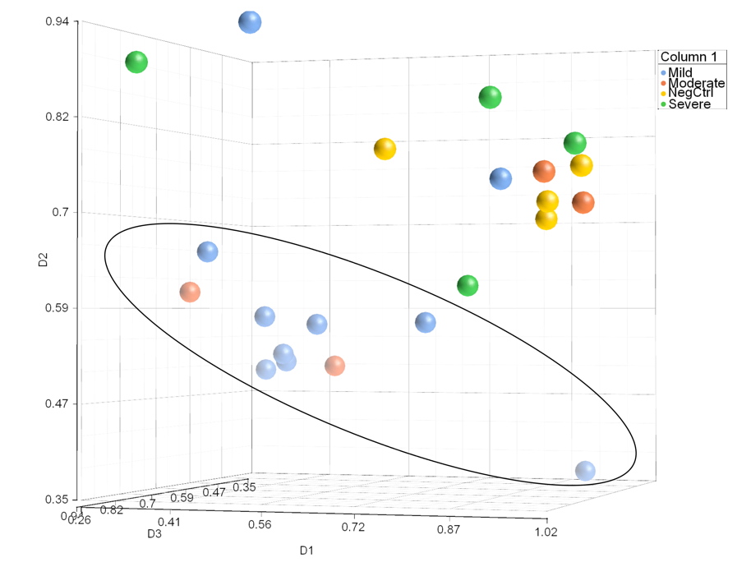

PCoA plot generated using matrix data with 3-dimensional scaling, Random Mapping, Method: Metric, Distance Function: Kendall dissimilarity and Max number of iterations: 100

