Supplementary Information

Acetylation turns leucine into a drug by membrane transporter switching

Grant C. Churchill^{1*}, Michael Strupp², Cailley Factor¹, Tatiana Bremova-Ertl^{3,4}, Mallory Factor¹, Marc C Patterson⁵, Frances M. Platt¹ and Antony Galione¹

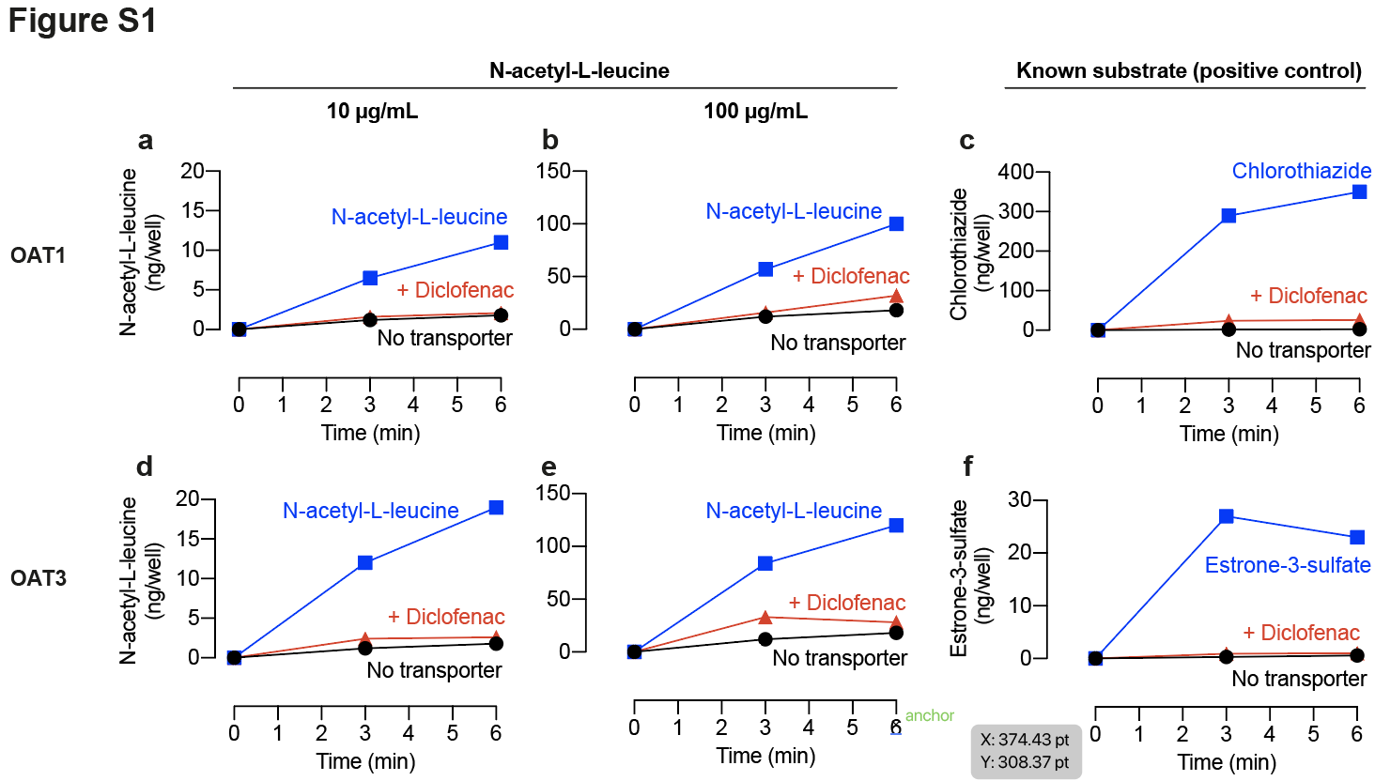

Figure S1. Time course of Solute Carrier (SLC) transporter-mediated active uptake of N-acetyl-L-leucine in vitro. (a-f) Plots N-acetyl-L-leucine or known substate uptake over time by cells expressing OAT1 (SLC22A6), OAT3 (SLC22A8) or OCT2 (SLC22A2). N-acetyl-L-leucine was present at 10 µg/mL or 100 µg/mL. A known substrate of each transporter was used as a positive control. Details of each experiment are shown as labelled on each panel. Symbols represent the mean ± SEM, n = 3. When the error bars are smaller than the symbol, they are not visible.

