S3 Table The details of native and mutant three-dimensional protein structure models predicted by I-TASSER, ERRAT score and Ramachandran plot.
Gene Symbol | Amino Acid |  |  | Native Models |  |  |  |  |  |  |  |  | Validation
Gene Symbol | Amino Acid | Templates | Model 1 |  | Model2 | Model3 |  | Model4 |  |  | Model5 |  |  | ERRAT |  |  |  |  |  |  | Ramachandran  Plot
LRRC34 | L286 | 1a4yA, 2bnh, 4perA, 4k17A, 6b5bA, 4kxfK, 2p1pB, 3ogmB,  5hywA, 4q62A | C-score:  -0.60  TM-score: 0.64±0.13  RMSD: 8.5±4.5Å |  | C-score: -2.42 | C-score: -2.46 |  | C-score: -3.48 |  | C-score: -3.41 |  |  |  | 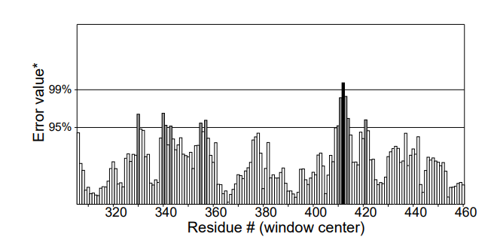  93.86 |  |  | 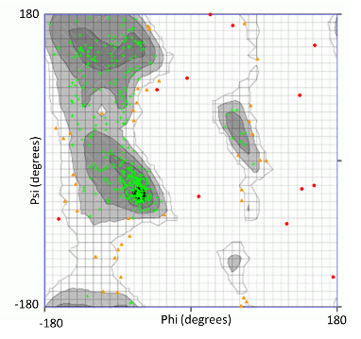  365/416  (87.74%)
FARP2 | T260 | 4gzuA, 4h6yA, 3vkhA, 6ez8A, 5xjcA, 3jb9A, 6ar6A, 6bcuA, 5h64A, 5d06A, | C-score:  -3.01  TM-score: 0.37±0.13  RMSD: 16.9±2.8Å |  | C-score: -3.14 | C-score: -3.22 |  | C-score: -3.28 |  | C-score: -3.17 |  |  |  | 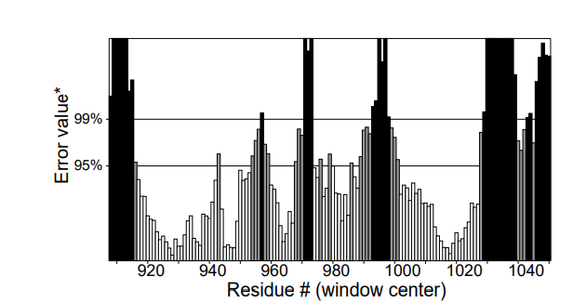  57.17 |  |  | 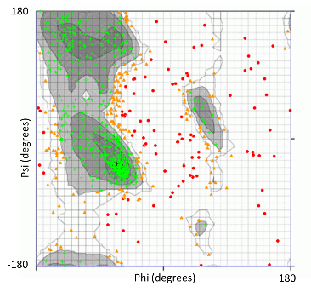  663/924  (71.75%)
TYR | R402 | 5m8lA, 4z11A, 5zrdA, 3w6qA, 4ouaB, 6elsA, 3nm8A, 4j3pA, 6hqiA, 4bedB | C-score:  -1.06  TM-score: 0.68±0.12  RMSD: 10.1±4.6Å |  | C-score: -1.14 | C-score: -1.48 |  | C-score: -2.39 | C-score: -3.06 |  |  | 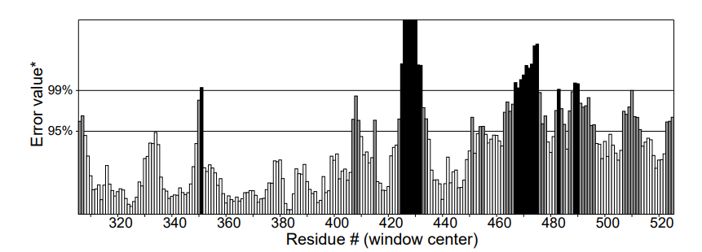  75.15 |  |  |  |  |  | 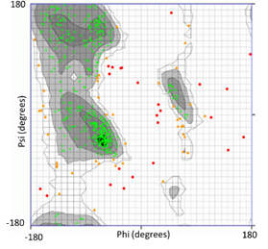  391/460  (85.00%)
 |  |  | Mutant Models
LRRC34 | I286 | 4perA, 1a4yA, 1dfjI, 4k17A, 6b5bA, 2p1pB, 3ogmB, 4kxfK, 5hywA, 4q62A | C-score:  -0.24  TM-score: 0.68±0.12  RMSD: 7.7±4.3Å |  | C-score: -1.52 |  | C-score: -2.38 | C-score: -3.18 |  | C-score: -1.71 |  |  |  | 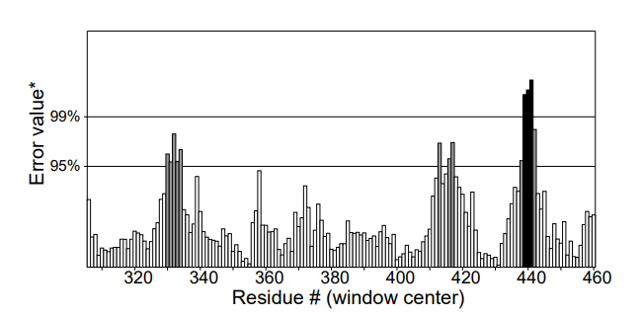  87.28 |  | 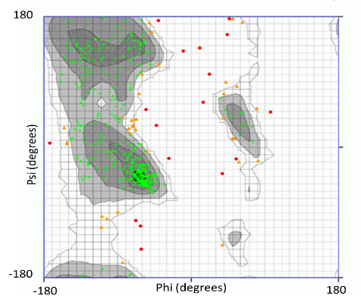  364/416  (87.50%)
FARP2 | N260 | 4gzuA, 4h6yA, 3jb9A, 5xjcA, 2vz8B, 5ganA, 5yz0A, 6bcuA, 5cskA, 5h64A | C-score: -3.02  TM-score: 0.37±0.13  RMSD: 16.9±2.8Å |  | C-score: -3.15 | C-score: -3.19 |  | C-score: -3.25 |  | C-score: -3.28 |  |  |  | 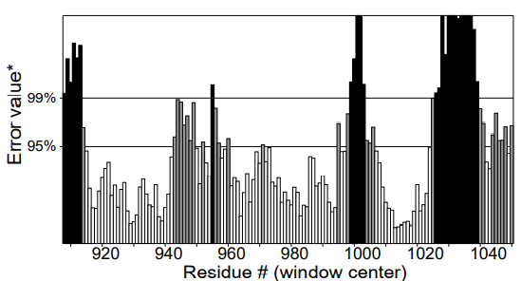  70.27 |  |  |  |  | 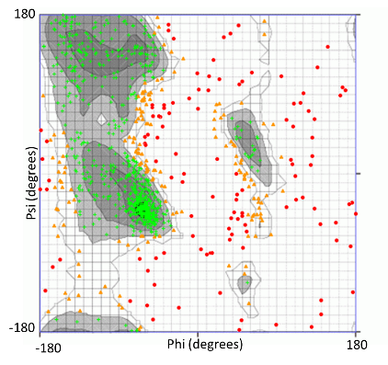  639/924  (69.16%)
TYR | Q402 | 5m8lA, 3w6qA, 4ouaB, 5zrdA 4z11A, 6elsA, 3nm8A, 4bedB, 4j3pA, 6hqiA | C-score: -1.29  TM-score: 0.54±0.15  RMSD: 10.7±4.6Å |  | C-score: -1.39 | C-score: -1.90 |  | C-score: -2.22 |  | C-score: -2.57 |  |  |  | 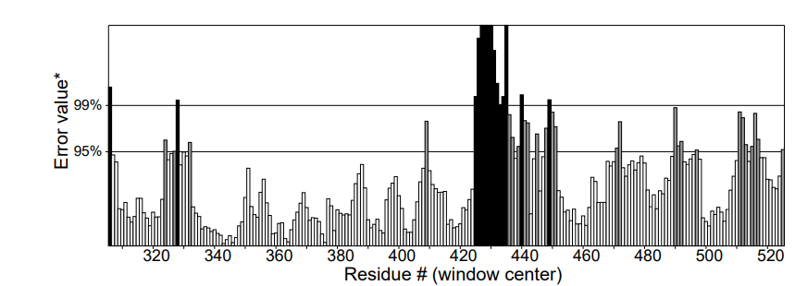  73.51 |  |  |  |  |  | 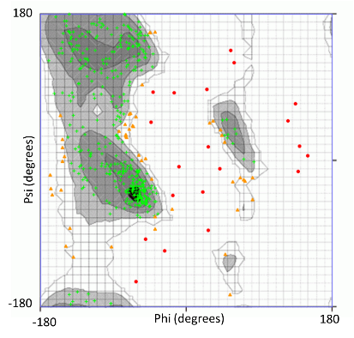  391/460  (85.00%  )
Highlighted column is the best model that were selected based on the highest C-score among the 5 generated models.

