Efficacy of sealants and bonding materials during fixed orthodontic treatment to prevent enamel demineralization – A systematic review and meta-analysis
R. Kamber^{1,*}, H. Meyer-Lueckel¹, D. Kloukos², C. Tennert¹, R. J. Wierichs¹
¹ Department of Restorative, Preventive and Pediatric Dentistry, zmk bern, University of Bern, Switzerland
² Department of Orthodontics and Dentofacial Orthopedics, zmk bern, University of Bern, Switzerland

Short title: Systematic review of coating materials during fixed orthodontic treatment
Keywords: demineralization; white spot lesion; prevention; enamel sealants; brackets; fluoride-containing materials

*Correspondence:
Dr. med. dent. Rita Kamber
Department of Restorative, Preventive and Pediatric Dentistry,
University of Bern, zmk Bern,
Freiburgstrasse 7,
3010 Bern, Switzerland
Tel.: +41 31 632 25 80
E-mail: rita.kamber@zmk.unibe.ch

Declaration of Interest: The authors declare no conflicts of interest.
Supplementary

Supplementary table S1. Search strategy
Nr. | Database | Search | Hits
1 | Pubmed | ((((((((((orthodon*) OR treatment) OR therapy) OR brace*) OR bracket) OR fixed appliance))) AND ((((((sealant) OR primer) OR adhesive) OR (pit and fissure sealant)) OR bonding))) AND ((((((caries) OR white spot) OR decalcification) OR demineralization) OR ICDAS))) AND (((((((((dmft) OR diagnodent) OR progression) OR index) OR visual*) OR ICDAS) OR Quantitative light-induced fluorescence) OR QLF)) | 715
2 | CENTRAL | Same | 354
3 | EMBASE | Same | 612
 | Sum (with overlap) |  | 1681
 | Sum (without overlap) |  | 984

Suppelmentary table S2. Exclusion by full-text
Author | Reason of exclusion
Al-Eesa 2017 ¹ | In vitro study
Alencar 2009 ² | In vitro study
Atilla 2019 ³ | Not relevant
Behnan 2010 ⁴ | In vitro study
Cain 2006 ⁵ | In vitro study
Cantekin 2014 ⁶ | In vitro study
Corry 2003 ⁷ | In Vitro study
Cosma 2019 ⁸ | No clinical study
Dalessandri 2012 ⁹ | No assessment of bonding system
Devados 2009 ¹⁰ | In vitro study
Feng 2017 ¹¹ | In vitro study
Gorton 2003 ¹² | Not relevant
Hess 2011 ¹³ | In vitro study
Horiuch 2009 ¹⁴ | In vitro study
Iijima 2012 ¹⁵ | In vitro study
Kim 2018 ¹⁶ | In vitro study
Knösel 2012 ¹⁷ | In vitro study
Knösel 2015 ¹⁸ | No assessment of demineralization
Krokmaz 2019 ¹⁹ | No fixed appliances
Korbmacher 2006 ²⁰ | In vitro study
Lee 2018 ²¹ | Cross-sectional study
Lucchese 2013 ²² | Cross-sectional
Nascimento 2016 ²³ | Systematic review
Nam 2019 ²⁴ | In vitro study
n/a 2017 ²⁵ | Ongoing clinical trial, not published yet
n/a 2018 ²⁶ | Ongoing clinical trial, not published yet
n/a 2017 ²⁷ | Ongoing clinical trial, not published yet
n/a 2015 ²⁸ | Ongoing clinical trial, not published yet
Machicek 2011 ²⁹ | In vitro study
Mitchell 1992 ³⁰ | No clinical study
Munjal 2016 ³¹ | No assessment of bonding systems
Ogaard 2006 ³² | No assessment of bonding system
Paschos 2009 ³³ | In vitro study
Pellegrini 2009 ³⁴ | No assessment of demineralization
Poosti 2013 ³⁵ | In vitro study
Pourhajibagher 2019 ³⁶ | In vitro study
Preciado 2017 ³⁷ | In vitro study
Rahimi 2017 ³⁸ | Systematic Review
Ramazanzade 2013 ³⁹ | In vitro study
Staudt 2004 ⁴⁰ | In vitro study
Underwood 1989 ⁴¹ | No full-text
Uysal 2011 ⁴² | Not relevant
Uysal 2010 ⁴³ | Not relevant
Uysal 2010 ⁴⁴ | In vitro study
Visel 2014 ⁴⁵ | No full-text
Wang 2015 ⁴⁶ | In vitro study
Yap 2014 ⁴⁷ | In vitro study
Yu 2017 ⁴⁸ | In vitro study
Zachrisson 1978 ⁴⁹ | No assessment of demineralization
Zhang 2016 ⁵⁰ | In vitro study
Zope 2016 ⁵¹ | No assessment of demineralization

Supplementary table S3. Characteristics of included studies

Study | Design; setting; country, language | Age at baseline [mean age (range)] [years] | No. of patients at baseline | No. of patients at end | Drop-out rate | No of teeth at baseline (per group) | No of teeth at end (per group) | Follow-up [months] | OH status; OH measures |  | Type of outcomes | Typ of intervention
Alabdullah et al. 2017 ⁵² | RCT_{sm}; Uni; Canada, Syria; EN | 17.6  (13-25) | 34 | 30 | 12% | 680 (340;3 40) | 600 (300; 300) | 12 | good OH; OH instructions |  | - visual (score: 0-3, own score)  - DIAGNOdent | non fluoride-containing adhesive resin vs. fluoride containing adhesive resin
Alshammari and Sanea 2019 ⁵³ | RCT_{sm}; Uni; Saudi Arabia; EN | n/a  (12-35) | 26 | 23 | 12% | 264 (n/a) | 255 (128; 127) | 6 | n/a |  | -DIAGNOdent | ACP-containing adhesive vs. conventional resin adhesive
Banks and Richmond 1994 ⁵⁴ | non-RCT_{sm}; PP; United Kingdom; EN | n/a | 80 | 80 | 0% | Total: 1182  chem (289; 282)  light (306; 305) | Total: 1182  chem (289; 282)  light (306; 305) | 3 | n/a |  | - visual (score: 0-3, Artun and Bobakken 1986) | viscous chemically cured sealant vs. non-viscous visible light-cured sealant vs. no sealant
Banks et al. 1997 ⁵⁵ | non-RCT ; n/a ; United Kingdom ; EN | n/a | 50 | 50 | 0% | 737 (366; 371) | 737 (366; 371) | 16.3 | n/a; OH instructions |  | - Visual (EDI – enamel decalcification index, Banks and Richmond 1994) | non fluoride-containing adhesive resin vs. fluoride containing adhesive resin
Bechtold et al. 2013 ⁵⁶ | RCT_{sm}; Uni; Germany; EN/G | 13.4+-1.7  (n/a) | 40 | 39 | 3% | 790 | 770 | 6 | PI, PBI; OH instructions |  | -DIAGNOdent | fluoride-containing sealant vs. no sealant
Benham et al. 2009 ⁵⁷ | RCT_{sm}; Uni; USA; EN | n/a  (11-16) | 60 | 60 | 0% | 573 | 573 | 15-18 | n/a |  | -visual (score: 0-4, Ogaard's modificaition of the scoring systems proposed by Gorelick et al. 1982)  -DIAGNOdent | sealant vs. no sealant
Chung et al. 1998 ⁵⁸ | RCT_{sm}; Uni; United Kingdoms; EN | 13.4  (n/a) | 26 | 26 | 0% | 96 (25; 23; 48) | 94 (2?; 2?; 47) | 1 | no extra fluoride; OH instructions |  | -visual (score: 0-2, own score) | fluoride uptake (compomer and resin-modified GIC vs. conventional resin adhesive)
Comert and Oz 2020 ⁵⁹ | non-RCT; n/a; Turkey; EN | 14.9+-1.43 and 15.8+-2.86  (n/a) | 60 | 56 | 7% | 1090 (546; 544) | 1090 (546; 544) | 13.29+-4.18 | n/a; OH instructions |  | - visual (score: 0-3, Gorelick et al., 1982)  -DIAGNOdent | fluoride containing adhesive vs. resin adhesive without fluoride
Fornell et al. 2002 ⁶⁰ | RCT_{sm}; Uni; Sweden; EN | 14.3  (12.4-18.8) | 40 | 39 | 3% | 434 (218; 216) | n/a | 14.7 | PI, GBI; OH instructions |  | -visual (score: n/a, Zachrisson&Zachrisson 1971) | anti-adhesive hydrophobic sealant
Gaworski et al. 1999 ⁶¹ | non-RCT; PP; USA; EN | n/a | 16 | 16 | 0% | 298 (149; 149) | 298 (149; 149) | 12-14 | n/a |  | - visual (score: none-slight-significant, own score) | conventional GIC vs. resin adhesive
Ghiz et al. 2009 ⁶² | RCT_{sm}; Uni; USA; EN | n/a | 25 | 25 | 0% | 469 (236; 233) | 469 (236; 233) | 18.24 | PI; OH instructions |  | -visual (score: 0-4, own score) | conventional etch sealant vs. self-etching primer
Hammad and Knosel 2016 ⁶³ | RCT; Uni; Egypt; EN | 14.57+-2.04  (12-18) | 50 | 42 | 16% | n/a (analysis on patient's level) | n/a (analysis on patient's level) | 12 | good OH, API; OH instructions |  | - visual (score: 0-1, own score) | sealant vs. no sealant
Heinig and Hartmann 2008 ⁶⁴ | non-RCT; PP; Germany; EN/GE | 15.9 (median)  (11.6-39.5) | 78 | 78 | 0% | 5788 surface regions  approximately 1447 | 5788 surface regions  approximately 1447 | 24 | n/a |  | - visual (score:0-3, Artun & Brobakken 1986, Banks & Richmond 1994, Zachrisson and Zachrisson 1971 and Gorelik et al. 1982) | fluoride containing sealant vs. no sealant
Study | Design; setting; country, language | Age at baseline [mean age (range)] [years] | No. of patients at baseline | No. of patients at end | Drop-out rate | No of teeth at baseline (per group) | No of teeth at end (per group) | Follow-up [months] | OH status; OH measures |  | Type of outcomes | Typ of intervention
Kumar Jena et al. 2015 ⁶⁵ | RCT_{sm}; Uni; India; EN | 15.5+-2.75  (12-20) | 40 | 40 | 0% | 480 (240; 240) | 480 (240; 240) | 6 | n/a |  | - visual (score 0-3, Ogaard's modification 1989, Gorelik et al. 1982)  -DIAGNOdent | varnish vs. no varnish
Leizer et al. 2010 ⁶⁶ | non-RCT_{sm}; PP; USA; EN | 17.6  (10-40) | 22 | 18 | 18% | 243 | 177 (87;90) | 14.6 | n/a; OH instructions | -visual (score 1-3, Wenderroth et al. 1999, Gaworski et al. 1997, Lee et al. 2018) |  | fluoride-releasing sealant vs. sealant without fluoride
Marcusson et al 1997 ⁶⁷ | RCT_{sm}; Uni; Sweden; EN | 13.7 | 60 | 60 | 0% | 222 (111; 111) | 222 (111; 111) | 12 | n/a; OH instructions | - visual (sorce: 1-3, Geiger et al 1988) |  | conventional GIC vs. resin adhesive
Millett et al. 1999 ⁶⁸ | non-RCT_{sm}; Uni; United Kingdom; EN | 13.4+-0.2  (n/a) | 40 | 40 | 0% | 138 (69; 69) | 138 (69; 69) | 15.3 | good OH; n/a | -visual (score: 0-8 and 0-3, Clarkson and O'Mullane 1989) |  | conventional GIC vs. resin adhesive
Millett et al. 2000 ⁶⁹ | non-RCT_{sm}; Uni; United Kingdom; EN | 14.4 (median) | 45 | 45 | 0% | 426 (213; 213) | 294 (147; 147) | compomer: 17,5 (median)  resin adhesive: 18,2 (median) | good OH; OH instructions | - visual (score: 1-3, Geiger et al 1988, Marcusson et al. 1997) |  | compomer vs. resin adhesive
O'Reilly et al. 2013 ⁷⁰ | non-RCT_{sm}; PP; USA; EN | 14.6+-3  (10.1-25.4) | 65 | 62 | 5% | n/a | 344 (185; 186) | 26.7+-5.1  range: 16.6-39.2 | n/a; OH instructions | - visual (score 0-3, Gorelik et al. 1982) |  | sealant vs. no sealant
Trimpeneers and Dermaut 1996 ⁷¹ | RCT_{sm}; Uni; Belgium; EN | 12.8  (10.8-16.2) | 50 | 50 | 0% | 375 (171; 204) | 375 (171; 204) | 21 | n/a; OH instructions | - 0-1 (presence or absence of WSL) |  | fluoride-releasing light cured material vs. chemically cured non mix resin
Tufekci et al. 2014 ⁷² | non-RCT_{sm}; Uni; USA; EN | n/a  (10-20) | 22 | 22 | 0% | 72 (36; 36) | 72 (36; 36) | 3 | good OH, PI, PBI; OH instructions | - visual (4 point scale, 0-1-2-3, Alexander and lpa 2000) |  | sealant with fluoride vs.  conventional primer without fluoride
Turner 1993 ⁷³ | non-RCT_{sm}; PP; United Kingdom; EN | 14.36+-3,15  (n/a) | 42 | 42 | 0% | 406 (203; 203) | 406 (164; 164)  for some parts n is reported as:  406 (203; 203) | 15.4+-4.7 | good OH, PI, GI; OH instructions | -visual (score: 0-3, own score) |  | fluoride containing adhesive vs. conventional adhesive
Wenderoth et al. 1999 ⁷⁴ | non-RCT_{sm}; Uni; USA; EN | 13.2  (9.25-18.8) | 20 | 20 | 0% | 234 (117; 117) | 225 (112; 113) -9 | 12.75 | good OH, PI, GI; OH instructions | - visual (score: 0-1-3, own score) |  | sealant vs. no sealant
Zingler et al. 2014 ⁷⁵ | RCT; PP; Germany; EN | n/a  (11-15) | 126 | 118 | 6% | 2520 (620; 640; 620; 640) | 2360 (560; 600; 580; 620) | 3 | PI, GI; n/a | - visual (score 0-1, DMFT/DMFS)  -plaque index (PIB, TQHI, MAPI)  -gingival index (PBI) |  | brushing device and sealer comparison

CT clinical trial; EN English; G German; GI gingiva index; GBI gingival bleeding index; GIC glass ionomer cement; mos months; OH oral hygiene; CT clinical trial; RCT randomized controlled trial; PI plaque index; PP private praxis or medical centre; RCT_{co} crossover randomized clinical trial; RCT_{sm} split mouth randomized clinical trial

Supplementary table S4. Sealants and bonding materials
Name | Manufacturer | Fluoride | Category | Studies
Aegis Ortho | Bosworth Co., Sokie, IL | No | Resin | ⁵³
AquaCem | DeTrey, Div., Dentsply Ltd, Wybridge, Surrey, UK | Yes | GIC | ⁶⁷
Assure | Reliance Orthodontic Products Inc, Illinois, USA | No | Resin | ⁷⁰
BisCover LV | Bisco, Schaumburg, Illunois, USA | No | Resin | ⁷⁰
Clinpro XT varnish | 3M Unitek, Monrovia, California, USA | Yes | GIC | ⁶⁵
Consice | 3M Unitek, Monrovia, California, USA | No | Resin | ⁷³
Dyract Ortho | DeTrey Dentsply, Kostanz, Germany | Yes | Compomer | ^{58,69}
Experimental orthodontic bracket resin K32 | De Trey Dentsply, Konstanz, Germany | Yes | Resin | ⁷³
Fuji LC Ortho | GC America Incorporated | Yes | GIC | ⁶¹
Grengloo | Ormco Corporation, Orange, Calif, USA | No | Resin | ⁷⁰
Ketac-Cem | Espe, Oberbay, Germany | Yes | GIC | ⁶⁸
Lee Insta-Bond | Lee Pharmaceuticals, El Monete, Calif, USA | No | Resin | ⁷¹
Light BondTM | Reliance Orthodontic Products Inc, Illinois, USA | Yes | Resin | ^{52,56,62,64}
Opal Seal | Ultradent, South Jordan, Utah, USA | Yes | Resin | ^{59,72}
Maximum Cure | Reliance Orthodontic Products Inc, Illinois, USA | No | Resin | ⁵⁴
Orthon | Orthon Dental, Inc. Vitoria, B.C., Canada | Yes | Resin | ⁷¹
Ortho-Solo | Ormco Corporation, Orange, Calif, USA | No | Resin | ⁵⁷
Polymeric tooth coating | 3M Unitek, Monrovia, California, USA | No | Resin | ⁶⁰
ProSeal | Reliance Orthodontic Products, Itsaca, Illinois, USA | Yes | Resin | ^{66,75}
Protection Plus sealant | Confi-Dental Products Co, Denver, Colorado, USA | Yes | Resin | ⁷⁴
Protecto | BonaDent, Franfurt am Main, Germany | Yes | Resin | ⁵⁶
Reliance Light Bond | Reliance Orthodontic Products, Itsaca, Illinois, USA | No | Resin | ⁶¹
(standard) Rely-a-Bond | Reliance Orthodontic Products, Itsaca, Illinois, USA | No | Resin | ⁵⁵
(fluoride releasing) Rely-a-Bond | Reliance Orthodontic Products, Itsaca, Illinois, USA | Yes | Resin | ⁷⁴
Right-On | TP Orthodontics, Inc., LaPorte, Indiana, USA | No | Resin | ^{54,58,68,69}
SeLECT DefenseTM sealant | Lubbock, TX, USA | No | Resin | ⁶³
TransbondTM | 3M Unitek, Monrovia, California, USA | No | Resin | ^{54,60,64,70}
Transbond MIP | 3M Unitek, Monrovia, California, USA | No | Resin | ⁶⁶
Transbond Plus | 3M Unitek, Monrovia, California, USA | No | Resin | ^{62,70}
Transbond Plus L-Pop Seal-Etching Primer | 3M Unitek, Monrovia, California, USA | No | Resin | ⁵⁷
Transbond XTTM | 3M Unitek, Monrovia, California, USA | No | Resin | ^{52,53,57,59,63,65,70,72,75}
Ultraseal XT Plus clear sealant | Ultradent Products, South Jordon, Utah, USA | No | Resin | ⁵⁷
Unite | 3M Unitek, Monrovia, California, USA | No | Resin | ⁶⁷
Vitremer | 3M Dental Products Devision, St. Paul, MN, USA | Yes | GIC | ⁵⁸

Supplementary table S5. Grading of evidence
Quality assessment |  |  |  |  |  |  | No of patients |  | Effect |  | Quality | Importance
No of studies | Design | Risk of bias | Inconsistency | Indirectness | Imprecision | Other considerations |  | Control | Relative  (95% CI) | Absolute | Quality | Importance
sealant vs. no sealant (follow-up 3-27 months; assessed with: visual-tactile)
6 | observational studies | serious¹ | serious² | no serious indirectness | no serious imprecision | reporting bias³ | 244/1161  (21%) | 319/1153  (27.7%) | RR 0.7 (0.53 to 0.93) | 83 fewer per 1000 (from 19 fewer to 130 fewer) | ⊕ΟΟΟ  VERY LOW
coating with fluoride release vs. coating without fluoride release (follow-up 1-24 months; assessed with: visual-tactile)
9 | observational studies | serious¹ | serious² | no serious indirectness | no serious imprecision | reporting bias⁴ | 568/1980  (28.7%) | 612/1988  (30.8%) | RR 0.84 (0.69 to 1.02) | 49 fewer per 1000 (from 95 fewer to 6 more) | ⊕ΟΟΟ  VERY LOW
¹ see risk of bias assessment
² I² value is large
³ 5 studies used a split-mouth design
⁴ 8 studies used a split-mouth design

Supplemetary figure S1
Meta-analysis for the comparison: sealant vs. no sealant without studies at high risk of bias. Visual-tactile assessments were used to calculate RR and 95%CI.
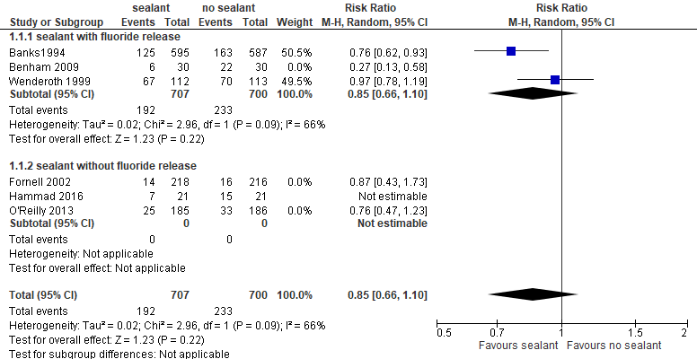

Supplemenary figure S2
Meta-analysis for the comparison: sealant vs. no sealant without studies using a parallel-arm design. Visual-tactile assessments were used to calculate RR and 95%CI.
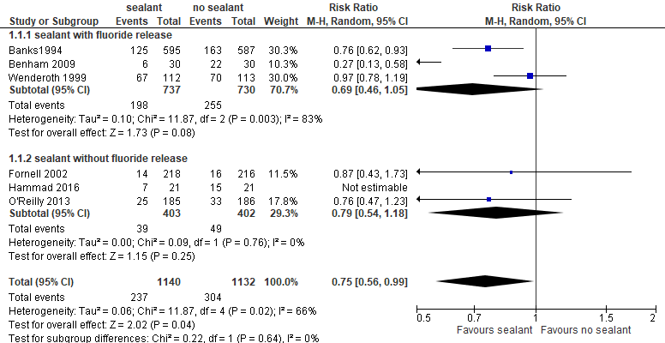

Supplementary figure S3
Meta-analysis for the comparison: coating with and without fluoride release without studies at high risk of bias. Visual-tactile assessments were used to calculate RR and 95%CI.
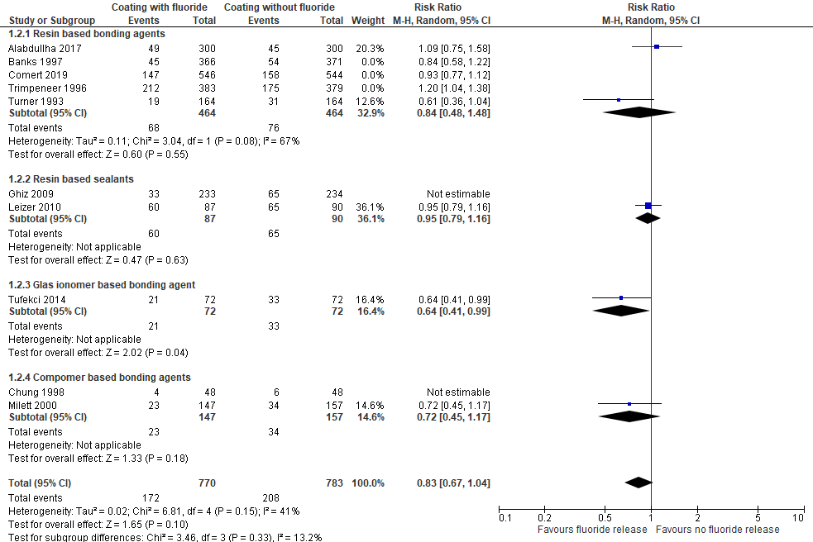

Supplementary figure S4
Meta-analysis for the comparison: coating with and without fluoride release studies using a parallel-arm design. Visual-tactile assessments were used to calculate RR and 95%CI.
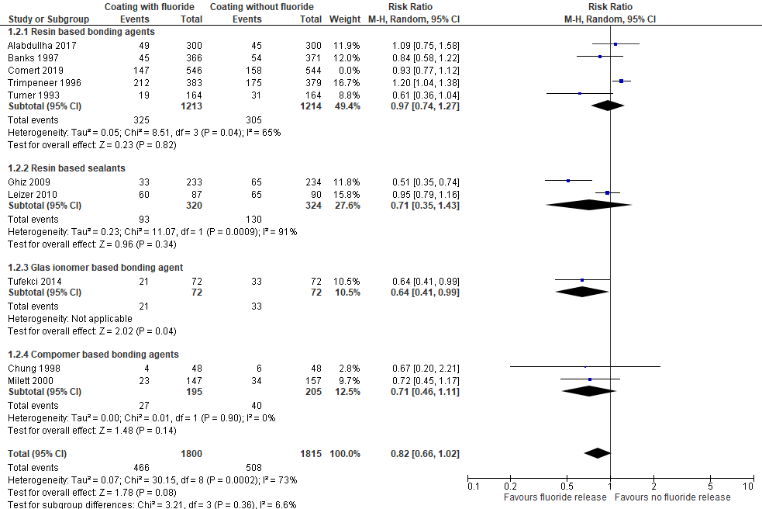

Supplementary figure S5
Meta-analysis for the comparison:
glass ionomer cement vs. resin adhesive without studies at high risk of bias, Visual-tactile assessments were used to calculate RR and 95%CI.
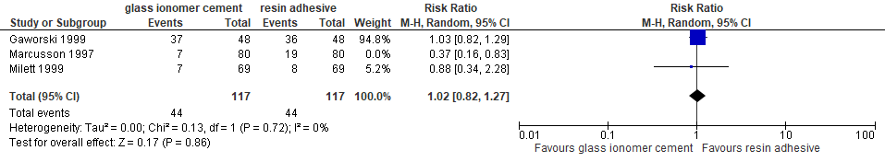

References

1 Al-Eesa, N. A., Wong, F. S. L., Johal, A. & Hill, R. G. Fluoride containing bioactive glass composite for orthodontic adhesives - ion release properties. Dental materials : official publication of the Academy of Dental Materials 33, 1324-1329, doi:10.1016/j.dental.2017.08.185 (2017).
2 Alencar, C. J., Braga, M. M., de Oliveira, E., Nicolau, J. & Mendes, F. M. Dye-enhanced laser fluorescence detection of caries lesions around brackets. Lasers Med Sci 24, 865-870, doi:10.1007/s10103-008-0572-0 (2009).
3 Atilla, A. O., Ozturk, T., Eruz, M. M. & Yagci, A. A comparative assessment of orthodontic treatment outcomes using the quantitative light-induced fluorescence (QLF) method between direct bonding and indirect bonding techniques in adolescents: a single-centre, single-blind randomized controlled trial. Eur J Orthod 42, 441-453, doi:10.1093/ejo/cjz058 (2020).
4 Behnan, S. M., Arruda, A. O., Gonzalez-Cabezas, C., Sohn, W. & Peters, M. C. In-vitro evaluation of various treatments to prevent demineralization next to orthodontic brackets. Am J Orthod Dentofacial Orthop 138, 712 e711-717; discussion 712-713, doi:10.1016/j.ajodo.2010.05.014 (2010).
5 Cain, K. et al. In vitro enamel caries formation and orthodontic bonding agents. Am J Dent 19, 187-192 (2006).
6 Cantekin, K. & Buyuk, S. K. Shear bond strength of a new low-shrinkage flowable composite for orthodontic bracket bonding. J Dent Child (Chic) 81, 63-66 (2014).
7 Corry, A., Millett, D. T., Creanor, S. L., Foye, R. H. & Gilmour, W. H. Effect of fluoride exposure on cariostatic potential of orthodontic bonding agents: an in vitro evaluation. J Orthod 30, 323-329; discussion 298-329, doi:10.1093/ortho/30.4.323 (2003).
8 Cosma, L. L., Şuhani, R. D., Mesaroş, A. & Badea, M. E. Current treatment modalities of orthodontically induced white spot lesions and their outcome - a literature review. Med Pharm Rep 92, 25-30, doi:10.15386/cjmed-1090 (2019).
9 Dalessandri, D., Dalessandri, M., Bonetti, S., Visconti, L. & Paganelli, C. Effectiveness of an indirect bonding technique in reducing plaque accumulation around braces. Angle Orthod 82, 313-318, doi:10.2319/041811-273.1 (2012).
10 Devados, B. R., Kailasam, V., Padmanabhan, S. & Chitharanjan, A. A comparison of the effects of argon laser and conventional light cure on demineralization resistance of human enamel. Biomedicine (India) 29, 226-230 (2009).
11 Feng, X. et al. Novel orthodontic cement containing dimethylaminohexadecyl methacrylate with strong antibacterial capability. Dent Mater J 36, 669-676, doi:10.4012/dmj.2016-370 (2017).
12 Gorton, J. & Featherstone, J. D. In vivo inhibition of demineralization around orthodontic brackets. Am J Orthod Dentofacial Orthop 123, 10-14, doi:10.1067/mod.2003.47 (2003).
13 Hess, E., Campbell, P. M., Honeyman, A. L. & Buschang, P. H. Determinants of enamel decalcification during simulated orthodontic treatment. Angle Orthod 81, 836-842, doi:10.2319/121710-726.1 (2011).
14 Horiuch, S. et al. Enamel bonding of self-etching and phosphoric acid-etching orthodontic adhesives in simulated clinical conditions: debonding force and enamel surface. Dent Mater J 28, 419-425, doi:10.4012/dmj.28.419 (2009).
15 Iijima, M. et al. Bracket bond strength and cariostatic potential of an experimental resin adhesive system containing Portland cement. Angle Orthod 82, 900-906, doi:10.2319/091311-589.1 (2012).
16 Kim, Y. M. et al. Antibacterial and remineralization effects of orthodontic bonding agents containing bioactive glass. Korean J Orthod 48, 163-171, doi:10.4041/kjod.2018.48.3.163 (2018).
17 Knösel, M., Forslund, L., Jung, K. & Ziebolz, D. Efficacy of different strategies in protecting enamel against demineralization during fixed orthodontic treatment. J Orofac Orthop 73, 194-203, doi:10.1007/s00056-012-0072-5 (2012).
18 Knosel, M., Ellenberger, D., Goldner, Y., Sandoval, P. & Wiechmann, D. In-vivo durability of a fluoride-releasing sealant (OpalSeal) for protection against white-spot lesion formation in orthodontic patients. Head Face Med 11, 11, doi:10.1186/s13005-015-0069-6 (2015).
19 Korkmaz, Y. N. & Yagci, A. Comparing the effects of three different fluoride-releasing agents on white spot lesion prevention in patients treated with full coverage rapid maxillary expanders. Clin Oral Investig 23, 3275-3285, doi:10.1007/s00784-018-2749-7 (2019).
20 Korbmacher, H., Huck, L., Adam, T. & Kahl-Nieke, B. Evaluation of an antimicrobial and fluoride-releasing self-etching primer on the shear bond strength of orthodontic brackets. Eur J Orthod 28, 457-461, doi:10.1093/ejo/cjl013 (2006).
21 Lee, S. M. et al. Enamel Anti-Demineralization Effect of Orthodontic Adhesive Containing Bioactive Glass and Graphene Oxide: An In-Vitro Study. Materials (Basel) 11, doi:10.3390/ma11091728 (2018).
22 Lucchese, A. & Gherlone, E. Prevalence of white-spot lesions before and during orthodontic treatment with fixed appliances. Eur J Orthod 35, 664-668, doi:10.1093/ejo/cjs070 (2013).
23 Nascimento, P. L., Fernandes, M. T., Figueiredo, F. E. & Faria, E. S. A. L. Fluoride-Releasing Materials to Prevent White Spot Lesions around Orthodontic Brackets: A Systematic Review. Braz Dent J 27, 101-107, doi:10.1590/0103-6440201600482 (2016).
24 Nam, H. J. et al. Fluorinated Bioactive Glass Nanoparticles: Enamel Demineralization Prevention and Antibacterial Effect of Orthodontic Bonding Resin. Materials (Basel) 12, doi:10.3390/ma12111813 (2019).
25 DRKS00012540. https://www.drks.de/drks_web/navigate.do?navigationId=trial.HTML&TRIAL_ID=DRKS00012540. (2017).
26 NCT03711097. https://clinicaltrials.gov/ct2/show/NCT03711097, 2018).
27 IRCT201705099086N3. https://www.cochranelibrary.com/central/doi/10.1002/central/CN-01886695/full, 2017).
28 NCT02400957. https://clinicaltrials.gov/ct2/show/NCT02400957, 2015).
29 Machicek, S. L. et al. Shear bond strengths of a selenium containing and a conventional light cured adhesive for orthodontic bonding. Tex Dent J 128, 1261-1267 (2011).
30 Mitchell, L. Decalcification during orthodontic treatment with fixed appliances--an overview. Br J Orthod 19, 199-205, doi:10.1179/bjo.19.3.199 (1992).
31 Munjal, D., Garg, S., Dhindsa, A., Sidhu, G. K. & Sethi, H. S. Assessment of White Spot Lesions and In-Vivo Evaluation of the Effect of CPP-ACP on White Spot Lesions in Permanent Molars of Children. J Clin Diagn Res 10, ZC149-154, doi:10.7860/JCDR/2016/19458.7896 (2016).
32 Ogaard, B., Alm, A. A., Larsson, E. & Adolfsson, U. A prospective, randomized clinical study on the effects of an amine fluoride/stannous fluoride toothpaste/mouthrinse on plaque, gingivitis and initial caries lesion development in orthodontic patients. Eur J Orthod 28, 8-12, doi:10.1093/ejo/cji075 (2006).
33 Paschos, E., Kurochkina, N., Huth, K. C., Hansson, C. S. & Rudzki-Janson, I. Failure rate of brackets bonded with antimicrobial and fluoride-releasing, self-etching primer and the effect on prevention of enamel demineralization. Am J Orthod Dentofacial Orthop 135, 613-620, doi:10.1016/j.ajodo.2008.01.016 (2009).
34 Pellegrini, P. et al. Plaque retention by self-ligating vs elastomeric orthodontic brackets: quantitative comparison of oral bacteria and detection with adenosine triphosphate-driven bioluminescence. Am J Orthod Dentofacial Orthop 135, 426 e421-429; discussion 426-427, doi:10.1016/j.ajodo.2008.12.002 (2009).
35 Poosti, M. et al. Shear bond strength and antibacterial effects of orthodontic composite containing TiO2 nanoparticles. Eur J Orthod 35, 676-679, doi:10.1093/ejo/cjs073 (2013).
36 Pourhajibagher, M., Salehi Vaziri, A., Takzaree, N. & Ghorbanzadeh, R. Physico-mechanical and antimicrobial properties of an orthodontic adhesive containing cationic curcumin doped zinc oxide nanoparticles subjected to photodynamic therapy. Photodiagnosis Photodyn Ther 25, 239-246, doi:10.1016/j.pdpdt.2019.01.002 (2019).
37 Preciado, R. M. et al. Efficacy of a resin-modified glass ionomer varnish in the prevention of tooth enamel demineralization around orthodontic brackets: An in vitro study. Investigacion Clinica (Venezuela) 58, 365-375 (2017).
38 Rahimi, F., Sadeghi, M. & Mozaffari, H. Efficacy of fluoride varnish for prevention of white spot lesions during orthodontic treatment with fixed appliances: A systematic review study. BMRAT [Internet] 4(08), 1513-1526. (2017).
39 Ramazanzadeh, B. A., Merati, M., Shafaee, H., Dogon, L. & Sohrabi, K. In-vitro evaluation of an experimental method for bonding of orthodontic brackets with self-adhesive resin cements. European J Gen Dent 2, 264-269, doi:10.4103/2278-9626.116018 (2013).
40 Staudt, C. B., Lussi, A., Jacquet, J. & Kiliaridis, S. White spot lesions around brackets: in vitro detection by laser fluorescence. Eur J Oral Sci 112, 237-243, doi:10.1111/j.1600-0722.2004.00133.x (2004).
41 Underwood, M. L., Rawls, H. R. & Zimmerman, B. F. Clinical evaluation of a fluoride-exchanging resin as an orthodontic adhesive. Am J Orthod Dentofacial Orthop 96, 93-99, doi:10.1016/0889-5406(89)90250-3 (1989).
42 Uysal, T., Amasyali, M., Ozcan, S., Koyuturk, A. E. & Sagdic, D. Effect of antibacterial monomer-containing adhesive on enamel demineralization around orthodontic brackets: an in-vivo study. Am J Orthod Dentofacial Orthop 139, 650-656, doi:10.1016/j.ajodo.2009.06.038 (2011).
43 Uysal, T. et al. In vivo effects of amorphous calcium phosphate-containing orthodontic composite on enamel demineralization around orthodontic brackets. Aust Dent J 55, 285-291, doi:10.1111/j.1834-7819.2010.01236.x (2010).
44 Uysal, T., Ustdal, A., Nur, M. & Catalbas, B. Bond strength of ceramic brackets bonded to enamel with amorphous calcium phosphate-containing orthodontic composite. Eur J Orthod 32, 281-284, doi:10.1093/ejo/cjp115 (2010).
45 Visel, D., Jacker, T., Jost-Brinkmann, P. G. & Prager, T. M. Demineralization adjacent to orthodontic brackets after application of conventional and self-etching primer systems. J Orofac Orthop 75, 358-373, doi:10.1007/s00056-014-0233-9 (2014).
46 Wang, X., Wang, B. & Wang, Y. Antibacterial orthodontic cement to combat biofilm and white spot lesions. Am J Orthod Dentofacial Orthop 148, 974-981, doi:10.1016/j.ajodo.2015.06.017 (2015).
47 Yap, J., Walsh, L. J., Naser-Ud Din, S., Ngo, H. & Manton, D. J. Evaluation of a novel approach in the prevention of white spot lesions around orthodontic brackets. Aust Dent J 59, 70-80, doi:10.1111/adj.12142 (2014).
48 Yu, F. et al. Antibacterial Activity and Bonding Ability of an Orthodontic Adhesive Containing the Antibacterial Monomer 2-Methacryloxylethyl Hexadecyl Methyl Ammonium Bromide. Sci Rep 7, 41787, doi:10.1038/srep41787 (2017).
49 Zachrisson, B. U. & Brobakken, B. O. Clinical comparison of direct versus indirect bonding with different bracket types and adhesives. Am J Orthod 74, 62-78, doi:10.1016/0002-9416(78)90046-5 (1978).
50 Zhang, N. et al. Novel protein-repellent and biofilm-repellent orthodontic cement containing 2-methacryloyloxyethyl phosphorylcholine. J Biomed Mater Res B Appl Biomater 104, 949-959, doi:10.1002/jbm.b.33444 (2016).
51 Zope, A. et al. Comparison of Self-Etch Primers with Conventional Acid Etching System on Orthodontic Brackets. J Clin Diagn Res 10, ZC19-ZC22, doi:10.7860/JCDR/2016/18842.9031 (2016).
52 Alabdullah, M. M., Nabawia, A., Ajaj, M. A. & Saltaji, H. Effect of fluoride-releasing resin composite in white spot lesions prevention: a single-centre, split-mouth, randomized controlled trial. Eur J Orthod 39, 634-640, doi:10.1093/ejo/cjx010 (2017).
53 Alshammari, F. M. & Sanea, J. A. Efficacy of Amorphous Calcium Phosphate (ACP) Containing Adhesive in Preventing Demineralization during Orthodontic Treatment, a Triple Blinded Randomized Clinical Trial (RCT). J Contemp Dent Pract 20, 727-731 (2019).
54 Banks, P. A. & Richmond, S. Enamel sealants: a clinical evaluation of their value during fixed appliance therapy. Eur J Orthod 16, 19-25, doi:10.1093/ejo/16.1.19 (1994).
55 Banks, P. A., Burn, A. & O'Brien, K. A clinical evaluation of the effectiveness of including fluoride into an orthodontic bonding adhesive. Eur J Orthod 19, 391-395, doi:10.1093/ejo/19.4.391 (1997).
56 Bechtold, T. E., Sobiegalla, A., Markovic, M., Berneburg, M. & Goz, G. R. In vivo effectiveness of enamel sealants around orthodontic brackets. J Orofac Orthop 74, 447-457, doi:10.1007/s00056-013-0178-4 (2013).
57 Benham, A. W., Campbell, P. M. & Buschang, P. H. Effectiveness of pit and fissure sealants in reducing white spot lesions during orthodontic treatment. A pilot study. Angle Orthod 79, 338-345, doi:10.2319/022808-30.1 (2009).
58 Chung, C. K., Millett, D. T., Creanor, S. L., Gilmour, W. H. & Foye, R. H. Fluoride release and cariostatic ability of a compomer and a resin-modified glass ionomer cement used for orthodontic bonding. J Dent 26, 533-538, doi:10.1016/s0300-5712(98)00017-7 (1998).
59 Comert, S. & Oz, A. A. Clinical effect of a fluoride-releasing and rechargeable primer in reducing white spot lesions during orthodontic treatment. Am J Orthod Dentofacial Orthop 157, 67-72, doi:10.1016/j.ajodo.2019.06.013 (2020).
60 Fornell, A. C., Skold-Larsson, K., Hallgren, A., Bergstrand, F. & Twetman, S. Effect of a hydrophobic tooth coating on gingival health, mutans streptococci, and enamel demineralization in adolescents with fixed orthodontic appliances. Acta Odontol Scand 60, 37-41, doi:10.1080/000163502753471989 (2002).
61 Gaworski, M., Weinstein, M., Borislow, A. J. & Braitman, L. E. Decalcification and bond failure: A comparison of a glass ionomer and a composite resin bonding system in vivo. Am J Orthod Dentofacial Orthop 116, 518-521, doi:10.1016/s0889-5406(99)70182-4 (1999).
62 Ghiz, M. A., Ngan, P., Kao, E., Martin, C. & Gunel, E. Effects of sealant and self-etching primer on enamel decalcification. Part II: an in-vivo study. Am J Orthod Dentofacial Orthop 135, 206-213, doi:10.1016/j.ajodo.2007.02.060 (2009).
63 Hammad, S. M. & Knosel, M. Efficacy of a new sealant to prevent white spot lesions during fixed orthodontic treatment : A 12-month, single-center, randomized controlled clinical trial. J Orofac Orthop 77, 439-445, doi:10.1007/s00056-016-0052-2 (2016).
64 Heinig, N. & Hartmann, A. Efficacy of a sealant : study on the efficacy of a sealant (Light Bond) in preventing decalcification during multibracket therapy. J Orofac Orthop 69, 154-167, doi:10.1007/s00056-008-0741-6 (2008).
65 Kumar Jena, A., Pal Singh, S. & Kumar Utreja, A. Efficacy of resin-modified glass ionomer cement varnish in the prevention of white spot lesions during comprehensive orthodontic treatment: a split-mouth study. J Orthod 42, 200-207, doi:10.1179/1465313315Y.0000000005 (2015).
66 Leizer, C., Weinstein, M., Borislow, A. J. & Braitman, L. E. Efficacy of a filled-resin sealant in preventing decalcification during orthodontic treatment. Am J Orthod Dentofacial Orthop 137, 796-800, doi:10.1016/j.ajodo.2008.11.025 (2010).
67 Marcusson, A., Norevall, L. I. & Persson, M. White spot reduction when using glass ionomer cement for bonding in orthodontics: a longitudinal and comparative study. Eur J Orthod 19, 233-242, doi:10.1093/ejo/19.3.233 (1997).
68 Millett, D. T., Nunn, J. H., Welbury, R. R. & Gordon, P. H. Decalcification in relation to brackets bonded with glass ionomer cement or a resin adhesive. Angle Orthod 69, 65-70, doi:10.1043/0003-3219(1999)069<0065:DIRTBB>2.3.CO;2 (1999).
69 Millett, D. T. et al. A comparative clinical trial of a compomer and a resin adhesive for orthodontic bonding. Angle Orthod 70, 233-240, doi:10.1043/0003-3219(2000)070<0233:ACCTOA>2.0.CO;2 (2000).
70 O'Reilly, M. T., De Jesus Vinas, J. & Hatch, J. P. Effectiveness of a sealant compared with no sealant in preventing enamel demineralization in patients with fixed orthodontic appliances: a prospective clinical trial. Am J Orthod Dentofacial Orthop 143, 837-844, doi:10.1016/j.ajodo.2013.01.021 (2013).
71 Trimpeneers, L. M. & Dermaut, L. R. A clinical evaluation of the effectiveness of a fluoride-releasing visible light-activated bonding system to reduce demineralization around orthodontic brackets. Am J Orthod Dentofacial Orthop 110, 218-222, doi:10.1016/s0889-5406(96)70112-9 (1996).
72 Tufekci, E., Pennella, D. R., Mitchell, J. C., Best, A. M. & Lindauer, S. J. Efficacy of a fluoride-releasing orthodontic primer in reducing demineralization around brackets: an in-vivo study. Am J Orthod Dentofacial Orthop 146, 207-214, doi:10.1016/j.ajodo.2014.05.016 (2014).
73 Turner, P. J. The clinical evaluation of a fluoride-containing orthodontic bonding material. Br J Orthod 20, 307-313, doi:10.1179/bjo.20.4.307 (1993).
74 Wenderoth, C. J., Weinstein, M. & Borislow, A. J. Effectiveness of a fluoride-releasing sealant in reducing decalcification during orthodontic treatment. Am J Orthod Dentofacial Orthop 116, 629-634, doi:10.1016/s0889-5406(99)70197-6 (1999).
75 Zingler, S. et al. A randomized clinical trial comparing the impact of different oral hygiene protocols and sealant applications on plaque, gingival, and caries index scores. Eur J Orthod 36, 150-163, doi:10.1093/ejo/cjt043 (2014).

