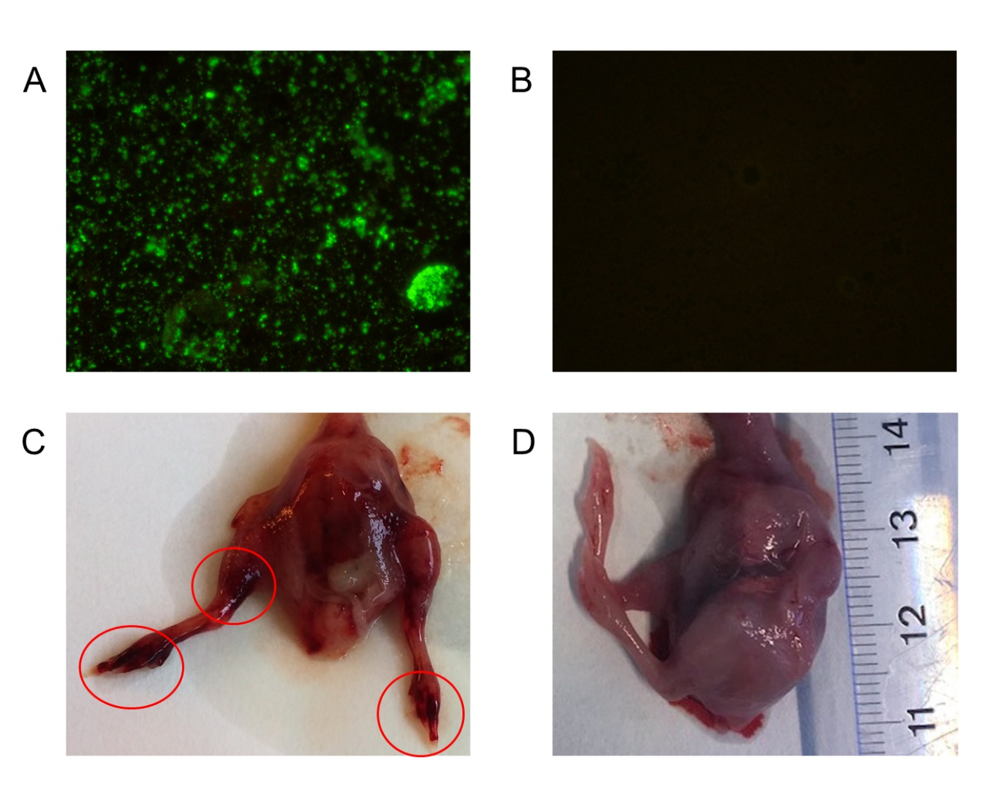

Fig S3. Results of yolk sac stamp stains and pathology in embryos during isolation in embryonated eggs.
(A) Positive and (B) negative immunofluorescence staining of yolk sac suspension stamps.
(C) Embryo of Chlamydia gallinacea infected egg and (B) an embryo of a negative control egg at day 8 after inoculation and day 14 of incubation. In the embryo of the infected egg (C) haemorrhages of the toes and upper leg are visible (red encircled). Furthermore the embryo of the infected egg is more red in color than the embryo of the uninfected egg.

