Supplementary Materials

Table S1. Gene-specific PCR primer sets for quantitative RT-PCR amplification.
Enzyme | Gene  name | Accession  no. | Sequence | Amplicon  size
Florigen | Hd3a | XM_015786465 | F: AGTTCCGGTCGGTCAGCAT  R: ACCGAGGTGGCAACAAAG | 117

Table S2. Differences in yield components in response to root cutting conditions and seedling age in rice.
Rice types | Treatment |  | Culm  length  (cm) | Panicle  length  (cm) | Number of  panicle  (ea) | Number of grains per panicle  (ea) | Ripening  ratio  (%) | 100-grain  weight  (g)
Odae | 10-day-old  seed-  lings | Transplanting  (cutting) | 80.2^{b} | 17.8^{ab} | 6.3^{c} | 76.2 ^{b} | 79.2 ª | 2.31 ª
Odae | 10-day-old  seed-  lings | Transplanting  (control) | 81.0^{b} | 18.0^{ab} | 7.0^{c} | 76.5 ^{b} | 79.0 ª | 2.25 ª
Odae | 10-day-old  seed-  lings | Direct  seeding | 86.8ª | 17.4^{b} | 12.0^{b} | 75.5 ^{b} | 77.5 ª | 2.29 ª
Odae | 20-day-old  seed-  lings | Transplanting  (cutting) | 69.5^{c} | 16.5^{c} | 3.2^{d} | 70.2 ^{d} | 79.9 ª | 2.23 ª
Odae | 20-day-old  seed-  lings | Transplanting  (control) | 71.3^{c} | 17.3^{b} | 3.9^{d} | 73.1 ^{c} | 78.1 ª | 2.19 ª
Odae | 20-day-old  seed-  lings | Direct  seeding | 80.3^{b} | 18.5ª | 13.7ª | 78.4 ª | 77.4 ª | 2.24 ª
Saenuri | 10-day-old  seed-  lings | Transplanting  (cutting) | 72.3^{ab} | 18.2^{b} | 6.7^{c} | 77.4 ^{b} | 85.4 ^{b} | 2.24 ª
Saenuri | 10-day-old  seed-  lings | Transplanting  (control) | 72.3^{ab} | 18.5^{b} | 7.1^{c} | 77.1 ^{b} | 84.9 ^{b} | 2.21 ª
Saenuri | 10-day-old  seed-  lings | Direct seedling | 73.5ª | 18.5^{b} | 8.2^{b} | 77.6 ^{b} | 86.6 ^{ab} | 2.26 ª
Saenuri | 20-day-old  seed-  lings | Transplanting  (cutting) | 65.8^{c} | 17.9^{b} | 4.0e | 76.9 ^{b} | 87.4 ª | 2.18 ª
Saenuri | 20-day-old  seed-  lings | Transplanting  (control) | 66.7^{c} | 18.2^{b} | 5.2^{d} | 76.8 ^{b} | 88.3ª | 2.28 ª
Saenuri | 20-day-old  seed-  lings | Direct  seeding | 71.5^{b} | 19.5ª | 9.7ª | 79.4 ª | 87.6 ª | 2.34 ª
- Significant differences were evaluated using Duncan’s multiple range test at 5% level

Table S3. Rice growth and development under conditions of cutting (x) and noncutting (o) of seeds and roots using 7-day-old seedlings. The roots were cut to a length of 1.5 cm.
Varieties | Treatment | Stem length  (cm) | Panicle length  (cm) | Number of tillers  (ea)_ | Number of panicles  (ea)
Odae | Direct seeding | 73.4^{b} | 20.4ª | 9.5ª | 7.6ª
Odae | Seed o, Root o | 78.2ª | 18.2b^{b} | 8.4^{b} | 7.4ª
Odae | Seed o, Root x | 78.5ª | 18.0^{b} | 6.6^{bc} | 5.0^{b}
Odae | Seed x, Root o | 77.1ª | 18.6^{b} | 6.0^{c} | 5.2^{b}
Odae | Seed x, Root x | 76.3ª | 18.5^{b} | 5.3^{c} | 4.0^{b}
Saenuri | Direct seeding | 71.4ª | 20.4ª | 9.6ª | 7.6ª
Saenuri | Seed o, Root o | 73.6ª | 19.4ª | 8.2^{b} | 7.0a^{ab}
Saenuri | Seed o, Root x | 73.4ª | 20.1ª | 7.6^{b} | 6.0^{b}
Saenuri | Seed x, Root o | 74.9ª | 19.8ª | 7.4^{b} | 5.5^{b}
Saenuri | Seed x, Root x | 72.5ª | 20.4ª | 7.2^{b} | 5.0^{b}
Significant differences were evaluated using Duncan’s multiple range test at the 5% level

Figures

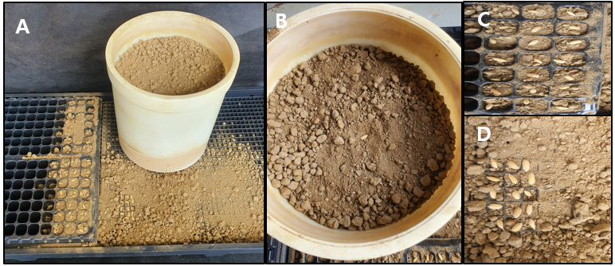
Figure S1. Photographs of Wagner pots and growing trays used to compare the growth and development of rice seedlings in experiment 3 (A). (B): 1/5000 a Wagner pots (3958 mL); (C): 406-cell seedling trays (4 mL); and (D): nursery seedling trays (0.5 mL).

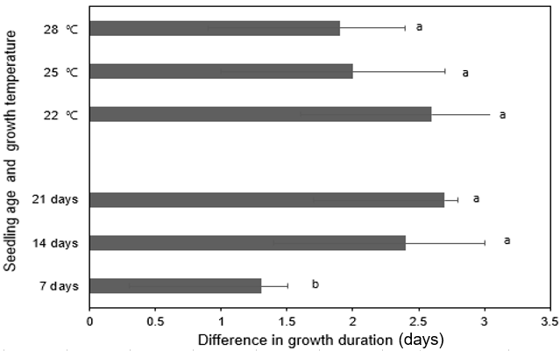Figure S2. Differences in growth duration among direct seeding and transplanting treatments (average of undamaged roots, roots cut to 1.5 cm, and roots cut to 3 cm) in response to temperature and seedling age. Error bars are standard deviations. Significant differences were evaluated using Duncan’s multiple range test at the 5% level.

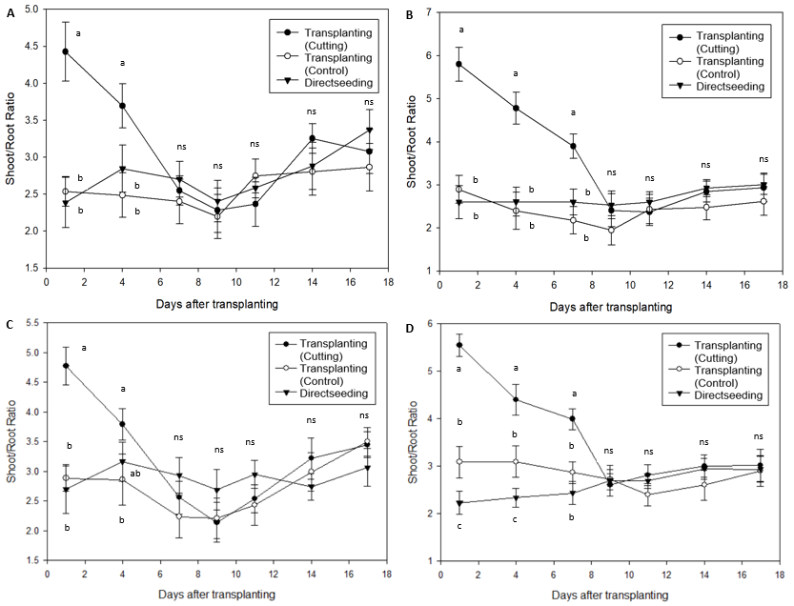
Figure S3. Changes in the ratio of shoots to roots after transplanting in response to root cutting conditions and seedling age. (A): Odae, 10-day-old seedlings; (B): Odae, 20-day-old seedlings; (C): Saenuri, 10-day-old seedlings; (D): Saenuri, 20-day-old seedlings. Error bars are standard deviations. Significant differences were evaluated using Duncan’s multiple range test at the 5% level.

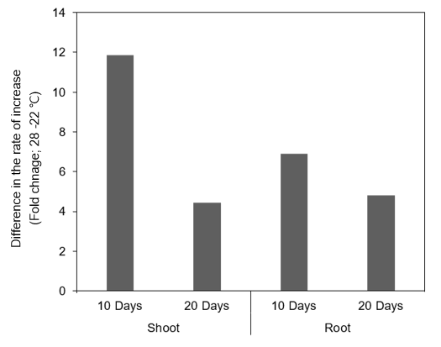
Figure S4. Difference in the rate of increase (fold change) in dry weight of shoots and roots for 17 days compared with 1 day after transplanting at temperature treatments of 28°C and 22°C for 10- and 20-day-old seedlings.

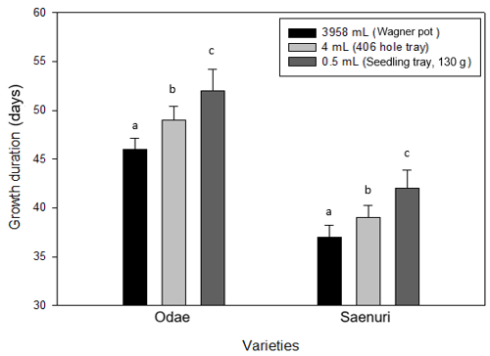
Figure S5. Changes in the growth duration from transplanting to heading according to seedlings with different leaf development in response to root growth space during the seedling period. Twenty-day-old seedlings were transplanted on the same day into 1/5000 а Wagner pots at a density of three plants per pot. Error bars are standard deviations.

